# **PREFACE**

" AI (Artificial Intelligence) is the new electricity.”

Electricity revolutionized all industries and changed our way of life, and AI is doing the same. It's reaching into every industry and discipline, and it's yielding advances that help multitudes of people." – Andrew Ng. (Cofounder of Coursera and from Google Brian)

**"*AI is not replacing your Jobs, probably those who knows it, replacing it*"—Hari K, The Author**

**AI Value creation by 2030: $13 Trillion**

AI's Impact on jobs worldwide:

Job Displaced by 2030 400-800 million

Job created by 2030 555-890 million.

(Source: McKinsey Global Institute)

Human brain typically Observe, Learn, Apply (OLA)

AI -> Artificial + Intelligence

Intelligence is " The Ability to Acquire and Apply Knowledge and Skills"

*When considering that 90 per cent of leading businesses already have ongoing investment in AI, AI-driven technology is likely to have a strong impact across sectors. Add to that the expectation that jobs requesting AI or machine learning skills will increase by 71 per cent in the next five years, it makes sense to start preparing for these changes today.*

AI has proven to be an integral part of building an efficient world. Industry leaders everywhere are quickly realizing the need to keep up with the hype. Google recently invested around $300 million into the development of Anthropic, a competitive foundation model that they hope will rival OpenAI’s ChatGPT.

But there is more to AI than chatbots. Applied AI can decrease costs, improve productivity, and increase revenue. These benefits do, however, come with certain risks. To understand and harness AI’s full potential, you first need to be prepared to address the challenges associated with its implementation in your business.

Welcome to Mastering AI, a comprehensive guide to understanding the transformative power of artificial intelligence. In the past decade, AI has evolved from a futuristic concept into a technology that is reshaping industries, enhancing human potential, and revolutionizing the way we interact with the world. Yet, for many, it remains a complex and often misunderstood topic.

This book is designed to bridge that gap. Whether you are a tech enthusiast, AI Job Seeker, AI Architect, Data scientist, Academician, Researcher, a business leader looking to integrate AI into your strategy, or simply someone curious about the technology future or an Inquisitive Student, Mastering AI will offer you valuable insights. We will explore the foundations of AI, from machine learning and neural networks to deep learning and natural language processing, breaking down complex concepts into accessible language, also provide easy step by step process to build your 1st AI model using simplified Knime Data analytics tool. (In our 2nd Edition i will explain building AI model using Azure MLflow & Python).

As a self-published work, this book is born from a passion for knowledge and a desire to make AI understandable and approachable for all with years of teaching and experience in building AI Models. Throughout these pages, you will find practical examples, real-world applications, Case studies exercise and do it yourself AI case studies and thought-provoking discussions on the ethical implications and future directions of AI and Quick Recap of the Topics you learned.

AI is not just a buzzword—it is a tool that, when harnessed correctly, can unlock unprecedented opportunities.

This is Book is one stop shop for all, from Novice to Expert for Artificial Intelligence.

Let this book be your guide to the fascinating world of artificial intelligence.

"Let's Begin your AI journey here.” - Hari

# **About the Authors**



**Hari C Krishna** is a Director of Data Analytics, enthusiastic Technologist, Professor, Data scientist, Mentor, Tutor, Researcher, and Advocate for accessible education in artificial intelligence. With 25 years of experience in the tech industry and a deep fascination with AI’s potential to transform the world, Hari has dedicated his career to making complex technological concepts understandable to all.

Driven by a belief that AI should be accessible to everyone, not just experts, Hari has authored this book to demystify AI and help readers navigate the rapidly evolving world of intelligent systems. When not writing or researching, He enjoy speaking at conferences, mentoring aspiring Students, tech enthusiasts, and exploring the ethical implications of emerging technologies.

Hari holds a degree in Bachelor of Engineering and

* + MBA in Management Information Systems
  + Executive Education on AI for Health Care from MIT Sloan School of Management,
  + Executive Education on AI Ethics, Carnegie Mellon University
  + Executive Education on AI for Business leaders at the Tepper School of Business, Carnegie Mellon University
  + Executive Education on Data science and AI/ML from Carlson school of Management, University of Minnesota.
  + Generative AI for Executives and Business Leaders, IBM

Hari is working as Director, Data Engineering & Analytics @United Health Care, Hartford, CT and has guided Many in Multiple AI projects across Industries and had taught more than 1000+ Students globally on AI Deep Neural Network and ML models.

Through this book, he aims to empower readers to not only understand AI but also think critically about how it will shape the future of work, society, and innovation.



**Nitin Talreja** B.Tech from premium institute (IIT), PMP-certified and MBA in Management Information Systems with more than 18 years of IT experience with relevant experience working in projects related to healthcare, insurance, media, and publishing industries with an emphasis on System Analysis.

Experience in providing cradle to grave management over large scale IT implementation projects. Demonstrated strong analytical and critical thinking skills, earned a reputation as someone offers a pro-active approach and is recognized as being results driven and an effective collaborator with exceptional leadership and communication skills. Talented with the data management policies, procedures, and widespread technical tools.

He is currently serving as Principal Data Engineer at UHC, Optum. He has successfully implemented cloud data migration in multiple projects and his research and interest areas are in data, decision support system, knowledge management, Deep Learning and Neural Network.

# **Foreword**

The field of artificial intelligence (AI) has evolved from a theoretical concept to a pivotal force driving technological advancement in every industry. As AI continues to grow in scope, it is reshaping how businesses operate, how products are developed, and how services are delivered. "Mastering AI: From Algorithms to Applications" is a timely and essential guide that equips readers with the foundational knowledge needed to thrive in this rapidly changing landscape. Whether you are a professional seeking to enhance your career or a student eager to dive into the world of AI, this book provides both theoretical insights and practical tools for understanding and leveraging AI.

The author, Hari C Krishna, has distilled his decades of experience in the tech industry into this comprehensive work. His goal is to make AI accessible, ensuring that readers can grasp complex concepts without needing extensive technical backgrounds. This democratization of AI knowledge is especially critical in today's world, where AI applications extend far beyond the realm of engineers and data scientists. By breaking down AI principles into digestible sections and incorporating hands-on exercises, this book ensures that readers not only learn but also apply their knowledge to real-world scenarios.

What sets this book apart is its focus on practical applications through tools like KNIME, allowing readers to experiment with AI models and analytics in tangible ways. Each chapter builds upon the previous, guiding readers from introductory concepts like regression and classification to more advanced topics such as neural networks, generative AI, and AI ethics. The book's structure reflects a balanced approach—both theoretical and practical—providing readers with a holistic understanding of AI. By the end of the book, readers will have the confidence to engage with AI tools and methodologies, setting them on a path toward successful AI implementations in their fields.

In a world where AI is increasingly becoming integrated into the fabric of society, understanding its mechanisms and implications is vital. Hari's deep passion for AI education is evident in his thoughtful writing and his commitment to empowering others. "Mastering AI: From Algorithms to Applications" is more than a guide—it is an invitation to explore, learn, and shape the future with AI.

**Stephen W Norcross**

**Vice President Data Analytics, UHC**

Berthoud, CO

10/21/24

# **Acknowledgment 1**

Authoring this book has been a journey that would not have been possible without the support and encouragement of many people.

Heartful thanks to my wife Dr. Sree Chandana Cherukuri and son Eashwar Krishna for their unwavering belief in me, your confidence in me, and for giving me the time and space to pursue this project. Your patience and understanding have meant the world to me.

My deepest gratitude to my late Mom and Dad for their encouragement

My sincerest gratitude and respect to Dr. Venkateshwaralu Cherukuri for his great contribution to the community that positively impacted the lives of more than a million people. Grateful for your advice and guidance for my success. Thank you!!

Specially thank Nitin Talreja, the Co-author of this book, I would not have done it without your sincerity, dedication, and hard work. Your amazing arduous work helped us to shape this book to perfection, Bravo!!

I am deeply grateful to Ms. Andrea Aiello, Associate Dean, School of Business, Clark university.

Special Thanks to My great Inspiring Leaders

Michael A Santoro, Chief Operating Officer @UHC

Dan McAloon, Vice President @UHC

Stephen W Norcross Vice President Data Analytics @UHC

David Weinandt Vice President @UHC

Martin Shindle Sr. Director @UHC

Nicholas W Dau, Vice President @UHC

I hope this work contributes, in some small way, to the conversations and innovations you are leading.

Thank you all.

Hari C Krishna

# **Acknowledgment 2**

I would like to express my deepest gratitude to my mother for her unwavering support and encouragement throughout this journey of book writing. I want to dedicate my work to my late father Shri Ashok Kumar.

I would not be able to get my work done without the continual support from Hari C. Krishna, who inspired and ignited the creative spark in me to author this book. This work would not have been possible without his collaboration. Acknowledging his support and scholarly insights and reviewing the script during the entire process of authoring this book.

I also take this opportunity to express a deep sense of gratitude to Prof. Jing Zhang for the opportunity @Clark University for the artificial intelligence program.

With love and thanks to my wife Aakanksha and my children for their enduring patience and support amidst the writing process.

Thanks

Nitin Talreja

# **INDEX**

**PREFACE** 1

**About the Authors** 3

**Foreword** 5

**Acknowledgment 1** 6

**Acknowledgment 2** 7

**INDEX** 8

**01 AI Introduction** 16

What is AI? 16

History of AI 17

Groundwork for AI: 17

Birth of AI: 1950-1956 17

AI maturation: 1957-1979 17

AI boom: 1980-1987 18

AI winter: 1987-1993 19

AI agents: 1993-2011 19

Artificial General Intelligence: 2012-present 20

How is AI used? 21

Types of AI 21

Brain Science and Problem Solving 22

The Turing Test 23

Structure of AI 24

Risks of AI for business 27

Data that Fuels AI 28

What is ML? 28

Machine Learning Methods 29

*Supervised machine learning* 29

*Unsupervised machine learning* 30

*Semi-supervised learning* 30

Bias and Variance in ML 31

Underfitting & Overfitting in ML 31

1.1 Key Takeaways 34

1.2 Quiz 35

**02 Introduction to ML Tools** 39

*Microsoft Azure Machine Learning* 39

*IBM Watson* 39

*TensorFlow* 40

*Amazon Machine Learning* 40

*OpenNN* 41

*PyTorch* 41

*Vertex AI* 41

*BigML* 41

*Apache Mahout* 42

Why KNIME? 42

*You can scale the interface by going to Menu > Interface scale.* 46

2.1 Key Takeaways 54

2.2 Quiz 55

**03 Exploratory Data Analysis** 59

What is EDA? 59

Steps Involved in EDA 61

EDA and data pre-processing practices 63

Exploratory Data Analysis Tools 63

Types of EDA 64

3.1 Key Takeaways 67

3.2 Quiz 68

3.3 Hands on Case Study: 72

3.4 Exercise do it yourself: 80

**04 Regression** 82

Types of Regression 83

1. Linear Regression 83

2. Logistic Regression 83

3. Polynomial Regression 83

4. Time series Regression 83

5. Support Vector Regression 83

Linear Regression 84

Types of Linear Regression 84

Evaluation Metrics for Linear Regression 88

Importance of linear regression 89

4.1 Key Takeaways 90

4.2 Quiz: 91

4.3 Hands-on Case Study: 95

4.4 Exercise do it yourself: 100

**05 Classification** 101

Machine Learning Classification Vs. Regression 102

Learners in Classifications Algorithm 103

Classification Types 105

Types of Classification Algorithms 108

Logistic Regression 108

❖ Decision Tree 110

Random Forest 111

Support Vector Machine (SVM) 112

Naive Bayes 114

K-Nearest Neighbors (KNN) 115

Evaluation of Classification Models 117

Confusion Matrix 118

Receiver-Operator Curve (ROC Curve) and Area Under the Curve (AUC) 121

What Are Special Cases for Classification Models? 122

5.1 Key Takeaways 123

5.2 Quiz : 124

5.3 Hands-on Case Study: 128

5.4 Exercise do it yourself: 137

**06 Neural Networks** 138

Evolution of Neural Networks 139

Deep Neural Network Architecture 140

What are the types of neural networks? 142

Feedforward neural networks. 142

Convolutional neural networks 143

Long Short-Term Memory Networks (LSTM) and Gated Recurrent Units (GRU) 143

Generative Adversarial Networks (GAN) 143

Multilayer Perceptrons 144

What is a Loss Function? 146

How Loss Functions Work? 146

Types of Loss Functions 148

What is an Activation Function? 148

Binary Step Function 149

Linear or Identity Activation Function 149

Non-linear Activation Function 150

Variants of Non-linear Activation Function 151

Training Deep Neural Network 157

Machine learning vs. Deep learning 159

Optimizing a Neural Network 159

6.1 Key Takeaways 161

6.2 Quiz : 162

6.3 Hands-on Case Study: 166

6.4 Exercise do it yourself: 177

**07 Ensemble Techniques** 178

Ensembles help overcome three main problems. 178

What are Ensemble Methods? 179

Ensemble Learning Strategies 179

A. Bagging : 180

B. Boosting 182

C. Stacking 183

Variance Reduction 185

Introduction to Decision trees 185

Types of Decision trees 186

A. Classification trees 186

B. Regression trees 186

Pruning 187

Types of Ensemble techniques 188

Random Forest 188

Random Forest Algorithm 189

Basic Step Involved in the algorithm. 189

Advantages 190

Disadvantages 190

Random Forest vs Decision Tree 190

What are hyperparameters? 191

Hyperparameters Tuning 191

Techniques for Hyperparameters Tuning 192

7.1 Key Takeaways 194

7.2 Quiz : 195

7.3 Hands-on Case Study: 199

7.4 Exercise do it yourself: 213

**08 Clustering** 214

Types of Clustering 215

Types of Clustering Algorithms 216

Optimizing k-means performance 220

Evaluation metrics for Clustering 222

Intrinsic measures 222

Extrinsic measures 222

Applications of Clustering 223

**Advantages of Clustering** 225

8.1 Key Takeaways 226

8.2 Quiz : 227

8.3 Hands-on Case Study: 232

8.4 Exercise do it yourself: 239

**09 Dimensionality Reduction** 240

Curse of Dimensionality 240

Benefits of Dimensionality Reduction 241

What is Principal Component Analysis? 242

How PCA works? 242

How is PCA calculated? 246

Assumptions and limitations of PCA 249

Advantages of PCA 250

Disadvantages of PCA 250

Uses of PCA 251

9.1 Key Takeaways 252

9.2 Quiz : 253

9.3 Hands-on Case Study: 257

9.4 Exercise do it yourself: 265

**10 NLP application – Sentimental Analysis** 266

Types Sentimental Analysis 266

Why Is Sentiment Analysis Important? 267

How Does Sentiment Analysis Work? 268

NLP methods for sentiment analysis 269

Sentiment Analysis Challenges 271

Applications of Sentiment Analysis 274

What is Natural Language Processing? 276

Understanding Hugging Face Transformers 276

Why Use Hugging Face Transformers? 278

10.1 Key Takeaways 279

10.2 Quiz : 280

10.3 Hands-on Case Study: 284

10.4 Exercise do it yourself: 290

**11 Recommendation Systems** 291

How Recommendation System Works? 292

Types of Recommendation Systems 292

Content based filtering. 292

Collaborative filtering 295

Collaborative filtering vs content-based filtering for recommender systems 299

Hybrid Recommendation Systems 300

Implicit Vs Explicit Feedback 304

Evaluation Metrics for Recommendation Systems 305

Steps to Build a Recommendation System 306

Challenges with Recommender System 307

AI recommendation system use cases. 308

Use Cases in Various Industries 308

Recommendation system in Music Industry 309

o **Problem:** 309

**Data** 309

**Model building** 309

Ephemeral, Contextual Personalization: A Glimpse into the Present 309

Benefits of Recommendation Systems 310

11.1 Key Takeaways 311

11.2 Quiz : 312

11.3 Hands-on Case Study: 317

11.4 Exercise do it yourself: 324

**12 AI Computer Vision** 325

Use cases of computer vision 327

How are images recognized by machines? 328

How does Computer Vision work? 330

Difference between computer vision and image processing? 337

What are common tasks that computer vision can perform? 338

12.1 Key Takeaways 344

12.2 Quiz : 345

**13 Generative AI** 349

The History of Generative AI 350

**1950s:** Text Analytics 350

**1980s:** Natural Language Processing Emerges 351

**2000s:** Machine Learning and Big Data Revolution 351

**2010s:** Virtual Assistants and Chatbots 351

**2020s:** GPT-3 and the Breakthrough in Generative AI 352

Top LLMs Comparison 352

What is RAG? 353

RAG Framework Basics 353

Types of RAG Technique 355

Difference between Retrieval-Augmented Generation and semantic search? 356

What are the benefits of RAG? 356

What is LangChain? 357

Core components of LangChain 358

How does LangChain work? 359

What are the benefits of LangChain? 360

Challenges of Using RAG 361

13.1 Key Takeaways 362

13.2 Quiz : 363

**14 AI Culture & Ethics** 367

Stakeholders in AI 368

UNESCO’s Human rights approach to AI 369

UNESCO Business Council for Ethics of AI 370

UNESCO's Women4Ethical 371

Women4Ethical AI's core aims are to: 371

Examples of AI ethics 371

Ethical challenges of AI 372

Organizations that promote AI ethics 374

14.1 Key Takeaways 377

14.2 Quiz: 378

**References** 382

Web Reference 382

**Answers to Quiz** 383

Glossary 386

# **01 AI Introduction**

Artificial Intelligence is no longer a concept restricted to the pages of futuristic novels and Sci-Fi movies. It is being adapted at a breakneck speed in the corporate world across different processes like planning, customer service, product design and development, operations etc. The implications of this incorporation are profound for business in terms of innovation and growth. In today’s evolving landscape the need for effective leadership is to harness the potential of Artificial Intelligence (AI) and Generative AI to drive decisions that are rooted in the data and show a competitive advantage.

*“By 2027, about 80 per cent of engineering workers will need to learn new skills to work with artificial intelligence (AI)”, according to a new report by Gartner.*

*Gartner's report suggests that while AI will change software engineering, it will not replace the need for skilled human developers. In fact, it will create new opportunities for those ready to learn AI-related skills.*

## What is AI?

AI which is the abbreviation for Artificial Intelligence can be defined as the simulation of human intelligence in the machines that can be programmed to think and act like humans. AI is a term used to describe machines that can perform tasks that requires human intelligence, such as visual perception, speech recognition, decision making and language translation. It includes a set of algorithms that makes use of information- in the form of data to make decisions and perform tasks like human. Some AIs are designed to be used in the robots for the rescue operations, able to navigate through difficult terrains and harsh conditions. Other AIs are expert in crunching data and specialize in various analytics jobs. AI tools are already having a significant impact on the way we conduct the business worldwide, completing tasks with speed and efficiency that would not be possible for the humans.

Mathematician Alan Turing was the first one to describe as to how the artificially intelligence machine could function. All computers built since then are artificially intelligent at some level and can perform computational tasks that could previously be done by humans. In recent time computer’s abilities speed, storage capacity and processing power have increased exponentially. Most AI is built on the analysis of BIG datasets that hold too much information for any human to analyze on their own in the reasonable amount of time. An AI model is built to find patterns on those datasets, and then using Probability and Statistical analysis it uses those patterns to predict future or additional patterns.

## History of AI

### Groundwork for AI:

1900-1950In the early 1900s, there was a lot of media created that centered around the idea of artificial humans. So much so that scientists of all sorts started asking the question: is it possible to create an artificial brain? Some creators even made some versions of what we now call “robots” (and the word was coined in a Czech play in 1921) though most of them were simple. These were steam-powered, and some could make facial expressions and even walk.

**1921**: Czech playwright Karel Čapek released a science fiction play “Rossum’s Universal Robots” which introduced the idea of “artificial people” which he named robots. This was the first known use of the word.

**1929**: Japanese professor Makoto Nishimura built the first Japanese robot, named Gakutensoku.

**1949**: Computer scientist Edmund Callis Berkley published the book “Giant Brains, or Machines that Think” which compared the newer models of computers to human brains.

### Birth of AI: 1950-1956

This range of time was when the interest in AI really came to a head. Alan Turing published his work “Computer Machinery and Intelligence” which eventually became The Turing Test, which experts used to measure computer intelligence. The term “artificial intelligence” was coined and came into popular use.

**1950:** Alan Turing published “Computer Machinery and Intelligence” which proposed a test of machine intelligence called The Imitation Game.

**1952**: A computer scientist named Arthur Samuel developed a program to play checkers, which is the first to ever learn the game independently.

**1955**: John McCarthy held a workshop at Dartmouth on “artificial intelligence” which is the first use of the word, and how it came into popular usage.

### AI maturation: 1957-1979

The time between when the phrase “artificial intelligence” was created, and the 1980s was a period of both rapid growth and struggle for AI research. The late 1950s through the 1960s was a time of creation. From programming languages that are still in use to this day to books and films that explored the idea of robots, AI became a mainstream idea quickly.

The 1970s showed similar improvements, such as the first anthropomorphic robot being built in Japan, to the first example of an autonomous vehicle being built by an engineering graduate student. However, it was also a time of struggle for AI research, as the U.S. government showed little interest in continuing to fund AI research.

**1958**: John McCarthy created LISP (acronym for List Processing), the first programming language for AI research, which is still in popular use to this day.

**1959**: Arthur Samuel created the term “machine learning” when doing a speech about teaching machines to play chess better than the humans who programmed them.

**1961**: The first industrial robot Unimate started working on an assembly line at General Motors in New Jersey, tasked with transporting die castings and welding parts on cars (which was deemed too dangerous for humans).

**1965**: Edward Feigenbaum and Joshua Lederberg created the first “expert system” which was a form of AI programmed to replicate the thinking and decision-making abilities of human experts.

**1966**: Joseph Weizenbaum created the first “chatterbot” (later shortened to chatbot), ELIZA, a mock psychotherapist, that used natural language processing (NLP) to converse with humans.1968: Soviet mathematician Alexey Ivakhnenko published “Group Method of Data Handling” in the journal “Avtomatika,” which proposed a new approach to AI that would later become what we now know as “Deep Learning.”

**1973**: An applied mathematician named James Lighthill gave a report to the British Science Council, underlining that strides were not as impressive as those that had been promised by scientists, which led to much-reduced support and funding for AI research from the British government.

**1979**: James L. Adams created The Standford Cart in 1961, which became one of the first examples of an autonomous vehicle. In ‘79, it successfully navigated a room full of chairs without human interference.

**1979**: The American Association of Artificial Intelligence which is now known as the Association for the Advancement of Artificial Intelligence (AAAI) was founded.

### AI boom: 1980-1987

Most of the 1980s showed a period of rapid growth and interest in AI, now labeled as the “AI boom.” This came from both breakthroughs in research, and additional government funding to support the researchers. Deep Learning techniques and the use of Expert System became more popular, both of which allowed computers to learn from their mistakes and make independent decisions.

**1980**: First conference of the AAAI was held at Stanford.

**1980**: The first expert system came into the commercial market, known as XCON (expert configure). It was designed to assist in the ordering of computer systems by automatically picking components based on the customer’s needs.

**1981**: The Japanese government allocated $850 million (over $2 billion dollars in today’s money) to the Fifth Generation Computer project. Their aim was to create computers that could translate, converse in human language, and express reasoning on a human level.

**1984**: The AAAI warns of an incoming “AI Winter” where funding and interest would decrease and make research significantly more difficult.

**1985**: An autonomous drawing program known as AARON is demonstrated at the AAAI conference.

**1986**: Ernst Dickmann and his team at Bundeswehr University of Munich created and demonstrated the first driverless car (or robot car). It could drive up to 55 mph on roads that did not have other obstacles or human drivers.

**1987**: Commercial launch of Alacrity by Alactrious Inc. Alacrity was the first strategy managerial advisory system and used a complex expert system with 3,000+ rules.

### AI winter: 1987-1993

As the AAAI warned, an AI Winter came. The term describes a period of low consumer, public, and private interest in AI which leads to decreased research funding, which, in turn, leads to few breakthroughs. Both private investors and the government lost interest in AI and halted their funding due to excessive cost versus low return. This AI Winter came about because of some setbacks in the machine market and expert systems, including the end of the Fifth-Generation project, cutbacks in strategic computing initiatives, and a slowdown in the deployment of expert systems.

**1987**: The market for specialized LISP-based hardware collapsed due to cheaper and more accessible competitors that could run LISP software, including those offered by IBM and Apple. This caused many specialized LISP companies to fail as the technology was now easily accessible.

**1988**: A computer programmer named Rollo Carpenter invented the chatbot Jabberwacky, which he programmed to provide interesting and entertaining conversation to humans.

### AI agents: 1993-2011

Despite the lack of funding during the AI Winter, the early 90s showed some impressive strides forward in AI research, including the introduction of the first AI system that could beat a reigning world champion chess player. This era also introduced AI into everyday life via innovations such as the first Roomba and the first commercially available speech recognition software on Windows computers. The surge in interest was followed by a surge in funding for research, which allowed even more progress to be made.

**1997**: Deep Blue (developed by IBM) beat the world chess champion, Gary Kasparov, in a highly publicized match, becoming the first program to beat a human chess champion.

**1997**: Windows released a speech recognition software (developed by Dragon Systems).

**2000**: Professor Cynthia Breazeal developed the first robot that could simulate human emotions with its face, which included eyes, eyebrows, ears, and a mouth. It was called Kismet.

**2002**: The first Roomba was released.

**2003**: Nasa landed two rovers onto Mars (Spirit and Opportunity), and they navigated the surface of the planet without human intervention.

**2006**: Companies such as Twitter, Facebook, and Netflix started utilizing AI as a part of their advertising and user experience (UX) algorithms.

**2010**: Microsoft launched the Xbox 360 Kinect; the first gaming hardware designed to track body movement and translate it into gaming directions.

**2011**: An NLP computer programmed to answer questions named Watson (created by IBM) won Jeopardy against two former champions in a televised game.

**2011**: Apple released Siri, the first popular virtual assistant.

### Artificial General Intelligence: 2012-present

This brings us to the most recent developments in AI, up to the present day. We have seen a surge in common-use AI tools, such as virtual assistants, search engines, etc. This period also popularized Deep Learning and Big Data.

**2012**: Two researchers from Google (Jeff Dean and Andrew Ng) trained a neural network to recognize cats by showing it unlabeled images and no background information.

**2015**: Elon Musk, Stephen Hawking, and Steve Wozniak (and over 3,000 others) signed an open letter to the worlds’ government systems banning the development of (and later, use of) autonomous weapons for purposes of war.

**2016**: Hanson Robotics created a humanoid robot named Sophia, who became known as the first “robot citizen” and was the first robot created with a realistic human appearance and the ability to see and replicate emotions, as well as to communicate.

**2017**: Facebook programmed two AI chatbots to converse and learn how to negotiate, but as they went back and forth, they ended up forgoing English and developing their own language, completely autonomously.

2018: A Chinese tech group called Alibaba’s language-processing AI beat human intellect on a Stanford reading and comprehension test.

**2019**: Google’s Alpha Star reached Grandmaster on the video game StarCraft 2, outperforming all but .2% of human players.

**2020**: OpenAI started beta testing GPT-3, a model that uses Deep Learning to create code, poetry, and other such language and writing tasks. While not the first of its kind, it is the first that creates content almost indistinguishable from those created by humans.

**2021**: OpenAI developed DALL-E, which can process and understand images enough to produce accurate captions, moving AI one step closer to understanding the visual world.

## How is AI used?

The use cases of AI are still expanding. Below are some real-world applications of AI:

* Finance: Many financial companies use AI to predict and find market trends in the stock market.
* Coding: AI offers the ability to quickly generate code, create documentation and scan code for vulnerabilities.
* Healthcare: AI can be used to diagnose health conditions, scan reports and aid doctor in predicting the disease accurately along with other repetitive tasks in the healthcare world.
* Self-driving automobiles: AI’s ability to make predictions enables it to respond to real-world situations in the road and helps in navigating the vehicle precisely.
* Chatbots: Some AI models can converse accurately with human sounding answers and can respond to the input from the users. Generative AI models are used here to generate speech, text, images, and video.

## Types of AI

The current AI system we have today can-do limited set of tasks quite well but might be mediocre in performing the other tasks. For instance, an image recognition AI might be great in reading and interpreting the images but might not correctly find the song form the music played and hence is termed as weak AI *(Narrow AI).* Weak AI works with in the pre-defined boundaries and cannot generalize beyond their specialized domain. It is also referred as *Artificial Narrow Intelligence (ANI).* Narrow AI has experienced many break throughs in the last decade, powered by progress made in the Machine Learning and deep learning. ANIs are currently used in the medical field to find and diagnose cancer and other diseases with extreme accuracy through replication of human cognition and reasoning. ANI’s machine intelligence comes from the use of natural language processing (NLP) to perform tasks, this is evident in chatbots and speech recognition of the Siri and Alexa.

General AI, also known as *Artificial General Intelligence (AGI)* or *Strong AI* refers to AI that possess human-level intelligence or even surpass human beings at wide range of tasks. AGI is capable of learning, understanding, reasoning, and applying knowledge to solve complex problem in a comparable manner to human cognition. While AI researchers are interested in the creation of AGI, it only exists as a theoretical concept and has not been achieved to date, but research in this area is going on as to how to build the machine consciousness and programming the full set of cognitive abilities. Machines would take the experiential learning to the next level, by not just improving the efficiency on the singular tasks but gaining the ability to apply experiential learning to the wider range of tasks.

Super intelligence has always been the part of Sci-fi fiction in which robot overthrow and enslave humans. The concept of artificial super intelligence sees AI evolve to be so akin to human emotions and experiences that it evokes human like emotions, desires, beliefs and needs of its own. *Artificial Super Intelligence (ASI) ,*it is the hypothetical AI that not only understand or replicate human behavior but where it becomes self-aware and surpass the ability of the human intelligence. ASI would be capable of solving complex problems that are beyond human capabilities and would be able to learn and adapt at a rate that far exceed human intelligence. The development of ASI is the goal of AI research. It would have the ability to perform any superhuman like tasks. It could solve the world’s most pressing problem, such as climate change, disease, and poverty. The development of Super AI also comes with its challenges and ethical implications that includes ethical decision making, Data privacy and Singularity where the ASI will become so intelligent that it can surpass human, this could lead to machines taking over the world and create disruption in the world.

## Brain Science and Problem Solving

A particular strength of human intelligence is the adaptivity. We can adjust to the various environmental condition and accordingly adjust and change our behavior accordingly through the learning. Humans can learn different tasks in succession. This can be explained with how the human brain can learn to sort the oranges first based on the size and can also learn to sort the same oranges based on the shape and texture of the oranges. It is easy for the human brain to learn both the task and remember but for an artificial neural network forgets the first task after learning the second task this phenomenon is called as catastrophic forgetting. Researchers now at the University of Oxford that were involved with the Human Brain Project, have successfully generated a neural network that models human-like continual learning. In contrast to standard neural networks, their updated one could learn the (equivalents of) orange-sorting tasks very well when one task was trained after the other –resembling the way humans learn – whereas a standard network performed better when it had to learn both tasks simultaneously. By applying insights from brain research to update neural networks, the study provides a step forward in the field of machine learning and towards neuro-inspired technology, e.g., for smarter robots.

Cognitive science is devoted to research into human thinking at a higher level. Similarly, to brain science, this field furnishes practical AI with many important ideas. On the other hand, algorithms and implementations lead to further important conclusions about how human reasoning functions. Thus, these three fields benefit from a fruitful interdisciplinary exchange. There are many interesting philosophical questions surrounding intelligence and artificial intelligence.

## The Turing Test

Turing Test is a method of inquiry in artificial intelligence (AI) for determining whether a computer is capable of thinking like a human being. The test is named after Alan Turing, the founder of the Turing Test and an English computer scientist, cryptanalyst, mathematician, and theoretical biologist.

Turing proposed that a computer can be said to possess artificial intelligence if it can mimic human responses under specific conditions. The original Turing Test requires three terminals, each of which is physically separated from the other two. One terminal is operated by a computer, while the other two are operated by humans. During the test, one of the humans’ functions as the questioner, while the second human and the computer function as respondents. The questioner interrogates the respondents within a specific subject area, using a specified format and context. After a preset length of time or number of questions, the questioner is then asked to decide which respondent was human and which was a computer. The test is repeated many times. If the questioner makes the correct determination in half of the test runs or less, the computer is considered to have AI because the questioner regards it as "just as human" as the human respondent.

The Turing Test has been criticized over the years, because historically, the nature of the questioning had to be limited for a computer to exhibit human-like intelligence. For many years, a computer might only score high if the questioner formulated the queries, so they had "Yes" or "No" answers or pertained to a narrow field of knowledge. When questions were open-ended and required conversational answers, it was less likely that the computer program could successfully fool the questioner. To many researchers, the question of whether a computer can pass a Turing Test has become irrelevant. Instead of focusing on how to convince someone they are conversing with a human and not a computer program, the real focus should be on how to make a human-machine interaction more intuitive and efficient. For example, by using a conversational interface.

Alternatives to Turing Tests were later developed because many see the Turing test to be flawed. These alternatives include tests such as:

*The Marcus Test* - in which a program that can 'watch' a television show is tested by being asked meaningful questions about the show's content.

*The Lovelace Test 2.0* - which is a test made to detect AI through examining its ability to create art.

*Winograd Schema Challenge* - which is a test that asks multiple-choice questions in a specific format.

Despite much debate about the relevance of the Turing Test today and the validity of the competitions that are based around it, the test still stands as a philosophical starting point for discussing and researching AI. As we continue to make advances in AI and better understand and map how the human brain functions, the Turing Test remains foundational for defining intelligence and is a baseline for the debate about what we should expect from technologies for them to be considered thinking machines.

## Structure of AI

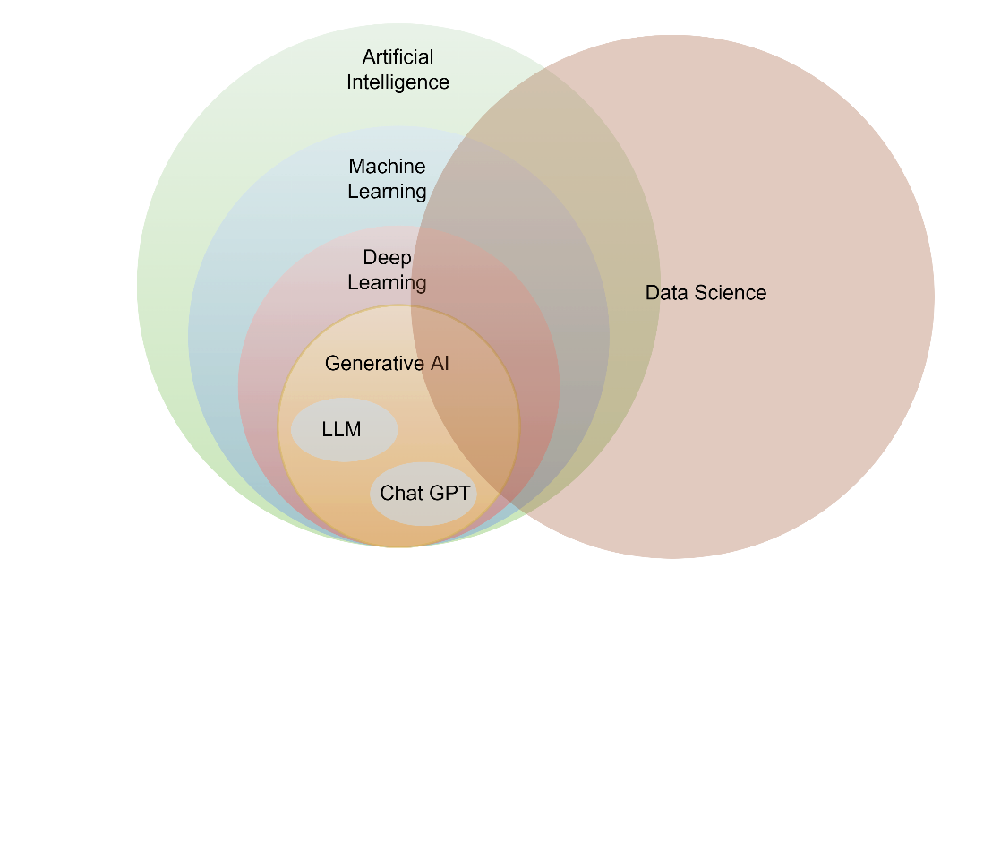 Artificial intelligence involves that equip computer to imitate human behaviour, enabling them to learn, make decisions, recognize patterns and solve complex problems in a manner akin to human intelligence.

Fig 1.1 : “Structure of AI” *(Credit: CCO Public Domain)*

There is no single definition of AI. AI can be look upon as the ability we can impart to a machine to enable it to learn from data and make intelligent decisions based on the insight and patterns drawn from the data.

Data Science is a descriptive field that uses scientific methods to capture, maintain, process and analyse data. DS is a multidisciplinary field focussed on drawing Insights. It serves as the basis of many AI, ML and Deep learning processes. The availability of huge volumes of data implies use of predictive analytics and identify hidden patterns in the data that was not possible initially. For instance, the bank may discover the credit worthy customers or identify financial products that new customers buy. Such data-driven insights can be extremenly valuable for cross-selling strategies and targeted advertisements to potential customers. Here are some examples of DS applications:

* Banking : Credit Risk Modelling, Fraud Detection.
* Finance: Risk Analytics and Strategic Decision making.
* Manufacturing: Automating units, Predicting Potential problems.
* Healthcare: Drug discovery, Virtual Assistant.
* E-commerce: Identifying Customers and Recommending Products.
* Transport: Automated, Self-driving Cars, Enhancing Passengers safety

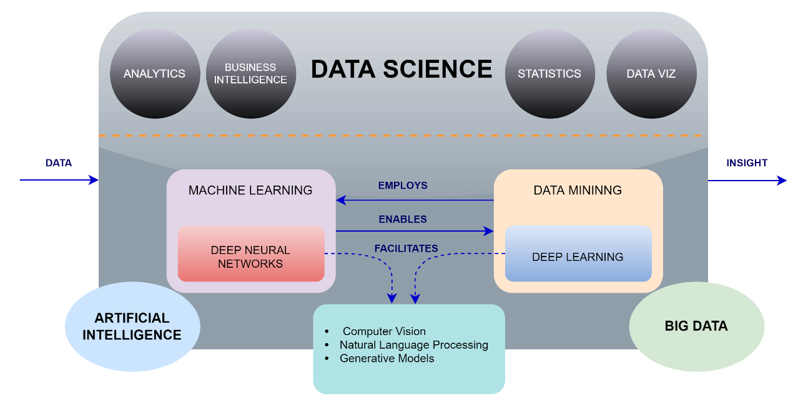

Fig 1.2: “Data Science Concepts” *(Credit: CCO Public Domain)*

Machine Learning is a subset of AI, uses advanced algorithms to detect patterns by analysing vast amounts of data sets and allowing machines to learn and adapt and answer a very specific question. ML improves its decision based on the experience. It uses both supervised and un-supervised learning methods. This can be explained by a simple example which involves feeding huge amount of data to the algoritham and allowing algoritham to adjust itself and improve. For example lets train our algoritham to identify Dog in the picture, for this we use millions of picture which has correctly tagged “Dog” versuses that do not. Then , the algoritham tries to build a model that can accurately tag a picture that contains Dog in it. Once the accuracy level is high enough, the machine has learned how dog looks like. ML relies on the access of large datasets and the use of pre-defined processes called algorithms. Machine learning is the core of some companies’ business models, like in the case of Netflix’s suggestions algorithm or Google’s search engine. Other companies are engaging deeply with machine learning, though it’s not their main business proposition.

Companies are already using machine learning in several ways, including:

* Recommendation algorithms
* Image analysis and object detection
* Fraud detection
* Medical imaging and diagnostics.

Deep learning (DL) is a subset of ML which uses neural network for in-depth data processing and analytics tasks. DL uses multiple layers of artificial neural networks to extract high level features from raw input data, simulating the way human brains perceive and understand the world. The concept of DL also referred to as “deep neural networks” due to the many layers involved. These layers can be seen as a nested hierarchy of related concepts or decision tree. Computational Intensively is one of the hallmarks of deep learning, and it is one reason GPUs are in demand to train the deep-learning models. DL was inspired by the structure and function of the human brain with multiple neurons interconnected together. Just like our bodies collect sensory input such as sight, sound, taste, touch, and smell. Our brains take that data, make sense, and do the decision making similarly Artificial Neural Networks (ANNs) are algorithms that mimic the biological structure of the brain. The process in which ANN works is that it keeps on measuring the error and change its parameter until it cannot achieve any less error. In short it is an optimization algorithm.

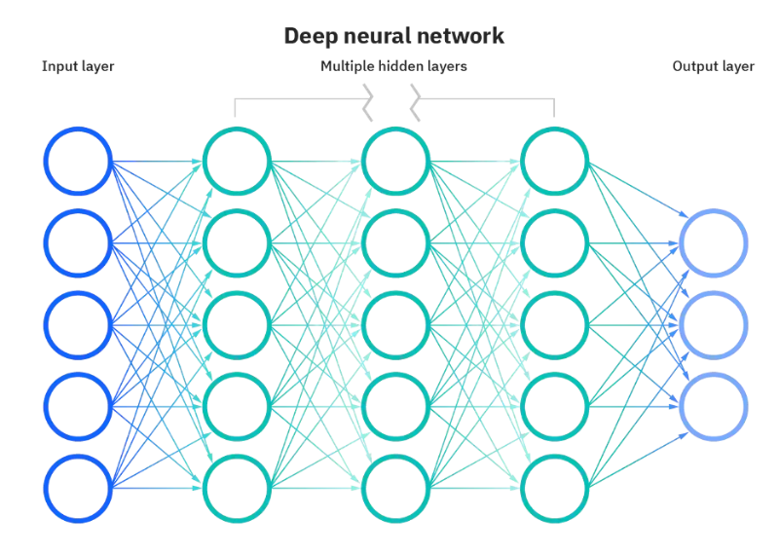

Fig 1.3: “Deep Neural Networks” *(Credit: CCO Public Domain)*

Neural networks are made up of node layers – an input layer, one or more hidden layers, and an output layer. Each node is an artificial neuron that connects to the next, and each has a weight and threshold value. When one node’s output is above the threshold value, that node is activated and sends its data to the network’s next layer. If it is below the threshold, no data passes along. Training data teach neural networks and help improve their accuracy over time. Once the learning algorithms are fined tuned, they become powerful computer science and AI tools because they allow us to very quickly classify and cluster data. Using neural networks, speech and image recognition tasks can happen in minutes instead of the hours they take when done manually. Google’s search algorithm is a well-known example of a neural network. Most deep neural networks are feed-forward, meaning they only flow in one direction from input to output. However, you can also train your model through back-propagation, meaning moving in the opposite direction, from output to input. Back-propagation allows us to calculate and attribute the error associated with each neuron, allowing us to adjust and fit the algorithm appropriately.

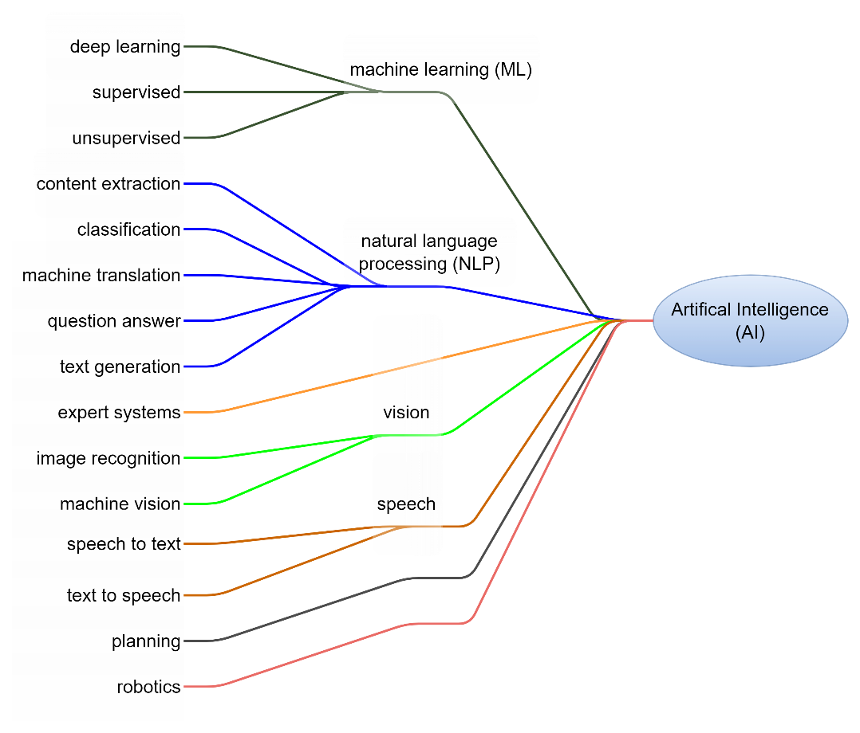

Fig 1.4 : “Concepts of AI” *(Credit: CCO Public Domain)*

Generative AI is a subset of Deep Learning models that generate content like text, images or code based on the provided input. Trained on vast datasets, these models detect patterns and create output without any explicit instructions, using a mix of supervised and unsupervised learning. Popular generative AI tools include Bard, Chat GPT and Llama.

### Risks of AI for business

* **Regulatory violations**: Using external AI resources can make organization more prone to data risk. Using AI might cause regulatory and compliance issues.
* **Data leaks**: AI services and LLM models use input data to further train the models and are currently not designed as the secure vault for the data. This increases the data exposure including source code and confidential information.
* **Hallucinations**: This normally happens when Generative AI tends to create information on its own which might not be from reliable source. This can cause misinformation and can impact the brand image of the organization.
* **Security flaws:**  AI applications are also prone to security vulnerabilities that can impact the data security of the organization.

## Data that Fuels AI

Big Data and AI have a synergistic relationship. Big Data analytics uses AI for better understanding and analysis of data. On the other hand, AI requires massive volume of data to learn and improve decision making process. AI can aid users in all phases of big data cycle, or the process involved in aggregation, storage, and retrieval of diverse types of data from various sources. These include pattern management, data management, decision making, context management, goal & risk analysis. AI can find data types, find connections among the datasets, and recognize knowledge using NLP. It can be used to automate and accelerate data preparation tasks, including the development of data models that helps in data exploration.

## What is ML?

In simple term Machine Learning (ML) is defined as the branch of AI that focuses on the using data and algorithms to enable AI to imitate the way that humans learn and gradually improving its accuracy. ML models are computer algorithms that uses data to make educated guesses or decisions. Machine-learning models differ from traditional algorithms by their designed as these ML algorithm uses data to get better at a specific task. For example, spam filters use machine learning. As more spam has arrived and been labeled as junk by human users, the machine-learning algorithms have gained more experience and become better at their job.

Machine learning, Deep learning, and Neural networks are all sub-fields of artificial intelligence. Neural network is a subset of machine learning, and deep learning is a subset of neural networks. The way in which Deep learning and Machine learning differ is in how each algorithm learns. "Deep" machine learning can use labeled datasets, also known as supervised learning, to inform its algorithm, but it does not necessarily require a labeled dataset. The Deep learning process can ingest unstructured data in its raw form (e.g., text or images), and it can automatically determine the set of features which distinguish various categories of data from one another. This eliminates some of the human intervention required and enables the use of enormous amounts of data. Think of deep learning as "scalable machine learning" as mentioned by Lex Fridman. Classical, or "non-deep," machine learning is more dependent on human intervention to learn. Human experts determine the set of features to understand the differences between data inputs, usually requiring more structured data to learn.

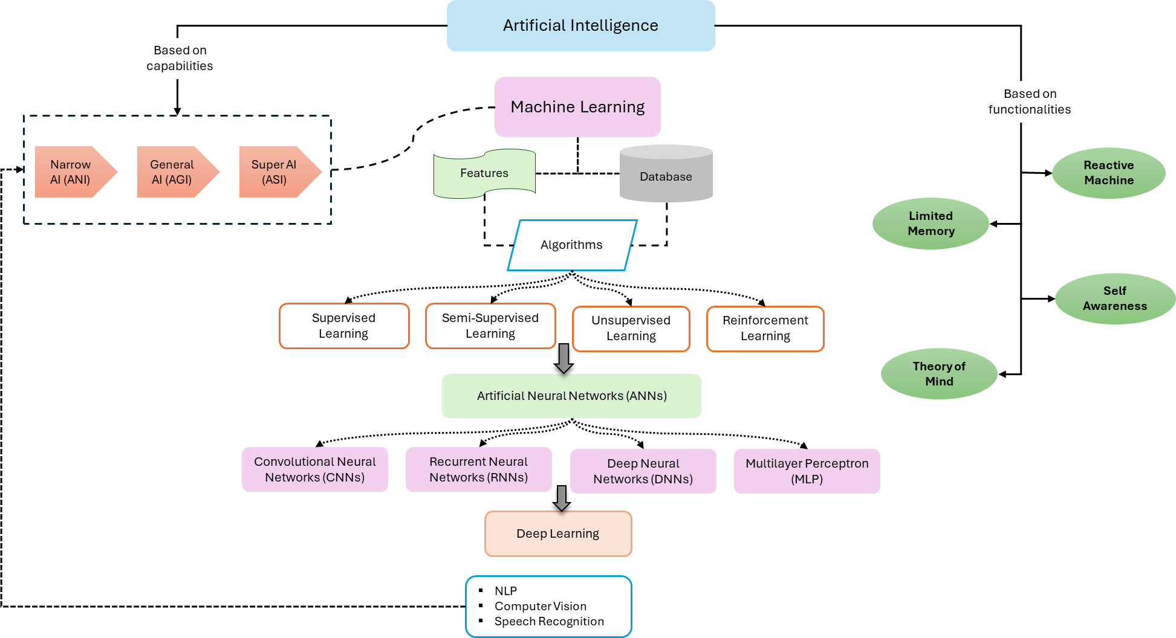

Fig 1.5: “Relationship between AI & ML” *(Credit: Researchgate.net)*

### Machine Learning Methods

ML models have three prime categories:

#### Supervised machine learning

Supervised machine learning (SML) is defined by its use of labeled datasets to train algorithms to classify data or predict outcomes accurately. As input data is fed into the model, the model adjusts its weights until it has been fitted appropriately. This occurs as part of the cross-validation process to ensure that the model avoids overfitting or underfitting. Supervised learning helps organizations solve a variety of real-world problems at scale, such as classifying spam in a separate folder from your inbox. Some methods used in supervised learning include neural networks, naïve bayes, linear regression, logistic regression, random forest, and support vector machine (SVM). Although Supervised learning is helpful with deep data insights and improved automation but there are challenges when building sustainable supervised models

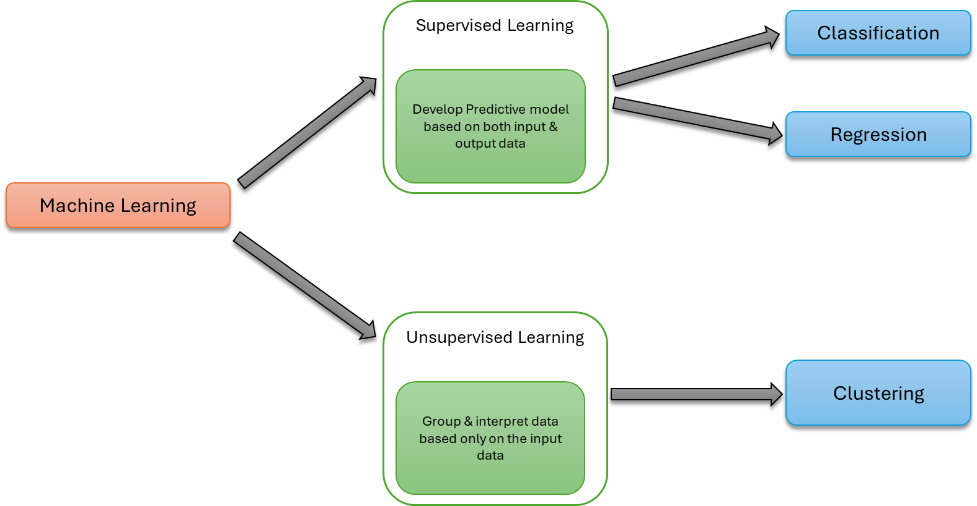

Fig 1.6 : “Machine Learning Methods”

#### Unsupervised machine learning

Unsupervised machine learning (UML) uses machine learning algorithms to analyze and cluster unlabeled datasets (subsets called clusters). These algorithms discover hidden patterns or data groupings without the need for human intervention. This method’s ability to discover similarities and differences in information make it ideal for exploratory data analysis (EDA), cross-selling strategies, customer segmentation, and image and pattern recognition. It is also used to reduce the number of features in a model through the process of dimensionality reduction. Principal component analysis (PCA) and singular value decomposition (SVD) are two common approaches for this. Other algorithms used in unsupervised learning include neural networks, k-means clustering, and probabilistic clustering methods.

#### Semi-supervised learning

Semi-supervised learning (SSL) is a branch of machine learning that combines supervised and unsupervised learning by using both labeled and unlabeled data to train artificial intelligence (AI) models for classification and regression tasks. During training, it uses a smaller labeled data set to guide classification and feature extraction from a larger, unlabeled data set. Semi-supervised learning methods are especially relevant when obtaining enough labeled data that is prohibitively difficult or expensive, but copious amounts of unlabeled data are easy to acquire. In such scenarios, neither fully supervised nor unsupervised learning methods will provide adequate solutions.

SSL techniques modify or supplement a supervised algorithm—called the “base learner,” to incorporate information from unlabeled examples. Labeled data points are used to ground the base learner’s predictions and add structure to the learning problem. The goal in training any classification model is for it to learn an accurate decision boundary: a line—or, for data with more than two dimensions, a “surface” or hyperplane—separates data points of one classification category from data points belonging to a different classification category. Though a fully supervised classification model can technically learn a decision boundary using only a few labeled data points, it might not generalize well to real-world examples, making the model's predictions unreliable. (Dave Bergmann, 2023)

### Bias and Variance in ML

#### *Bias*

Bias refers to the error due to overly simplistic assumptions in the learning algorithm. These assumptions make the model easier to comprehend and learn but might not capture the underlying complexities of the data. It is the error due to the model’s inability to represent the true relationship between input and output accurately. When a model has mediocre performance both on the training and testing data means high bias because of the simple model, indicating underfitting.

#### Variance

Variance, on the other hand, is the error due to the model’s sensitivity to fluctuations in the training data. It is the variability of the model’s predictions for different instances of training data. High variance occurs when a model learns the training data’s noise and random fluctuations rather than the underlying pattern. As a result, the model performs well on the training data but poorly on the testing data, indicating overfitting.

### Underfitting & Overfitting in ML

#### Underfitting

A statistical model or a machine learning algorithm is said to have underfitting when a model is too simple to capture data complexities. It represents the inability of the model to learn the training data effectively result in inferior performance both on the training and testing data. In simple terms, an underfit models are inaccurate, especially when applied to new, unseen examples. It happens when we use quite simple model with overly simplified assumptions. To address underfitting problem of the model, we need to use more complex models, with enhanced feature representation, and less regularization. The underfitting model has High bias and low variance.

###### Reasons for Underfitting

* The model is too simple, so it may be not capable to represent the complexities in the data.
* The input features which are used to train the model is not the adequate representations of underlying factors influencing the target variable.
* The size of the training dataset used is not enough.
* Excessive regularizations are used to prevent the overfitting, which constraint the model to capture the data well.
* Features are not scaled.

###### Techniques to Reduce Underfitting

* Increase model complexity.
* Increase the number of features, performing feature engineering.
* Remove noise from the data.
* Increase the number of epochs or increase the duration of training to get better results.

#### Overfitting

A statistical model is said to be overfitted when the model does not make accurate predictions on testing data. When a model gets trained with so much data, it starts learning from the noise and inaccurate data entries in our data set. And when testing with test data results in High variance. Then the model does not categorize the data correctly, because of too many details and noise. The causes of overfitting are the non-parametric and non-linear methods because these types of machine learning algorithms have more freedom in building the model based on the dataset and therefore, they can really build unrealistic models. A solution to avoid overfitting is using a linear algorithm if we have linear data or using the parameters like the maximal depth if we are using decision trees. Overfitting is a problem where the evaluation of machine learning algorithms on training data is different from unseen data.

###### Reasons for Overfitting:

* High variance and low bias.
* The model is too complex.
* The size of the training data.

###### Techniques to Reduce Overfitting

* Improving the quality of training data reduces overfitting by focusing on meaningful patterns, mitigate the risk of fitting the noise or irrelevant features.
* Increase the training data can improve the model’s ability to generalize to unseen data and reduce the likelihood of overfitting.
* Reduce model complexity.
* Early stopping during the training phase (have an eye over the loss over the training period as soon as loss begins to increase stop training).
* Ridge Regularization and Lasso Regularization.
* Use dropout for neural networks to tackle overfitting.

#### Good Fit in a Statistical Model

Ideally, the case when the model makes the predictions with 0 error, is said to have a good fit on the data. This situation is achievable at a spot between overfitting and underfitting. With the passage of time, our model will keep on learning, and thus the error for the model on the training and testing data will keep on decreasing. If it will learn for too long, the model will become more prone to overfitting due to the presence of noise and less useful details. Hence the performance of our model will decrease. To get a good fit, we will stop at a point just before where the error starts increasing. At this point, the model is said to have good skills in training datasets as well as our unseen testing dataset.

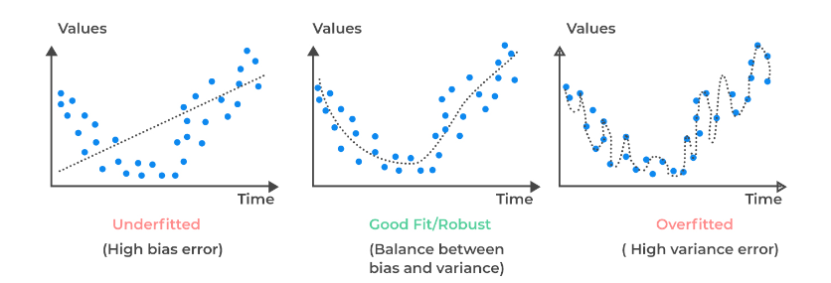

Fig 1.7: “Overfitting & Underfitting” *(Credit: CCO Public Domain)*



### 1.1 Key Takeaways



* An AI model is built to find patterns on the big data, and then using Probability and Statistical analysis it uses those patterns to predict future or additional patterns.
* AI is used across multiple industry from Finance, Healthcare to Self-driving, chatbots and automating code.
* Weak or Narrow AI works within the pre-defines boundaries and cannot generalize beyond their specialized domain.
* Machine Learning has three categories: Supervised, Unsupervised, and semi-supervised learning.
* Turing test is a method of inquiry in AI for determining whether a computer is capable of thinking like humans.
* To get a good fit, stop at a point just before where the error starts increasing. At this point, the model is said to have good skills in training datasets as well as testing dataset.
* Deep Learning uses neural network for in-depth data processing and analytics tasks.
* Artificial Neural Network uses optimization technique and mimic the biological structure of the brain.
* Neural networks are made up of node layers – an input layer, one or more hidden layers, and an output layer.
* Back-propagation allows us to calculate the error associated with each neuron and to adjust and fit the algorithm appropriately.
* Generative AI is subset of Deep Learning model.

### Quiz



Q1. ________ is the application of machine learning.

1. Sentimental analysis
2. Traffic prediction
3. Speech and face recognition
4. All the above

Q2. Which of the following is the main goal of machine learning?

1. Enable computers to learn data.
2. To automate manual tasks
3. To make computers intelligent
4. To generate self-aware machines

Q3. Choose the real-world application of ML from the following.

1. Fraud detection
2. Chatbots
3. Digital assistants
4. All the above

Q4. Which of the following ML algorithms can be used with unlabeled data?

1. Instance-based algorithms.
2. Regression algorithms
3. Clustering algorithm
4. All the above

Q5. Machine learning is a subset of _______.

1. Deep learning
2. Data earning
3. Artificial intelligence
4. All the above

Q6. From the following, ________ is not machine learning.

1. Rule-based interference
2. Artificial intelligence
3. Both A and B
4. Neither A nor B

Q7. Choose a machine learning technique from the following.

1. Speech recognition and regression
2. Genetic programming and induction learning
3. Both A and B are correct
4. Neither A nor B is correct

Q8. Which statement best sums up Machine Learning?

A. The selective acquisition of knowledge using computer programs

B. The selective acquisition of knowledge using manual programs

C. The autonomous acquisition of knowledge using computer programs

D. The autonomous acquisition of knowledge using manual programs

Q9. Choose the options below that do not fall within the category of Machine Learning:

1. Semi-unsupervised learning
2. Supervised learning
3. Reinforcement learning
4. Unsupervised learning

Q10. What is overfitting in Machine Learning?

1. When a statistical model describes random error or noise instead of underlying pattern
2. Robots are programed so that they can perform the task based on data they gather from
3. While involving the process of learning, ‘overfitting’ occurs.
4. A set of data is used to discover the potentially predictive relationship.

Q11. What is meant by Artificial Intelligence?

1. Artificial intelligence is defined as a field aiming to make humans more intelligent.
2. Artificial intelligence is defined as a field aiming to improve security.
3. Artificial intelligence is defined as a field aiming to mine the data.
4. Artificial intelligence is defined as a field aiming to develop intelligent machines.

Q12. Which among the below is the purpose of a learning curve in machine learning?

1. To visualize the model’s accuracy over training iterations
2. To visualize decision boundaries in feature space
3. To visualize feature importance
4. To visualize the training time of a model

Q13. How is the model’s performance affected by the bias-variance trade-off?

1. High bias can lead to underfitting, and high variance can lead to overfitting.
2. Increasing bias improves model accuracy.
3. Low bias and low variance lead to better ML models
4. Increasing variance improves model generalization.

Q14. ML comprises learning algorithms that.

1. Improve their performance.
2. Over time with experience
3. At executing some task
4. All the above

Q15. What do we call an application of machine learning methods to large databases?

1. Big data computing
2. Artificial intelligence
3. Data mining
4. Internet of Things (IoT)

Q16. If the ML model output does not include the target variable, the model is called ______.

1. Predictive model
2. Descriptive model
3. Reinforcement learning
4. All the above

Q17. What is the main aim of Artificial Intelligence?

1. To solve real-world issues
2. To explain different sorts of intelligence
3. To solve artificial problems
4. To obtain information about scientific causes

Q18. Choose a valid statement with respect to bias and variance.

1. Models that underfit possess a low variance.
2. Models that overfit possess a low bias.
3. Models that underfit possess a high bias.
4. Both A and B

Q19. On whose name is the Turing test named?

1. Paul Turing
2. Michal Turing
3. Alan Turing
4. Stephen Paul

Q20. The Turing test is also known as:

1. The artificial intelligence testing
2. Imitation game
3. Imitation of humans by machines
4. None of the above

# **02 Introduction to ML Tools**

Imagine a world where whenever you have completed an experiment, you must write the outcomes on a piece of paper, and when you have deployed models, buying new servers is the only way to scale your applications. Quite frankly, many of these are not so hard to believe for those who have been around long enough because it was their reality. Many could not enter the field because they could not translate mathematical formulas into code — mathematics was not their background. The introduction of various tools lowered this barrier to entry.

Nowadays, it is possible to implement a machine algorithm without fully knowing the inner workings or mathematical formulas that govern them. Note this does not mean you do not need to know (you do); it just means you do not need to know to implement the algorithm. Another reason tools in machine learning are important is because they speed up processes. For example, since it is no longer necessary to code entire algorithms from scratch, it is possible to perform many experiments in less time, which means you will find the champion model to take to production faster. Machine learning tools simplify complex tasks and speed up the process of taking models from the research environment to production.

Machine learning has witnessed exponential growth in tools and frameworks designed to help data scientists and engineers efficiently build and deploy ML models. Below is a detailed overview of some of the top machine learning tools, highlighting their key features.

#### Microsoft Azure Machine Learning

Microsoft Azure is a cloud-based environment for training, deploying, automating, managing, and tracking ML models. It is designed to help data scientists and ML engineers leverage their existing data processing and model development skills and frameworks.

###### Key Features

* Drag-and-drop visual interface (Azure ML Studio).
* Support for popular ML frameworks and languages.
* Scalable cloud resources for training and deployment.

#### IBM Watson

IBM Watson is an enterprise-ready AI service, applications, and tooling suite. It provides various tools for data analysis, natural language processing, and machine learning model development and deployment.

###### Key Features

* Pre-built applications for various industries.
* Powerful natural language processing capabilities.
* Robust toolset for building, training, and deploying models.

#### TensorFlow

TensorFlow is an open-source software library that facilitates numerical computation through data flow graphs. Developed by the Google Brain team's researchers and engineers, it is utilized in both research and production activities within Google.

###### Key Features

* Extensive library for deep learning and machine learning.
* Staunch support for research and production projects.
* Runs on CPUs, GPUs, and TPUs.

#### Amazon Machine Learning

Amazon Machine Learning is a cloud service that makes it easy for professionals of all skill levels to use machine learning technology. It provides visualization tools and wizards to create machine learning models without learning complex ML algorithms and technology.

###### Key Features

* Easy to use for creating ML models.
* Automatic data transformation and model evaluation.
* Integration with Amazon S3, Redshift, and RDS for data storage.

#### *KNIME, or Konstanz Information Miner*

is a free, open-source platform for data science that allows users to perform data analytics, reporting, and integration. It is designed to be easy to learn, but still capable of performing complex analyses. KNIME integrates various components for machine learning and data mining through its modular data pipelining "Building Blocks of Analytics" concept.

###### Key Features

* Drag-and-drop visual interface.
* Automatic data transformation and model evaluation.
* Consolidates all the functions of the entire process into a single workflow.

#### OpenNN

OpenNN is an open-source neural network library written in C++. It is designed to implement neural networks flexibly and robustly, focusing on advanced analytics.

###### Key Features

* High performance and parallelization.
* Comprehensive documentation and examples.
* Designed for research and development in deep learning.

#### PyTorch

PyTorch is an open-source machine-learning framework built upon the Torch library. It supports a wide range of applications, including computer vision and natural language processing. It is celebrated for its adaptability and capacity to dynamically manage computational graphs.

###### Key Features

* Dynamic computation graph that allows for flexibility in model architecture.
* Staunch support for deep learning and neural networks.
* Large ecosystem of tools and libraries.

#### Vertex AI

Vertex AI is Google Cloud's AI platform. It consolidates its ML offerings into a unified API, client library, and user interface, enabling ML engineers and data scientists to accelerate the development and maintenance of artificial intelligence models.

###### Key Features

* Unified tooling and workflow for model training, hosting, and deployment.
* AutoML features for training high-quality models with minimal effort.
* Integration with Google Cloud services for storage, data analysis, and more.

#### BigML

BigML is a machine learning platform that helps users create, deploy, and maintain machine learning models. It offers a comprehensive environment for preprocessing, machine learning, and model evaluation tasks.

###### Key Features

* Interactive visualizations for data analysis.
* Automated model tuning and selection.
* REST API for integration and model deployment.

#### Apache Mahout

Apache Mahout is a scalable linear algebra framework and offers a mathematically expressive Scala-based domain-specific language (DSL). This design aims to facilitate the rapid development of custom algorithms by mathematicians, statisticians, and data scientists. Its primary application areas include filtering, clustering, and classification, streamlining these processes for professionals in the field.

###### Key Features

* Scalable machine learning library.
* Support for multiple distributed backends (including Apache Spark).
* Extensible and customizable for developing new ML algorithms.

Analysts and other data consumers need a tool that allows them to connect to various data sources, create calculations and restructure tables, and output data into files and databases. There are many tools available in the marketplace that can do this, but in this book, we will be using an open-source, drag-and-drop tool known as KNIME.

If you have no background in coding and find it difficult to cope with, you can start learning data science with a tool which is GUI (Graphic User Interface) driven. As one of the biggest challenges for beginners in ML & data science is that there is too much to learn simultaneously. Especially so if you do not know how to code. In this book we will get you started with one such GUI based tool – KNIME. This enables you to focus your efforts on learning the subject in initial days. Once you are comfortable with basic concepts, you can always learn how to code later.

### Why KNIME?

KNIME, or Konstanz Information Miner, is a free, open-source platform for data science that allows users to perform data analytics, reporting, and integration. It is designed to be easy to learn, but still capable of performing complex analyses. KNIME integrates various components for machine learning and data mining through its modular data pipelining "Building Blocks of Analytics" concept. A graphical user interface and use of JDBC allows assembly of nodes blending different data sources, including preprocessing (ETL: Extraction, Transformation, Loading), for modeling, data analysis and visualization without, or with minimal, programming.

KNIME allows users to visually create data flows (or pipelines), selectively execute some or all analysis steps, and later inspect the results, models, using interactive widgets and views. KNIME is written in Java and based on Eclipse. It makes use of an extension mechanism to add plugins providing additional functionality. The core version includes hundreds of modules for data integration (file I/O, database nodes supporting all common database management systems through JDBC or native connectors: SQLite, MS-Access, SQL Server, MySQL, Oracle, PostgreSQL, Vertica and H2), data transformation (filter, converter, splitter, combiner, joiner), and the commonly used methods of statistics, data mining, analysis and text analytics. Visualization is supported with the Report Designer extension. KNIME workflows can be used as data sets to create report templates that can be exported to document formats such as doc, ppt, xls, pdf and others. Other capabilities of KNIME are:

KNIME is a low-code data science and data preparation platform that makes understanding data and designing analytic workflows accessible to everyone. The KNIME suite includes two tools:

* KNIME Analytics Platform is a desktop-based tool where analysts and developers construct workflows.
* KNIME Server is enterprise software designed for team-based collaboration, automation, management, and deployment of workflows.

#### 1. Setting Up Your System

To begin with KNIME, you first need to install it and set it up on your PC.

Go to [www.knime.com/downloads](http://www.knime.com/downloads)

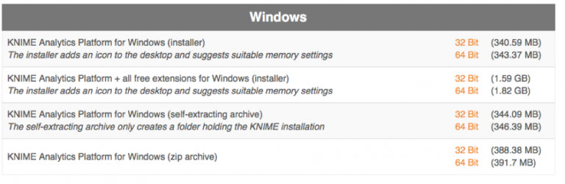

More details about KNIME is available in the below link

<https://www.knime.com/getting-started-guide>



### 2.1 Key Takeaways



* ML tools simplify complex tasks and speed up the process of taking models from the research environment to production.
* Microsoft Azure ML is scalable cloud resource for training and deployment.
* IBM Watson has powerful NLP capabilities.
* Tensor Flow runs on CPU, GPU and TPUs along with staunch support for research and production projects.
* KNIME consolidates all functions and comes with drag and drop visual interface.
* KNIME workflows are made up of individual tasks, represented by nodes.
* A collection of interconnected nodes, using the input ports on the left and output ports on the right, constitutes a workflow.
* PyTorch is an open-source ML framework built upon the Torch library and supports a large eco-system of tools and libraries.
* Vertex AI is Google Cloud’s AI platform and integrates with GCP services for storage and data analysis.
* BigML is a machine learning platform that helps users create, deploy, and maintain ML models. It uses REST API for integration and model deployment.
* KNIME integrates various components of ML and data mining through its modular data pipelining “Building Blocks of Analytics” concept.

### 2.2 Quiz



Q1. What is KNIME?

1. A software application for data analysis
2. A programming language
3. A hardware device
4. A database management system

Q2. What is a node in KNIME?

1. A data visualization tool
2. A component that performs a specific function
3. A database table
4. A programming language

Q3. What is a workflow in KNIME?

1. A set of instructions for data analysis
2. A collection of data sources
3. A graphical interface for data visualization
4. A programming language

Q4. What is the KNIME Hub?

1. A community-driven platform for sharing workflows and components.
2. A visualization tool for displaying data.
3. A database management tool
4. A programming language

Q5. Which of the following is not a type of data source supported by KNIME?

1. CSV file
2. Excel file
3. JSON file
4. MP3 file

Q6. What is the KNIME Server?

1. A visualization tool for displaying data.
2. A database management tool
3. A programming language
4. A server-based platform for deploying, managing, and monitoring KNIME workflows.

Q7. What is the difference between a KNIME extension and a KNIME node?

1. A KNIME extension is a component that performs a specific function within a workflow, while a KNIME node is a package that adds new functionality to KNIME.
2. There is no difference between a KNIME extension and a KNIME node.
3. A KNIME extension is a package that adds new functionality to KNIME, while a KNIME node is a component that performs a specific function within a workflow.
4. A KNIME extension and a KNIME node are both types of data sources.

Q8. What is the difference between a KNIME workflow and a KNIME project?

1. A KNIME workflow is a single workflow, while a KNIME project can contain multiple workflows.
2. A KNIME workflow is a visual representation of a data processing task, while a KNIME project is a collection of files and resources related to a specific task.
3. There is no difference between a KNIME workflow and a KNIME project.
4. A KNIME workflow and a KNIME project are both types of data sources.

Q9. What is the difference between a data mining workflow and a data analysis workflow?

1. A data mining workflow focuses on finding patterns and relationships in large datasets, while a data analysis workflow focuses on summarizing and visualizing data.
2. A data mining workflow and a data analysis workflow are the same thing.
3. A data mining workflow focuses on summarizing and visualizing data, while a data analysis workflow focuses on finding patterns and relationships in large datasets.
4. There is no difference between a data mining workflow and a data analysis workflow.

Q10. What is the purpose of the KNIME Quick form node?

1. To provide a way to interactively adjust node parameters within a workflow
2. To provide a way to visualize data in a workflow
3. To provide a way to export data from a workflow
4. To provide a way to import data into a workflow

Q11. What is the purpose of the KNIME Analytics Platform Server?

1. To provide additional computational power for running workflows
2. To allow for collaboration on workflows
3. To manage workflow scheduling and execution
4. All the above

Q12. What is the purpose of the KNIME Node Repository?

1. To store and manage data sources.
2. To store and manage configuration settings.
3. To store and manage workflow nodes.
4. To store and manage workflow outputs.

Q13. What is the purpose of the KNIME Server?

1. To provide additional computational power for running workflows
2. To allow for collaboration on workflows
3. To manage workflow scheduling and execution
4. All the above

Q14. ____ is not an application of AI.

1. Database Management System
2. Digital Assistants
3. Natural language processing
4. Computer Vision

Q15. ____ is a component of AI.

1. Training
2. Designing
3. Learning
4. Puzzling

Q16. ____ is an example of an Artificial Intelligence Agent.

1. Human
2. Autonomous spacecraft
3. Robot
4. All the above

Q17. Which of the following is not a type of KNIME node?

1. Data Reader
2. Data Writer
3. Data Manipulation
4. Data Visualization

Q18. Which of the following is not a way to connect nodes in KNIME?

1. Drag and drop.
2. Copy and paste.
3. Right-click and select.
4. Type the connection name.

Q19. What is a meta node in KNIME?

1. A type of node that represents a sub-workflow.
2. A visualization tool for displaying metadata.
3. A database management tool
4. A programming language

Q20. What is a data flow variable in KNIME?

1. A variable that stores the output of a node
2. A variable that stores the input of a node
3. A placeholder for data values that can be used to pass data between nodes.
4. A variable that stores the name of a workflow

# **03 Exploratory Data Analysis**

In a world inundated with data, EDA serves as a potent ally in unveiling the inherent stories and nuances within datasets. It empowers data scientists to discern hidden patterns, identify outliers, and even inspire the formulation of new hypotheses. EDA acts as a compass, fostering this intimate connection with the data, guiding analysts toward the most fitting analytical methodologies. It excels in helping identify missing values, find correlations between other variables, locate the third quartile, and calculate the interquartile range. EDA plays an invaluable role in deciphering the complexities of most datasets and the varied relationships between data points. Its enduring relevance in the data science landscape underscores its indispensable role in shaping the future of data-driven decision-making.

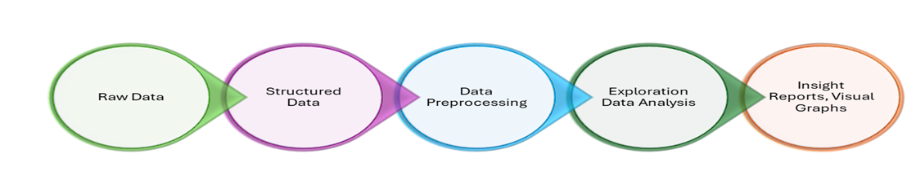

Fig 3.1 : “Data Processing Steps”

### What is EDA?

Exploratory Data Analysis (EDA) is a fundamental and widely utilized approach within data science. It involves thoroughly investigating and analyzing a dataset to summarize its main characteristics through various visual and statistical methods. EDA serves multiple purposes, including the discovery of data patterns, the identification of anomalies, hypothesis testing, and the validation of assumptions. It closely aligns with Data analytics and data analysis, which are interrelated processes to extract valuable insights from data to facilitate informed decision-making. The pioneering American mathematician John Tukey conceived Exploratory Data Analysis (EDA) in the 1970s. Fast forward to today, and EDA techniques remain a cornerstone in the data discovery process, standing the test of time as a widely employed method. Going beyond formal modeling or hypothesis testing, EDA unfurls a vast opportunity for gaining a deeper understanding of dataset variables and the intricate web of relationships among them. Furthermore, it plays a pivotal role in ascertaining the suitability of the statistical techniques earmarked for data analysis.

EDA can be briefly defined as a method that empowers scientists to determine the most effective means of manipulating a given dataset to achieve their desired goals and extract meaningful information.

Every Machine Learning project demands a deep understanding of the data that is used to understand whether the data is representative of the problem. EDA is a systematic approach to describing and understanding the data by statistical and visualization techniques to bring important aspects of that data into focus for further analysis. Doing exploratory analysis of the data is a significant step before doing deep dive into machine learning and statistical modelling. EDA involves inspecting the dataset from many angles, describing, and summarizing it without making any assumptions about its contents.

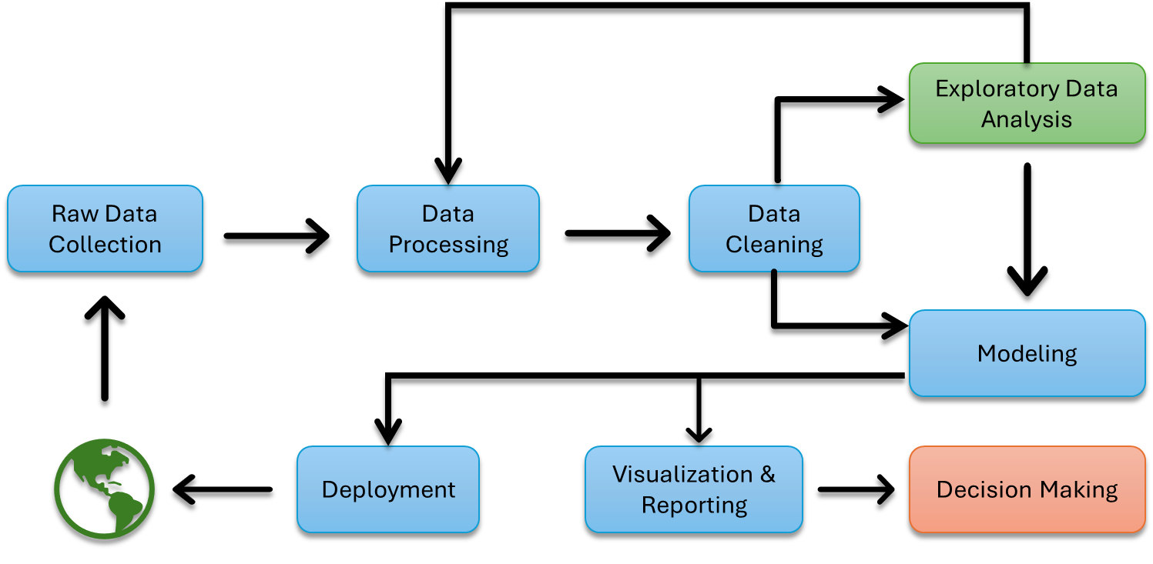

Fig 3.2 : “Data Science Process” *(Credit: CCO Public Domain)*

It is crucial to understand it in depth before performing the data analysis and running any algorithm on the data. You need to know the patterns in your data and determine which variables are important and do not play a significant role in the output. Further, some variables may have correlations with other variables. You also need to recognize errors in your data.

EDA is an iterative cycle.

* Generate questions about your data.
* Search for answers by visualizing, transforming, and modelling your data.
* Use what you learn to refine your questions and/or generate new questions.

Fig 3.2: “EDA Steps”

### Steps Involved in EDA

The main steps undertaken to perform EDA are as follows:

#### Data Collection

Nowadays, data is generated in huge volumes and various forms belonging to every sector of human life, like healthcare, sports, manufacturing, tourism, and so on. Every business knows the importance of using data beneficially by properly analyzing it. However, this depends on collecting the required data from various sources through surveys, social media, and customer reviews, to name a few. Without collecting sufficient and relevant data, further activities cannot begin.

#### *Data Exploration*

This step involves getting familiar with the data by examining its structure, contents, and quality. It involves:

1. Checking the size of the data set, the number of columns, and rows.
2. Looking at the data types of each column and checking if they are the expected data types.
3. Checking for missing values and understanding the distribution of data.
4. Visualizing the data using graphs, histograms, and box plots to identify patterns and outliers.

#### Preprocess the data.

This step involves cleaning, transforming, and restructuring the data to make it ready for analysis. It involves:

1. Removing or filling missing values.
2. Removing duplicates and irrelevant columns.
3. Converting data types, scaling, and normalizing the data.
4. Encoding categorical variables.

#### Analyze the data.

Finding a correlation between variables helps to know how a particular variable is related to another. The correlation matrix method gives a clear picture of how different variables correlate, which further helps in understanding vital relationships among them. In this step, we apply statistical and machine learning techniques to extract insights and identify patterns in the data. It involves:

1. Applying descriptive statistics to understand the central tendency, variability, and distribution of the data.
2. Applying inferential statistics to make inferences about the population based on the sample data.
3. Applying machine learning algorithms to build predictive models and classify data.

#### Visualize the results.

Visualization is a powerful tool to communicate the findings of the analysis. It involves creating plots, graphs, and charts to illustrate the patterns and insights found in the data. Once the analysis is over, the findings are to be observed cautiously and carefully so that proper interpretation can be made. The trends in the spread of data and correlation between variables give good insights for making suitable changes in the data parameters. The data analyst should have the requisite capability to analyze and be well-versed in all analysis techniques.

#### *Draw conclusions and make recommendations.*

In this step, we interpret the results of the analysis and draw conclusions that are relevant to the problem at hand. It involves:

1. Summarizing the findings in a clear and concise manner.
2. Identifying key insights and trends.
3. Making recommendations based on the insights and trends identified in the analysis.

#### Document the process.

It is important to document the EDA process to ensure that the analysis can be reproduced, and the findings can be communicated effectively. It involves:

1. Creating a report that includes the problem statement, data collection process, EDA steps, findings, and recommendations.
2. Sharing the report with stakeholders and team members.

### EDA and data pre-processing practices

###### Have a well-defined problem statement.

It is always advised to have a clear goal and not add items to it. In data science terms, “controlled exploration yields best results.”

###### Level the data set and re-iterate.

When EDA reveals interesting findings and patterns that are not related to the original problem statement, do not get diverted. You can note it down for later use but immediately return to the initial exploration.

### Exploratory Data Analysis Tools

Exploratory Data Analysis (EDA) is a necessary process in data analysis, and several tools are available to help data scientists and analysts in this endeavor. Among the most popular tools for EDA are R, Python, and SAS. Each tool has its strengths and weaknesses, making it essential to choose the right one for your specific needs.

#### R:

The data science community widely acknowledges R as an exceptional tool for visualizing data during EDA. R furnishes an extensive repertoire of plots and charts, encompassing histograms, box plots, and scatter plots, which analysts can employ to investigate data from various perspectives. R provides a rich set of visualization options and an extensive collection of statistical functions, making it valuable for performing more advanced analyses. R is favored by statisticians and data scientists for its versatility and comprehensive statistical capabilities.

#### Python:

Python is another robust tool for EDA. It shares many features with R, making it a compelling choice for data analysis. Python’s advantage lies in its user-friendliness and versatility, making it a good option for beginners just getting started with data analysis. The Python ecosystem includes libraries like Pandas, Matplotlib, Seaborn, and Plotly, which facilitate data manipulation and visualization. Python’s readability and extensive community support further enhance its appeal for data exploration.

#### SAS:

SAS is a powerful software package for statistical analysis and data exploration. It is renowned for its capabilities in handling complex calculations and conducting advanced statistical analyses. While SAS is a formidable tool, it is important to note that it tends to be more expensive than open-source alternatives like R and Python. However, the investment can be worthwhile for organizations and professionals who require the robust statistical features SAS offers.

In addition to these three primary tools, other software and platforms can be valuable for EDA. For instance, tools like Tableau, Excel, Power BI, and KNIME offer user-friendly interfaces for interactive data exploration and visualization, making them suitable for a broader audience, including non-technical stakeholders.

### Types of EDA

There are three main types of EDA are univariate, bivariate, and multivariate EDA.

Univariate EDA involves looking at a single variable at a time. Univariate EDA can help understand the data distribution and identify any outliers.

Bivariate EDA involves looking at two variables at a time. Bivariate EDA can help understand the relationship between two variables and identify any patterns that might exist.

Multivariate EDA involves looking at three or more variables at a time. Multivariate EDA can help understand the relationships between several variables and identify any complex patterns or outliers that might exist.

Within each of these types of EDA, there are both graphical and non-graphical methods:

Graphical methods involve creating charts, graphs, and other visualizations to explore the data, while non-graphical methods involve using statistical techniques to explore the data.

Univariate graphical EDA involves creating charts and graphs to explore a single variable. This can help you understand the distribution of the data and identify any outliers. Common types of univariate graphics include:

* Stem-and-leaf plots, which show all data values and the shape of the distribution.
* Histograms, a bar plot in which each bar represents the frequency (count) or proportion (count/total count) of cases for a range of values.
* Box plots, which graphically depict the five-number summary of minimum, first quartile, median, third quartile, and maximum.

Univariate non-graphical EDA involves using statistical techniques to explore a single variable. This can include measures of central tendency (like the mean or median), measures of spread (like the range or standard deviation), and measures of shape (like skewness or kurtosis). Since it is a single variable, it does not deal with causes or relationships. The main purpose of univariate analysis is to describe the data and find patterns that exist within it.

Multivariate graphical EDA involves creating charts and graphs to explore three or more variables simultaneously. This can help you understand the relationships between several variables and identify any complex patterns or outliers. The most used graphic is a grouped bar plot or bar chart with each group representing one level of one of the variables and each bar within a group representing the levels of the other variable.

Multivariate non-graphical EDA involves using statistical techniques to explore three or more variables simultaneously. This can include techniques like regression analysis or principal component analysis. This EDA techniques show the relationship between two or more variables of the data through cross-tabulation or statistics.

The Other common types of multivariate graphics include:

* Scatter plot: Is used to plot data points on a horizontal and a vertical axis to show how much another affects one variable.
* Multivariate chart: Is a graphical representation of the relationships between factors and a response.
* Run chart: Is a line graph of data plotted over time.
* Bubble chart: Is a data visualization that displays multiple circles (bubbles) in a two-dimensional plot.
* Heat map: Is a graphical representation of data where values are depicted by color.

EDA is an iterative process, and the choice of techniques and visualizations depends on the data’s nature and the analysis’s specific goals. It helps analysts gain insights, make decisions, and prepare the data for further modeling or analysis.



### 3.1 Key Takeaways



* EDA serves multiple purposes, including the discovery of data patterns, the identification of anomalies, hypothesis testing, and the validation of assumptions.
* Data Exploration involves visualizing the data using graphs, histograms, and box plots to identify patterns and outliers.
* Pre-processing the data involves converting data types, scaling, and normalizing the data.
* Most popular tools for EDA are R, Python, and SAS.
* Univariate EDA can help understand the data distribution and identify any outliers.
* Bivariate EDA can help understand the relationship between two variables and identify any patterns that might exist.
* Multivariate EDA can help understand the relationships between several variables and identify any complex patterns or outliers that might exist.
* Scatter plot: Is used to plot data points on a horizontal and a vertical axis to show how much another affects one variable.
* Bubble chart is a data visualization that displays multiple circles (bubbles) in a two-dimensional plot.
* Heat map is a graphical representation of data where values are depicted by color.
* EDA is an iterative process, and the choice of techniques and visualizations depends on the data’s nature and the analysis’s specific goals.

### 3.2 Quiz



Q1. What is the primary purpose of Exploratory Data Analysis (EDA)?

1. To visualize data using graphs
2. To analyze the data for statistical significance
3. To examine and understand data characteristics.
4. To clean and preprocess data.

Q2. Which of the following is a key characteristic that EDA aims to identify in a dataset?

1. Data storage format
2. Underlying assumptions
3. Reliability of the data source
4. Number of missing values

Q3. Which of the following is NOT a common EDA technique for visualizing data distributions?

1. Box Plot
2. Histogram
3. Scatter Plot
4. Bar Chart

Q4. In EDA, what is the term for a graphical representation that displays the distribution of a continuous variable?

1. Pie Chart
2. Histogram
3. Bar Chart
4. Scatter Plot

Q5. What is the primary purpose of scatter plot in EDA?

1. To show the distribution of a single variable.
2. To visualize relationship between variables.
3. To display categorical data.
4. To represent time series data.

Q6. In EDA, which measure of central tendency is typically represented by the height of a box in a box plot?

1. Mean
2. Median
3. Mode
4. Variance

Q7. Which EDA technique is used to identify and visualize outliers in a dataset?

1. Bar Chart
2. Histogram
3. Box Plot
4. Scatter Plot

Q8. What is the purpose of correlation matrix in EDA?

1. To visualize the distribution of data
2. To display relationship between variables
3. To identify missing values
4. To calculate summary statistics

Q9. Which EDA technique is used to visualize the relationship between two continuous variables with a line connecting data points?

1. Scatter Plot
2. Histogram
3. Bar Chart
4. Box Plot

Q10. What does the term “outlier” refer to in context of EDA?

1. A point that falls within the data range.
2. A data point that is part of the main cluster.
3. A data point that falls far from the rest.
4. A data point that is missing.

Q11. Which EDA technique is used to visualize the relationship between a categorical variable and a continuous variable?

1. Box Plot
2. Scatter Plot
3. Histogram
4. Bar Chart

Q12. What does the term “skewness” refer to in the context of data distribution analysis in EDA?

1. The symmetry of a data distribution.
2. The kurtosis of a data distribution.
3. The spread of a data distribution.
4. The presence of outliers.

Q13. What is the goal of a density plot in EDA?

1. To visualize the distribution of data.
2. To display relationship between variables.
3. To identify missing values
4. To calculate summary statistics.

Q14. What is the primary purpose of a bar chart in EDA?

1. To visualize the distribution of data.
2. To display relationship between variables.
3. To compare multiple categories.
4. To identify missing values.

Q15. Which EDA technique is used to visualize the distribution of a single continuous variable?

1. Box Plot
2. Histogram
3. Scatter Plot
4. Bar Chart

Q16. In EDA, what does the term “box” represents in a box plot?

1. Median
2. Mode
3. Range
4. Standard Deviation

Q17. What is the primary purpose of Heat Map?

1. To visualize the distribution of data.
2. To display relationship between variables.
3. To identify missing values.
4. To calculate summary statistics.

Q18. What does the term “correlation” refer to?

1. A measure of central tendency
2. A measure of the spread of data
3. A measure of relationship between variables.
4. A measure of data distribution.

Q19. What is the primary purpose of Pie Chart?

1. To visualize the distribution of data
2. To display relationship between variables.
3. To compare multiple categories.
4. To identify missing values.

Q20. What does the term “mode” refer to in the context of data distribution analysis in EDA?

1. The most frequent occurring value.
2. The average value.
3. The spread of data.
4. The presence of outliers.

### Research with solid fill3.3 Hands on Case Study:

*Exploratory Data Analysis Modelling*

*Download Source Data Set from GitHub link* : <https://github.com/Smartbrain2024/Mastering_AI_2.git>

**Chapters/Chp_03/3.3/Hands_on/CardioGoodFitness.csv**

#### Data summary:

A Fitness retail store ‘Cardio Good Fitness’ wants to analyze the demand for its treadmill products. For this, it has collected data on customers such as their Age, Gender, Marital Status, Education, etc. . Further, it has also sent a survey to collect information on the miles run by the customers on the treadmills in the last month (this data is captured automatically in the treadmill) they have bought previously.

#### Problem Statement

The store wants to understand its customers based on their profiles such that it can sell the relevant treadmill products to them.

###### Objectives

* Explore the dataset and practice extracting basic observations about the data.
* Perform Univariate and Bivariate analysis using different visualization.
* Generate a set of insights and recommendations that will help the company in targeting new customers.

The data is about customers of the treadmill product(s) of a retail store called Cardio Good Fitness. It contains.

the following variables-

*Column Name Description*

* **Product**: The model no. of the treadmill - TM195, TM498, TM798
* **Age**: Age of the customer in no of years
* **Gender**: Gender of the customer - Male or Female
* **Education**: Education of the customer in no. of years
* **Marital Status:** The marital status of the customer - Partnered or Single
* **Income**: Income of the customer
* **Fitness**: Self-rated fitness score of the customer (5 - very fit, 1 - very unfit)
* **Usage Avg.:** number of times the customer uses the treadmill every week.
* **Miles**: Miles that a customer ran in the last month

*Hands on Exercise Solution in GitHub link* : <https://github.com/Smartbrain2024/Mastering_AI_2.git>

**Chapters/Chp_03/3.3/Hands_on/3.3_Exercise_Solutions.docx**



### 3.4 Exercise do it yourself:

*Download Source Data Set from GitHub link* : <https://github.com/Smartbrain2024/Mastering_AI_2.git>

**Chapters/Chp_03/3.4/DIY_Exercise/Melbourne_housing_FULL.csv**

**Context:**

The original dataset contains price of different properties in Melbourne Housing Market and distinctive characteristics of those properties. Here we have considered the housing price data on a particular date, so that we can analyze how the different attributes of the properties relate to their price on a particular day. Attributes describing the location of the property, the type of property, the method by which it was sold, the price at which it was sold, etc. . are present.

**Problem Statement:**

The objective of this case study is to analyze the data which will help us draw insights and identify factors that affect the price of property.

#### Learning Summary:

* Visualize the dataset, take a feel of the different attributes present.
* Use the ‘Remove Duplicate Rows’ module to remove the duplicate rows.
* Use the ‘Edit metadata’ module to convert the categorical type variables.
* Perform univariate & Bivariate Analysis in the visualization window using different plots.
* Treat the missing values using the ‘Clean Missing Data’ module.
* Treat Outliers using the ‘Clip Values’ module.
* Use the ‘Threshold Filter’ & ‘Apply Filter’ modules for cleaning anomalous data.
* Apply the ‘Math Operation’ module for any feature engineering.
* Perform One Hot Encoding using the ‘Convert to Indicator Values’ module.

|  |  |
| --- | --- |
| Attribute Name | Description |
| Suburb | Suburb where property is located |
| Address | Address of the property |
| Rooms | Number of rooms |
| Type | h - house, cottage, villa, semi, terrace; u - unit, duplex;  t - townhouse; |
| SellerG | Real Estate Agent |
| Date | Date sold of property |
| Distance | Distance from CBD (Melbourne city center) in Kilometers. |
| ParkingArea | Parking Area Type |
| Attribute Name | Description |
| Method | S - property sold  SP - property sold prior PI - property passed in  PN - sold prior not disclosed SN - sold not disclosed.  VB - vendor bid.  W - withdrawn prior to auction SA - sold after auction  SS - sold after auction price not disclosed |
| Postcode | Post Code |
| Regionname | General Region (West, Northwest, North, Northeast …etc. .) |
| Propertycount | Number of properties that exist in the suburb. |
| Price | Price in Australian dollars |

# **04 Regression**

*Regression techniques are essential for uncovering relationships within data and building predictive models for a wide range of enterprise use cases, from sales forecasts to risk analysis.*

Regression is a statistical method for evaluating relationship between a single dependent variable and one or more independent variables. Regression is commonly used in finance, investing, analytics and other discipline to determine the strength and characteristics of relationship between a dependent variable and one or more independent variables.

The notation in regression equations is denoted with “Y” for the dependent variable and “X” for the independent variables. Each independent variable is associated with the regression coefficient describing the strength and sign of that variable’s relationship to the dependent variable. A regression might look like this (where “b” represents the regression coefficient):

$$Y=b0+b1X1+b2X2+b3X3+…bnXn$$

A regression model can show whether changes observed in the dependent variable are associated with changes in one or more of the independent variables. Regression analysis uncovers the association between variables observed in the data but cannot easily indicate causation.

In statistical analysis, regression is used to identify the associations between the variables occurring in some data. It can show the magnitude of such an association and determine its statistical significance. Regression is the powerful tool for statistical inference and has been used to try to predict future outcomes based on past observations.

Regression analysis is a way of predicting future happenings between a dependent (target) and one or more independent variables (also known as a predictor). For example, it can be used to predict the relationship between reckless driving and the total number of road accidents caused by a driver, or, to use a business example, the effect on sales and spending a certain amount of money on advertising. (Beers, 2024)

Two common techniques used in regression in machine learning are interpolation and extrapolation. In interpolation, the goal is to estimate values within the available data points. Extrapolation aims to predict values beyond the bounds of existing data, based on the existing regression relationships.

Regression is commonly used for many types of forecasting; by revealing the nature of the relationship between variables, regression techniques give businesses insight into key issues, such as customer churn, price elasticity and more. David Stewart, head of data science at global asset manager Legal & General, noted that regression models are used to make predictions based on information we already know, making them widely relevant across different industries. For example, linear regression, which forecasts a numerical outcome, could be used to gauge someone's height based on factors such as age and sex. In contrast, logistic regression could help predict a person's likelihood of buying a new product by using their past product purchases as indicators.

## Types of Regression

### 1. Linear Regression

Linear regression models assume a linear relationship between a target and predictor variables. The model aims to fit a straight line representing the data points. Linear regression predicts a continuous output by modeling a straight-line relationship between input features and target variables. It is useful when there is a linear relationship between the variables, such as predicting sales based on advertising expenditure or estimating the impact of price changes on demand.

### 2. Logistic Regression

Logistic regression is used when the target variable is binary or has two classes. It models the probability of an event occurring -- for example, yes/no or success/failure -- based on predictor variables. Logistic regression is commonly used in business contexts for binary classification tasks such as customer churn prediction or transaction fraud detection.

### 3. Polynomial Regression

Polynomial regression extends linear regression by incorporating polynomial concepts such as quadratic and cubic equations to format the predictor variables and capture cases where a straightforward linear relationship does not exist, such as estimating the impact of ad spending on sales, by fitting a polynomial curve to data points.

### 4. Time series Regression

Time series regression predicts future values in a time-dependent dataset, such as autoregressive integrated moving average models, incorporate time dependencies and trends to forecast future values based on past observations. These are useful for business applications such as sales forecasting, demand prediction and stock market analysis.

### 5. Support Vector Regression

Support vector regression, otherwise known as SVR, is a regression version of support vector machines and is particularly suitable for handling nonlinear relationships in high-dimensional spaces. SVR approximates a continuous function by identifying a hyperplane that best represents the data’s structure. It is valuable in various applications, including financial market prediction, customer churn forecasting or predicting customer lifetime value.

Let us discuss in detail each of these regression types.

## Linear Regression

Linear regression is an algorithm that provides a linear relationship between an independent variable and a dependent variable to predict the outcome of future events. It is a statistical method used in data science and machine learning for predictive analysis. Linear regression is not merely a predictive tool; it forms the basis for various advanced models. Techniques like regularization and support vector machines draw inspiration from linear regression, expanding its utility. Additionally, linear regression is a cornerstone in assumption testing, enabling researchers to validate key assumptions about the data.

The independent variable is also the predictor or explanatory variable that remains unchanged due to the change in other variables. The dependent variable changes with the fluctuations in the independent variable. The regression model predicts the value of the dependent variable. Thus, linear regression is the supervised learning algorithm that simulates a mathematical relationship between variables and makes predictions for continuous or numeric variables such as sales, salary, and age.

### Types of Linear Regression

There are two main types of linear regression:

#### Simple Linear Regression

This is the simplest form of linear regression, and it involves only one independent variable and one dependent variable. The equation for simple linear regression is:

$$Y = a+bX+u$$

*where?*

Y: *The dependent variable you are trying to predict or explain*

X: *The explanatory (independent) variables that is being used to predict or associate with Y*

a: *The y-intercept*

b: *Bets-coefficient is the slope of the explanatory variables.*

u: *The regression residual or error term.*

In the below diagram, a sloped straight line represents the linear regression model. Here, a line plotted for the given data points that suitably fit the model and hence it is called “best fit line.” The goal of the linear regression model is to find this best fit line or the “Line of Regression.” The idea behind the best fit line assumes that the data are scattered around the straight line. The criterion for the best fit line is that the sum of the squared error (SSE) is minimized, that is made as small as possible, due to this the best fit line is also called the **least square regression line**.

Here X-axis: Independent variable

Y-axis: Output/ dependent variable

Line of regression: Best fit line for a model

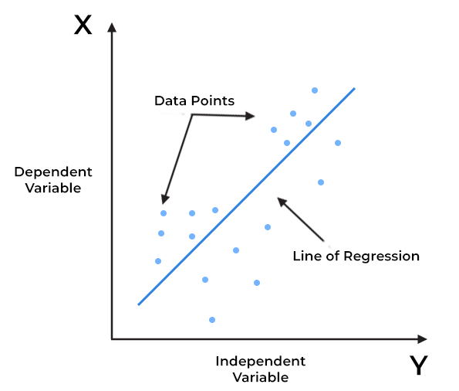

Fig 4.1: “Linear Regression” (*Credit: CCO Public Domain)*

##### Linear Regression assumptions

Before performing linear regression, procedure there are list of assumptions that needs to be considered:

1. The variables should be measured at a continuous level. Examples of continuous variables are time, sales, and weight.
2. Use a scatter plot to find out quickly if there is a linear relationship between those two variables.
3. The observations should be independent of each other.
4. Your data should have no significant outliers.
5. The residual errors of the best-fit regression line follow normal distribution.
6. There must be homoskedasticity, or the variance of the variables and error term must remain constant- a statistical concept in which the variances along the best-fit-linear-regression line remains similar all through that line.

##### Key benefits of linear regression

*Easy Implementation*

The linear regression model is computationally simple to implement as it does not demand a lot of engineering overheads, neither before the model launches nor during its maintenance.

Interpretability

Unlike other Deep learning and Neural networks, linear regression is straight forward. Due to this the algorithm stands ahead of black box models that fall short in justifying which input variable caused the output variable to change.

Scalability

Linear regression is not computationally heavy and therefore fits well in cases where scaling is essential, especially with the increased data volume.

##### Limitations of linear Regression

Despite the popularity of linear regression models, it has some significant drawbacks that one should be aware of before using them. Some of the drawbacks are as below:

* Limited flexibility

Linear models assume a linear relationship between the dependent variable and independent variables. This assumption can be limiting, especially when the relationship between the variables is not linear. Nonlinear relationships are often more complicated and may require more complex models to capture their nuances.

* Susceptible to Outliers

Linear regression models are sensitive to outliers. An outlier is a datapoint that differs significantly from other data points. Outliers can influence the slope and intercept of the regression line, leading to inaccurate predictions.

* Overfitting

Linear regression can be prone to overfitting, which can lead to poor prediction performance and generalization.

* Not suitable for classification

Linear regression deals with continuous values, while classification problems require discrete values. Linear regression is also not ideal when new data points are added because the threshold value may shift.

* Multicollinearity

Linear regression is sensitive to multicollinearity, which occurs when independent variables are highly correlated with each other. This can affect the stability and precision of the coefficients.

#### Multivariate Regression

Multivariate linear regression is a statistical model that uses a single set of predictor variables to model multiple dependent variables. It is different from multiple linear regression, which only predicts a single scalar variable, while multivariate linear regression predicts multiple correlated dependent variables. For example, it can be used when examining if gender and age predict rating congruence in the test score. It is a compact way of simultaneously writing several multiple linear regression models. The various multiple linear regression models can be compactly written as:

$${Y=β0+β1X1+β1X2+…..+βnXn }_{}$$

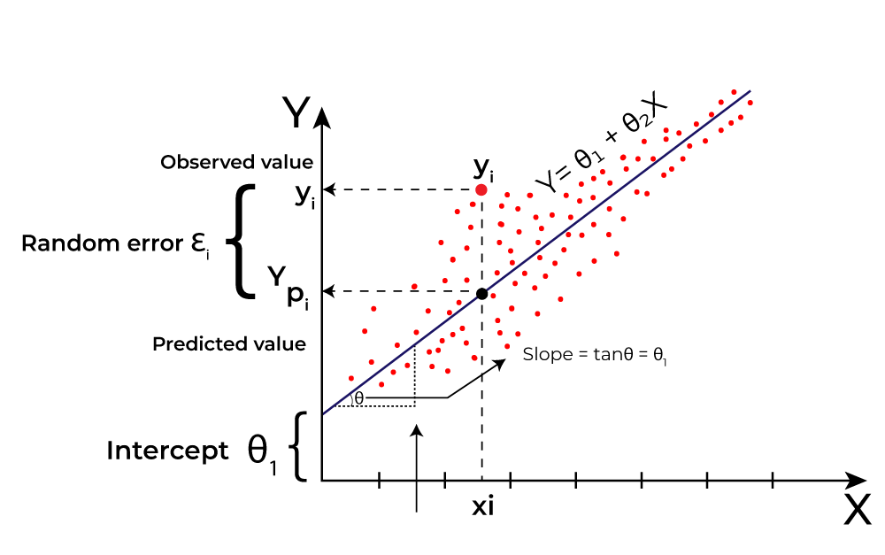

Where *Y* is the dependent variable

*X1, X2, …, Xn* are the independent variables.

β0 is the intercept.

β1, β2, …, βn are the slopes

Fig 4.2: “Multiple Linear Regression (Line of Best Fit)” *(Credit:* [*https://www.geeksforgeeks.org/ml-linear-regression/*](https://www.geeksforgeeks.org/ml-linear-regression/)*)*

The goal of the algorithm is to find the best Fit Line equation that can predict the values based on the independent variables. The best Fit Line equation provides a straight line that represents the relationship between the dependent and independent variables. The slope of the line indicates how much the dependent variable changes for a unit change in the independent variable(s). The cost function is utilized to compute the best values to get the best fit line since different values for weights or the coefficient of lines result in different regression lines.

### Evaluation Metrics for Linear Regression

A variety of evaluation measures can be used to determine the strength of any linear regression model. These assessment metrics often give an indication of how well the model is producing the observed outputs. The most common measurements are.

#### Mean Absolute Error (MAE) is a quite simple metric which calculates the absolute difference between actual and predicted values. Let us take an example of input data and output data and use Linear Regression, which draws a best-fit line. Now to find the MAE in the model which is a mistake made by the model known as an error, find the difference between the actual value and predicted value that is an absolute error but here finds the mean absolute of the complete dataset.

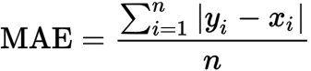

[Mean Squared Error (MSE)](https://www.geeksforgeeks.org/python-mean-squared-error/) is an evaluation metric that calculates the average of the squared differences between the actual and predicted values for all the data points. The difference is squared to ensure that negative and positive differences do not cancel each other out.

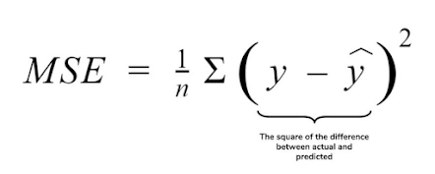

#### Root Mean Squared Error (RMSE) As RMSE is clear by the name itself, that it is a simple square root of mean squared error.

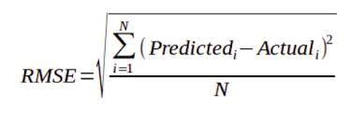

#### R Squared (R2) score is a metric that tells the performance of your model, not the loss in an absolute sense that how many wells did your model perform. In contrast, MAE and MSE depend on the context as we have seen whereas the R2 score is independent of context.

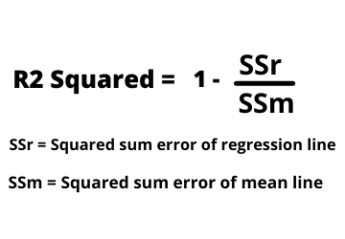

### Importance of linear regression

Regression has a wide range of real-life applications. The main uses of regression analysis are forecasting, time series modeling and finding the cause-and-effect relationship between variables. It is essential for any machine learning problem that involves continuous numbers – this includes, but is not limited to, a host of examples, including:

* Financial forecasting (like house price estimates, or stock prices)
* Sales and promotions forecasting
* Testing automobiles
* Weather analysis and prediction
* Time series forecasting
* Assess risk in an insurance company.
* Sports analysis

Specifically, it can estimate the strength of impact that multiple variables will have on a dependent variable. Businesses can use regression analysis to evaluate the effects of variables as measured on different scales. With it in your toolbox, you can assess the best set of variables to use when building predictive models, increasing the accuracy of your forecasting.

Finally, regression analysis is the best way of solving regression problems in machine learning using data modeling. By plotting data points on a chart and running the best fit line



### 4.1 Key Takeaways



* A regression model can show whether changes observed in the dependent variable are associated with changes in one or more of the independent variables.
* Support vector regression is particularly suitable for handling nonlinear relationships in high-dimensional spaces.
* Outliers can influence the slope and intercept of the regression line, leading to inaccurate predictions.
* Linear regression is sensitive to multicollinearity, which occurs when independent variables are highly correlated with each other.
* Multivariate linear regression is a statistical model that uses a single set of predictor variables to model multiple dependent variables.
* The best Fit Line equation provides a straight line that represents the relationship between the dependent and independent variables.
* Mean Squared Error (MSE) is an evaluation metric that calculates the average of the squared differences between the actual and predicted values for all the data points.
* R Squared (R2) score is a metric that tells the performance of your model.
* Businesses can use regression analysis to evaluate the effects of variables as measured on different scales.
* The main uses of regression analysis are forecasting, time series modeling and finding the cause-and-effect relationship between variables.

### 4.2 Quiz:



Q1. Which of the following are the broad steps involved in building Machine Learning models?

* 1. Take data as input.
  2. Find patterns in the data.
  3. Summarize the pattern in a mathematically precise way.
  4. All the above

Q2*. Statement 1*: The extent of association between x and y after eliminating the influence of z is measured by the partial correlation coefficient between x and y.

*Statement 2*: In the analysis of partial correlation coefficient x and y are the dependent variables and z is the independent variable.

1. Both Statement 1 and 2 are correct
2. Both statement 1 and 2 are wrong
3. Statement 1 is correct but 2 is wrong.
4. Statement 2 is correct but 1 is wrong.

Q3. Which of the following are types of correlation?

1. Positive and Negative
2. Simple, Partial and Multiple
3. Linear and Nonlinear
4. All the above

Q4. Which of the following is true for the coefficient of correlation?

1. The coefficient of correlation is not dependent on the change of scale.
2. The coefficient of correlation is not dependent on the change of origin.
3. The coefficient of correlation is not dependent on both the change of scale and change of origin.
4. None of the above

Q5. Which of the following statements is true for correlation analysis?

1. It is a bivariate analysis.
2. It is a multivariate analysis.
3. It is a univariate analysis.
4. Both A and C

Q6. If the values of two variables move in the same direction, ___________

1. The correlation is said to be non-linear.
2. The correlation is said to be linear.
3. The correlation is said to be negative.
4. The correlation is said to be positive.

Q7. If the values of two variables move in the opposite direction, ___________

1. The correlation is said to be linear.
2. The correlation is said to be non-linear.
3. The correlation is said to be positive.
4. The correlation is said to be negative.

Q8. Which of the following techniques is an analysis of the relationship between two variables to help provide the prediction mechanism?

1. Standard error
2. Correlation
3. Regression
4. None of the above

Q9. Which of the following statements is true about the arithmetic mean of two regression coefficients?

1. It is less than the correlation coefficient.
2. It is equal to the correlation coefficient.
3. It is greater than or equal to the correlation coefficient.
4. It is greater than the correlation coefficient.

Q10. What is the meaning of the testing of the hypothesis?

1. It is a significant estimation of the problem.
2. It is a rule for acceptance or rejection of the hypothesis of the research problem.
3. It is a method of making a significant statement.
4. None of the above

Q11. Which of the following statements is true about the null hypothesis?

1. Any wrong decision related to the null hypothesis results in two types of errors.
2. Any wrong decision related to the null hypothesis results in one type of an error.
3. Any wrong decision related to the null hypothesis results in four types of errors.
4. Any wrong decision related to the null hypothesis results in three types of errors.

Q12. Which of the following statements is true about the type two error?

1. Type two error means to accept an incorrect hypothesis.
2. Type two error means to reject an incorrect hypothesis.
3. Type two error means to accept a correct hypothesis.
4. Type two error means to reject a correct hypothesis.

Q13. Which of the following statements is true about the level of significance?

1. In evaluating a hypothesis, we take the level of significance as 2% if it is not mentioned earlier.
2. In evaluating a hypothesis, we take the level of significance as 1% if it is not mentioned earlier.
3. In evaluating a hypothesis, we take the level of significance as 10% if it is not mentioned earlier.
4. In evaluating a hypothesis, we take the level of significance as 5% if it is not mentioned earlier.

Q14. The independent variable is used to explain the dependent variable in ________.

1. Linear regression analysis
2. Multiple regression analysis
3. Non-linear regression analysis
4. None of the above

Q15. Which of the following statements is true about the regression line?

1. A regression line is also known as the line of the average relationship.
2. A regression line is also known as the estimating equation.
3. A regression line is also known as the prediction equation.
4. All the above

Q16. Which of the following statements is true about the correlational analysis between two sets of data?

1. The correlational analysis between two sets of data is known as a simple correlation.
2. The correlational analysis between two sets of data is known as multiple correlation.
3. The correlational analysis between two sets of data is known as partial correlation.
4. None of the above

Q17. The original hypothesis is known as ______.

1. Alternate hypothesis
2. Null hypothesis
3. Both A and B are incorrect
4. Both A and B are correct

Q18. In which category does linear regression belong to?

1. Neither supervised nor unsupervised learning
2. Both supervised and unsupervised learning
3. Unsupervised learning
4. Supervised learning

Q19. The target variable is represented along ____________

1. Y axis
2. X axis
3. Either Y-axis or X-axis, it does not matter.
4. Depends on the dataset.

Q20. How many variables are required to represent a linear regression model?

1. 3
2. 2
3. 1
4. 4

### Research with solid fill4.3 Hands-on Case Study:

*Linear Regression Modelling*

*Download Source Data Set from GitHub link* : <https://github.com/Smartbrain2024/Mastering_AI_2.git>

**Chapters/Chp_04/4.3/Hands_on/auto-mpg.csv**

**Problem Statement**

**Background**

Klassic Cars is a car dealer reselling classic and vintage cars. It has been realized based on past transactions that the mileage of a car is a key factor when it comes to deciding on the price and driving its sales. Klassic Cars wants to use mileage as a deciding parameter when making decisions related to pricing, inventory planning, purchase, and marketing.

**Problem Statement**

Klassic Cars wishes to create a linear regression model that is accurately able to predict the mileage of different car models based on the different parameters such as the number of cylinders, horsepower of the car, acceleration, etc. .

**Objectives**

Preprocess the data and make it ready for model building. Build a Linear Regression model to predict the mileage of a car, observe the model coefficients and its performance.

**Data Dictionary**

The description of the different variables in the dataset is provided below.

|  |  |
| --- | --- |
| **Column Name** | **Description** |
| mpg | Mileage of the car in miles per gallon |
| cylinders | Number of cylinders |
| displacement | Displacement of the engine in cc |
| horsepower | Horsepower of engine |
| weight | Weight of the car in pounds |
| acceleration | Acceleration of the car |
| model year | Year that model was made in the 1900s, for example, 70 means 1970 |
| origin | Origin continent of the carmaker, it is encoded as 1,2,3 and another file on the mapping it to actual continent names: America, Europe, and Asia are provided. |
| car name | Model name of the car |



### 4.4 Exercise do it yourself:

*Credit Kaggle for Source Data Set*

<https://www.kaggle.com/datasets/toramky/automobile-dataset>

#### About Dataset

##### Context

This dataset consists of data from 1985 Ward's Automotive Yearbook. Here are the sources.

Sources:

1. 1985 Model Import Car and Truck Specifications, 1985 Ward's Automotive Yearbook.  
   2) Personal Auto Manuals, Insurance Services Office, 160 Water Street, New York, NY 10038  
   3) Insurance Collision Report, Insurance Institute for Highway Safety, Watergate 600, Washington, DC 20037

##### Content

This data set consists of three types of entities: (a) the specification of an auto in terms of various characteristics, (b) it assigned insurance risk rating, (c) its normalized losses in use as compared to other cars. The second rating corresponds to the degree to which the auto is riskier than its price indicates. Cars are initially assigned a risk factor symbol associated with its price. Then, if it is riskier (or less), this symbol is adjusted by moving it up (or down) the scale. Actuaries call this process "symbolling". A value of +3 indicates that the auto is risky, -3 that it is safe.

The third factor is the relative average loss payment per insured vehicle year. This value is normalized for all autos within a particular size classification (two-door small, station wagons, sports/specialty, etc. .), and represents the average loss per car per year.

Note: Several of the attributes in the database could be used as a "class" attribute.

Inspiration

Please bring it on whatever inferences you can get it. through them, you can predict each data point’s likelihood of error.

# **05 Classification**

Classification is a task that requires the use of machine learning algorithms that learn how to assign a class label to examples from the problem domain. It is one of the most common and widely used machine learning processes for supervised learning. In Supervised Learning, the model learns by an example, along with the input variable the model is also provided with corresponding correct labels. While training, the model gets to look at which label corresponds to the data and hence identify patterns between the data and those labels.

In layperson’s term classification is defined as the process of recognition, understanding, and grouping of objects into preset categories. With the help of these pre-categorized training datasets, classification in ML programs leverage a wide range of algorithms to classify future datasets into respective and relevant categories. Classification algorithms used in machine learning utilize input training data for the purpose of predicting the likelihood or probability that the data that follows will fall into one of the predetermined categories. For example, a classification model might be trained on a dataset of images labeled as either dogs or cats and then used to predict the class of new, unseen images of dogs or cats based on their features such as color, texture, and shape. Classification algorithms are often used to detect email spam by analyzing email content. These algorithms enable machines to quickly recognize spam trends and make real-time judgments, improving email security.

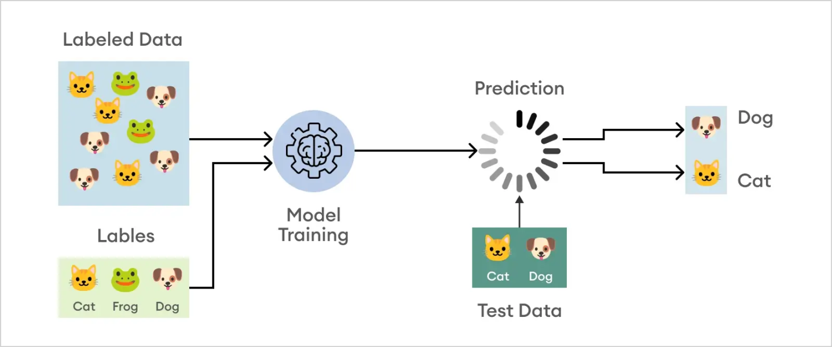

Fig 5.1 : “Classification of Data” *(Credit: CCO Public Domain)*

Supervised Machine Learning Classification has different applications in multiple domains of our day-to-day life. Below are some examples.

Healthcare: Training a machine learning model on historical patient data can help healthcare specialists accurately analyze their diagnoses

Education: is one of the domains dealing with the most textual, video, and audio data. This unstructured information can be analyzed with the help of Natural Language technologies to perform different tasks such as the classification of documents per category.

Transportation: is the key component of many countries' economic development. As a result, industries are using machines and deep learning models: Predict potential issues that may occur in specific locations due to weather conditions.

Sustainable Agriculture: Introducing sustainability in agriculture can help improve farmers' productivity at a different level without damaging the environment: By using classification models to predict which type of land is suitable for a given type of seed and predict the weather to help them take proper preventive measures.

## Machine Learning Classification Vs. Regression

Although classification and regression are both from the category of supervised learning, they are not the same. The prediction task is a classification when the target variable is discrete. An application is the identification of the underlying sentiment of a piece of text. The prediction task is a regression when the target variable is continuous. An example can be the prediction of the salary of a person given their education degree, previous work experience, geographical location, and level of seniority.

Fig 5.2 : “Classification Vs Regression”

## Learners in Classifications Algorithm

#### Lazy Learners

Lazy Learners are also known as instance-based learners, lazy learners do not learn a model during the training phase. Lazy Learning memorizes the entire training dataset and uses it as a knowledge source for predicting new, unseen instances. In lazy learning, the model does not create a generalized data representation during training. Instead, it stores the training data points in memory and uses them directly when a new instance needs to be classified data. Unlike traditional models, lazy learning does not require an extensive training phase. Instead, it relies on the memorization of training instances, leading to several notable features:

*No Pre-Training*: Lazy learning models skip the conventional training phase. They store training data instances as they are without creating a generalized model. This approach means the model does not require a separate training process before making predictions.

*Flexible Adaptation*: These models are highly adaptable to changes in data. They can seamlessly incorporate new data instances without being completely retrained, allowing them to adjust quickly to new patterns or variations in the data.

*Complex Relationship Handling*: Lazy learning manages datasets with intricate and non-linear relationships. By directly applying the stored knowledge from the training data, these models can address complex patterns that might be challenging for other learning methods.

*Interpretable Predictions*: The decision-making process in lazy learning models is straightforward. It involves identifying and examining similar instances from the training data, which makes the predictions more transparent and easier to understand.

These algorithms are particularly useful for tasks where model training needs to be flexible and adapt quickly to new data. Some of the examples are case-based reasoning and the KNN algorithm.

#### Eager Learners

Eager Learners are also known as model-based learners and are widely used in Machine Learning. In this paradigm, the model is trained on a labeled dataset before making predictions on new, unseen data. The key characteristic of Eager Learning is that the model eagerly generalizes from the training data, representing the underlying patterns and relationships. This representation allows the model to classify or regress new instances efficiently. It emphasizes pre-training a model to optimize performance. This method involves training the model on a labeled dataset to create a robust and generalized data representation. Here are the key features of Eager Learning:

*Training before Prediction*: The model undergoes a comprehensive training phase on a labeled dataset. During this time, it learns and captures the underlying patterns and relationships within the data. This pre-training phase is crucial for building an effective model.

*Fast Predictions*: The model can quickly generate predictions for new data instances after training. The prediction process is efficient and rapid since it has already learned the data patterns.

*Offline Predictions*: Eager Learning models do not need access to the entire training dataset during prediction. This characteristic makes them ideal for situations where predictions must be made offline or in scenarios where training data is inaccessible at the time of prediction.

*Optimized Performance*: These models typically perform well on well-labeled datasets. The optimization during the training phase enables the model to deliver accurate and reliable predictions.

Examples of eager learners include decision trees, random forests, and support vector machines.

*Tabular representation of the difference between Lazy and Eager Learning*

|  |  |  |
| --- | --- | --- |
| Feature | Lazy Learning | Eager Learning |
| Training Approach | Memorizes entire training data during training. | Creates a generalized representation during training. |
| Prediction Process | Searches for similar instances during prediction and applies their labels. | Directly applies the learned representation for prediction. |
| Adaptibility to New Data | Quickly adapts to new data without retraining. | Less adaptable to new data; retraining might be necessary. |
| Prediction Speed | It can be slower, especially with large datasets. | Faster predictions due to pre-trained model. |
| Offline Predictions | Requires access to training data during prediction. | Can make predictions offline or without training data. |
| Managing Complex Relationships | Effective at handling complex and non-linear relationships. | Better suited for well-defined patterns and relationships. |
| Model Representation | No fixed model representation; relies on memorized data. | Requires a fixed model representation from training. |
| Interpretability of Predictions | More interpretable predictions are based on similar instances. | Interpretability might be limited depending on the model type. |
| Efficiency with Large Datasets | It can be efficient, as it only involves searching in memory during prediction. | It might be less efficient with large datasets due to the training phase. |
| Imbalanced Datasets | Can manage imbalanced datasets effectively. | It might require additional techniques to manage imbalanced data. |
| Application Areas | Online learning, dynamic environments, real-time predictions. | Static environments, well-structured datasets. |

## Classification Types

Binary Classification

Binary is a type of problem in classification in machine learning that has only two outcomes. Typically, binary classification problems often require two classes, one representing the normal state and the other representing the aberrant state. For instance, the normal condition is "not spam," while the abnormal state is "spam." Class label 0 is given to the class in the normal state, whereas class label 1 is given to the class in the abnormal condition. Examples comprise – Email spam detection (spam or not), Churn prediction (churn or not), Conversion prediction (buy or not), Health of the patient (Healthy or Unhealthy)

A model that forecasts a Bernoulli probability distribution for each case is frequently used to represent a binary classification task. The discrete probability distribution known as the Bernoulli distribution deals with the situation where an event has a binary result of either 0 or 1. In terms of classification, this indicates that the model forecasts the likelihood that an example would fall within class 1, or the abnormal state.

The following are well-known binary classification algorithms:

* + Logistic Regression
  + Support Vector Machines
  + Simple Bayes
  + Decision Trees

Some algorithms, such as Support Vector Machines and Logistic Regression, were created expressly for binary classification and do not by default support more than two classes.

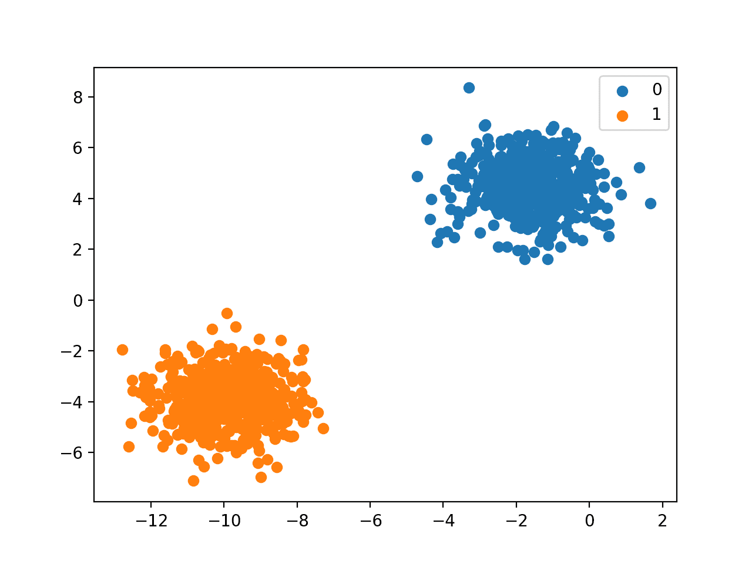

Fig 5.2: “Binary Classification” (*Credit: CCO Public Domain)*

Multi-Class Classification

Multi-class is a type of classification problem with more than two outcomes and does not have the concept of normal and abnormal outcomes. Instead, instances are grouped into one of several well-known classes. In some cases, the number of class labels could be high. In a facial recognition system, for instance, a model might predict that a shot belongs to one of thousands or tens of thousands of faces. Text translation models and other problems involving word prediction could be categorized as a particular case of multi-class classification. Each word in the sequence of words to be predicted requires a multi-class classification, where the vocabulary size determines the number of classes that may be predicted and may range from tens of thousands to hundreds of thousands of words.

Examples include, classifying images, classifying species, and character recognition using optical, classification of types of crops, classification of types of music, among others. The Multinominal distribution is a discrete probability distribution that covers a case where an event will have a categorical outcome. For multi-class classification, many binary classification techniques are applicable. Popular algorithms that can be used for multi-class classification include:

* k-Nearest Neighbors.
* Decision Trees.
* Naive Bayes.
* Random Forest.
* Gradient Boosting.

Algorithms that are designed for binary classification can be adapted for use for multi-class problems. This involves using a strategy of fitting multiple binary classification models for each class vs. all other classes (**one-vs-rest**) or one model for each pair of classes (**one-vs-one**).

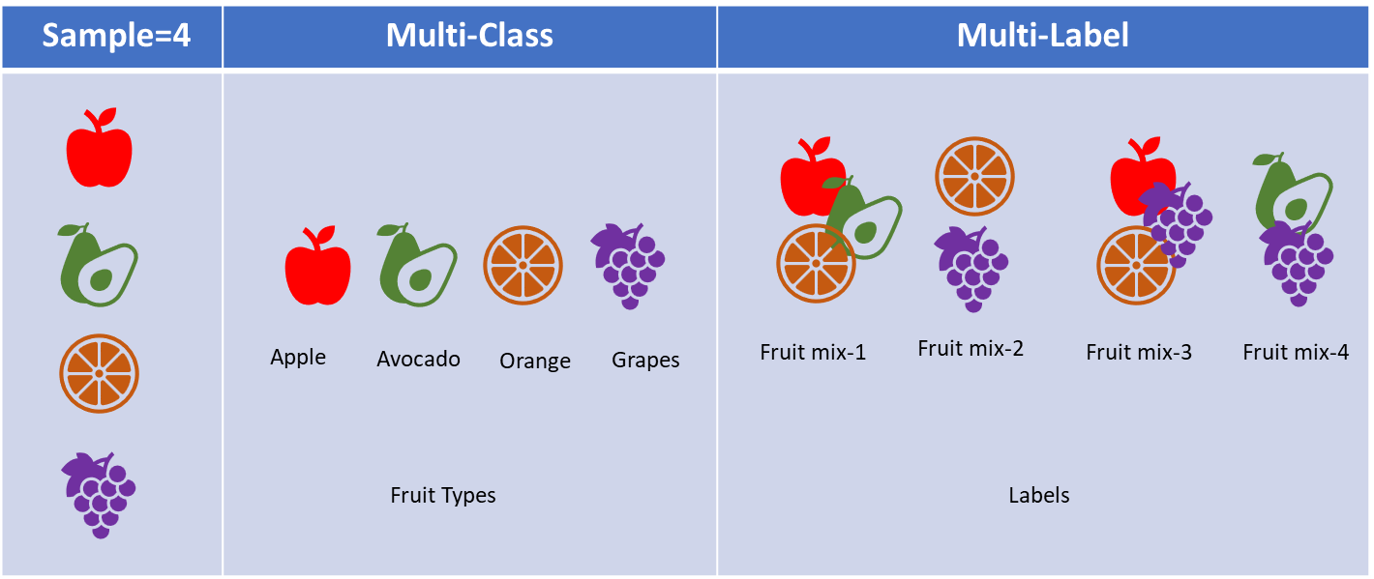

Fig 5.3 : “Multi-class Vs Multi-label classification”

Multi-Label Classification

Multi-label is a type of classification problem that may have more than one class label assigned to the data. Here the model will have multiple outcomes. For example, a book or a movie can be categorized into multiple genres, or an image can have multiple objects. A particular photo may have multiple objects in the scene. This contrasts with multi-class classification and binary classification, which anticipate a single class label for each occurrence. Multi-label classification problems are frequently modeled using a model that forecasts many outcomes, with each outcome being forecast as a Bernoulli probability distribution. This approach predicts several binary classifications for each example. It is not possible to directly apply multi-label classification methods used for multi-class or binary classification. The so-called multi-label versions of the algorithms, which are specialized versions of the conventional classification algorithms, include:

* Multi-label Gradient Boosting
* Multi-label Random Forests
* Multi-label Decision Trees

Another strategy is to forecast the class labels using a different classification algorithm.

Imbalanced Classification

Most machine learning algorithms assume equal data distribution. When the data distribution is not equal, it leads to imbalance. An imbalanced classification problem is a type of classification problem where the distribution of the dataset is skewed or biased. This method employs specialized techniques to change the composition of data samples. Some examples of imbalanced classification are spam filtering, disease screening, and fraud detection.

These problems are modeled as binary classification tasks and may require specialized techniques that may be used to change the composition of samples in the training dataset by under sampling the majority class or oversampling the minority class. Examples comprise - SMOTE Oversampling, Random Under sampling. It is possible to utilize specialized modeling techniques, like the cost-sensitive machine learning algorithms, which give the minority class more consideration when fitting the model to the training dataset.

## Types of Classification Algorithms

Some of the top ranked ML algorithms for Classification are:

### Logistic Regression

It is a supervised learning classification technique that forecasts the likelihood of a target variable when there will only be a two-class choice. Data can be coded as either one or yes, representing success, or as 0 or no, representing failure. The dependent variable can be predicted most effectively using logistic regression. Logistic regression predicts the output of a categorical dependent variable. Therefore, the outcome must be of a categorical or discrete value. In Logistic regression, instead of fitting a regression line, we fit an “S” shaped logistic function, which predicts two maximum values (0 or 1). Many fields employ it because of its simplicity, interpretability, and efficiency. Logistic Regression works well when features and event probability are linear.

The sigmoid function is a mathematical function used to map the predicted values to its probabilities. It maps any real value into another value within a range of 0 and 1. The value of the logistic regression must be between 0 and 1, which cannot go beyond this limit, so it forms a curve like the “S” form. The S-form curve is called the Sigmoid function or the logistic function. In logistic regression there is a concept of the threshold value, which defines the probability of either 0 or 1. Such as values above the threshold value tends to 1, and a value below the threshold values tends to 0.

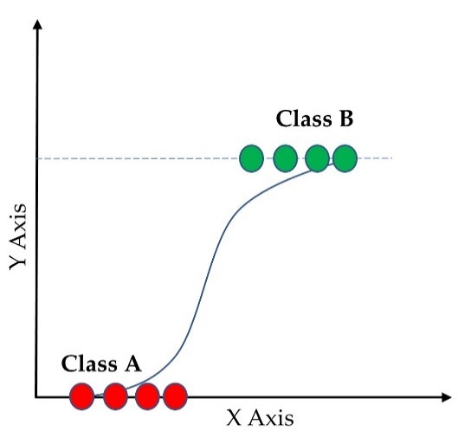

Fig 5.4 : “Logistic Regression” *(Credit:* [*https://www.researchgate.net*](https://www.researchgate.net/publication/367007823/figure/fig1/AS:11431281112303217@1673379396543/Logistic-regression-of-binary-classification-353-Support-Vector-Machine-SVM.ppm)*)*

The logistic regression model transforms the linear regression function continuous value output into categorical value output using a sigmoid function, which maps any real-valued set of independent variables input into a value between 0 and 1. This function is known as the logistic function. There are certain assumptions that ensure appropriate application of the logistic regression model. These are as follows:

1. *Independent observations:* Each observation is independent of the other. meaning there is no correlation between any input variables.
2. *Binary dependent variables*: It takes the assumption that the dependent variable must be binary or dichotomous, meaning it can take only two values. For more than two categories SoftMax functions are used.
3. *Linearity relationship between independent variables and log odds:* The relationship between the independent variables and the log odds of the dependent variable should be linear.
4. *No outliers:* There should be no outliers in the dataset.
5. *Large sample size:* The sample size is sufficiently large.

Based on the categories, Logistic Regression can be classified into three types:

* Binomial: In binomial Logistic regression, there can be only two types of dependent variables, such as 0 or 1, Pass or Fail, etc. .
* Multinomial: In multinomial Logistic regression, there can be 3 or more possible unordered types of the dependent variable, such as “cat”, “dogs”, or “sheep”
* Ordinal: In ordinal Logistic regression, there can be 3 or more possible ordered types of dependent variables, such as “Low”, “Medium”, or “High”.

### Decision Tree

A decision tree is a non-parametric supervised learning algorithm, which is utilized for both classification and regression tasks. It has a hierarchical tree structure, which consists of a root node, branches, internal nodes, and leaf nodes. It starts with a root node, which does not have any incoming branches. The outgoing branches from the root node then feed into the internal nodes, also known as decision nodes. Based on the available features, both node types conduct evaluations to form homogenous subsets, which are denoted by leaf nodes, or terminal nodes. The leaf nodes represent all the possible outcomes within the dataset.

Fig 5.5: “Decision Tree”

This type of flowchart structure helps to create an easy to digest representation of decision-making, allowing diverse groups across an organization to better understand why a decision was made. Decision tree learning employs a divide and conquer strategy by conducting a greedy search to identify the optimal split points within a tree. This process of splitting is then repeated in a top-down, recursive manner until all, or most records have been classified under specific class labels. Whether or not all data points are classified as homogenous sets is dependent on the complexity of the decision tree. Smaller trees are more easily able to attain pure leaf nodes or data points in a single class. However, as a tree grows, it becomes increasingly difficult to maintain this purity, and it usually results in too little data falling within a given subtree also known as data fragmentation, and it can often lead to overfitting. As a result, decision trees have preference for small trees, which is consistent with the principle of parsimony in Occam’s Razor; that is, “*entities should not be multiplied beyond necessity*.” To reduce complexity and prevent overfitting, pruning is usually employed; this is a process, which removes branches that split on features with low importance. The model’s fit can then be evaluated through the process of cross-validation. Another way that decision trees can maintain their accuracy is by forming an ensemble via a random forest algorithm; this classifier predicts more accurate results, particularly when the individual trees are uncorrelated with each other. There are three types of Decision trees : ID3, C4.5 and CART (Classification and Regression Tree).

### Random Forest

The random forest algorithm is an extension of the bagging method as it utilizes both bagging and feature randomness to create an uncorrelated forest of decision trees. Bagging involves using different samples of data (training data) rather than just one sample. A training dataset comprises observations and features that are used for making predictions. The decision trees produce different outputs, depending on the training data fed to the random forest algorithm. These outputs will be ranked, and the highest will be selected as the final output. Feature randomness, also known as feature bagging or the random subspace method generates a random subset of features, which ensures low correlation among decision trees. While decision trees consider all the possible feature splits, random forests only select a subset of those features. This algorithm was developed by Leo Bregman and Adele Cutler, which combines the output of multiple decision trees to reach a single result. Its ease of use and flexibility have fueled its adoption, as it manages both classification and regression problems.

Random forest algorithms have three main hyperparameters, which need to be set before training. These include node size, the number of trees, and the number of features sampled. From there, the random forest classifier can be used to solve regression or classification problems. As it is made up of a collection of decision trees, and each tree in the ensemble is comprised of a data sample drawn from a training set with replacement, called the bootstrap sample. Of that training sample, one-third of it is set aside as test data, known as the out-of-bag (oob) sample. Another instance of randomness is then injected through feature bagging, adding more diversity to the dataset, and reducing the correlation among decision trees. Depending on the type of problem, the determination of the prediction will vary. For a regression task, the individual decision trees will be averaged, and for a classification task, a majority vote—i.e., the most frequent categorical variable—will yield the predicted class. Finally, the oob sample is then used for cross-validation, finalizing that prediction.

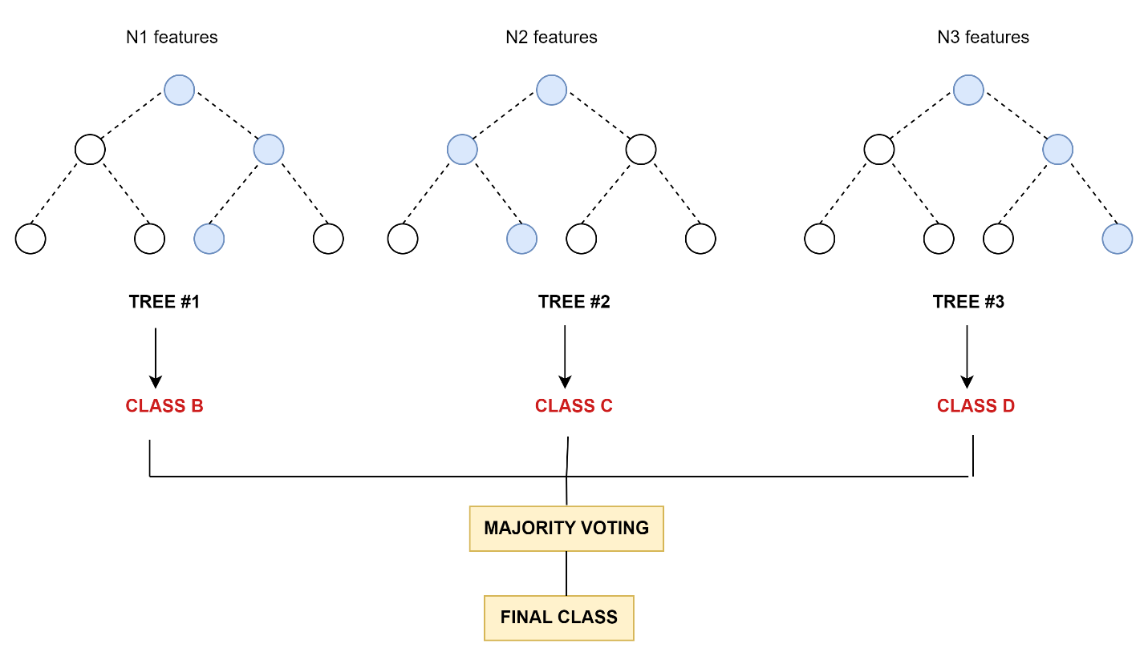

Fig 5.6: “Random Forest”

Since random forest can manage both regression and classification tasks with a high degree of accuracy, it is a popular method among data scientists. Feature bagging also makes the random forest classifier an effective tool for estimating missing values as it maintains accuracy when a portion of the data is missing. As this algorithm can manage large data sets, they will provide more accurate predictions but can be slow to process data as they are computing data for each individual decision tree and require more resources to store the data.

### Support Vector Machine (SVM)

A Support Vector Machine (SVM) is a supervised machine learning algorithm used for both classification and regression tasks. While it can be applied to regression problems, SVM is best suited for classification tasks. The primary objective of the SVM algorithm is to identify the optimal hyperplane in an N-dimensional space that can effectively separate data points into different classes in the feature space. The algorithm ensures that the margin between the closest points of different classes, known as support vectors, is maximized. The dimension of the hyperplane depends on the number of features. For instance, if there are two input features, the hyperplane is simply a line, and if there are three input features, the hyperplane becomes a 2-D plane. As the number of features increases beyond three, the complexity of visualizing the hyperplane also increases.

Consider two independent variables, x1 and x2, and one dependent variable represented as either a blue circle or a red circle. In this scenario, the hyperplane is a line because we are working with two features (x1 and x2). There are multiple lines (or hyperplanes) that can separate the data points. The challenge is to determine the best hyperplane that maximizes the separation margin between the red and blue circles.

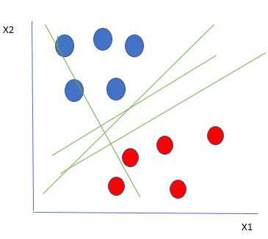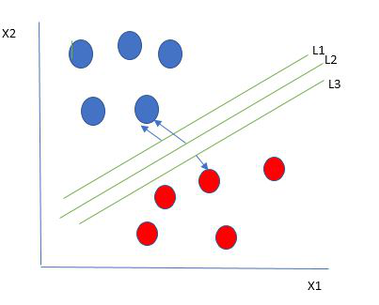

Fig 5.7: “Support Vector Machine (SVM)” *(Credit: CCO Public Domain)*

One reasonable choice for the best hyperplane in a Support Vector Machine (SVM) is the one that maximizes the separation margin between the two classes. The maximum-margin hyperplane, also referred to as the hard margin, is selected based on maximizing the distance between the hyperplane and the nearest data point on each side. The lines (L1 & L3) that are adjacent to the optimal hyperplane are known as support vectors as these vectors run through the data points that determine the maximal margin.

Basic terminology used in SVM.

1. **Hyperplane**: *The hyperplane is the decision boundary used to separate data points of different classes in a feature space. For linear classification, this is a linear equation represented as wx+b=0.*
2. **Support Vectors**: *Support vectors are the closest data points to the hyperplane. These points are critical in determining the hyperplane and the margin in Support Vector Machine (SVM).*
3. **Margin**: *The margin refers to the distance between the support vector and the hyperplane. The primary goal of the SVM algorithm is to maximize this margin, as a wider margin typically results in better classification performance.*
4. **Kernel**: *The kernel is a mathematical function used in SVM to map input data into a higher-dimensional feature space. This allows the SVM to find a hyperplane in cases where data points are not linearly separable in the original space. Common kernel functions include linear, polynomial, radial basis function (RBF), and sigmoid.*
5. **Hard Margin**: *A hard margin refers to the maximum-margin hyperplane that perfectly separates the data points of different classes without any misclassifications.*
6. **Soft Margin**: *When data contains outliers or is not perfectly separable, SVM uses the soft margin technique. This method introduces a slack variable for each data point to allow some misclassifications while balancing between maximizing the margin and minimizing violations.*
7. **C**: *The C parameter in SVM is a regularization term that balances margin maximization and the penalty for misclassifications. A higher C value imposes a stricter penalty for margin violations, leading to a smaller margin but fewer misclassifications.*
8. **Hinge Loss**: *The hinge loss is a common loss function in SVMs. It penalizes misclassified points or margin violations and is often combined with a regularization term in the objective function.*
9. **Dual Problem**: *The dual problem in SVM involves solving for the Lagrange multipliers associated with the support vectors. This formulation allows for the use of the kernel trick and facilitates more efficient computation.*

#### Types of SVM classifiers

##### Linear SVMs: They used with linearly separable data; this means that the data does not need to undergo any transformations to separate the data into different classes. *wx + b = 0*

*(where w is the weight vector, x is the input vector, and b is the bias term).*

##### Nonlinear SVMs: Much of the data in real-world scenarios are not linearly separable, and that’s where nonlinear SVMs come into play. To make the data linearly separable, preprocessing methods are applied to the training data to transform it into a higher-dimensional feature space. That said, higher dimensional spaces can create more complexity by increasing the risk of overfitting the data and by becoming computationally taxing.

##### Support vector regression (SVR) : This is an extension of SVMs, which is applied to regression problems (i.e., the outcome is continuous). Like linear SVMs, SVR finds a hyperplane with the maximum margin between data points, and it is typically used for time series prediction.

### Naive Bayes

The “Naive” part of the name indicates the simplifying assumption made by the Naïve Bayes classifier. The classifier assumes that the features used to describe an observation are conditionally independent, given the class label. The “Bayes” part of the name refers to Reverend Thomas Bayes, an 18th-century statistician and theologian who formulated Bayes’ theorem.

Naive Bayes classifiers are a collection of classification algorithms based on Bayes’ Theorem. It is a family of algorithms where all of them share a common principle, i.e., every pair of features being classified is independent of each other. One of the most simple and effective classification algorithms, the Naïve Bayes classifier aids in the rapid development of machine learning models with rapid prediction capabilities. The Naïve Bayes algorithm is used for classification problems and is used in text classification. In the text classification tasks, data contains high dimension where each word represents one feature in the data. It is also used in spam filtering, sentiment detection, rating classification etc. . The advantage of using naïve Bayes is its speed that helps in making prediction is easy with high dimension of data.

The fundamental Naive Bayes assumption is that each feature makes an:

* 1. Feature independence: The features of the data are conditionally independent of each other, given the class label.
  2. Continuous features are normally distributed: If a feature is continuous, then it is assumed to be normally distributed within each class.
  3. Discrete features have multinomial distributions: If a feature is discrete, then it is assumed to have a multinomial distribution within each class.
  4. Features are equally important: All features are assumed to contribute equally to the prediction of the class label.
  5. No missing data: The data should not contain any missing values.

$$P\left(\left.A\right|B\right)=\frac{\text{P}\left(\left.\text{B}\right|\text{A}\right)\text{P}\left(\text{A}\right)}{\text{P}\left(\text{B}\right)}$$ $$\text{Posterior=}\frac{\text{prior x likelihood}}{\text{evidence}}$$

Where P(A|B) = how often A happens given that B happens

P(A) = how likely A will happen

P(B) = how likely B will happen

P(B|A) = how often B happens given that A happens

This model uses Bayes theorem in the algorithm for training and prediction and predicts the probability of an instance that belongs to a class with a given set of feature values. It is a probabilistic classifier and assumes that one feature in the model is independent of the existence of another feature. In other words, each feature contributes to the predictions with no relation between each other. In the real world, this condition is satisfied rarely.

### K-Nearest Neighbors (KNN)

The K-nearest neighbor (KNN) is a supervised machine learning algorithm. It is used mostly to classify data points and can also perform regression. The KNN algorithm classify new data points to a particular category based on its similarity with the other data points in that category. The algorithm grabs the freedom to select any functional form from the training data to map the input data to the target data. This algorithm belongs to the category of nonparametric algorithms as it does not take any specific assumption about the mapping function.

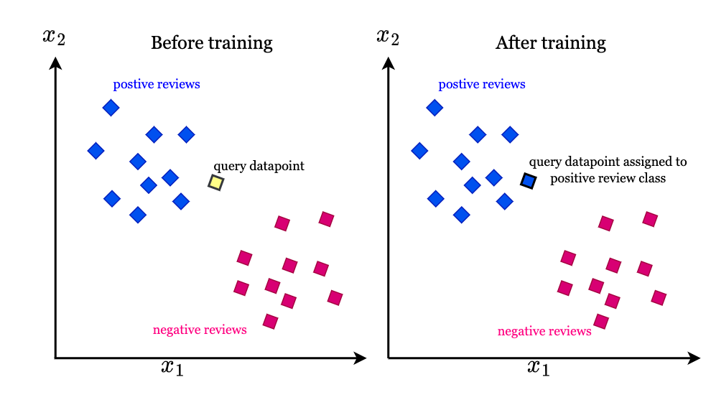

Fig 5.8 : “K-nearest-neighbors-algorithm” *(Credit:* [*https://intuitivetutorial.com*](https://intuitivetutorial.com)*)*

Let us understand this concept using movie review, a new review belongs to the category of positive review or negative review. Each word in review will be converted into a vector for the sake of interpretability of a machine learning algorithm. The KNN algorithm classifies the text vectors into the category of positive and negative review based on the similarity in the text vector it finds during training. The algorithm learns a mathematical function to classify new data points to suitable categories based on its similarity to a particular group of text vectors.

Below are the steps executed by KNN to perform classification?

1. **Decide the number *K* in KNN**

*K* in KNN algorithms is the number of neighborhood points to a query point. The assignment of a class label to a query point depends on the hyperparameter. If we assign a value of 5 for *K*, then 5 nearest neighbor data points need to be considered to the query point. The class label will be assigned based on the majority class label out of the 5 neighborhood points.

1. **Find the similarity based on Euclidean distance.**

The shortest distance between two data points is called Euclidean distance, in 2D the distance between A (x1, y1) and B(x2,y2) is $$D=\sqrt{\left({\left(x2-x1\right)}^{2}-{\left(y2-y1\right)}^{2}\right)}$$

In this approach, the points which are closer are considered as more similar and grouped into the same category. The points which are farther away are treated as points belonging to distinct categories.

1. **Measure the Euclidean distance of query point to K nearest neighbors.**

In the case as *K*=5, the KNN algorithm analyzes 5 data points which are at the shortest distance from the query point using Euclidean distance measure.

1. **Assign the class label to the query point.**

The class label of the query point as the same as that of the majority data points in the neighborhood. It estimates out of the nearest neighbors, to which class most of the neighboring points belongs. It is presumed that the query point is more like the majority data points in the neighborhood based on Euclidean distance.

The procedure for regression using KNN algorithm is the same as that of classification. The only difference is, in regression the algorithm takes the mean or median of nearest neighbors to assign the class label whereas for classification problems, the class label is assigned based on majority vote.

## Evaluation of Classification Models

There are many ways for measuring classification performance. Accuracy, confusion matrix, log-loss, and AUC-ROC are some of the most popular metrics. Precision-recall is a widely used metric for classification problems.

Accuracy is the conventional method of evaluating classification models. Accuracy is defined as the proportion of correctly classified examples over the complete set of examples.

$$Accuracy=\left(Numberofcorrectpredictions\right)/\left(Overallnumberofpredictions\right)$$

When using only accuracy to evaluate the model we may run into problems, one of which is evaluating models on imbalanced datasets. Because of its shortcomings, accuracy is often used in conjunction with other methods. One way to check whether you can use accuracy as a metric is to construct a confusion matrix.

### Confusion Matrix

The confusion matrix describes the model performance and gives us a matrix or table as an output, it is also known as error matrix. The matrix is made up of the results of the forecasts in a condensed manner, together with the total number of right and wrong guesses.

A confusion matrix is defined as the table that is often used to describe the performance of a classification model on a set of the test data for which the true values are known. The matrix appears in the following table:

|  |  |  |
| --- | --- | --- |
|  | Actual Positive | Actual Negative |
| Predicted Positive | True Positive | False Positive |
| Predicted Negative | False Negative | True Negative |

$$Accuracy=\left(TP+TN\right)/\left(TP+TN+FP+FN\right)$$

True Positive (TP) : We predicted positive, and it is true.

True Negative (TN): We predicted negative, and it is true.

False Positive (FP): We predicted positive, and it is false (Type 1 Error).

False Negative (FN): We predicted negative, and it is false (Type 2 Error).

#### Precision

Precision is useful in the cases where False Positive is a higher concern than False Negatives. It means how many of the correctly predicted cases turned out to be positive. The importance of Precision is in music or video recommendation systems, e-commerce websites, etc. . where wrong results could lead to customer churn, and this could be harmful to the business. Precision for a label is defined as the number of true positives divided by the number of predicted positives.

$$Precision=TP/\left(TP+FP\right)$$

#### Recall (Sensitivity)

Recall is a useful metric in cases where False Negative is of higher concern than False Positive.   It explains how many of the actual positive cases were predicted correctly by the model. It is important in medical cases where it does not matter whether we raise a false alarm, but the actual positive cases should not go undetected. Recall for a label is defined as the number of true positives divided by the total number of actual positives.

$$Recall=TP/\left(TP+FN\right)$$

#### Precision/Recall Tradeoff

In an ideal scenario, if the data is perfectly separable, a value of 1.0 for both precision and recall can be achieved. In most practical situations, which is impossible, and a tradeoff arises: increasing one of these two parameters will decrease the other. By virtue of that tradeoff, optimal threshold needs to be defined that will lead to an optimal tradeoff. This threshold does not necessarily achieve a perfect balance between precision and recall. The situation at hand might need a tradeoff that is biased towards one of them. This will vary from situation to situation. A typical example is high-risk scenarios, such as classifying patients by whether they are at risk of having a heart attack or not. In these situations, being biased towards recall is preferable. It is more important that we classify all patients that can potentially have a heart attack as positive, even if you get a few extra false positives in that class. Having extremely high precision in such a case is a luxury. The aim is for high recall, even if precision is sacrificed. The easiest way to find that balance is to look at a graph that contains both the precision and the recall curves.

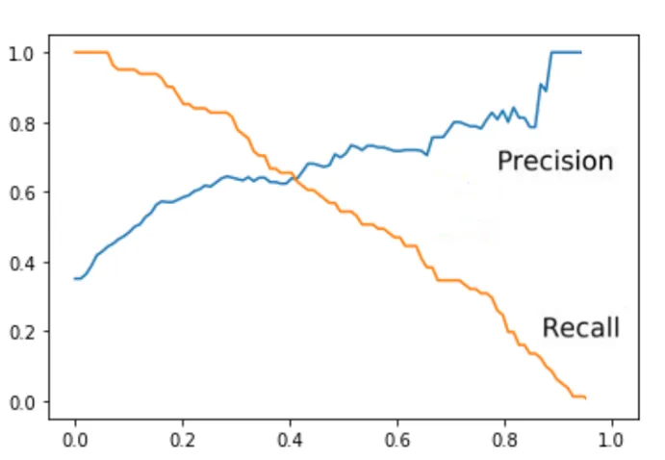

Fig 5.9: “Precision/Recall Tradeoff” (Credit: Precision and Recall tradeoff, Edlitera)

#### F1 Score

It gives a combined idea about Precision and Recall metrics. It is maximum when Precision is equal to Recall. F1 Score is the harmonic means of precision and recall. The F1 score makes sure that you achieve a good balance between precision and recall. Whenever any of those two values is low, the F1 score will also be low. A high F1 score is a good indicator that your model performs well, since it achieves high values for both precision and recall.

$$F1=2.\left(PrecisionxRecall\right)/\left(Precision+Recall\right)$$

The F1 score punishes extreme values more. F1 Score could be an effective evaluation metric in the following cases:

* When FP and FN are equally costly.
* Adding more data does not effectively change the outcome.
* True Negative is high.

#### Specificity (True Negative Rate)

Specificity is equivalent to sensitivity, only the focus is on the negative class. It is the proportion of true negative cases which were correctly identified as such. The equation for specificity is:

$$Specificity=\left(TN\right)/\left(TN+FP\right)$$

#### Fall-out (False Positive Rate)

Fall-out determines the probability of determining a positive value when there is no positive value. It is the proportion of actual negative cases that were incorrectly classified as positive. The equation for fall-out is:

$$Fall-out=\left(FalsePositive\right)/\left(TrueNegative+FalsePositive\right)$$

#### Miss Rate (False Negative Rate)

Miss rate can be defined as the proportion of positive values that were incorrectly classified as negative examples.

$$MissRate=\left(Falsenegative\right)/\left(Truepositive+Falsenegative\right)$$

### Receiver-Operator Curve (ROC Curve) and Area Under the Curve (AUC)

The Receiver Operator Characteristic (ROC) is a probability curve that plots the TPR (True Positive Rate) against the FPR (False Positive Rate) at various threshold values and separates the ‘signal’ from the ‘noise.’ The Area Under the Curve (AUC) is the measure of the ability of a classifier to distinguish between classes. This curve allows to find a good probability threshold. Probability thresholds are decision points used by the model for classification. They define the minimum predicted positive class probability resulting in a positive class prediction.

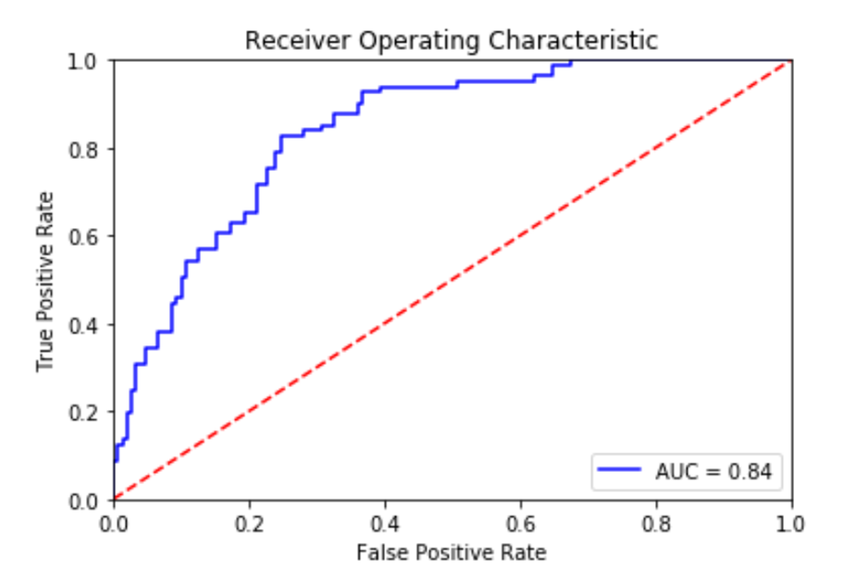

Fig 5.10 : “ROC curve and AUC score” (Credit: <https://towardsdatascience.com/roc-curve-in-machine-learning-fea29b14d133>)

The best model is the one with a curve away from the dashed line. The dashed line represents a 50% chance of guessing correctly, so the further away you are from it, the better. To decide which model performs best, you can also look at the area under the curve, or AUC, value. AUC size is directly connected to model performance. Models that perform better will have higher AUC values. A random model will have an AUC of 0.5, while a perfect classifier would have an AUC of 1.

From the graph shown above, the greater the AUC, the better is the performance of the model at different threshold points between positive and negative classes. This simply means that When AUC is equal to 1, the classifier can perfectly distinguish between all Positive and Negative class points. When AUC is equal to 0, the classifier would be predicting all Negatives as Positives and vice versa. When AUC is 0.5, the classifier is not able to distinguish between the Positive and Negative classes.

### What Are Special Cases for Classification Models?

There are some exceptional cases. You are mostly talking about losses that are used with neural networks. Neural networks function differently than standard machine learning algorithms. The two basic metrics used to define how well a neural network model performs are:

#### Binary Cross-Entropy

Binary cross-entropy is used when dealing with binary classification problems. Binary cross-entropy is also known as log loss. As a metric, it is used in neural networks. Binary cross-entropy considers the uncertainty that comes with predictions. It considers how much a prediction varies from the actual label. This leads to increased performance and better results, but it also leaves the model susceptible to problems that arise from imbalanced datasets. When dealing with imbalanced datasets, you need to modify binary cross-entropy. Class weight or some other type of constraint needs to be introduced to make sure that the metric accurately evaluates the quality of your model.

#### Categorical Cross-Entropy

Categorical cross-entropy is used when dealing with multiclass problems. Binary cross-entropy generalizes well for multiclass problems. That generalization is what we call categorical cross-entropy. Therefore, categorical cross-entropy brings about both the same benefits and problems that go along with using binary cross-entropy.



### 5.1 Key Takeaways



* Classification is one of the most common and widely used machine learning processes for supervised learning.
* Lazy Learning memorizes the entire training dataset and uses it as a knowledge source for predicting new, unseen instances.
* The key characteristic of Eager Learning is that the model eagerly generalizes from the training data, representing the underlying patterns and relationships.
* Typically, binary classification problems often require two classes, one representing the normal state and the other representing the aberrant state.
* Multi-class is a type of classification problem with more than two outcomes and does not have the concept of normal and abnormal outcomes.
* Logistic regression is a supervised learning classification technique that forecasts the likelihood of a target variable when there will only be a two-class choice.
* The sigmoid function is a mathematical function used to map the predicted values to its probabilities.
* A decision tree is a non-parametric supervised learning algorithm, which is utilized for both classification and regression tasks.
* The random forest algorithm is an extension of the bagging method as it utilizes both bagging and feature randomness to create an uncorrelated forest of decision trees.
* Naïve Bayes classifier assumes that the features used to describe an observation are conditionally independent, given the class label.

### 5.2 Quiz :



Q1. The output is whether a person will vote or not, based on several features. It is an example of multiclass classification.

1. True
2. False

Q2. The output is whether a person will surely vote or surely not vote or may cast a vote, based on one feature. It is an example of multiclass classification.

1. True
2. False

Q3. Which of the following hyper-parameter (s), when increased, may cause the random forest to over fit the data?

1. Number of Trees
2. Depth of Tree
3. Learning Rate
4. Only 1
5. Only 2
6. Only 3
7. 1 and 2

Q4. Which of the following option is true about k-NN algorithm?

1. It can be used for classification.
2. It can be used for regression.
3. It can be used in both classification and regression.
4. None of the above

Q5. Which of the following statement is true about k-NN algorithm?

1. k-NN performs much better if all the data have the same scale.
2. k-NN works well with a small number of input variables (p) but struggles when the number of inputs is exceptionally large.
3. k-NN makes no assumptions about the functional form of the problem being solved.
4. 1 and 2
5. 1 and 3
6. Only 1
7. All the above

Q6. Which of the following machine learning algorithm can be used for imputing missing values of both categorical and continuous variables?

1. K-NN
2. Linear Regression
3. Logistic Regression
4. All the above

Q7. Which of the following is true about Manhattan distance?

1. It can be used for continuous variables.
2. It can be used for categorical variables.
3. It can be used for categorical as well as continuous.
4. None of these

Q8. Which of the following distance measure do we use in case of categorical variables in k-NN?

1. Hamming Distance
2. Euclidean Distance
3. Manhattan Distance
4. 1
5. 2
6. 3
7. 1 and 2

Q9. Which of the following will be true about k in k-NN in terms of Bias?

1. When you increase the k, the bias will be increases.
2. When you decrease the k, the bias will be increases.
3. Cannot say.
4. None of these

Q10. Which of the following will be true about k in k-NN in terms of variance?

1. When you increase the k, the variance will increase.
2. When you decrease the k, the variance will increase.
3. Cannot say.
4. None of these

Q11. What do you mean by generalization error in terms of the SVM?

1. How far the hyperplane is from the support vectors.
2. How accurately the SVM can predict outcomes for unseen data.
3. The threshold amount of error in an SVM
4. All the above

Q12. What do you mean by a hard margin?

1. The SVM allows an extremely low error in classification.
2. The SVM allows a high amount of error in the classification.
3. Both A and B
4. None of the above

Q13. The effectiveness of an SVM depends upon _____________.

1. Selection of Kernel trick
2. Kernel Parameters
3. Soft Margin Parameter C
4. All the above

Q14. Support vectors are the data points that lie closest to the decision surface.

1. TRUE
2. FALSE

Q15. Consider a complex pattern classification problem, what is the logic behind using Kernel SVM?

1. When such a problem is cast in high dimensional space linearly it is more likely to be linearly separable than in a low dimensional space, provided that the space is not densely populated.
2. When such a problem is cast in a low dimensional space it is more likely to be linearly separable
3. When such a problem is cast in high dimensional space nonlinearly it is more likely to be linearly separable than in a low dimensional space, provided that the space is not densely populated.
4. None of these

Q16. Which of the following is true about SVM when data is NOT completely linearly separable?

1. A hinge loss function is introduced which adds penalty for crossing over the margin.
2. The penalty used is proportional to the distance of the points from the margin.
3. Both above
4. None of these

Q17. The SVM’s are less effective when:

1. The data is linearly separable.
2. The data is clean and ready to use.
3. The data is noisy and contains overlapping points.
4. All the above

Q18. The cost parameter in the SVM means:

1. The number of cross-validations to be made
2. The kernel to be used.
3. The tradeoff between misclassification and simplicity of the model
4. None of the above

Q19. Which of the following are real-world applications of the SVM?

1. Text and Hypertext Categorization (NLP)
2. Image Classification
3. Clustering of News Articles
4. All the above

Q20. Which of the following option would you be more likely to consider iterating SVM next time?

1. You want to increase your data points.
2. You want to decrease your data points.
3. You will try to calculate more variables.
4. You will try to reduce the features.

### Research with solid fill5.3 Hands-on Case Study:

*Logical Regression Modelling*

*Credit Kaggle for Source Data Set*

Use Linear regression & Logistic classification to build models to be used for redefining loan approval and loan pricing strategy to minimize loss for an American auto finance company.

**AutoFinc** is a US based provider of auto financial services including banking, vehicle finance & vehicle insurance for cars, bikes and commercial vehicles servicing retail as well as corporate customers.

Auto financers aim to have **high approval rates** to increase overall efficiency and strengthen relationship with auto dealerships. At the same time, they try to **mitigate losses and defaults**. This overall is a tricky balance to achieve.

**Auto FinTech is a market leader in the car financing in the retail customer segment with a 22% market share, but the vertical has seen 17% more default rate and 12% more loss due to default as compared to what was predicted.**

**The Risk Analytics team is assigned the task to come out with new decision rules for loan approval and loan pricing to minimize loss.**

**Problem Overview :**

* To produce new decision rules for loan approval and loan pricing, the team will need to estimate the expected loss for each loan applicant using the below formula. This will depend on factors like an applicant’s demographic, socio-economic profiles, and application details (credit amount, duration etc.).
* Expected Loss = PD x EAD
* PD = the probability that a loan applicant will default
* EAD (Exposure at Default) = the outstanding loan amount at the time of default
* For this, the Risk Analytics team needs to:
* Build a logistic regression model which will predict probability of default (PD)
* Build a linear regression model to predict the exposure at default (EAD)

**Data Dictionary:**

The dataset contains demographic, socio-economic, credit amount and loan duration for 1000 customers.

The data contains whether a customer defaulted and if he/she defaulted what the outstanding amount was.

The data has been checked for missing values, duplicate rows, and data type. We can move directly to EDA step.

|  |  |
| --- | --- |
| **Variable** | **Description** |
| Age | Numerical: Age in years |
| Sex | Categorical: male, female |
| Job | Categorical: unskilled and non-resident, unskilled and resident, skilled, highly skilled |
| Housing | Categorical: own, rent, or free |
| Saving accounts | Categorical: little, moderate, quite rich, rich |
| Checking account | Categorical: little, moderate, rich |
| Duration | Numerical: Duration for which the credit is given in months |
| Credit Amount | Numerical: Amount of loan credit in USD |
| Risk | Categorical: 0 – Person is not at risk, 1 – Person is at risk(defaulter) |

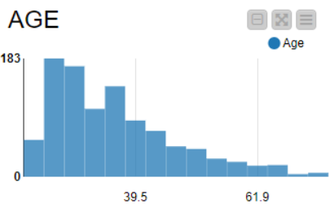

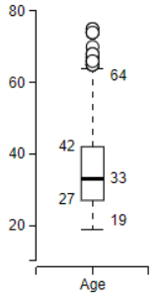

The distribution of “Age” is right skewed. Youngest 25% of customers are 19-27 years old; 50% are under 33 years. 33 years is median age and 35 years mean.

The distribution of “Duration” is also right skewed. 75% of the loans have duration 4-24 months. 18 months is the median duration and 21 months mean.

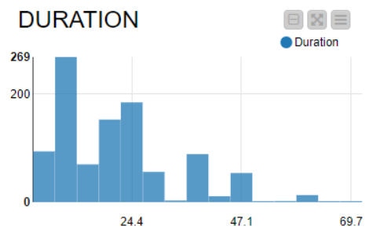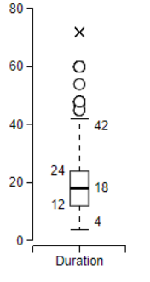

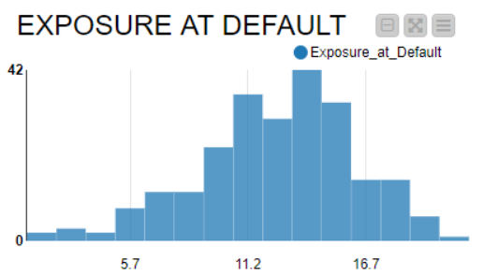

The distribution of “Exposure at Default” is normally distributed with median at 12806 USD and mean at 12538 USD.

The distribution of “Credit Amount” is normally distributed with 17949 USD median and 17881 USD mean.

The distribution of “Credit Amount” is normally distributed with 17949 USD median and 17881 USD mean.

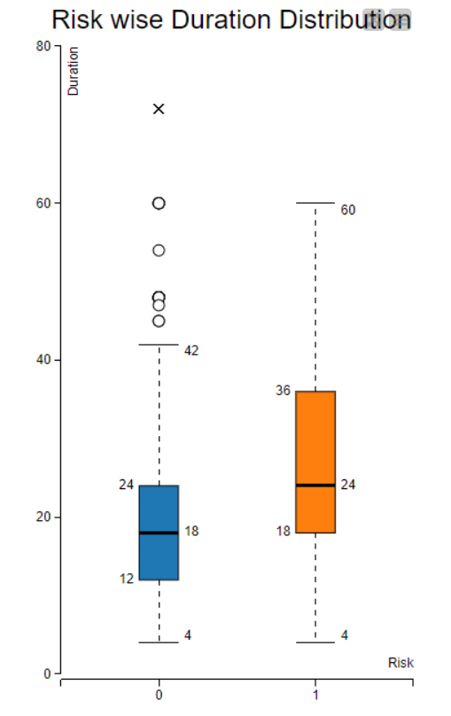EDA – Bivariate Analysis

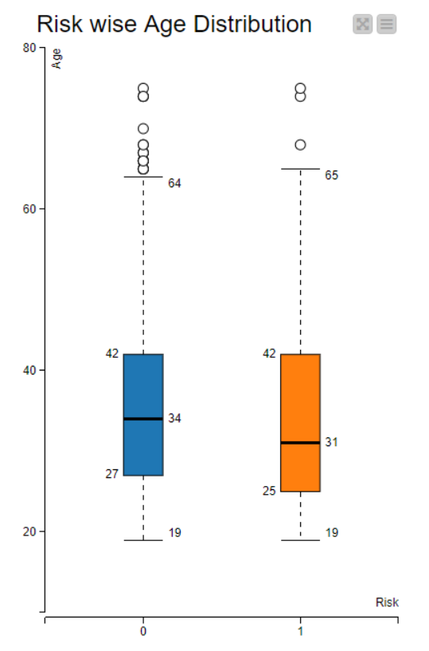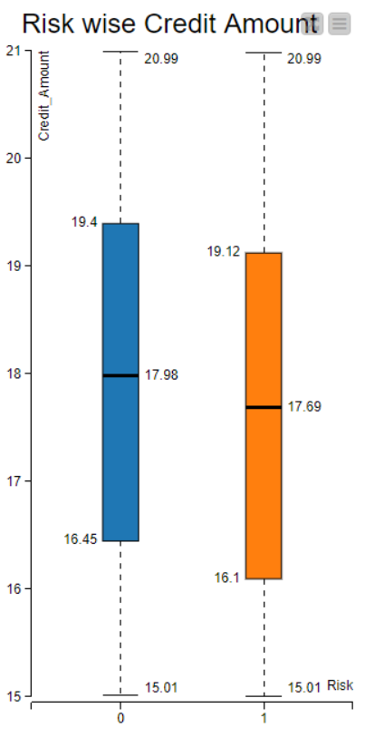

Second and third quartiles of duration of defaulters is much more than that of non-defaulters. This shows that customers with high duration are more likely to default.

* “Age” distribution is similar for defaulters and others. Defaulters are slightly younger with a median at 31 years.
* There is not a lot of difference in defaults depending on credit amount.



* Females see a higher percentage of defaulters at 30% as compared to 21% for males.
* Default % decreases as skill level increases.
* Default % goes higher as the saving account health declines.
* Default % goes higher as the checking account health declines.

##### Model Building – Logistic Regression

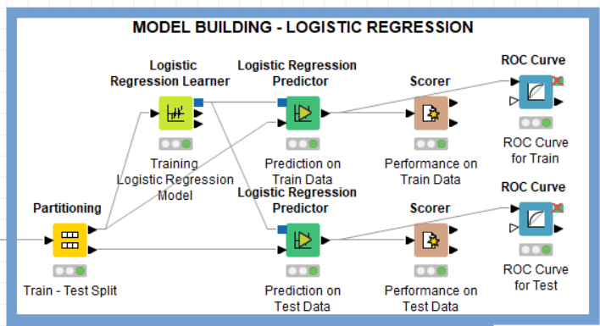

* The random state can be set to 1 while using the ‘Partitioning’ node.
* Target Variable is “Risk”

*Model Evaluation – Accuracy Statistics*

* We want to predict whether a customer will default (1) on his/ her loan payment using the above information.
* This model can make wrong predictions as:
  + It predicts a non-defaulter (0) as a defaulter (1) – **False Positive**
  + It predicts a defaulter (1) as a non-defaulter (0) – **False Negative**
* Auto Fintech would want the model to reduce its False Negatives as a defaulter has an excessive cost to the company. So, a good model should have a **high Recall.** While, more False Positives would result in higher loan rejections (which is loss of business)

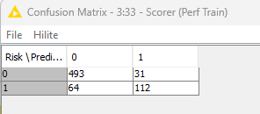 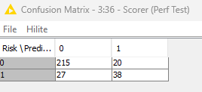

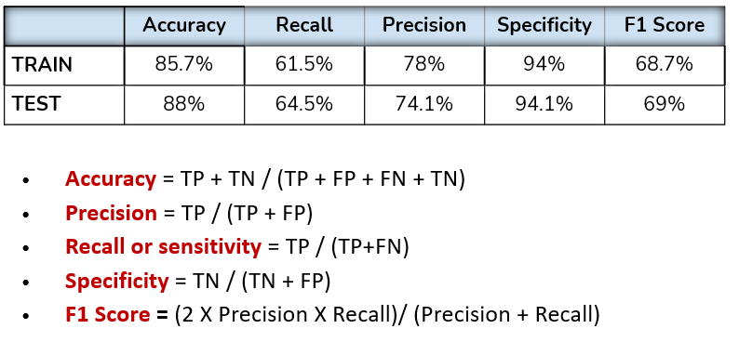

* Our model has given a high overall accuracy of 88% on test data.
* We are getting a Recall of 64.5% and an F1 Score of 69% for Test data. F1 lets us minimize both False Positive & False Negative.
* The Area under ROC curve is 0.878 for Test data.

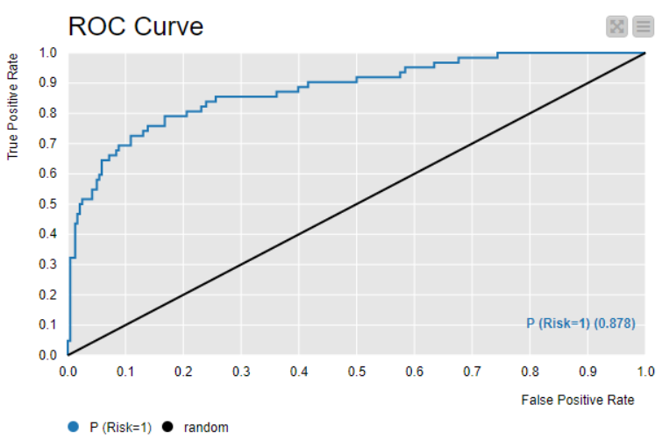

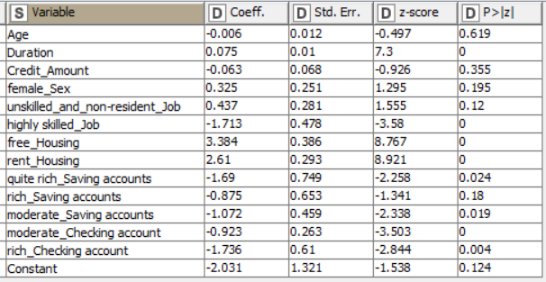

* P-value of a variable indicates if the variable is significant or not. If we consider the significance level to be 0.05 (5%), then any variable with a p-value less than 0.05 would be considered significant.

###### Insights & Recommendations:

* From our logistic regression model, we identified that Job, housing & savings & checking accounts health is a significant predictor of a customer being a defaulter.
  + Customers whose profile gives a high-risk probability should not be given high duration loans.
  + Customers with skilled and unskilled/non-resident jobs are elevated risk customers.
  + Customers owning a house are less likely to default while those with free or rented housing are at elevated risk of default. The bank should have thorough KYC documentation (Know Your Customer) to keep more details about such customers like hometown addresses, etc. to be able to track them as not owning a home is substantial risk.
  + Customers with little amount in saving accounts are more likely to default as compared to rest.
  + Customers with little amount in checking accounts are most likely to default as compared to moderate and rich.
* We saw in our analysis that customers with a little amount. The bank can be stricter with its rules or interest rates to compensate for the risk.
* Auto Fintech should try to sell more shorter duration loans as they have lesser chance of default.
* Moderate savings amount customers who default tend to have a high Exposure at Default.
* Exposure at default is proportional to credit amount and hence policy can have an upper limit on credit amount for high & moderate risk customers.



### 5.4 Exercise do it yourself:

*Credit Kaggle for Source Data Set*

<https://www.kaggle.com/datasets/faysalmiah1721758/breast-cancer-data>

###### Cancer Prediction

Context:

This breast cancer dataset was provided by M. Zwitter & M. Soklic, physicians at Institute of Oncology, University Medical Center, Ljubljana, former Yugoslavia.

In the dataset, each entry represents a patient’s medical record. Each patient is classiﬁed into no-recurrence or recurrence of cancer.

Problem Statement:

The objective of this case study is to build a classiﬁcation model that can predict the likelihood of recurrence of breast cancer given some input features like age, menopause status, tumor scan attributes, etc. and identify factors that affect the likelihood of recurrence of breast cancer and help in early diagnosis.

Approaching the Problem :

1. Understand the problem statement and attributes of the dataset.
2. Gather insights from the data by performing Univariate & Bivariate analysis.
3. Preprocess the data and make it ﬁt for model building.
4. Build a Logistic Regression model to predict the probability of recurrence of breast cancer in a patient.
5. Choose the appropriate evaluation metric(s) and observe the performance of the model on Train Data and Test Data.
6. Tune the thresholds and observe the change in model performance.

# **06 Neural Networks**

Neural network is also popularly referred to as Artificial Neural Network (ANN), this word was first coined by one of the first neuro computer scientist Dr. Robert Hecht-Nielsen. He defines it as “*a computing system made up of a number of simple, highly interconnected processing elements, which process information by their dynamic state response to external inputs.*”

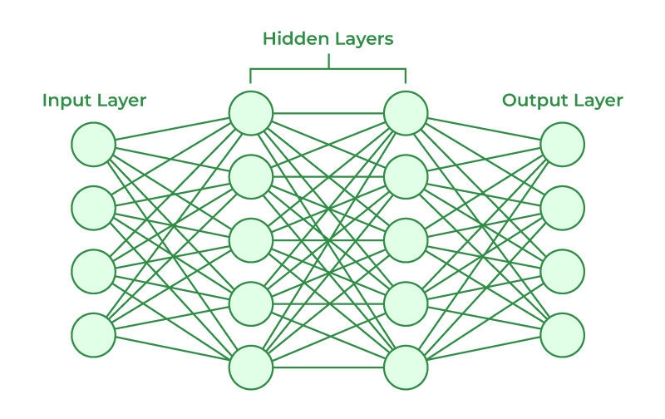

Fig 6.1 : “Neural Network” *(Credit: CCO Public Domain)*

A neural network is a method in artificial intelligence that teaches computers to process data in a way that is inspired by the human brain. It is a type of machine learning process, called deep learning, which uses interconnected nodes or neurons in a layered structure that resembles the human brain. It creates an adaptive system that computers use to learn from their mistakes and improve continuously. Thus, artificial neural networks attempt to solve complicated problems, like summarizing documents or recognizing faces, with greater accuracy.

The human brain Is the Inspiration ”ehin’ neural network architecture. Human brain cells, called neurons, form a complex, highly interconnected network, and send electrical signals to each other to help humans process information. Similarly, an artificial neural network is made of artificial neurons that work together to solve a problem. Artificial neurons are software modules, called nodes, and artificial neural networks are software programs or algorithms that, at their core, use computing systems to solve mathematical calculations.

The structures and operations of human neurons serve as the basis for artificial neural networks. It is also known as neural networks or neural nets. The input layer of an artificial neural network is the first layer, and it receives input from external sources and releases it to the hidden layer, which is the second layer. In the hidden layer, each neuron receives input from the previous layer neurons, computes the weighted sum, and sends it to the neurons in the next layer. These connections are weighted means effects of the inputs from the previous layer are optimized by assigning different-different weights to each input and it is adjusted during the training process by optimizing these weights for improved model performance.

## Evolution of Neural Networks

Since the 1940s, there have been several noteworthy advancements in the field of neural networks:

#### 1940s-1950s: Early Concepts :

Neural networks began with the introduction of the first mathematical model of artificial neurons by McCulloch and Pitts. But computational constraints made progress difficult.

#### 1960s-1970s: Perceptrons:

This era is defined by the work of Rosenblatt on perceptrons. These are single-layer networks whose applicability was limited to issues that could be solved linearly separately.

#### 1980s: Backpropagation and Connectionism:

Multi-layer network training was made possible by Rumelhart, Hinton, and Williams’ invention of the backpropagation method. With its emphasis on learning through interconnected nodes, connectionism gained appeal.

#### 1990s: Boom and Winter:

With applications in image identification, finance, and other fields, neural networks saw a boom. Neural network research did, however, experience a “winter” due to exorbitant computational costs and inflated expectations.

#### 2000s: Resurgence and Deep Learning:

Larger datasets, innovative structures, and enhanced processing capability spurred a comeback. Deep learning has shown amazing effectiveness in several disciplines by utilizing numerous layers.

#### 2010s-Present: Deep Learning Dominance:

Convolutional neural networks (CNNs) and recurrent neural networks (RNNs), two deep learning architectures, dominated machine learning. Their power was demonstrated by innovations in gaming, picture recognition, and natural language processing.

## Deep Neural Network Architecture

The ability of neural networks to identify patterns, solve intricate puzzles, and adjust to changing surroundings is essential. Their capacity to learn from data has far-reaching effects, ranging from revolutionizing technology like natural language processing and self-driving automobiles to automating decision-making processes and increasing efficiency in numerous industries.

Deep neural networks, or deep learning networks, have several hidden layers with millions of artificial neurons linked together. A number, called weight, represents the connections between one node and another. The weight is a positive number if one node excites another, or negative if one node suppresses the other. Nodes with higher weight values have more influence on the other nodes.

Theoretically, deep neural networks can map any input type to any output type. However, they also need much more training as compared to other machine learning methods. They need millions of examples of training data rather than the hundreds or thousands that a simpler network might need.

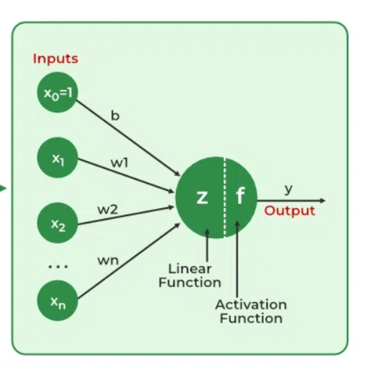

Fig 6.2 : “Neural Network Architecture” *(Credit:* [*https://www.geeksforgeeks.org/*](https://www.geeksforgeeks.org/)*)*

A basic neural network has interconnected artificial neurons in three layers:

#### Input Layer

Information from the outside world enters the artificial neural network from the input layer. Input nodes process the data, analyze, or categorize it, and pass it on to the next layer.

#### Hidden Layer

Hidden layers take their input from the input layer or other hidden layers. Artificial neural networks can have many hidden layers. Each hidden layer analyzes the output from the previous layer, processes it further, and passes it on to the next layer.

#### Output Layer

The output layer gives the result of all the data processing by the artificial neural network. It can have single or multiple nodes. For instance, if we have a binary (yes/no) classification problem, the output layer will have one output node, which will give the result as 1 or 0. However, if we have a multi-class classification problem, the output layer might consist of more than one output node.

The two stages of the basic process are called backpropagation and forward propagation.

#### Forward Propagation

Input Layer: Each feature in the input layer is represented by a node on the network, which receives input data.

Weights and Connections: The weight of each neuronal connection indicates how strong the connection is. Throughout training, these weights are changed.

Hidden Layers: Each hidden layer neuron processes inputs by multiplying them by weights, adding them up, and then passing them through an activation function. By doing this, non-linearity is introduced, enabling the network to recognize intricate patterns.

Output: The result is produced by repeating the process until the output layer is reached.

#### Backpropagation

Backpropagation is short for “backward propagation of errors.” In the context of backpropagation, SGD involves updating the network's parameters iteratively based on the gradients computed during each batch of training data. Instead of computing the gradients using the entire training dataset (which can be computationally expensive for large datasets), SGD computes the gradients using small random subsets of the data called mini batches. Here is an overview of how backpropagation algorithm works:

Forward Pass: During the forward pass, input data is fed into the neural network, and the network's output is computed layer by layer. Each neuron computes a weighted sum of its inputs, applies an activation function to the result, and passes the output to the neurons in the next layer.

Loss Computation: After the forward pass, the network's output is compared to the true target values, and a loss function is computed to measure the discrepancy between the predicted output and the actual output.

Backward Pass (Gradient Calculation): In the backward pass, the gradients of the loss function with respect to the network's parameters (weights and biases) are computed using the chain rule of calculus. The gradients represent the rate of change of the loss function with respect to each parameter and provide information about how to adjust the parameters to decrease the loss.

Parameter update: Once the gradients have been computed, the network's parameters are updated in the opposite direction of the gradients to minimize the loss function. This update is typically performed using an optimization algorithm such as stochastic gradient descent (SGD), that we discussed earlier.

Iterative Process: Steps 1-4 are repeated iteratively for a fixed number of epochs or until convergence criteria are met. During each iteration, the network's parameters are adjusted based on the gradients computed in the backward pass, gradually reducing the loss, and improving the model's performance.

## What are the types of neural networks?

Artificial neural networks can be categorized by how the data flows from the input node to the output node. Below are some examples:

### Feedforward neural networks.

Feedforward neural networks process data in one direction, from the input node to the output node. Every node in one layer is connected to every node in the next layer. A feedforward network uses a feedback process to improve predictions over time. These are the simplest form of ANNs, where information flows in one direction, from input to output. There are no cycles or loops in the network architecture. Multilayer perceptrons (MLP) are a type of feedforward neural network.

#### Backpropagation algorithm

Artificial neural networks learn continuously by using corrective feedback loops to improve their predictive analytics. In simple terms, you can think of the data flowing from the input node to the output node through many different paths in the neural network. Only one path is the correct one that maps the input node to the correct output node. To find this path, the neural network uses a feedback loop, which works as follows:

1. Each node makes a guess about the next node in the path.
2. It checks if the guess was correct. Nodes assign higher weight values to paths that lead to more correct guesses and lower weight values to node paths that lead to incorrect guesses.
3. For the next data point, the nodes make a new prediction using the higher weight paths and then repeat Step 1.

### Convolutional neural networks

The hidden layers in convolutional neural networks perform specific mathematical functions, like summarizing or filtering, called convolutions. CNNs are designed to effectively process grid-like data, such as images. They consist of layers of convolutional filters that learn hierarchical representations of features within the input data. They are especially useful for image classification because they can extract relevant features from images that are useful for image recognition and classification. The new form is easier to process without losing features that are critical for making a good prediction. Each hidden layer extracts and processes different image features, like edges, color, and depth.

### Long Short-Term Memory Networks (LSTM) and Gated Recurrent Units (GRU)

These are specialized types of recurrent neural networks designed to address the vanishing gradient problem in traditional RNN. LSTMs and GRUs incorporate gated mechanisms to better capture long-range dependencies in sequential data, making them particularly effective for tasks like speech recognition, machine translation, and sentiment analysis.

#### Autoencoder

It is designed for unsupervised learning and consists of an encoder network that compresses the input data into a lower-dimensional latent space, and a decoder network that reconstructs the original input from the latent representation. Autoencoders are often used for dimensionality reduction, data denoising, and generative modeling.

### Generative Adversarial Networks (GAN)

GANs consist of two neural networks, a generator, and a discriminator, trained simultaneously in a competitive setting. The generator learns to generate synthetic data samples that are indistinguishable from real data, while the discriminator learns to distinguish between real and fake samples. GANs have been widely used for generating realistic images, videos, and other types of data.

### Multilayer Perceptrons

A multilayer perceptron is a type of feedforward neural network consisting of fully connected neurons with a nonlinear kind of activation function. It is widely used to distinguish data that is not linearly separable. MLPs have been widely used in various fields, including image recognition, natural language processing, and speech recognition, among others. Their flexibility in architecture and ability to approximate any function under certain conditions make them a fundamental building block in deep learning and neural network research. In a multilayer perceptron, neurons process information in a step-by-step manner, performing computations that involve weighted sums and nonlinear transformations.

#### Input layer

The input layer consists of nodes or neurons that receive the initial input data. Each neuron represents a feature or dimension of the input data. The number of neurons in the input layer is determined by the dimensionality of the input data.

* The input layer of an MLP receives input data, which could be features extracted from the input samples in a dataset. Each neuron in the input layer represents one feature.
* Neurons in the input layer do not perform any computations; they simply pass the input values to the neurons in the first hidden layer.

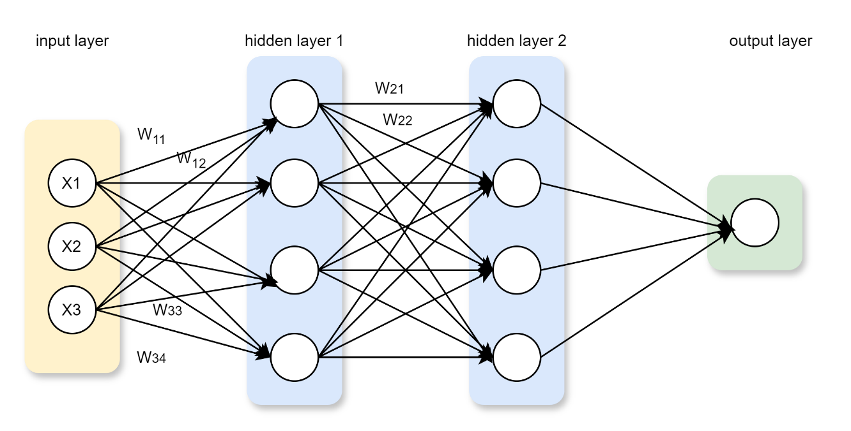

Fig 6.3 : “Working of a Multilayer Perceptron: Layer by layer”

#### Hidden layer

Between the input and output layers, there can be one or more layers of neurons. Each neuron in a hidden layer receives inputs from all neurons in the previous layer (either the input layer or another hidden layer) and produces an output that is passed to the next layer. The number of hidden layers and the number of neurons in each hidden layer are hyperparameters that need to be determined during the model design phase.

* The hidden layers of an MLP consist of interconnected neurons that perform computations on the input data.
* Each neuron in a hidden layer receives input from all neurons in the previous layer. The inputs are multiplied by corresponding weights, denoted as $w$. The weights determine how much influence the input from one neuron has on the output of another.
* In addition to weights, each neuron in the hidden layer has an associated bias, denoted as $b$. The bias provides an additional input to the neuron, allowing it to adjust its output threshold. Like weights, biases are learned during training.
* For each neuron in a hidden layer or the output layer, the weighted sum of its inputs is computed. This involves multiplying each input by its corresponding weight, summing up these products, and adding the bias.

$$Weighted Sum=\sum_{i=1}^{n}{\left(Wi*Xi\right)+b}$$

#### Output layer

This layer consists of neurons that produce the final output of the network. The number of neurons in the output layer depends on the nature of the task. In binary classification, there may be either one or two neurons depending on the activation function and representing the probability of belonging to one class; while in multi-class classification tasks, there can be multiple neurons in the output layer.

* The output layer of an MLP produces the final predictions or outputs of the network. The number of neurons in the output layer depends on the task being performed (e.g., binary classification, multi-class classification, regression).
* Each neuron in the output layer receives input from the neurons in the last hidden layer and applies an activation function. This activation function is usually different from those used in the hidden layers and produces the final output value or prediction.

#### Weights

Neurons in adjacent layers are fully connected to each other. Each connection has an associated weight, which determines the strength of the connection. These weights are learned during the training process. During the training process, the network learns to adjust the weights associated with each neuron's inputs to minimize the discrepancy between the predicted outputs and the true target values in the training data. By adjusting the weights and learning the appropriate activation functions, the network learns to approximate complex patterns and relationships in the data, enabling it to make accurate predictions on new, unseen samples. This adjustment is guided by an optimization algorithm, such as stochastic gradient descent (SGD), which computes the gradients of a loss function with respect to the weights and updates the weights iteratively.

#### Bias neurons

In addition to the input and hidden neurons, each layer (except the input layer) usually includes a bias neuron that provides a constant input to the neurons in the next layer. Bias neurons have their own weight associated with each connection, which is also learned during training. The bias neuron effectively shifts the activation function of the neurons in the subsequent layer, allowing the network to learn an offset or bias in the decision boundary. By adjusting the weights connected to the bias neuron, the MLP can learn to control the threshold for activation and better fit the training data.

## What is a Loss Function?

The loss function, also referred to as the error function, is a crucial component in machine learning that quantifies the difference between the predicted outputs of a machine learning algorithm and the actual target values. For example, within a regression problem to predict car prices based on historical data, a loss function evaluates a neural network prediction based on a training sample from the training dataset. The loss function quantifies the gap, or the error margin of the car price predicted by the network to the actual price. The resulting value, the loss, reflects the accuracy of the model's predictions. During training, a learning algorithm such as the backpropagation algorithm uses the gradient of the loss function with respect to the model's parameters to adjust these parameters and minimize the loss, effectively improving the model's performance on the dataset. Often, the terms loss function and cost function are used interchangeably; despite this, both terms have distinct definitions:

As mentioned earlier, the loss function, also known as the error function, quantifies how well a single prediction of the machine learning algorithm is compared to the actual target value. The key takeaway is that a loss function applies to a single training example and is part of the overall model's learning process that provides the signal by which the model's learning algorithm updates the weights and parameters.

The cost function, sometimes called the objective function, is an average of the loss function of an entire training set containing several training examples. The cost function quantifies the model's performance on the whole training dataset.

### How Loss Functions Work?

The learning algorithm and mechanisms in a ML model are optimized to minimize the prediction error, so this means that after a calculation of the value for the loss function, which is determined by the prediction error, the learning algorithm leverages this information to conduct weight and parameter updates which in effect during the next training pass leads to a lower prediction error. Empirical Risk Minimization(ERM) is an approach to selecting the optimal parameters of a machine learning algorithm that minimizes the empirical risk. The empirical risk, in this case, is the training dataset. The risk minimization component of ERM is the process by which the internal learning algorithm minimizes the error of prediction of machine learning algorithm to a known dataset in the outcome that the model has an expected performance and accuracy in a scenario where an unseen dataset or data sample which could have similar statical data distribution as the dataset the models has been initially trained on.

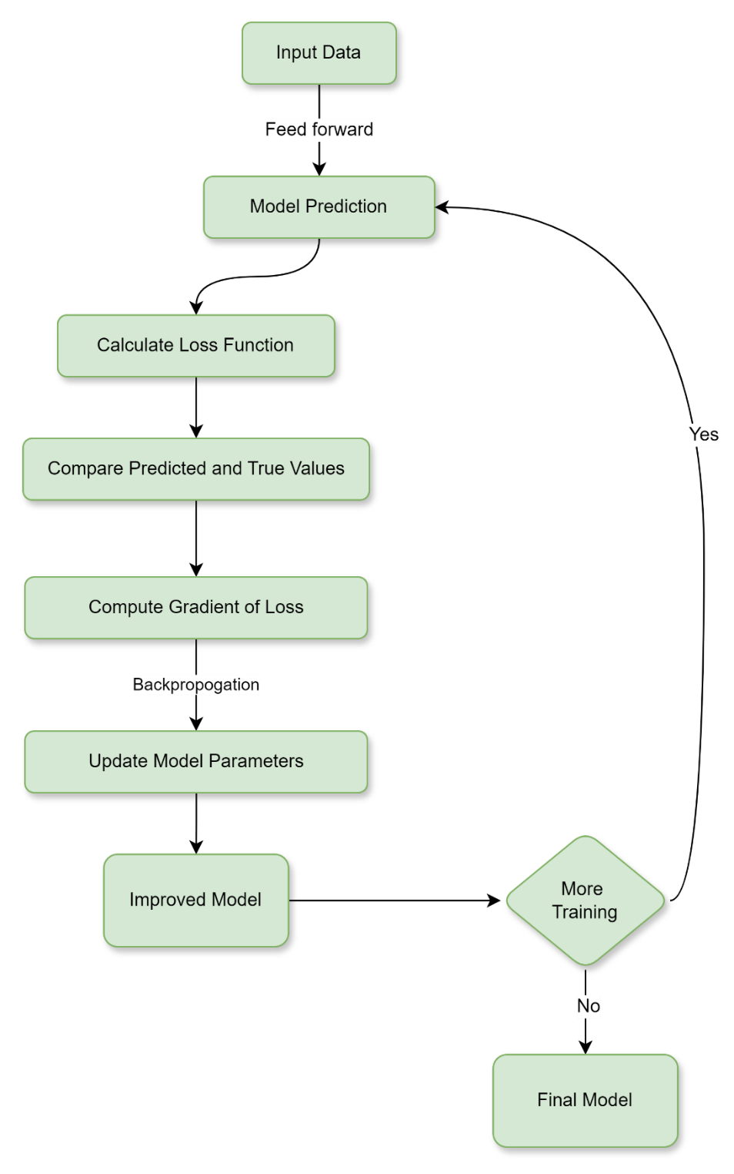

Fig 6.3 : “How Loss Function Works”

### Types of Loss Functions

Loss functions in machine learning can be categorized based on the machine learning tasks to which they are applicable. Most loss functions apply to regression and classification machine learning problems.

|  |  |  |
| --- | --- | --- |
| Loss Function | Applicability to Classification | Applicability to Regression |
| Mean Square Error (MSE) / L2 Loss | No | Yes |
| Mean Absolute Error (MAE) / L1 Loss | No | Yes |
| Binary Cross-Entropy Loss / Log Loss | Yes | No |
| Categorical Cross-Entropy Loss | Yes | No |
| Hinge Loss | Yes | No |
| Huber Loss / Smooth Mean Absolute Error | No | Yes |
| Log Loss | Yes | No |

## What is an Activation Function?

An activation function in the context of neural networks is a mathematical function applied to the output of a neuron. The purpose of an activation function is to introduce non-linearity into the model, allowing the network to learn and represent complex patterns in the data. Without non-linearity, a neural network would behave like a linear regression model, regardless of the number of layers it has. The activation function decides whether a neuron should be activated or not by calculating the weighted sum and further adding bias to It. The purpose of the activation function is to introduce non-linearity into the output of a neuron. We know, the neural network has neurons that work in correspondence with weight, bias, and their respective activation function. In a neural network, we would update the weights and biases of the neurons based on the error at the output. This process is known as back-propagation. Activation functions make the back-propagation possible since the gradients are supplied along with the error to update the weights and biases.

The Activation Functions can be divided into 3 types-

1. Binary Step Function
2. Linear Activation Function
3. Non-linear Activation Functions

### Binary Step Function

Binary step function depends on a threshold value that decides whether a neuron should be activated or not. The input fed to the activation function is compared to a certain threshold; if the input is greater than it, then the neuron is activated, else it is deactivated, meaning that its output is not passed on to the next hidden layer. Some of the limitations of binary step function:

* It cannot provide multi-value outputs—for example, it cannot be used for multi-class classification problems.
* The gradient of the step function is zero, which causes a hindrance in the backpropagation process.

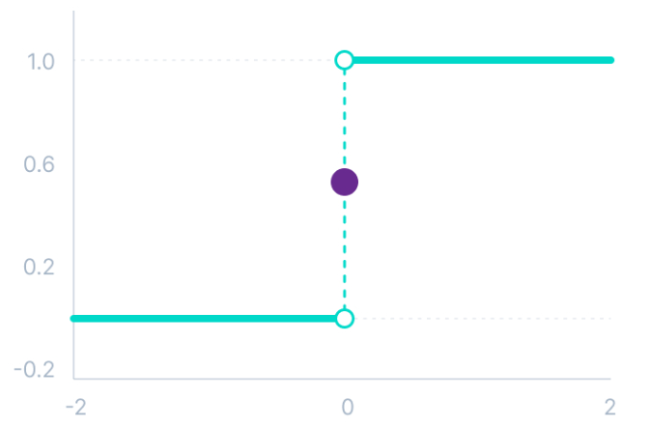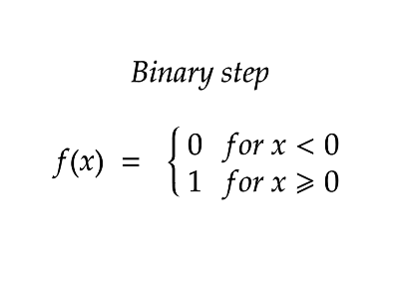

Fig 6.4 : “Binary Step Function” *(Credit: CCO Public Domain)*

### Linear or Identity Activation Function

The linear activation function, also known as “no activation,” or “identity function” (multiplied x1.0), is where the activation is proportional to the input. The function does not do anything to the weighted sum of the input, it simply spits out the value it was given.

Equation : f(x) = x

Range: (-infinity to infinity)

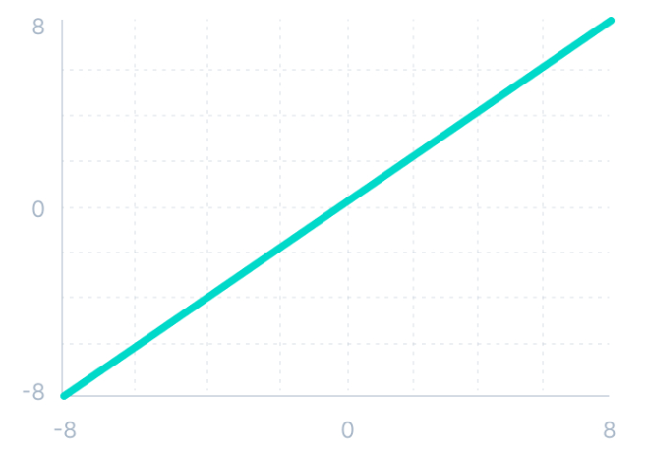

Fig 6.5 : “Linear or Identity Activation Function” *(Credit: CCO Public Domain)*

A linear activation function has two major problems :

* It is not possible to use backpropagation as the derivative of the function is a constant and has no relation to the input x.
* All layers of the neural network will collapse into one if a linear activation function is used. No matter the number of layers in the neural network, the last layer will still be a linear function of the first layer. So, a linear activation function turns the neural network into just one layer.

### Non-linear Activation Function

The Nonlinear Activation Functions are the most used activation functions. Nonlinearity helps to makes it easy for the model to generalize or adapt with variety of data and to differentiate between the output. Non-linear activation functions solve the following limitations of linear activation functions:

1. They allow backpropagation because now the derivative function would be related to the input, and it is possible to go back and understand which weights in the input neurons can provide a better prediction.
2. They allow the stacking of multiple layers of neurons as the output would now be a non-linear combination of input passed through multiple layers. Any output can be represented as a functional computation in a neural network.

The main terminologies needed to understand for nonlinear functions are:

*Derivative or Differential: Change in y-axis with respect to change in x-axis. It is also known as slope.*

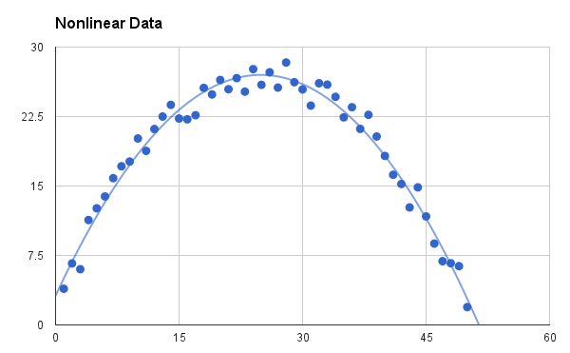*Monotonic function: A function which is either entirely non-increasing or non-decreasing.*

Fig 6.6 : “Non-linear Activation Function” *(Credit: CCO Public Domain)*

### Variants of Non-linear Activation Function

##### Sigmoid / Logistic Activation Function

This function takes any real value as input and outputs values in the range of 0 to 1. The larger the input (more positive), the closer the output value will be to 1.0, whereas the smaller the input (more negative), the closer the output will be to 0.0. Sigmoid function is commonly used for models where we must predict the probability as an output. Since probability of anything exists only between the range of 0 and 1, sigmoid is the right choice because of its range. The function is differentiable and provides a smooth gradient, i.e., preventing jumps in output values. This is represented by an S-shape of the sigmoid activation function. Sigmoid/logistic activation function is one of the most widely used functions:

* It is commonly used for models to predict the probability as an output. Since probability of anything exists only between the range of 0 and 1, sigmoid is the right choice because of its range.
* The function is differentiable and provides a smooth gradient, i.e., preventing jumps in output values. This is represented by an S-shape of the sigmoid activation function.

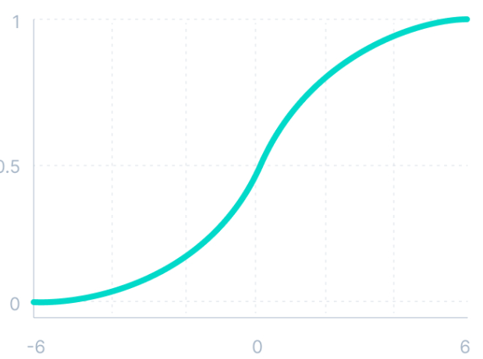 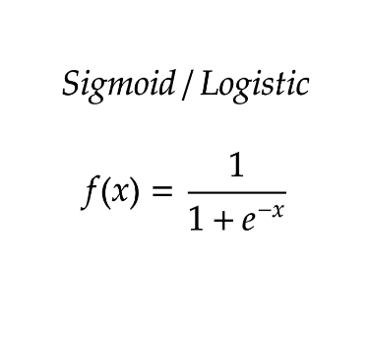

Fig 6.7 : “Sigmoid Activation Function” *(Credit: CCO Public Domain)*

##### Tanh Function (Hyperbolic Tangent)

Tanh function is like the sigmoid/logistic activation function, and even has the same S-shape with the difference in output range of -1 to 1. In Tanh, the larger the input (more positive), the closer the output value will be to 1.0, whereas the smaller the input (more negative), the closer the output will be to -1.0.

Advantages of using this activation function are:

* The output of the tanh activation function is Zero centered; hence we can easily map the output values as strongly negative, neutral, or strongly positive.
* Usually used in hidden layers of a neural network as its values lie between -1 to; therefore, the mean for the hidden layer comes out to be 0 or remarkably close to it. It helps in centering the data and makes learning for the next layer much easier.

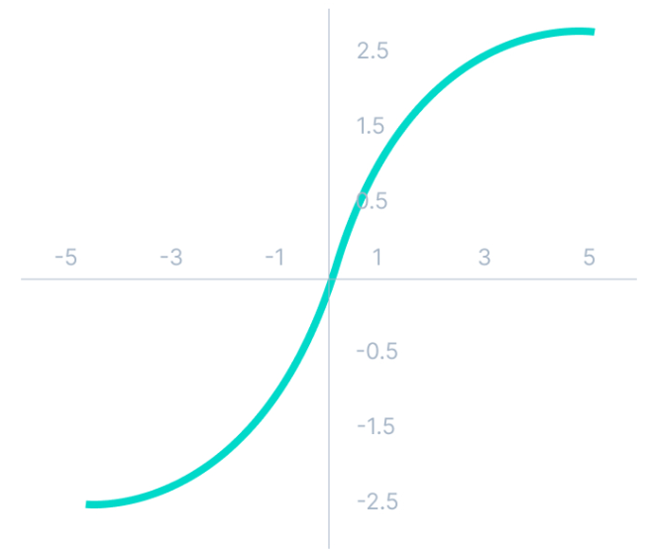 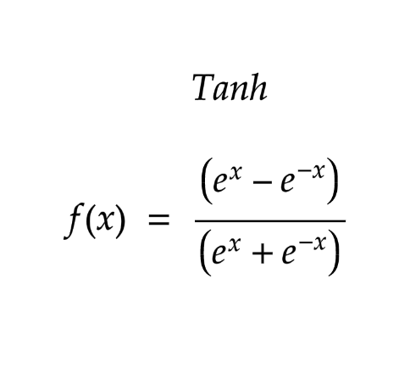

Fig 6.8 : “Tanh Activation Function” *(Credit: CCO Public Domain)*

##### ReLU Function

ReLU stands for Rectified Linear Unit. Although it gives an impression of a linear function, ReLU has a derivative function and allows for backpropagation while simultaneously making it computationally efficient. The main catch here is that the ReLU function does not activate all the neurons at the same time. The neurons will only be deactivated if the output of the linear transformation is less than 0.

The advantages of using ReLU as an activation function are as follows:

* Since only a certain number of neurons are activated, the ReLU function is far more computationally efficient when compared to the sigmoid and tanh functions.
* ReLU accelerates the convergence of gradient descent towards the global minimum of the loss function due to its linear, non-saturating property.

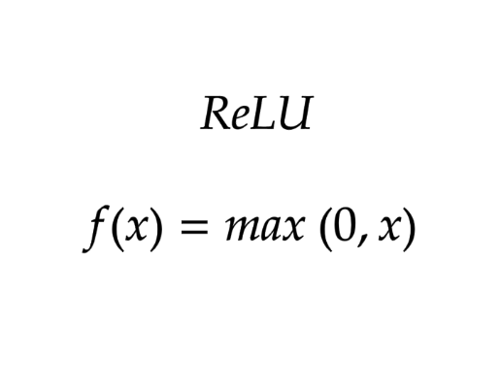 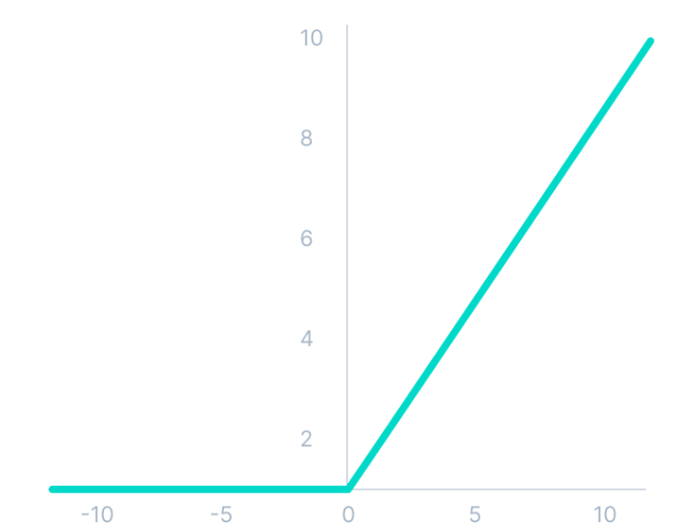

Fig 6.9: “ReLU Activation Function” *(Credit: CCO Public Domain)*

##### SoftMax Function

SoftMax function is described as a combination of multiple sigmoid. It calculates the relative probabilities. Like the sigmoid/logistic activation function, the SoftMax function returns the probability of each class. It is commonly used as an activation function for the last layer of the neural network in the case of multi-class classification.

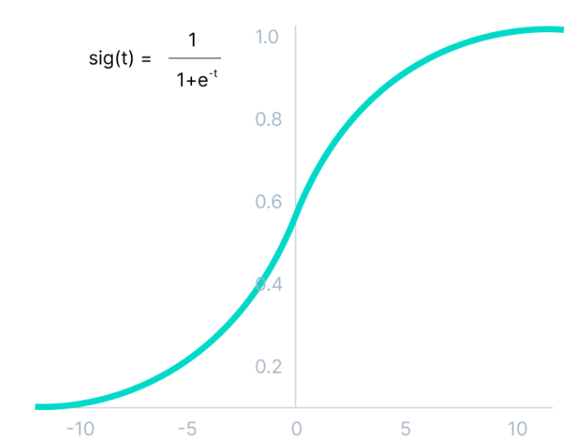

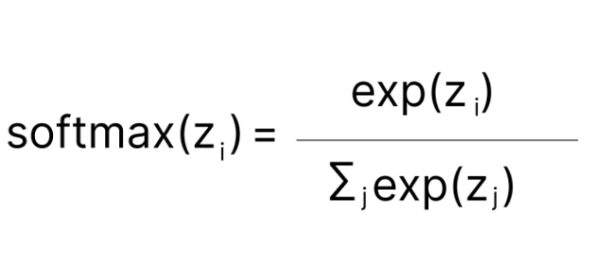

Fig 6.10: “Probability” *(Credit: CCO Public Domain)*

##### Swish Activation Function

It is a self-gated activation function developed by researchers at Google. Swish consistently matches or outperforms ReLU activation function on deep networks applied to various challenging domains such as image classification, machine translation etc. . This function is bounded below but unbounded above i.e., Y approaches to a constant value as X approaches negative infinity but Y approaches to infinity as X approaches infinity. Advantages of the Swish activation function over ReLU:

* Swish is a smooth function that means that it does not abruptly change direction like ReLU does near x = 0. Rather, it smoothly bends from 0 towards values < 0 and then upwards again.
* Small negative values were zeroed out in ReLU activation function. However, those negative values may still be relevant for capturing patterns underlying the data. Large negative values are zeroed out for reasons of sparsity making it a win-win situation.
* The swish function being non-monotonous enhances the expression of input data and weight to be learnt.

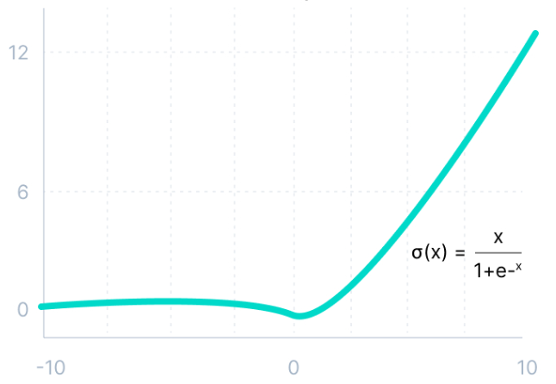

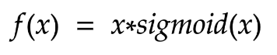

Fig 6.11 : “Swish Activation Function” *(Credit: CCO Public Domain)*

##### Gaussian Error Linear Unit (GELU)

The Gaussian Error Linear Unit (GELU) activation function is compatible with BERT, ROBERT, ALBERT, and other top NLP models. This activation function is motivated by combining properties from dropout, zone out, and ReLUs. ReLU and dropout together yield a neuron’s output. ReLU does it deterministically by multiplying the input by zero or one (depending upon the input value being positive or negative) and dropout stochastically multiplying by zero. This distribution is chosen since neuron inputs tend to follow a normal distribution, especially with Batch Normalization. GELU nonlinearity is better than ReLU and ELU activations and finds performance improvements across all tasks in domains of computer vision, natural language processing, and speech recognition. Mathematically it is represented as:

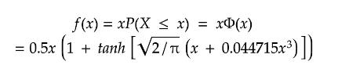

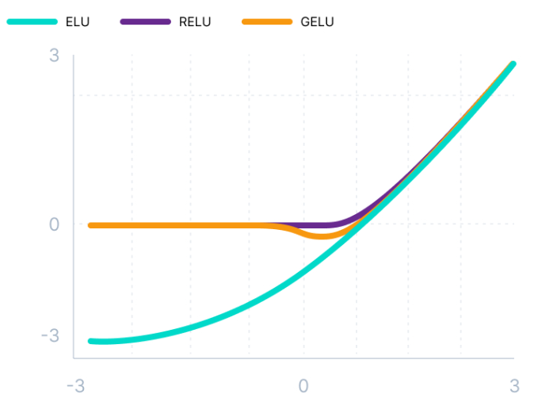

Fig 6.12 : “GELU Activation Function” *(Credit: CCO Public Domain)*

##### Scaled Exponential Linear Unit (SELU)

SELU is defined in self-normalizing networks and takes care of internal normalization which means each layer preserves the mean and variance from the previous layers. SELU enables this normalization by adjusting the mean and variance. SELU has both positive and negative values to shift the mean, which was impossible for ReLU activation function as it cannot output negative values. Gradients can be used to adjust the variance. The activation function needs a region with a gradient larger than one to increase it. Mathematically it can be represented as:

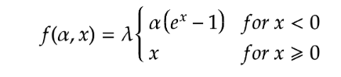

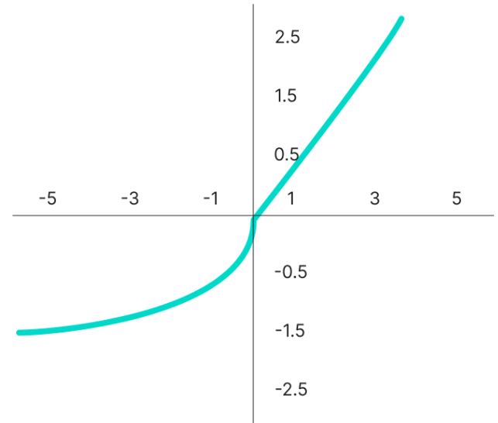

Fig 6.13 : “SELU Activation Function” *(Credit: CCO Public Domain)*

SELU has values of alpha α and lambda λ predefined. Here is the main advantage of SELU over ReLU: Internal normalization is faster than external normalization, which means the network converges faster.

## Training Deep Neural Network

Neural network training is the process of teaching a neural network to perform a task. Neural networks learn by initially processing several large sets of labeled or unlabeled data. By using these examples, they can then process unknown inputs more accurately.

###### Learning with supervised learning

In supervised learning, the neural network is guided by a teacher who has access to both input-output pairs. The network creates outputs based on inputs without considering the surroundings. By comparing these outputs to the teacher-known desired outputs, an error signal is generated. To reduce errors, the network’s parameters are changed iteratively and stop when performance is at an acceptable level.

###### Learning with Unsupervised learning

Equivalent output variables are absent in unsupervised learning. Its main goal is to comprehend incoming data’s (X) underlying structure. No instructor is present to offer advice. Modeling data patterns and relationships is the intended outcome instead. Words like regression and classification are related to supervised learning, whereas unsupervised learning is associated with clustering and association.

###### Learning with Reinforcement Learning

Through interaction with the environment and feedback in the form of rewards or penalties, the network gains knowledge. Finding a policy or strategy that optimizes cumulative rewards over time is the goal for the network. This kind is frequently utilized in gaming and decision-making applications.

There are two challenges you might encounter when training your deep neural networks.

#### Vanishing Gradients

Like the sigmoid function, certain activation functions squish an ample input space into a small output space between 0 and 1. Therefore, a substantial change in the input of the sigmoid function will cause a slight change in the output. Hence, the derivative becomes small. For shallow networks with only a few layers that use these activations, this is not a big problem. However, when more layers are used, it can cause the gradient to be too small for training to work effectively.

#### Exploding Gradients

Exploding gradients are problems where significant error gradients accumulate and result in exceptionally large updates to neural network model weights during training. An unstable network can result when there are exploding gradients, and the learning cannot be completed. The values of the weights can also become so large as to overflow and result in something called NaN values.

Choosing the right activation function is important to overcome these above-mentioned challenges. It is important to match your activation function for your output layer based on the type of prediction problem that you are solving—specifically, the type of predicted variable. As a rule of thumb, you can begin with using the ReLU activation function and then move over to other activation functions if ReLU does not provide optimum results.

* ReLU activation function should only be used in the hidden layers.
* Sigmoid/Logistic and Tanh functions should not be used in hidden layers as they make the model more susceptible to problems during training (due to vanishing gradients).
* Swish function is used in neural networks having a depth greater than 40 layers.
* For choosing the activation function for your output layer based on the type of prediction problem that you are solving:

*Regression* – Linear Activation Function

*Binary Classification*—Sigmoid/Logistic Activation Function

*Multiclass Classification*—SoftMax

*Multilabel Classification*—Sigmoid

*Convolutional Neural Network (CNN)*: ReLU activation function.

*Recurrent Neural Network*: Tanh and/or Sigmoid activation function.

## Machine learning vs. Deep learning

Traditional machine learning methods require human input for the machine learning software to work sufficiently well. A data scientist manually determines the set of relevant features that the software must analyze. This limits the software’s ability, which makes it tedious to create and manage.

On the other hand, in deep learning, the data scientist gives only raw data to the software. The deep learning network derives the features by itself and learns more independently. It can analyze unstructured datasets like text documents, identify which data attributes to prioritize, and solve more complex problems.

For example, if you were training a machine learning software to identify an image of a pet correctly, you would need to take these steps:

* Find and label thousands of pet images, like cats, dogs, horses, hamsters, parrots manually.
* Tell the machine learning software what features to look for so it can identify the image using elimination. For instance, it might count the number of legs, then check for eye shape, ear shape, tail, and fur.
* Manually assess and change the labeled datasets to improve the software’s accuracy. For example, if your training set has too many pictures of black cats, the software will correctly identify a black cat but not a white one.
* In deep learning, however, the neural networks would process all the images and automatically determine that they need to analyze the number of legs and the face shape first, then look at the tails last to correctly identify the animal in the image.

## Optimizing a Neural Network

Optimizers and loss functions are two components that help improve the performance of the model. By calculating the difference between the expected and actual outputs of a model, a loss function evaluates the effectiveness of a model. Among the loss functions are log loss, hinge loss, and mean square loss. By modifying the model’s parameters to reduce the loss function value, the optimizer contributes to its improvement. RMSProp, ADAM, and SGD are a few examples of optimizers. The optimizer’s job is to determine which combination of the neural network’s weights and biases will give it the best chance to generate accurate predictions.

##### Optimization Rule in Deep Neural Networks

There are various optimization techniques to change model weights and learning rates, like Gradient Descent, Stochastic Gradient Descent, Stochastic Gradient descent with momentum, Mini-Batch Gradient Descent, AdaGrad, RMSProp, AdaDelta, and Adam. These optimization techniques play a critical role in the training of neural networks, as they help improve the model by adjusting its parameters to minimize the loss of function value. Choosing the best optimizer depends on the application.



### 6.1 Key Takeaways



* A neural network is a method in artificial intelligence that teaches computers to process data in a way that is inspired by the human brain.
* The input layer of an artificial neural network is the first layer, and it receives input from external sources and releases it to the hidden layer, which is the second layer.
* Deep neural networks have several hidden layers with millions of artificial neurons linked together. A number, called weight, represents the connections between one node and another.
* During the forward pass, input data is fed into the neural network, and the network's output is computed layer by layer.
* Loss function is computed to measure the discrepancy between the predicted output and the actual output.
* Artificial neural networks learn continuously by using corrective feedback loops to improve their predictive analytics.
* Convolutional neural network consists of layers of convolutional filters that learn hierarchical representations of features within the input data.
* Autoencoder is designed for unsupervised learning and consists of an encoder network that compresses the input data into a lower-dimensional latent space, and a decoder network that reconstructs the original input from the latent representation.
* A multilayer perceptron is a type of feedforward neural network consisting of fully connected neurons with a nonlinear kind of activation function.
* Empirical Risk Minimization is an approach to selecting the optimal parameters of a machine learning algorithm that minimizes the empirical risk.

### 6.2 Quiz :



Q1. What is an Artificial Neural Network (ANN)?

1. A computational model inspired by the human brain.
2. A machine learning algorithm used for image processing.
3. A statistical analysis technique for data clustering
4. A programming language for neural network implementation

Q2. What is the basic building block of an Artificial Neural Network?

1. Neuron
2. Activation function
3. Gradient descent
4. Loss function

Q3. Which of the following activation functions is commonly used in ANNs?

1. ReLU (Rectified Linear Unit)
2. Sigmoid
3. Tanh (Hyperbolic Tangent)
4. All the above

Q4. What is the purpose of the activation function in an ANN?

1. It determines the output of a neuron.
2. It introduces non-linearity to the network.
3. It enables the network to learn complex patterns.
4. All the above

Q5. What is the function of the input layer in an ANN?

1. It receives input data and passes it to the hidden layers.
2. It performs mathematical computations on the input data.
3. It stores the trained weights and biases of the network.
4. None of the above

Q6. Which layer of an ANN is responsible for making predictions or producing the final output?

1. Input layer
2. Hidden layer
3. Output layer
4. All layers contribute equally.

Q7. What is the purpose of the backpropagation algorithm in ANN training?

1. To update the weights and biases based on the prediction error.
2. To initialize the weights and biases of the network
3. To determine the number of hidden layers and neurons
4. None of the above

Q8. Which of the following is a common loss function used in ANNs for binary classification?

1. Mean Absolute Error (MAE)
2. Mean Squared Error (MSE)
3. Binary Cross-Entropy
4. Categorical Cross-Entropy

Q9. What is the purpose of the forward pass in ANN training?

1. To compute the predicted output based on the current weights and biases.
2. To adjust the weights and biases using gradient descent
3. To identify misclassified samples and update the model.
4. None of the above

Q10. What is the primary goal of training an ANN?

1. To minimize the prediction error on the training data
2. To maximize the number of neurons in the hidden layers
3. To achieve 100% accuracy on the test data
4. None of the above

Q11. Which of the following is a common optimization algorithm used in ANN training?

1. Gradient Descent
2. Stochastic Gradient Descent (SGD)
3. Adam
4. All the above

Q12. What is the purpose of regularization in ANN training?

1. To prevent overfitting by adding a penalty term to the loss function
2. To increase the model's capacity for learning complex patterns
3. To speed up the training process by adjusting the learning rate
4. None of the above

Q13. What is the vanishing gradient problem in ANNs?

1. When the gradients become extremely small during backpropagation
2. When the gradients become extremely large during backpropagation
3. When the weights and biases are initialized randomly
4. None of the above

Q14. Which type of ANN architecture is used for processing sequential data?

1. Recurrent Neural Network (RNN)
2. Convolutional Neural Network (CNN)
3. Multilayer Perceptron (MLP)
4. Radial Basis Function Network (RBFN)

Q15. What is the purpose of dropout regularization in ANN training?

1. To randomly disable neurons during training to prevent overfitting
2. To increase the learning rate for faster convergence
3. To add additional layers to the network for increased capacity
4. None of the above

Q16. Which of the following is an advantage of using ANNs for pattern recognition?

1. Ability to learn from substantial amounts of data.
2. Robustness to noise and variations in input
3. Scalability to manage complex tasks.
4. All the above

Q17. What is the purpose of cross-validation in ANN training?

1. To evaluate the generalization performance of the model
2. To split the data into training and test sets
3. To perform hyperparameter tuning
4. None of the above

Q18. Which type of ANN architecture is commonly used for image classification tasks?

1. Convolutional Neural Network (CNN)
2. Recurrent Neural Network (RNN)
3. Radial Basis Function Network (RBFN)
4. Multilayer Perceptron (MLP)

Q19. What is the purpose of weight initialization in ANN training?

1. To set the initial values of the weights and biases in the network
2. To adjust the learning rate during training
3. To compute the gradient of the loss function
4. None of the above

Q20. Which activation function is commonly used in the output layer for binary classification in ANNs?

1. Sigmoid
2. ReLU (Rectified Linear Unit)
3. Tanh (Hyperbolic Tangent)
4. Softmax

### Research with solid fill6.3 Hands-on Case Study:

*Neural Network Classification*

*Credit Kaggle for Source Data Set*

<https://www.kaggle.com/datasets/rajgupta2019/medical-insurance-dataset>

**Context**

People are always confused about their medical insurance and do not know the cost of insurance at different ages and conditions. This data is useful for these people and is useful to make predictions of the insurance cost they will have to pay.

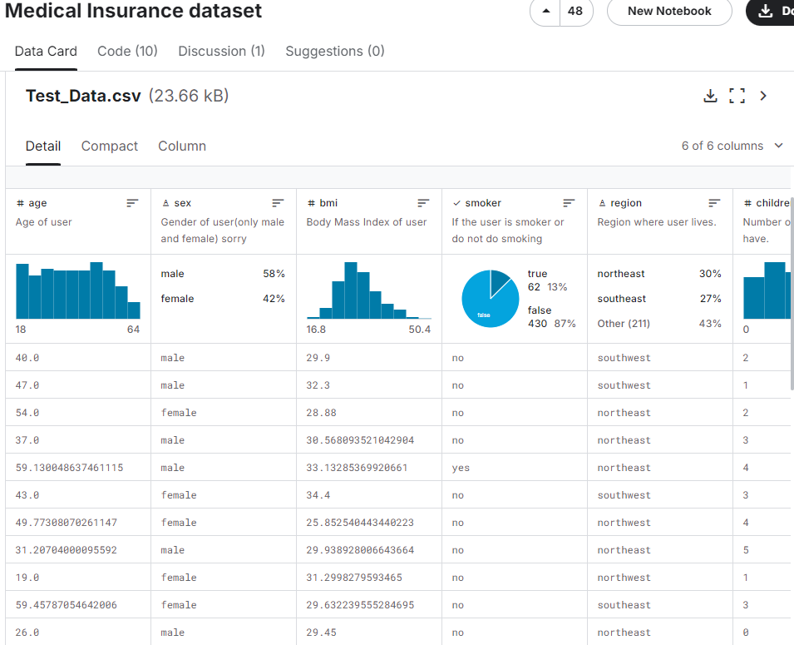

Step 1 : Configure Source data set : insurance charges.csv.

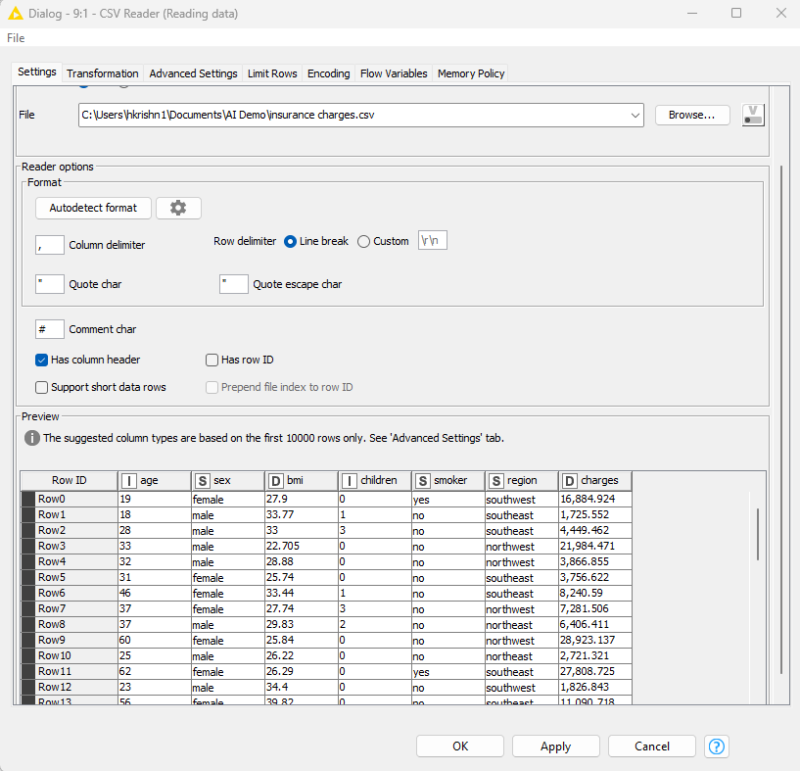

Step 2: Perform EDA

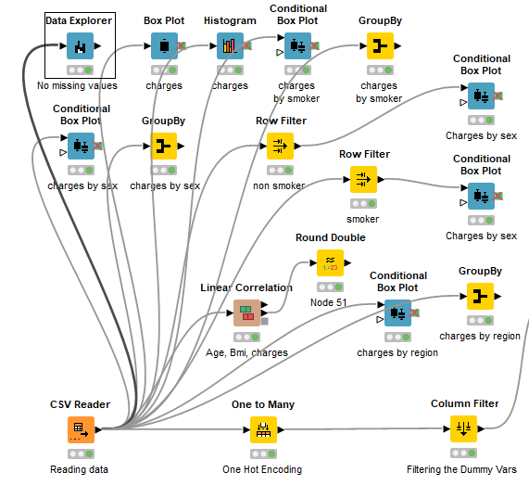

Data Explorer

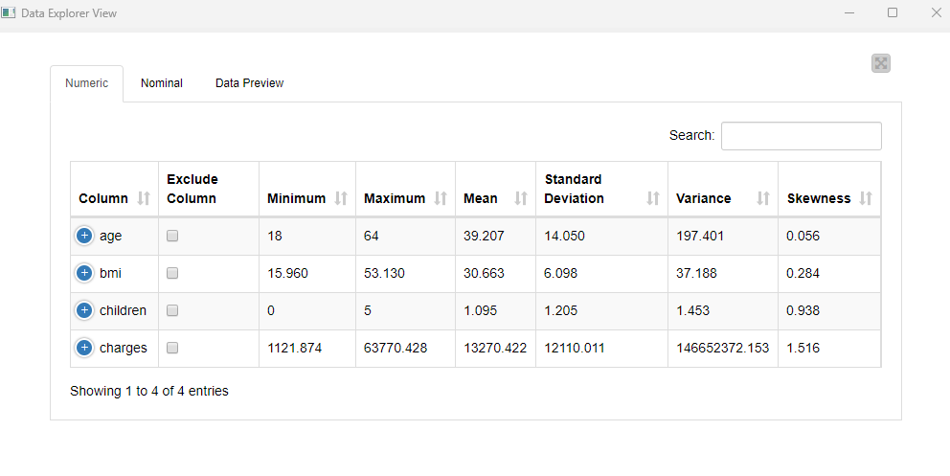

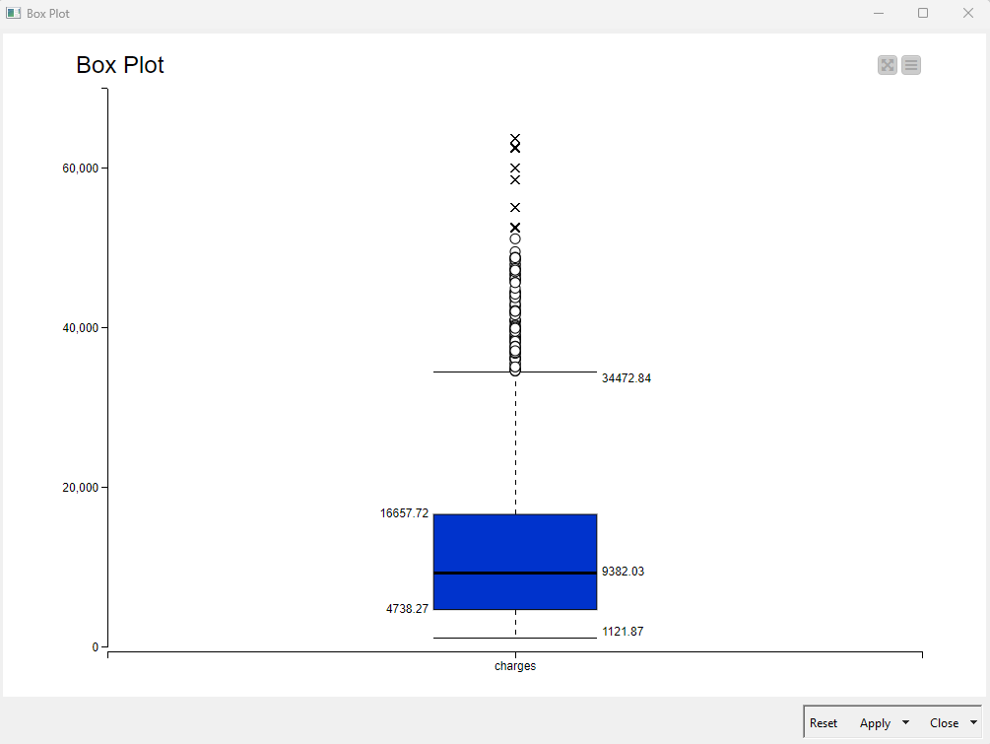

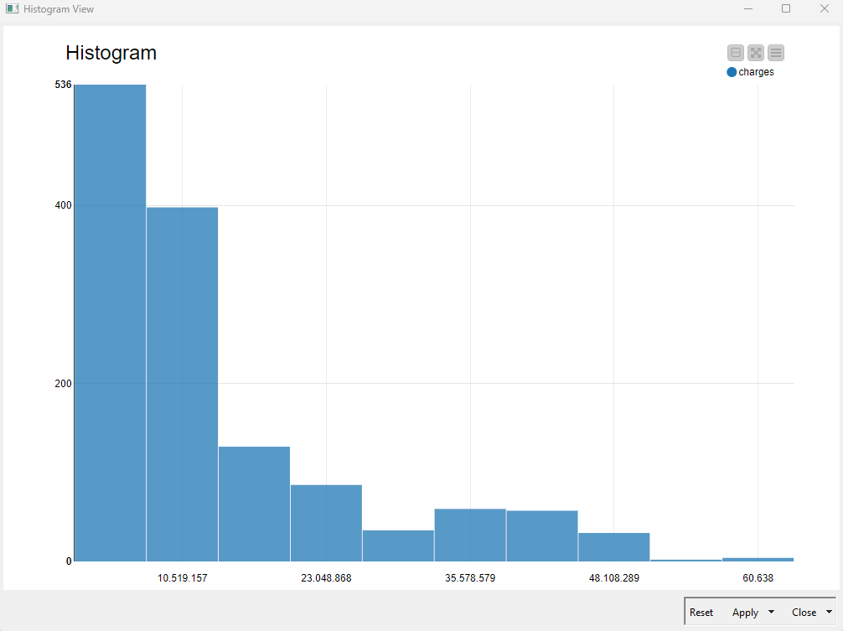

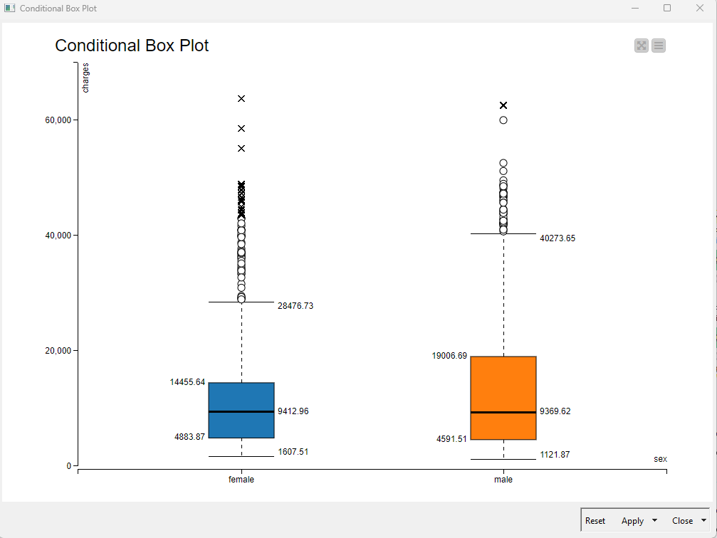

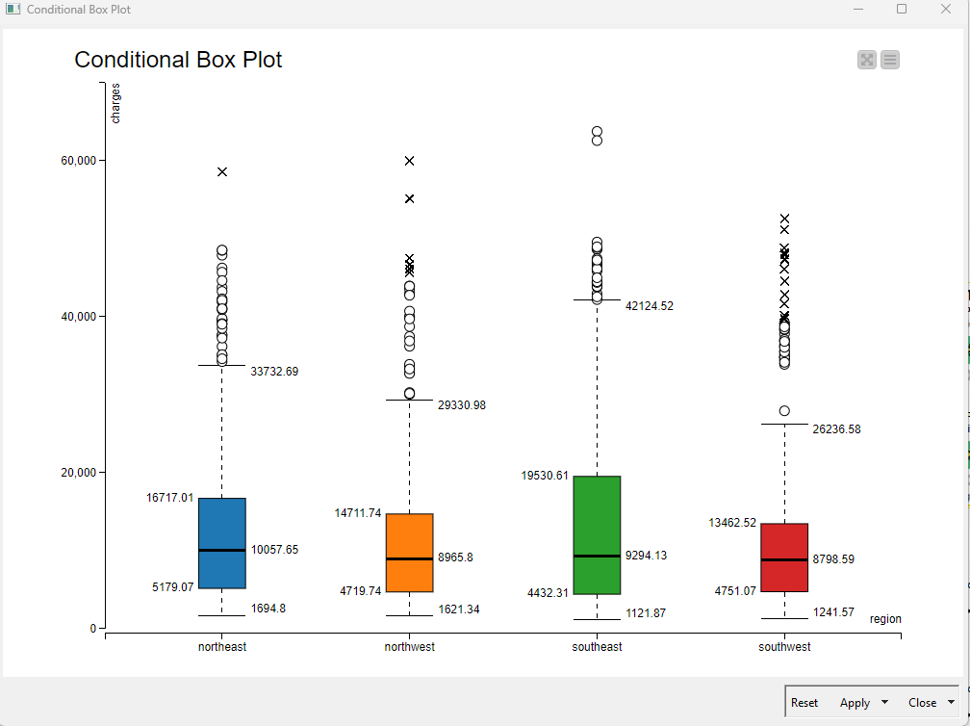

Step 3 : Data Preprocessing

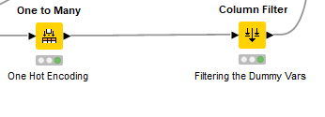

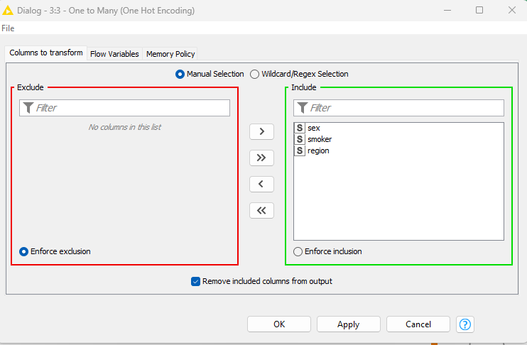

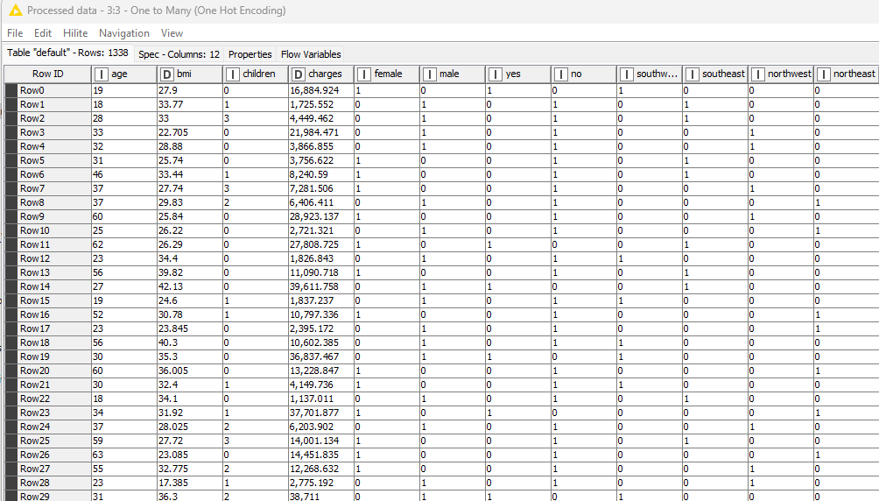

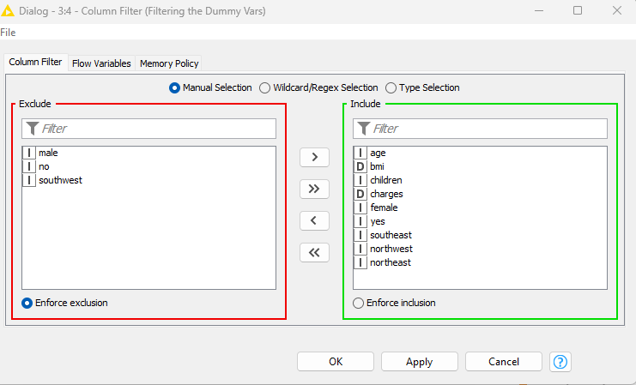

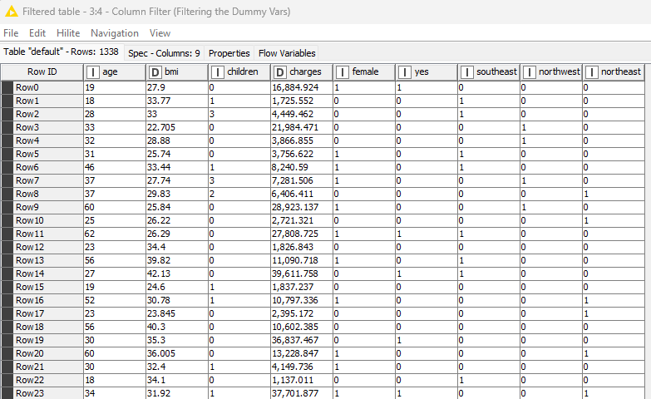

Step 4: Partitioning and Normalization

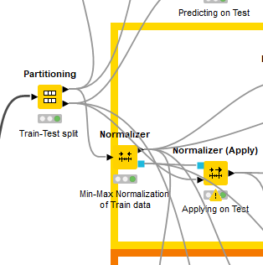

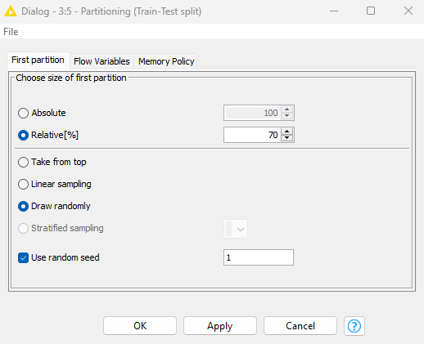

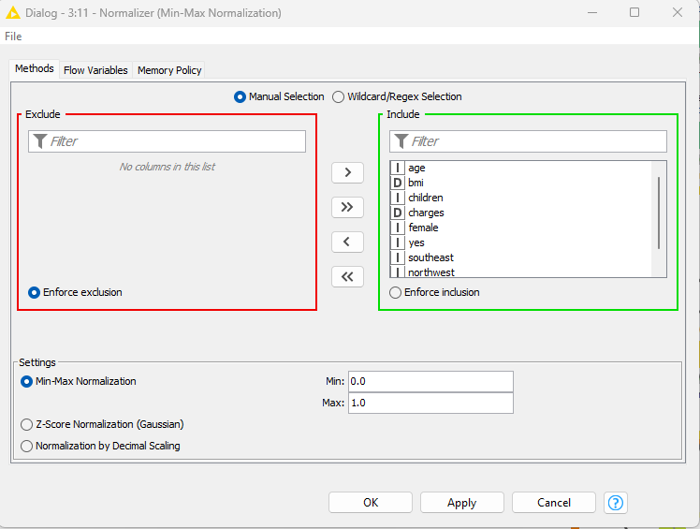

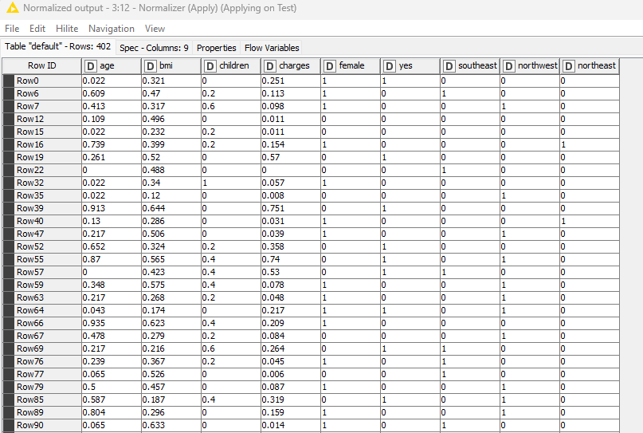

Step 5 : Model building Unpruned NN Vs Pruned NN Modeling

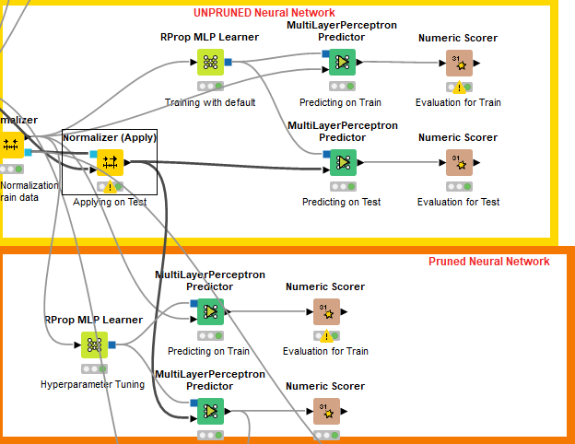

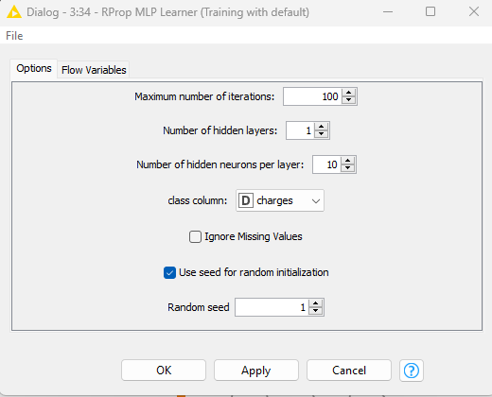

Unpruned NN Model Statistics Pruned NN Model Statistics

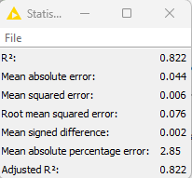 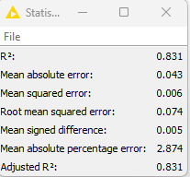

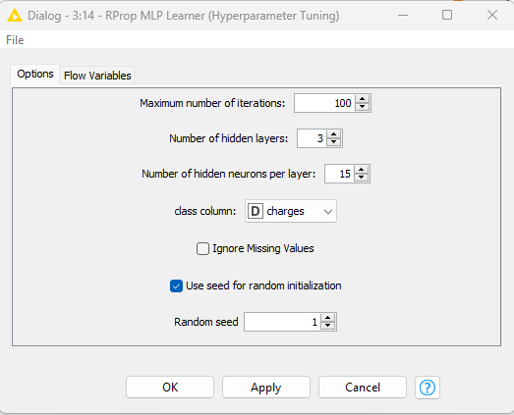



### 6.4 Exercise do it yourself:

*Credit Kaggle for Source Data Set*

<https://www.kaggle.com/datasets/imakash3011/online-shoppers-purchasing-intention-dataset>

**Problem Statement – Build Neural Networks Regression Hands-On**

##### About Dataset

###### Context

Data Set Information:

The dataset consists of feature vectors belonging to 12,330 sessions.

The dataset was formed so that each session would belong to a different user in a 1-year period to avoid any tendency to a specific campaign, special day, user profile, or period.

###### Content

The dataset consists of 10 numerical and 8 categorical attributes.

The ‘Revenue’ attribute can be used as the class label.

“Administrative,” “Administrative Duration,” “Informational,” “Informational Duration,” “Product Related” and “Product Related Duration” represent the number of several types of pages visited by the visitor in that session and total time spent in each of these page categories. The values of these features are derived from the URL information of the pages visited by the user and updated in real time when a user takes an action, e.g., moving from one page to another. The “Bounce Rate,” “Exit Rate” and “Page Value” features represent the metrics measured by “Google Analytics” for each page in the e-commerce site. The value of “Bounce Rate” feature for a web page refers to the percentage of visitors who enter the site from that page and then leave (“bounce”) without triggering any other requests to the analytics server during that session. The value of “Exit Rate” feature for a specific web page is calculated as for all pageviews to the page, the percentage that were the last in the session. The “Page Value” feature represents the average value for a web page that a user visited before completing an e-commerce transaction. The “Special Day” feature indicates the closeness of the site visiting time to a specific special day (e.g., Mother’s Day, Valentine’s Day) in which the sessions are more likely to be finalized with transaction. The value of this attribute is determined by considering the dynamics of e-commerce such as the duration between the order date and delivery date.

# **07 Ensemble Techniques**

Ensemble learning helps improve machine learning results by combining several models. This approach allows the production of better predictive performance compared to a single model. Basic idea is to learn a set of classifiers (experts) and to allow them to vote.

It enhances accuracy and resilience in forecasting by merging predictions from multiple models and aims to mitigate errors or biases that may exist in individual models by leveraging the collective intelligence of the ensemble.

The underlying concept behind ensemble learning is to combine the outputs of diverse models to create a more precise prediction. By considering multiple perspectives and utilizing the strengths of different models, ensemble learning improves the overall performance of the learning system. This approach not only enhances accuracy but also provides resilience against uncertainties in the data. By effectively merging predictions from multiple models, ensemble learning has proven to be a powerful tool in various domains, offering more robust and reliable forecasts.

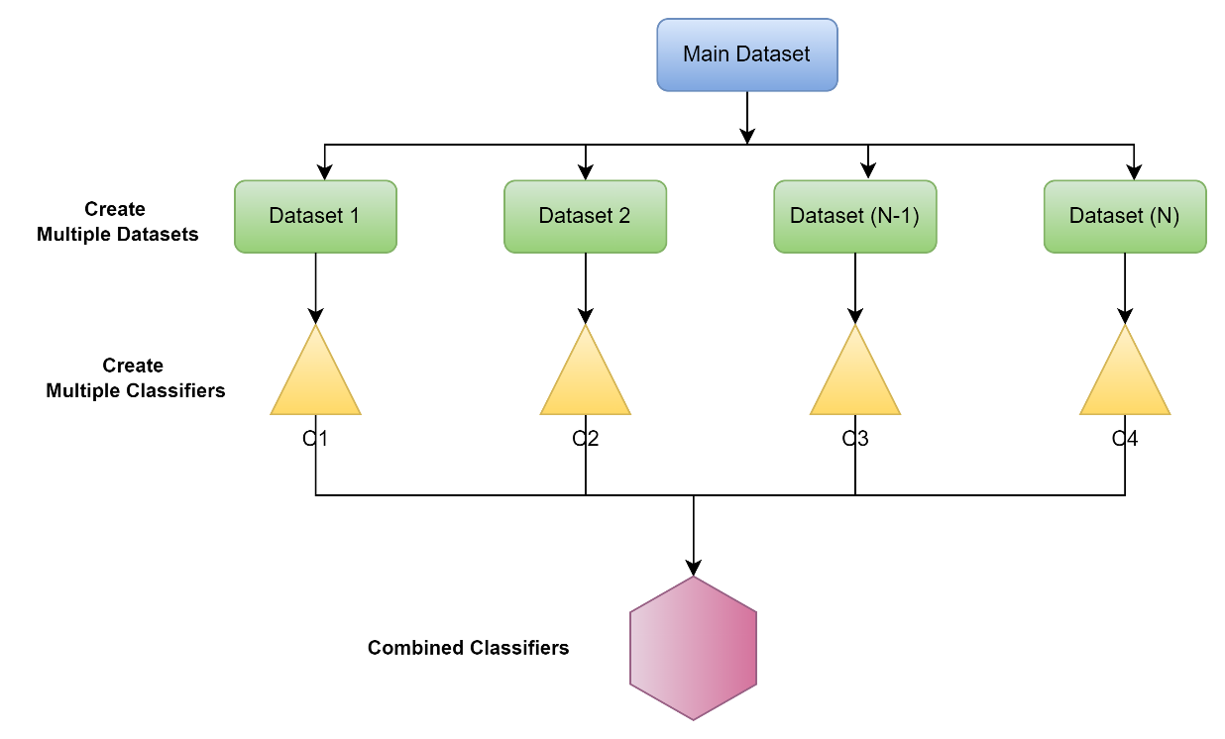

Fig 7.1 : “Ensemble Classifier”

### Ensembles help overcome three main problems.

Statistical Problem – The Statistical Problem arises when the hypothesis space is too large for available data. Hence, there are many hypotheses with the same accuracy on the data and the learning algorithm chooses only one of them. There is a risk that the accuracy of the chosen hypothesis is low on the unseen data.

Computational Problem – The Computational Problem arises when the learning algorithm cannot guarantees finding the best hypothesis.

Representational Problem – The Representational Problem arises when the hypothesis space does not contain any good approximation of the target class(es).

## What are Ensemble Methods?

Ensemble methods are techniques that aim at improving the accuracy of results in models by combining multiple models instead of using a single model. The combined models increase the accuracy of the results significantly. This has boosted the popularity of ensemble methods in machine learning.

Ensemble methods fall into two broad categories, i.e., sequential ensemble techniques and parallel ensemble techniques. Sequential ensemble techniques generate base learners in a sequence, e.g., Adaptive Boosting (AdaBoost). The sequential generation of base learners promotes the dependence between the base learners. The performance of the model is then improved by assigning higher weights to previously misrepresented learners.

In parallel ensemble techniques, base learners are generated in a parallel format, e.g., random forest. Parallel methods utilize the parallel generation of base learners to encourage independence between the base learners. The independence of base learners significantly reduces the error due to the application of averages.

Most ensemble techniques apply a single algorithm in base learning, which results in homogeneity in all base learners. Homogenous base learners refer to base learners of the same type, with similar qualities. Other methods apply heterogeneous base learners, giving rise to heterogeneous ensembles. Heterogeneous base learners are learners of distinct types.

## Ensemble Learning Strategies

Ensemble learning refers to algorithms that combine the predictions from two or more models. There are three classes of ensemble learning techniques that are most discussed and used in practice. Their popularity is due in large part to their ease of implementation and success on a wide range of predictive modeling problems.

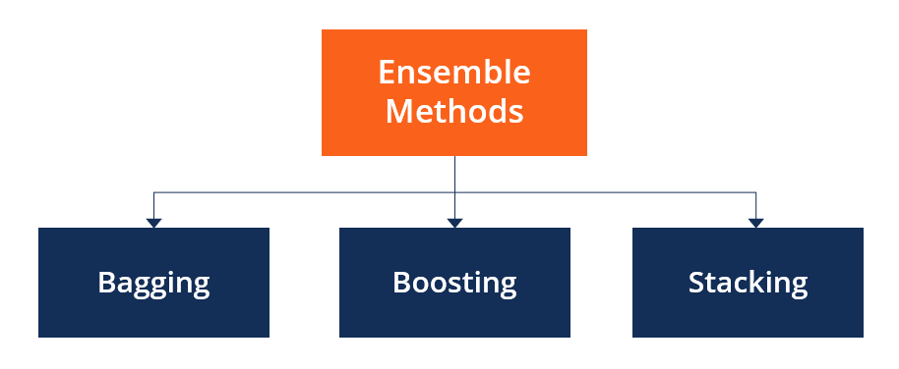

Fig 7.2 : “Type of Ensemble Learning Strategies”

### Bagging :

Bagging, the short form for bootstrap aggregating, is applied in classification and regression. It increases the accuracy of models through decision trees, which reduces variance. The reduction of variance increases accuracy, eliminating overfitting, which is a challenge to many predictive models.

Bagging is classified into two types, i.e., bootstrapping and aggregation. Bootstrapping is a sampling technique where samples are derived from the entire population (set) using the replacement procedure. The sampling with replacement method helps make the selection procedure randomized. The base learning algorithm is run on the samples to complete the procedure. Aggregation in bagging is done to incorporate all outcomes of the prediction and randomize the outcome. Without aggregation, predictions will not be accurate because all outcomes are not put into consideration. Therefore, the aggregation is based on the probability bootstrapping procedures or based on all outcomes of the predictive models. Bagging is advantageous since weak base learners are combined to form a single strong learner that is more stable than single learners. It also eliminates any variance, thereby reducing the overfitting of models. One limitation of bagging is that it is computationally expensive. Thus, it can lead to more bias in models when the proper procedure of bagging is ignored.

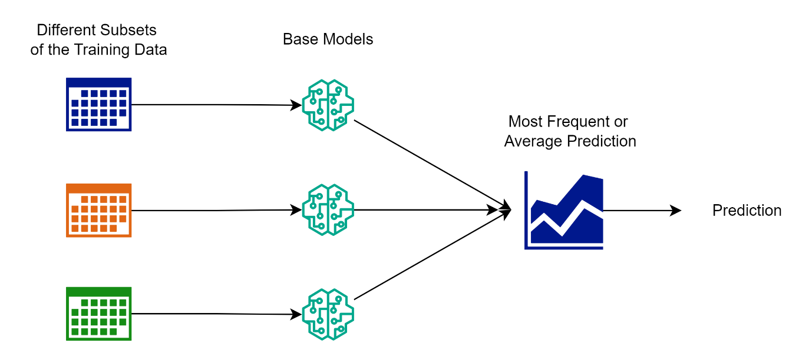

Fig 7.3 : “Bagging”

The idea behind bagging is combining the results of multiple models (for instance, all decision trees) to get a generalized result. Here is a question: If you create all the models on the same set of data and combine it, will it be useful? There is a high chance that these models will give the same result since they are getting the same input. So how can we solve this problem? One of the techniques is bootstrapping. Bootstrapping is a sampling technique in which we create subsets of observations from the original dataset, with replacement. The size of the subsets is the same as the size of the original set. Bagging (or Bootstrap Aggregating) technique uses these subsets (bags) to get a fair idea of the distribution (complete set). The size of subsets created for bagging may be less than the original set.

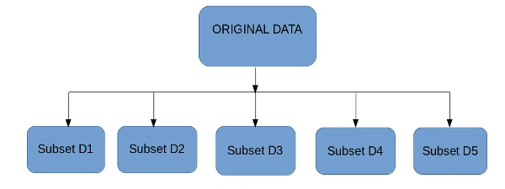

Fig 7.4 : “Bags of Dataset”

* Multiple subsets are created from the original dataset, selecting observations with replacement.
* A base model (weak model) is created on each of these subsets.
* The models run in parallel and are independent of each other.

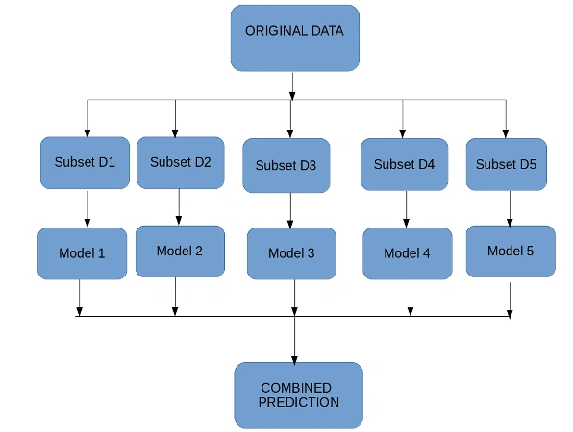

Fig 7.5 : “Bootstrap Aggregation ”

### Boosting

Boosting is an ensemble technique that learns from previous predictor mistakes to make better predictions in the future. The technique combines several weak base learners to form one strong learner, thus significantly improving the predictability of models. Boosting works by arranging weak learners in a sequence, such that weak learners learn from the next learner in the sequence to create better predictive models.

Boosting is a sequential process, where each subsequent model attempts to correct the errors of the previous model. The succeeding models are dependent on the previous model. Let us understand the way boosting works in the below steps.

1. A subset is created from the original dataset.
2. Initially, all data points are given equal weights.
3. A base model is created on this subset.
4. This model is used to make predictions on the whole dataset.
5. Errors are calculated using the actual values and predicted values.
6. The observations which are incorrectly predicted, are given higher weights. (Here, the three misclassified blue-plus points will be given higher weights)
7. Another model is created, and predictions are made on the dataset. (This model tries to correct the errors from the previous model).
8. Similarly, multiple models are created, each correcting the errors of the previous model.
9. The final model (strong learner) is the weighted mean of all the models (weak learners).
10. Thus, the boosting algorithm combines several weak learners to form a strong learner. The individual models would not perform well on the entire dataset, but they work well for some part of the dataset. Thus, each model boosts the performance of the ensemble.

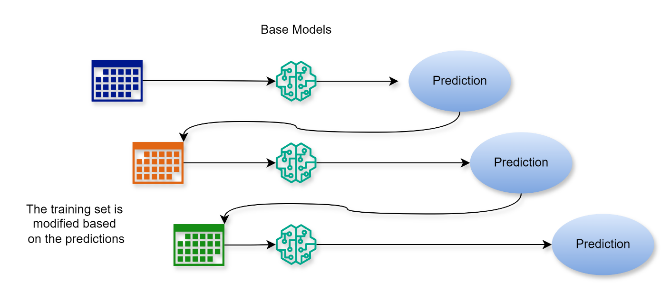

Fig 7.6 : “Boosting ”

Boosting takes many forms, including gradient boosting, Adaptive Boosting (AdaBoost), and XGBoost (Extreme Gradient Boosting). AdaBoost uses weak learners in the form of decision trees, which mostly include one split that is popularly known as decision stumps. AdaBoost’s main decision stump comprises observations carrying similar weights. Gradient boosting adds predictors sequentially to the ensemble, where preceding predictors correct their successors, thereby increasing the model’s accuracy. New predictors are fit to counter the effects of errors in the previous predictors. The gradient of descent helps the gradient booster identify problems in learners’ predictions and counter them accordingly. XGBoost makes use of decision trees with boosted gradient, providing improved speed and performance. It relies heavily on the computational speed and the performance of the target model. Model training should follow a sequence, thus making the implementation of gradient boosted machines slow.

### Stacking

Stacking, another ensemble method, is often referred to as stacked generalization. This technique works by allowing a training algorithm to ensemble several other similar learning algorithm predictions. Stacking has been successfully implemented in regression, density estimations, distance learning, and classifications. It can also be used to measure the error rate involved during bagging.

Unlike bagging, in stacking, the models are typically different (e.g., not all decision trees) and fit on the same dataset (e.g., instead of samples of the training dataset). In stacking, a single model is used to learn how to best combine the predictions from the contributing models (e.g., instead of a sequence of models that correct the predictions of prior models).

The architecture of a stacking model involves two or more base models, often referred to as level 0 models, and a meta-model that combines the predictions of the base models, referred to as a level 1 model.

Level 0 Models (Base-Models): Models fit on the training data and whose predictions are compiled.

Level 1 Model (Meta-Model): Model that learns how to best combine the predictions of the base models.

The meta-model is trained on the predictions made by base models on out-of-sample data. That is, data not used to train the base models is fed to the base models, predictions are made, and these predictions, along with the expected outputs, provide the input and output pairs of the training dataset used to fit the meta-model. The outputs from the base models used as input to the meta-model may be real value in the case of regression, and probability values, probability like values, or class labels in the case of classification. The most common approach to preparing the training dataset for the meta-model is via k-fold cross-validation of the base models, where the out-of-fold predictions are used as the basis for the training dataset for the meta-model.

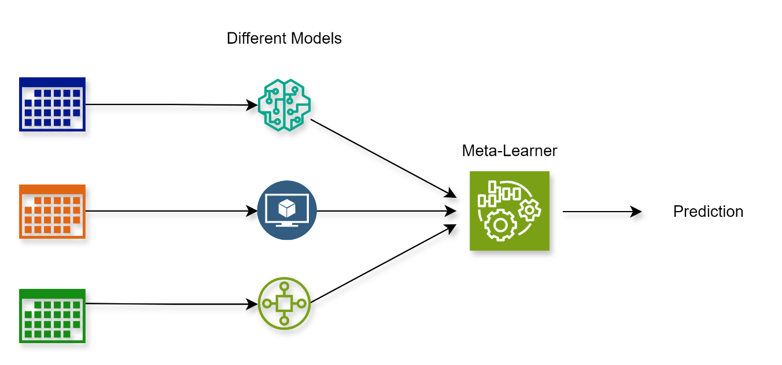

Fig 7.7 : “Stacking ”

The training data for the meta-model may also include the inputs to the base models, e.g., input elements of the training data. This can provide an additional context to the meta-model as to how to best combine the predictions from the meta-model. Once the training dataset is prepared for the meta-model, the meta-model can be trained in isolation on this dataset, and the base-models can be trained on the entire original training dataset. Stacking is appropriate when multiple different machine learning models have skill on a dataset but have skill in diverse ways. Another way to say this is that the predictions made by the models or the errors in predictions made by the models are uncorrelated or have a low correlation.

### Variance Reduction

Ensemble methods are ideal for reducing the variance in models, thereby increasing the accuracy of predictions. The variance is eliminated when multiple models are combined to form a single prediction that is chosen from all other predictions from the combined models. An ensemble of models combines various models to ensure that the resulting prediction is the best possible, based on the consideration of all predictions.

## Introduction to Decision trees

A decision Tree is one of most popular and effective supervised learning techniques for classification problems that equally works well with both categorical and quantitative variables. It is a graphical representation of all the workable solutions to a decision that is based on certain conditions. In this algorithm, the training sample points are split into two or more sets based on the split condition over input variables. A simple example of a decision tree can be as a person has to take a decision for going to sleep or restaurant based on parameters like he is hungry or have 25$ in his pocket.

Decision tree learning employs a divide and conquer strategy by conducting a greedy search to identify the optimal split points within a tree. This process of splitting is then repeated in a top-down, recursive manner until all, or most records have been classified under specific class labels. Whether or not all data points are classified as homogenous sets is dependent on the complexity of the decision tree. Smaller trees are more easily able to attain pure leaf nodes—i.e., data points in a single class. However, as a tree grows, it becomes increasingly difficult to maintain this purity, and it usually results in too little data falling within a given subtree. When this occurs, it is known as data fragmentation, and it can often lead to overfitting. As a result, decision trees have preference for small trees, which is consistent with the principle of parsimony in Occam’s Razor; that is, “entities should not be multiplied beyond necessity.” Said differently, decision trees should add complexity only, if necessary, as the simplest explanation is often the best. To reduce complexity and prevent overfitting, pruning is usually employed; this is a process, which removes branches that split on features with low importance. The model’s fit can then be evaluated through the process of cross-validation. Another way that decision trees can maintain their accuracy is by forming an ensemble via a random forest algorithm; this classifier predicts more accurate results, particularly when the individual trees are uncorrelated with each other.

## Types of Decision trees

Decision trees in machine learning can either be classification trees or regression trees. Together, both types of algorithms fall into a category of “classification and regression trees” and are sometimes referred to as CART. Their respective roles are to “classify” and to “predict.”

### Classification trees

Classification trees or categorical variable decision trees determine whether an event happened or did not happen. Usually, this involves a “yes” or “no” outcome. We often use this type of decision-making in the real world. Here are a few examples to help contextualize how decision trees work for classification:

*Example 1: How to spend your free time after work*

What you do after work in your free time can be dependent on the weather. If it is sunny, you might choose between having a picnic with a friend, grabbing a drink with a colleague, or running errands. If it is raining, you might opt to stay home and watch a movie instead. There is a clear outcome. In this case, which is classified as whether to “go out” or “stay in.”

*Example 2: Homeownership based on age and income*

In a classification tree, the data set splits according to its variables. There are two variables, age, and income, which determine whether someone buys a house. If training data tells us that 70 percent of people over age 30 bought a house, then the data gets split there, with age becoming the first node in the tree. This split makes the data 80 percent “pure.” The second node then addresses income from there.

### Regression trees

Regression trees also known as continuous variable decision tree, on the other hand, predict continuous values based on previous data or information sources. For example, they can predict the price of gasoline or whether a customer will purchase eggs (including which type of eggs and at which store). This type of decision-making is more about programming algorithms to predict what is likely to happen, given previous behavior or trends.

*Example 1: Housing prices in Colorado*

Regression analysis could be used to predict the price of a house in California, which is plotted on a graph. The regression model can predict housing prices in the coming years using data points of what prices have been in previous years. This relationship is a linear regression since housing prices are expected to continue rising. Machine learning helps us predict specific prices based on a series of variables that have been true in the past.

*Example 2: Bachelor’s degree graduates in 2025*

A regression tree can help a university predict how many bachelor’s degree students there will be in 2025. On a graph, one can plot the number of degree-holding students between 2010 and 2022. If the number of university graduates increases linearly each year, then regression analysis can be used to build an algorithm that predicts the number of students in 2025.

**Classification and Regression Tree (CART)** is a predictive algorithm used in machine learning that generates future predictions based on previous values. These decision trees are at the core of machine learning and serve as a basis for other machine learning algorithms such as random forest, bagged decision trees, and boosted decision trees. CART is one of the most well-established machine learning techniques. In non-technical terms, CART algorithms work by repeatedly finding the best predictor variable to split the data into two subsets. The subsets partition the target outcome better than before the split.

## Pruning

In machine learning and data mining, pruning is a technique associated with decision trees. Pruning reduces the size of decision trees by removing parts of the tree that do not provide power to classify instances. Decision trees are the most susceptible out of all the machine learning algorithms to overfitting and effective pruning can reduce this likelihood. As the name implies, pruning involves cutting back the tree. After a tree has been built (and in the absence of early stopping discussed below) it may be overfitted. The CART algorithm will repeatedly partition data into smaller and smaller subsets until those final subsets are homogeneous in terms of the outcome variable. In practice this often means that the final subsets (known as the leaves of the tree) each consist of only one or a few data points. The tree has learned the data exactly, but a new data point that differs very slightly might not be predicted well. For best accuracy, minimum error pruning without early stopping is usually an excellent choice. For a compromise between accuracy and an interpretable tree, try smallest tree pruning without early stopping. To produce an even smaller tree or reduce the running time while allowing accuracy to decrease, you can turn on early stopping. We can prune our decision tree by using information gain in both post-pruning and pre-pruning. In pre-pruning, we check whether information gain at a particular node is greater than minimum gain. In post-pruning, we prune the subtrees with the least information gain until we reach a desired number of leaves.

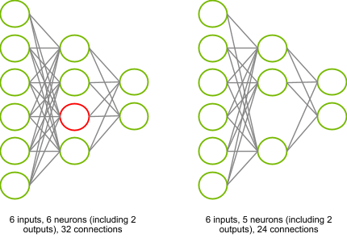

Fig 7.8 : “Pruning ” (Credit : <https://www.edge-ai-vision.com/>)

***Reduced Error Pruning (REP)***

REP belongs to the post-pruning category. In REP, pruning is performed with the help of a validation set. In REP, all nodes are evaluated for pruning in a bottom-up fashion. A node is pruned if the resulting pruned tree performs no worse than the original tree on the validation set. The subtree at the node is replaced with a leaf node which is assigned the most common class.

***Cost-complexity pruning***

Cost-complexity pruning also falls under the post-pruning category. Cost-complexity pruning works by calculating a Tree Score based on Residual Sum of Squares (RSS) for the subtree, and a Tree Complexity Penalty that is a function of the number of leaves in the subtree. The Tree Complexity Penalty compensates for the difference in the number of leaves.

## Types of Ensemble techniques

## Random Forest

Random Forest is another ensemble machine learning algorithm that follows the bagging technique. It is an extension of the bagging estimator algorithm. The base estimators in random forest are decision trees. Unlike bagging meta estimator, random forest randomly selects a set of features which are used to decide the best split at each node of the decision tree. It is a supervised machine learning algorithm which means it is used on a labelled dataset. It is used for both classification and regression. We can say that just like a forest which comprises many trees. Random forest algorithm comprises many decision trees.

Random forest generates decision trees on randomly selected subsample of the complete dataset and calculates prediction on each decision tree and selects the best decision tree by the means of voting.

Random Forest is used in various domains such as classification of images, feature selection and recommendation engines, it lies the foundation of Boruta algorithm which is used in the selection of key features in the dataset.

## Random Forest Algorithm

In Layman’s term let us suppose you want to watch a movie. You can watch online, read reviews on blogs, and you can also ask some friends to help you.

Assuming you ask your friends about their favorite movies. You will get some recommendations from every friend with the help of these recommendations. You can make a list of recommended movies and ask them to vote on the list that you have made. The movie with the highest number of votes will be the final choice to watch.

In the above example you can clearly see that there are two basic steps. The first one is asking your friends about their favorite movies and choosing one recommendation out of the many movies they have watched. This part is just like a decision tree algorithm.

In the second part is the voting part that is selecting the best movie out of the list of recommended movies. This entire process of getting recommendations from friends and voting on them to select the best one is known as the Random Forest algorithm.

Random forest is an ensemble technique which is based on the philosophy of divide and conquer methodology. It generates small decision trees using random subsamples of the dataset where the collection of the generated decision tree is defined as forest. Every individual tree is created using an attribute selection indicator such as Gini Index, entropy, and information gain.

In classification problems voting is done by each tree and most voted class is considered as the result whereas in case of regression the average method is used to get the outcome.

### Basic Step Involved in the algorithm.

1. Selection of random subsample of a given dataset.

2. Using attribute selection indicators create a decision tree for each subsample and record the prediction outcome from each model.

3. Apply the voting/averaging method over predicted outcomes of individual models.

4. Consider the results as average value or most voted value.

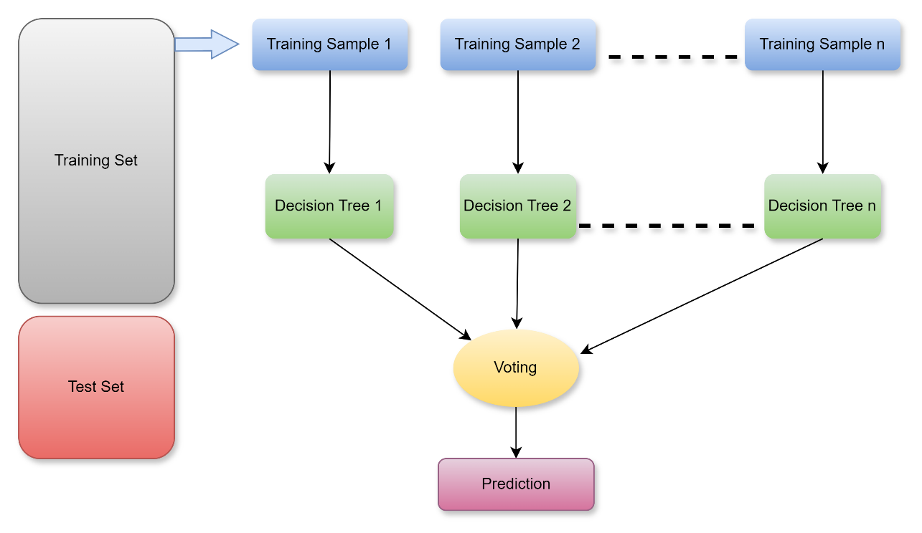

Fig 7.9 : “Training and Testing the model ”

### Advantages

* + It can be used for both classification and regression process.
  + It is one of the most accurate algorithms present out there because of the number of decision trees taking part in the process.
  + Random Forest does not suffer overfitting.
  + It is used to select features of more importance and helps in feature selection.

### Disadvantages

* + The Random Forest algorithm is terribly slow compared to others because it calculates prediction for each decision tree for every sub sample and then votes on them to select the best one which is time consuming.
  + It is difficult to explain the model as compared to a decision tree where you can easily make the decision following the path of the tree.

### Random Forest vs Decision Tree

* + Random Forest is a collection of multiple decision trees.
  + Decision trees are computationally faster than Random Forest.
  + Random forest does not suffer from overfitting, but decision tree suffers.
  + It is easy to interpret a decision tree as compared to a random forest.

## What are hyperparameters?

Hyperparameters are external configuration variables that data scientists use to manage machine learning model training. Sometimes called model hyperparameters, the hyperparameters are manually set before training a model. They are different from parameters, which are internal parameters automatically derived during the learning process and not set by data scientists. They control the learning process itself, rather than being learned from the data. These parameters express important properties of the model such as its complexity or how fast it should learn. Hyperparameters are often used to tune the performance of a model, and they can have a significant impact on the model’s accuracy, generalization, and other metrics.

Examples of hyperparameters include the number of nodes and layers in a neural network and the number of branches in a decision tree. Hyperparameters determine key features such as model architecture, learning rate, and model complexity. The order in which you tune hyperparameters depends on the specific model and dataset. However, a good rule of thumb is to start with the most important hyperparameters, such as the learning rate, and then move on to less important ones. Unfortunately, there are no set rules on which hyperparameters work best nor their optimal or default values. You need to experiment to find the optimum hyperparameter set. This activity is known as hyperparameter tuning or hyperparameter optimization.

## Hyperparameters Tuning

Hyperparameter tuning is the process of selecting the optimal values for a machine learning model’s hyperparameters. Hyperparameters are settings that control the learning process of the model, such as the learning rate, the number of neurons in a neural network, or the kernel size in a support vector machine. The goal of hyperparameter tuning is to find the values that lead to the best performance on a given task. It allows data scientists to tweak model performance for optimal results. This process is an essential part of machine learning, and choosing appropriate hyperparameter values is crucial for success. For example, assume you are using the learning rate of the model as a hyperparameter. If the value is too high, the model may converge too quickly with suboptimal results. Whereas if the rate is too low, training takes too long, and results may not converge. A good and balanced choice of hyperparameters results in accurate models and excellent model performance.

### Techniques for Hyperparameters Tuning

#### GridSearchCV

Grid search can be considered as a “brute force” approach to hyperparameter optimization. We fit the model using all combinations after creating a grid of potential discrete hyperparameter values. We log each set’s model performance and then choose the combination that produces the best results. This approach is called GridSearchCV, because it searches for the best set of hyperparameters from a grid of hyperparameters values. An exhaustive approach that can identify the ideal hyperparameter combination is grid search. But the slowness is a disadvantage. It often takes a lot of processing power and time to fit the model with every potential combination, which might not be available. GridSearchCV will go through all the intermediate combinations of hyperparameters which makes grid search computationally extremely expensive.

#### RandomizedSearchCV

As the name suggests, the random search method selects values at random as opposed to the grid search method’s use of a predetermined set of numbers. Every iteration, random search attempts a separate set of hyperparameters and logs the model’s performance. It returns the combination that provided the best outcome after several iterations. This approach reduces unnecessary computation. It solves the drawbacks of GridSearchCV, as it goes through only a fixed number of hyperparameter settings. It moves within the grid in a random fashion to find the best set of hyperparameters. The advantage is that, in most cases, a random search will produce a comparable result faster than a grid search. It is possible that the outcome could not be the ideal hyperparameter combination is a disadvantage.

#### Bayesian Optimization

Bayesian optimization is a technique based on Bayes’ theorem, which describes the probability of an event occurring related to current knowledge. When this is applied to hyperparameter optimization, the algorithm builds a probabilistic model from a set of hyperparameters that optimizes a specific metric. It uses regression analysis to iteratively choose the best set of hyperparameters. It treats the search for optimal hyperparameters as an optimization problem. It considers the previous evaluation results when selecting the next hyperparameter combination and applies a probabilistic function to choose the combination that will yield the best results. This method discovers a good hyperparameter combination in few iterations.

Data scientists use a probabilistic model when the objective function is unknown. The probabilistic model estimates the probability of a hyperparameter combination’s objective function result based on past evaluation results.

**P(score(y)|hyperparameters(x))**

It is a “surrogate” of the objective function, which can be the root-mean-square error (RMSE), for example. The objective function is calculated using the training data with the hyperparameter combination, and we try to optimize it (maximize or minimize, depending on the objective function selected). Applying the probabilistic model to the hyperparameters is computationally inexpensive compared to the objective function. Therefore, this method typically updates and improves the surrogate probability model every time the objective function runs. Better hyperparameter predictions decrease the number of objective function evaluations needed to achieve a good result. Gaussian processes, random forest regression, and tree-structured Parzen estimators (TPE) are examples of surrogate models.

The Bayesian optimization model is complex to implement, but off-the-shelf libraries like Ray Tune can simplify the process. It is worth using this type of model because it finds an adequate hyperparameter combination in few iterations. However, compared to grid search or random search, we must compute Bayesian optimization sequentially, so it does not allow distributed processing. Therefore, Bayesian optimization takes longer yet uses fewer computational resources. It requires an understanding of the underlying probabilistic model.



### 7.1 Key Takeaways



* Ensemble learning enhances accuracy and resilience in forecasting by merging predictions from multiple models and aims to mitigate errors or biases that may exist in individual models by leveraging the collective intelligence of the ensemble.
* Ensemble methods fall into two broad categories, i.e., sequential ensemble techniques and parallel ensemble techniques.
* Bootstrapping is a sampling technique where samples are derived from the entire population (set) using the replacement procedure.
* Boosting is an ensemble technique that learns from previous predictor mistakes to make better predictions in the future. The technique combines several weak base learners to form one strong learner, thus significantly improving the predictability of models.
* Stacking technique works by allowing a training algorithm to ensemble several other similar learning algorithm predictions.
* The variance is eliminated when multiple models are combined to form a single prediction that is chosen from all other predictions from the combined models.
* Decision tree learning employs a divide and conquer strategy by conducting a greedy search to identify the optimal split points within a tree.
* Regression trees also known as continuous variable decision tree, on the other hand, predict continuous values based on previous data or information sources.
* Pruning reduces the size of decision trees by removing parts of the tree that do not provide power to classify instances.
* Random forest generates decision trees on randomly selected subsample of the complete dataset and calculates prediction on each decision tree and selects the best decision tree by the means of voting.

### 7.2 Quiz :



Q1. Which of the following statements is false about Ensemble voting?

1. It takes a linear combination of the learners.
2. It takes non-linear combination of the learners.
3. It is the simplest way to combine multiple classifiers.
4. It is also known as ensembles and linear opinion pools.

Q2. Which of the following is an example of an ensemble learning algorithm?

1. Decision Tree
2. Support Vector Machine (SVM)
3. Random Forest
4. K-Nearest Neighbors (KNN)

Q3. Bagging is an ensemble technique that:

1. Combines predictions using a weighted average.
2. Trains multiple models on different subsets of the data.
3. Constructs an ensemble by iteratively updating weights.
4. Uses a committee of experts to make predictions.

Q4. Boosting is an ensemble technique that:

1. Combines predictions using a weighted average.
2. Trains multiple models on different subsets of the data.
3. Constructs an ensemble by iteratively updating weights.
4. Uses a committee of experts to make predictions.

Q5. AdaBoost is an example of:

1. Bagging algorithm
2. Boosting algorithm
3. Randomized algorithm
4. Reinforcement learning algorithm.

Q6. Gradient Boosting is an ensemble technique that:

1. Combines predictions using a weighted average.
2. Trains multiple models on different subsets of the data.
3. Constructs an ensemble by iteratively updating weights.
4. Uses a committee of experts to make predictions.

Q7. XGBoost is a popular implementation of:

1. Bagging algorithm.
2. Boosting algorithm.
3. Random Forest algorithm.
4. K-Means clustering algorithm.

Q8. Stacking is an ensemble technique that:

1. Combines predictions using a weighted average.
2. Trains multiple models on different subsets of the data.
3. Constructs an ensemble by iteratively updating weights.
4. Trains a meta-model to make predictions based on outputs of base models.

Q9. Which ensemble learning algorithm uses bootstrapping and feature sampling?

1. Random Forest
2. AdaBoost
3. Gradient Boosting
4. Stacking

Q10. The purpose of using ensemble learning is to:

1. Reduce overfitting and improve generalization.
2. Increase training time and complexity.
3. Decrease the number of models required.
4. Eliminate the need for labeled data.

Q11. Bagging algorithms are effective in:

1. Managing imbalanced datasets.
2. Sequential data prediction.
3. Clustering high-dimensional data.
4. Text classification tasks.

Q12. Which ensemble learning algorithm assigns weights to base models based on their performance?

1. AdaBoost
2. Random Forest
3. Gradient Boosting
4. Stacking

Q13. Which ensemble learning algorithm uses a committee of experts to make predictions?

1. Bagging
2. Boosting
3. Random Forest
4. Stacking

Q14. Which ensemble learning algorithm is prone to overfitting if the base models are too complex?

1. Bagging
2. Boosting
3. Random Forest
4. Stacking

Q15. Which ensemble learning algorithm can manage both regression and classification tasks?

1. Bagging
2. AdaBoost
3. Gradient Boosting
4. Stacking

Q16. Ensemble learning algorithms are useful when:

1. The dataset is small and low-dimensional.
2. The dataset is large and high-dimensional.
3. The dataset is perfectly balanced.
4. The dataset contains only categorical variables.

Q17. Ensemble learning algorithms can improve model performance by:

1. Reducing bias
2. Reducing variance
3. Increasing interpretability
4. Increasing training time

Q18. Which ensemble learning algorithm can manage both numerical and categorical data without requiring one-hot encoding?

1. Bagging
2. AdaBoost
3. Gradient Boosting
4. Stacking

Q19. Which ensemble learning algorithm is less sensitive to outliers?

1. Bagging
2. Boosting
3. Random Forest
4. Stacking

Q20. The majority voting method in ensemble learning refers to:

1. Combining predictions by averaging their probabilities
2. Combining predictions by taking the mode of their classes
3. Combining predictions by multiplying their probabilities
4. Combining predictions by taking the median of their values

### Research with solid fill7.3 Hands-on Case Study:

*Build Ensemble Technique : Decision Tree & Gradient Booster Model*

*Credit Kaggle for Source Data Set*

<https://www.kaggle.com/datasets/imakash3011/online-shoppers-purchasing-intention-dataset>

**About Dataset**

**Context**

**Data Set Information:**

The dataset consists of feature vectors belonging to 12,330 sessions.  
The dataset was formed so that each session  
would belong to a different user in a 1-year period to avoid  
any tendency to a specific campaign, special day, user  
profile, or period.

**Content**

The dataset consists of 10 numerical and 8 categorical attributes.  
The ‘Revenue’ attribute can be used as the class label.

“Administrative,” “Administrative Duration,” “Informational,” “Informational Duration,” “Product Related” and “Product Related Duration” represent the number of several types of pages visited by the visitor in that session and total time spent in each of these page categories. The values of these features are derived from the URL information of the pages visited by the user and updated in real time when a user takes an action, e.g., moving from one page to another. The “Bounce Rate,” “Exit Rate” and “Page Value” features represent the metrics measured by “Google Analytics” for each page in the e-commerce site. The value of “Bounce Rate” feature for a web page refers to the percentage of visitors who enter the site from that page and then leave (“bounce”) without triggering any other requests to the analytics server during that session. The value of “Exit Rate” feature for a specific web page is calculated as for all pageviews to the page, the percentage that were the last in the session. The “Page Value” feature represents the average value for a web page that a user visited before completing an e-commerce transaction. The “Special Day” feature indicates the closeness of the site visiting time to a specific special day (e.g., Mother’s Day, Valentine’s Day) in which the sessions are more likely to be finalized with transaction. The value of this attribute is determined by considering the dynamics of e-commerce such as the duration between the order date and delivery date. For example, for Valentina’s day, this value takes a nonzero value between February 2 and February 12, zero before and after this date unless it is close to another special day, and its maximum value of 1 on February 8. The dataset also includes operating system, browser, region, traffic type, visitor type as returning or new visitor, a Boolean value indicating whether the date of the visit is weekend, and month of the year.

Objective : Build AI Model with highest accuracy for Revenue using Ensemble technique – Decision Tree ,Gradient Booster Algo in KNIME workflow .

Step 1 EDA: Convert Number into String

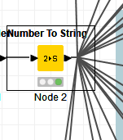

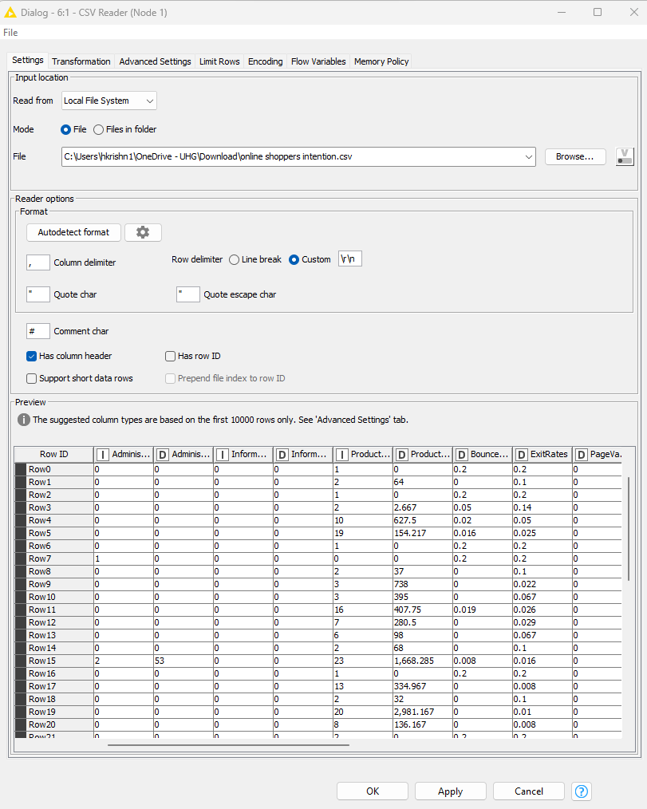

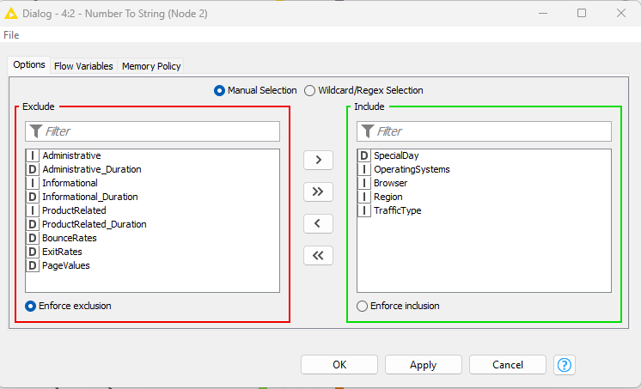

Step 2: Univariate and Bi variate EDA analysis :

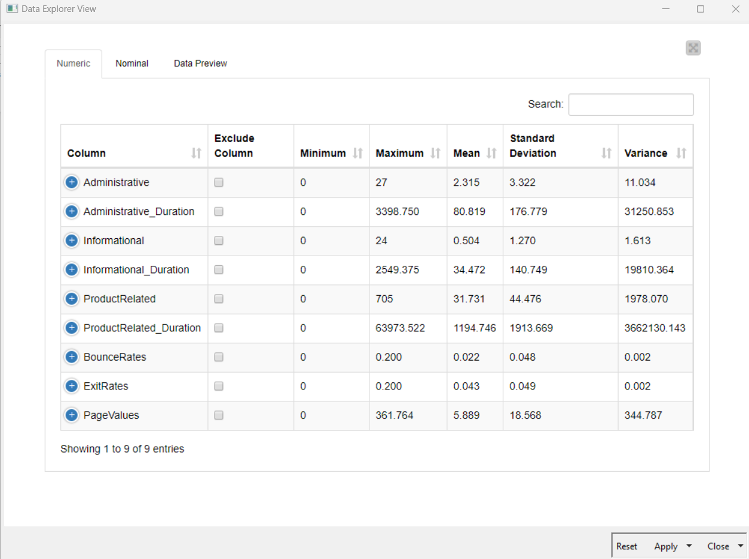

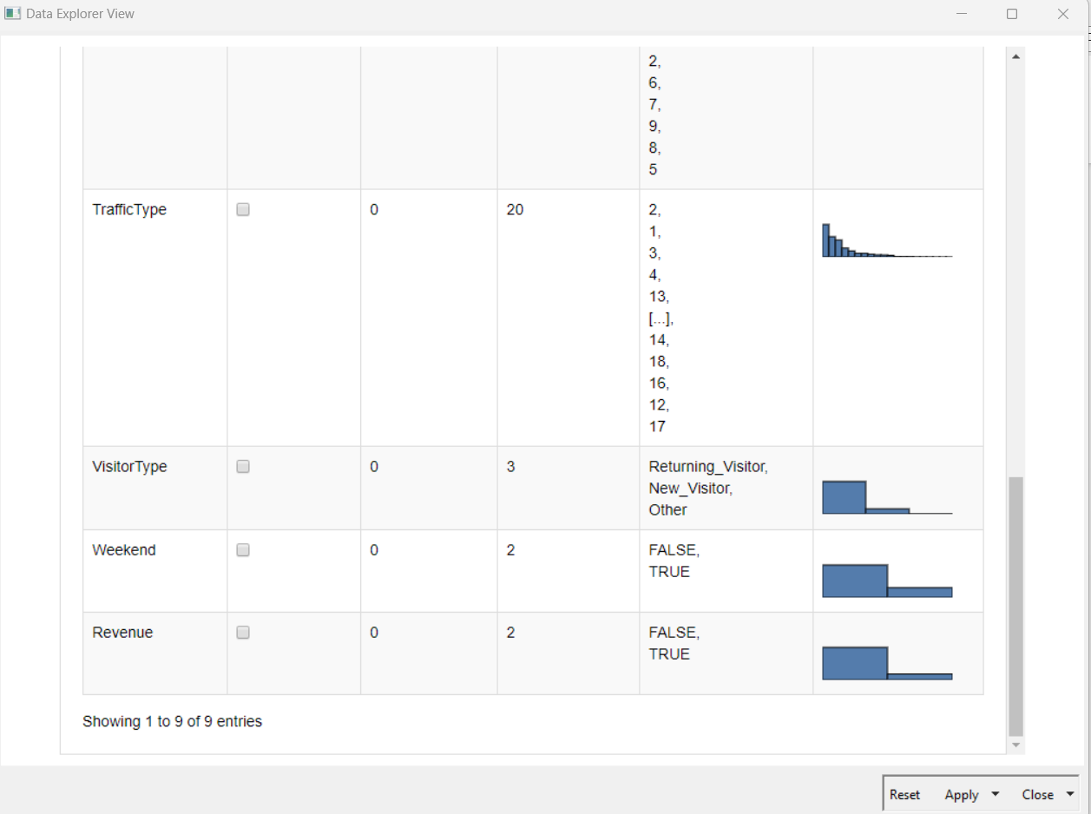

Revenue Counts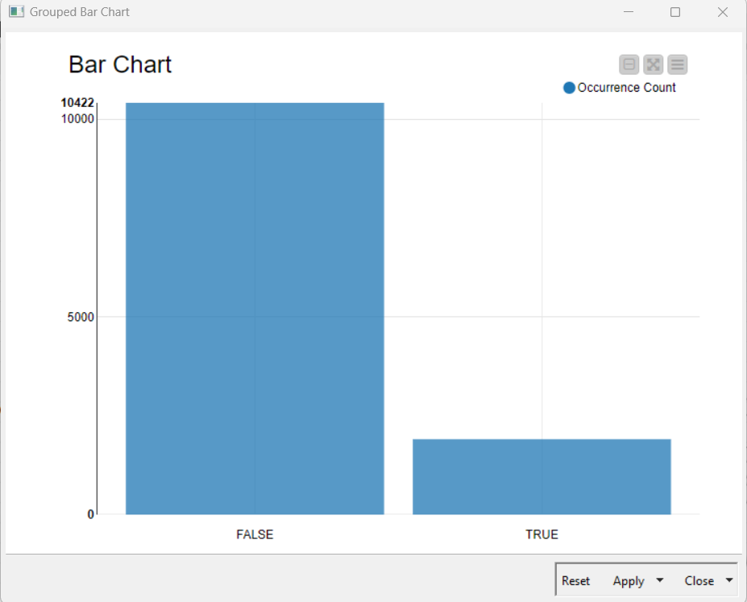

Visitor Type analysis

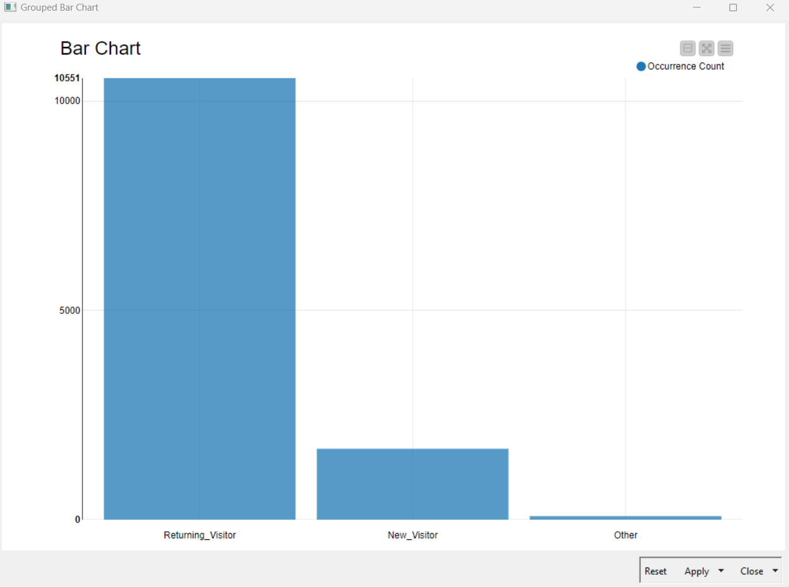

Conditional Box Plot : Revenue Vs Page value

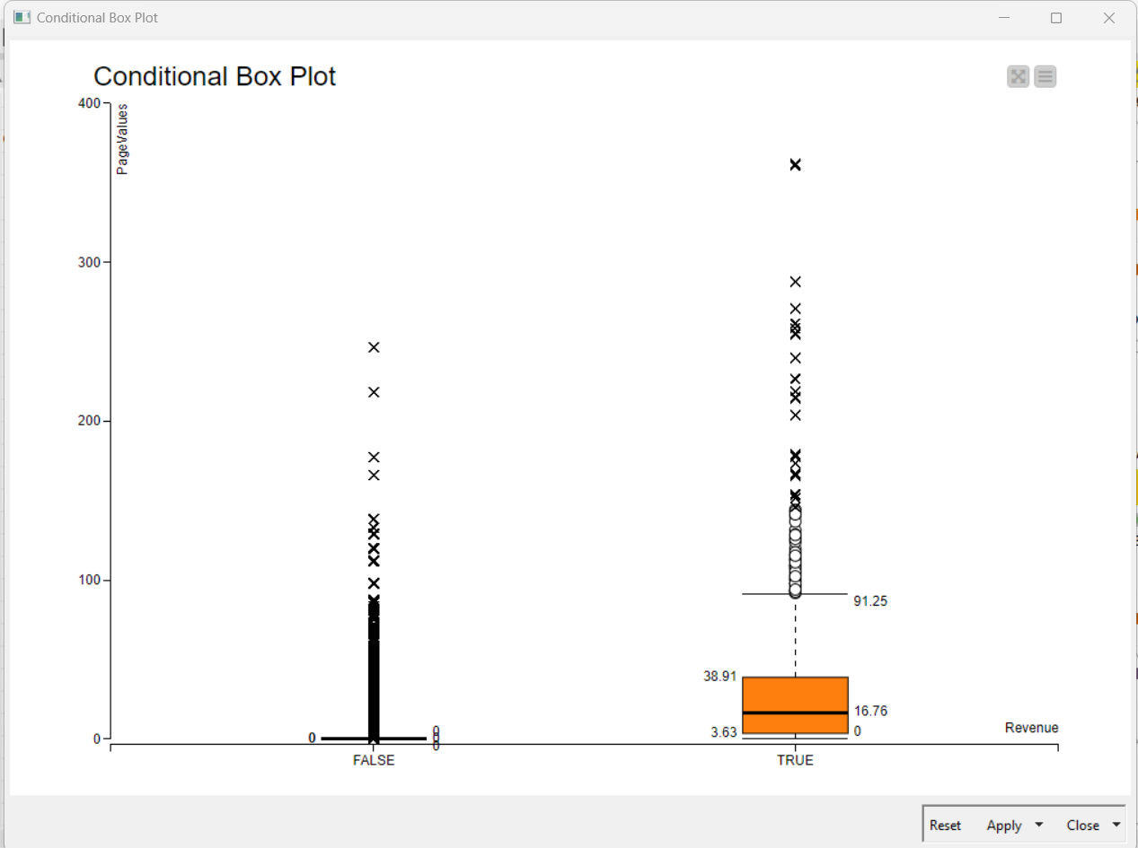

Cross Tab Analysis: Revenue Vs Month

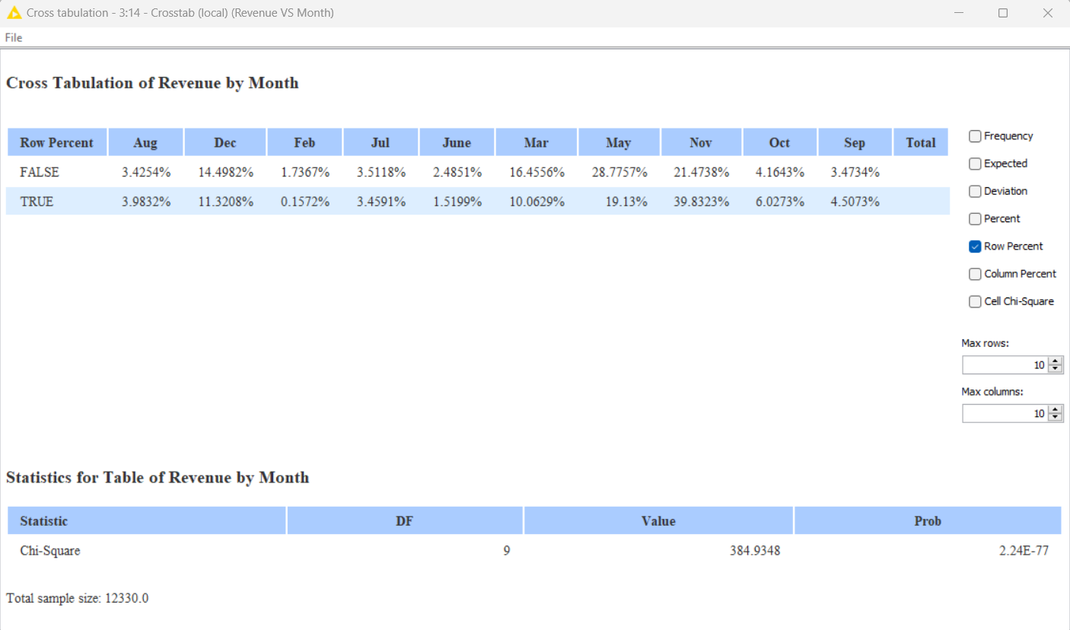

Linear correlation Analysis:

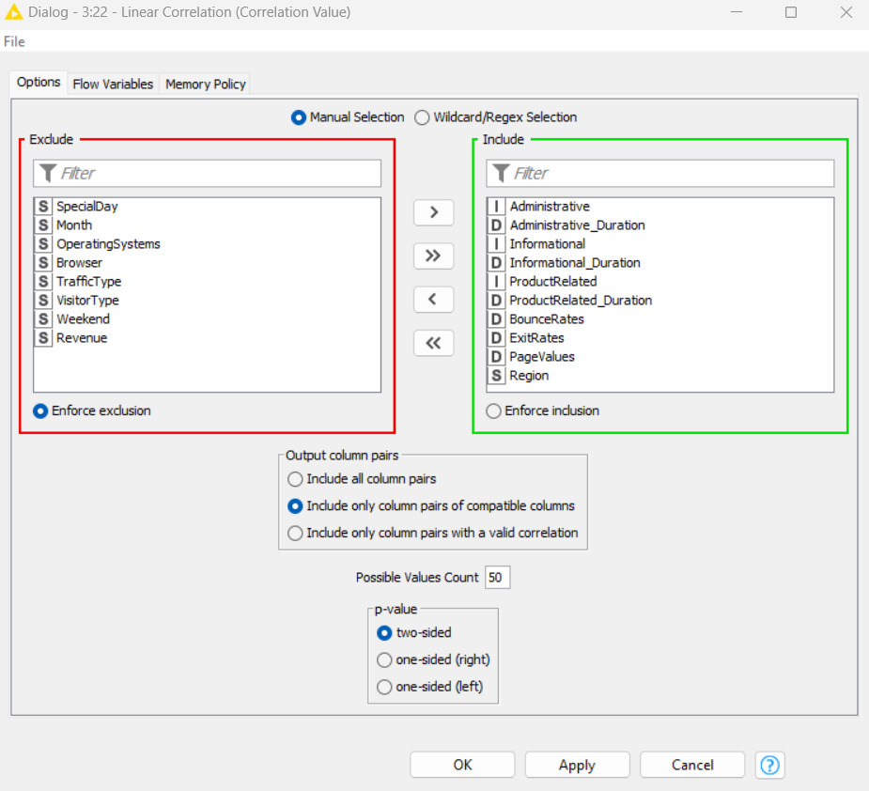

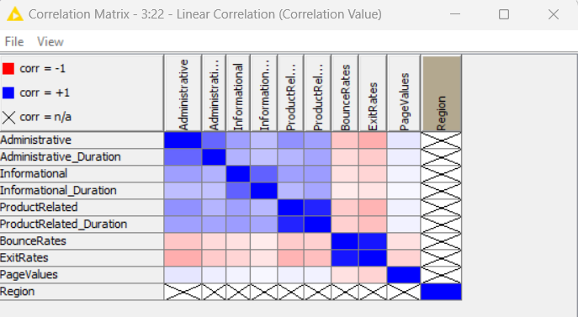

Data Preprocessing:

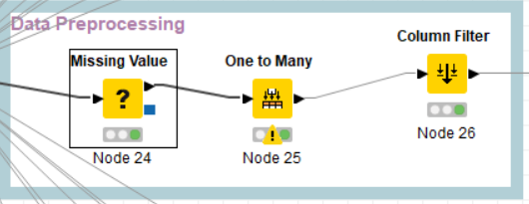

Step 3: Data Preprocessing



Missing Values Component:



One to Many :



Step 4: Column Filter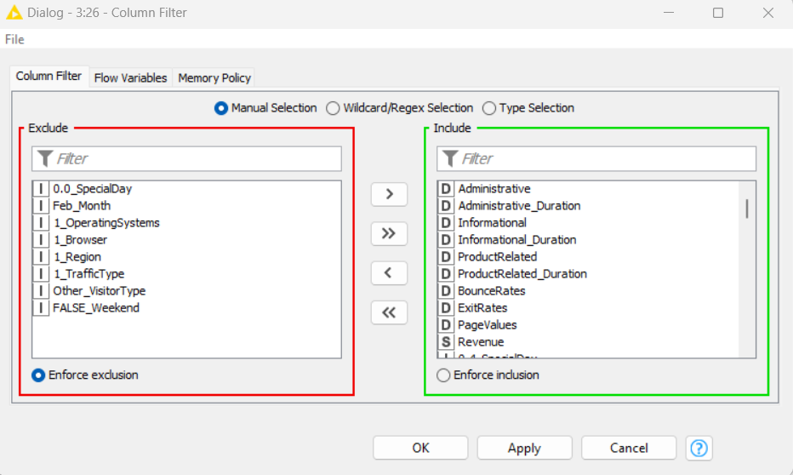

Step 5 : Partitioning Train and Test Data

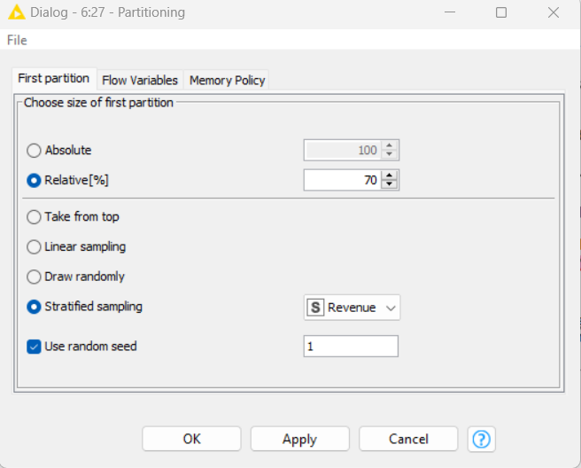

Decision Tree Modelling:

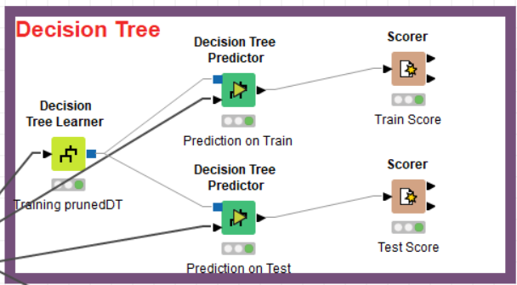

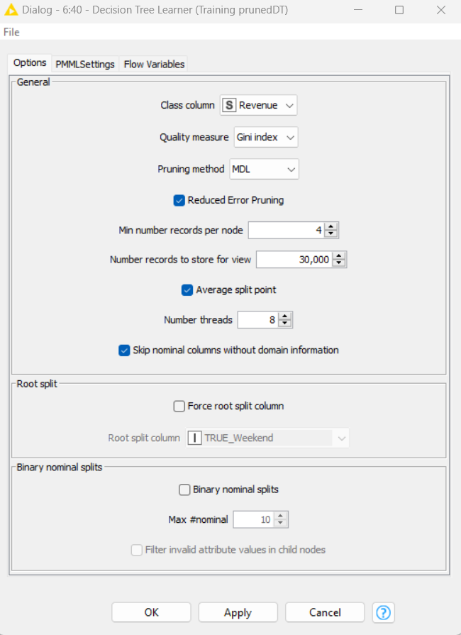

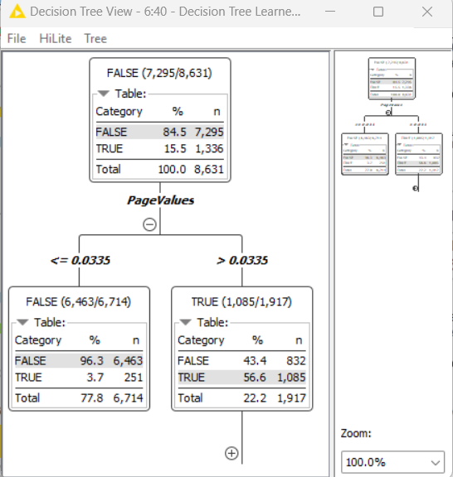

Train Scorer:

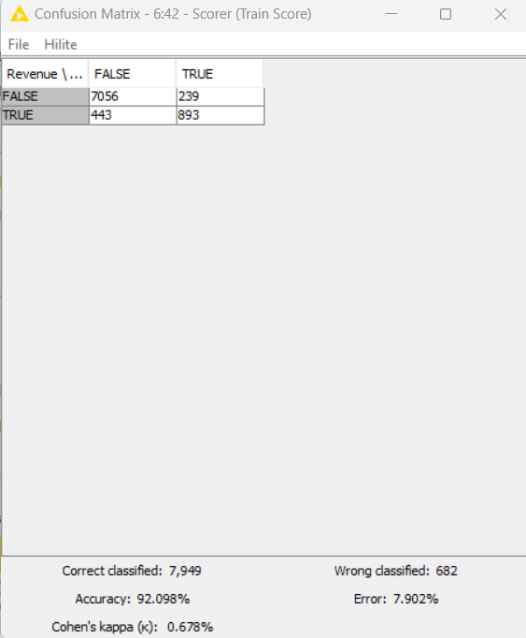

Test Scorer

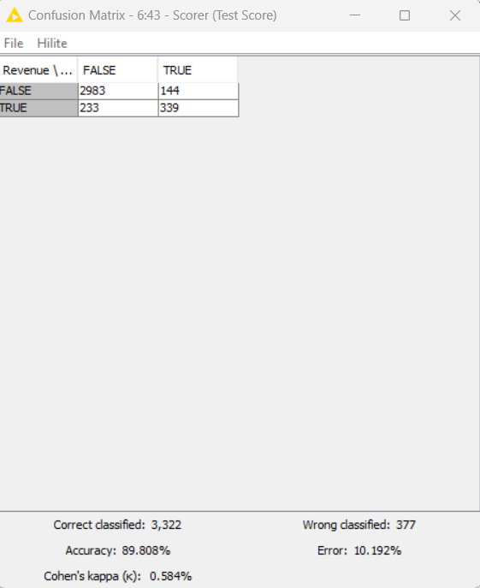

Gradient Booster:

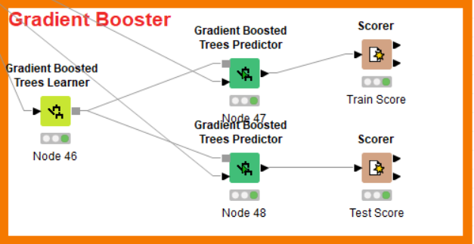

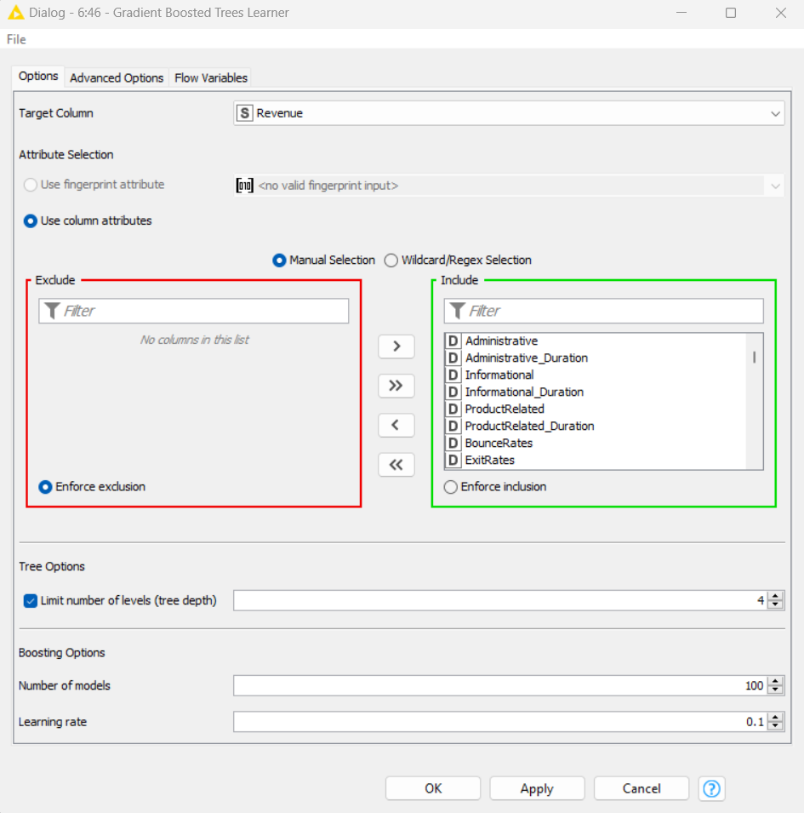

Train Scorer:

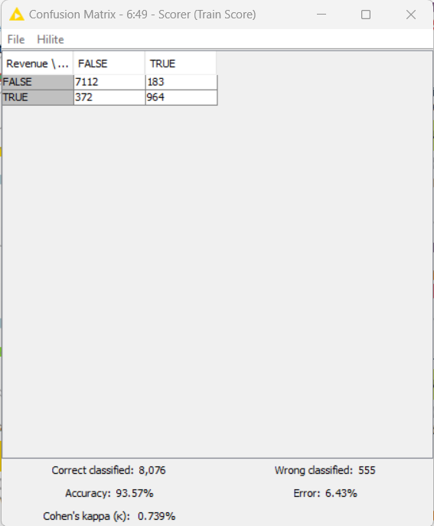

Test Scorer:

**Conclusion:**

|  |  |  |  |  |
| --- | --- | --- | --- | --- |
| Algo Model | Data Sample | Accuracy % | Cohen’s Kappa % | Error % |
| Decision Tree | Train | 92.09 | 0.67 | 7.9 |
| Decision Tree | Test | 89.8 | 0.59 | 10.03 |
| Gradient Booster | Train | **93.57** | **0.73** | **6.43** |
| Gradient Booster | Test | 89.97 | 0.59 | 10.03 |

Choosing Gradient Booster Model with Highest Accuracy is the best choice and further modifying Hyper parameters will gain more accuracy in determining higher Revenue.



### 7.4 Exercise do it yourself:

*Credit Kaggle for Source Data Set*

<https://www.kaggle.com/datasets/radheshyamkollipara/bank-customer-churn>

**About this file**

Every bank wants to hold their customers for sustaining their business and thus this Anonymous Multinational bank.

Below is the customer data of account holders at Anonymous Multinational Bank and the aim of the data will be predicting the Customer Churn.

**About Dataset**

RowNumber—corresponds to the record (row) number and has no effect on the output.  
CustomerId—contains random values and has no effect on customer leaving the bank.  
Surname—the surname of a customer has no impact on their decision to leave the bank.  
CreditScore—can have an effect on customer churn, since a customer with a higher credit score is less likely to leave the bank.  
Geography—a customer’s location can affect their decision to leave the bank.  
Gender—it’s interesting to explore whether gender plays a role in a customer leaving the bank.  
Age—this is certainly relevant, since older customers are less likely to leave their bank than younger ones.  
Tenure—refers to the number of years that the customer has been a client of the bank. Normally, older clients are more loyal and less likely to leave a bank.  
Balance—also a very good indicator of customer churn, as people with a higher balance in their accounts are less likely to leave the bank compared to those with lower balances.  
NumOfProducts—refers to the number of products that a customer has purchased through the bank.  
HasCrCard—denotes whether or not a customer has a credit card. This column is also relevant, since people with a credit card are less likely to leave the bank.  
IsActiveMember—active customers are less likely to leave the bank.  
EstimatedSalary—as with balance, people with lower salaries are more likely to leave the bank compared to those with higher salaries.  
Exited—whether or not the customer left the bank.  
Complain—customer has complaint or not.  
Satisfaction Score—Score provided by the customer for their complaint resolution.  
Card Type—type of card hold by the customer.  
Points Earned—the points earned by the customer for using credit card.

# **08 Clustering**

Clustering in machine learning is the task of dividing the unlabeled data or data points into different clusters such that similar data points fall in the same cluster than those which differ from the others. In simple words, the aim of the clustering process is to segregate groups with similar traits and assign them into clusters. The task of grouping data points based on their similarity with each other is called Clustering or Cluster Analysis. Clustering aims at forming groups of homogeneous data points from a heterogeneous dataset. It evaluates the similarity based on a metric like Euclidean distance, Cosine similarity, Manhattan distance and then group the points with highest similarity score together.

In real world, not every data we work upon has a target variable. This kind of data cannot be analyzed using supervised learning algorithms. We need the help of unsupervised algorithms. One of the most popular types of analysis under unsupervised learning is Cluster analysis. When the goal is to group similar data points in a dataset, then we use cluster analysis. In practical situations, we can use cluster analysis for customer segmentation for targeted advertisements, or in medical imaging to find unknown or new infected areas and many more use cases.

Let us understand this with an example. Suppose you are the head of a rental store and wish to understand the preferences of your customers to scale up your business. Is it possible for you to look at the details of each customer and devise a unique business strategy for each one of them? Definitely not. But what you can do is cluster all your customers into, say 10 groups based on their purchasing habits and use a separate strategy for customers in each of these 10 groups. And this is what we call clustering methods.

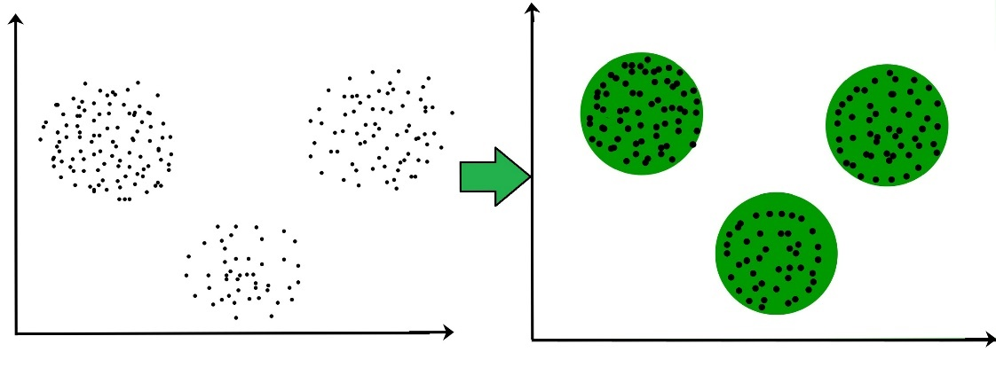

Fig 8.1 : “Clusters of Data points” *(Credit: CCO Public Domain)*

The classification into clusters is done using criteria such as smallest distances, density of data points, graphs, or various statistical distributions. Cluster analysis has wide applicability, including in unsupervised machine learning, data mining, statistics, Graph Analytics, image processing, and numerous physical and social science applications. The shape of clusters can be arbitrary. There are many algorithms that work well with detecting arbitrary shaped clusters.

For example, In the below given graph we can see that the clusters formed are not circular in shape.

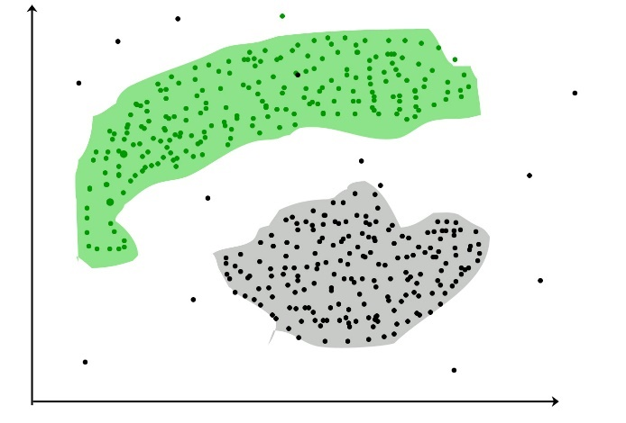

Fig 8.2 : “Clustering” *(Credit: CCO Public Domain)*

### Types of Clustering

There are 2 types of clustering that can be performed to group similar data points:

Hard Clustering: In this type of clustering, each data point belongs to a cluster completely or not. For example, let us say there are 4 data point, and we must cluster them into 2 clusters. So, each data point will either belong to cluster 1 or cluster 2.

|  |  |
| --- | --- |
| Data Points | Clusters |
| A | C1 |
| B | C2 |
| C | C2 |
| D | C1 |

Soft Clustering**:** In this type of clustering, instead of assigning each data point into a separate cluster, a probability or likelihood of that point being that cluster is evaluated. For example, let us say there are 4 data point, and we must cluster them into 2 clusters. So, we will be evaluating a probability of a data point belonging to both clusters. This probability is calculated for all data points.

|  |  |  |
| --- | --- | --- |
| Data Points | Probability of C1 | Probability of C2 |
| A | 0.91 | 0.09 |
| B | 0.3 | 0.7 |
| C | 0.17 | 0.83 |
| D | 1 | 0 |

### Types of Clustering Algorithms

There are many clustering algorithms, simply because there are many notions of what a cluster should be or how it should be defined. The analysis of clusters is not the job of a single algorithm. Rather, various algorithms usually undertake the broader task of analysis, each often being significantly different from others. Ideally, a clustering algorithm creates clusters where intra-cluster similarity is extremely high, meaning the data inside the cluster is like one another. Also, the algorithm should create clusters where the inter-cluster similarity is much less, meaning each cluster contains information that is as dissimilar to other clusters as possible. But few of the algorithms are used popularly. Let us look at them in detail:

Fig 8.3 : “Types of Clustering”

#### Density-based Clustering (Model-based methods)

Density-based clustering, a model-based method, finds groups based on the density of data points. Contrary to centroid-based clustering, which requires that the number of clusters be predefined and is sensitive to initialization, density-based clustering determines the number of clusters automatically and is less susceptible to beginning positions. They are great at handling clusters of varied sizes and forms, making them ideally suited for datasets with irregularly shaped or overlapping clusters. These methods manage both dense and sparse data regions by focusing on local density and can distinguish clusters with a variety of morphologies. These methods of clustering recognize clusters of dense regions that possess some similarity and are distinct from low dense regions of the space. These methods have sufficient accuracy and the high ability to combine two clusters. Its examples include.

1. DBSCAN *(Density-based Spatial Clustering of Applications with Noise)*
2. OPTICS *(Ordering Points to Identify Clustering Structure)*

These methods implement distance measures between the objects to cluster the objects. In most of the cases, clusters, produced using this method, are spherical in shape, so sometimes it becomes hard to identify arbitrary shaped clusters. Moreover, clusters are produced in all directions if the density, residing neighborhood, surpass some threshold. Density-based methods save data sets from outliers, the entire density of a point is treated and deciphered for determining features or functions of a dataset that can impact a specific data point. Some algorithms like OPTICS, Den Stream, etc. . deploy the approach that automatically filtrates noise (outliers) and generates arbitrary shaped clusters.

In contrast, centroid-based grouping, like k-means, has trouble finding arbitrary shaped clusters. Due to its preset number of cluster requirements and extreme sensitivity to the initial positioning of centroids, the outcomes can vary. Furthermore, the tendency of centroid-based approaches to produce spherical or convex clusters restricts their capacity to manage complicated or irregularly shaped clusters. In conclusion, density-based clustering overcomes the drawbacks of centroid-based techniques by autonomously choosing cluster sizes, being resilient to initialization, and successfully capturing clusters of diverse sizes and forms. The most popular density-based clustering algorithm is DBSCAN.

#### Connectivity-based Clustering (Hierarchical clustering)

A method for assembling related data points into hierarchical clusters is called hierarchical clustering. Each data point is initially considered as a separate cluster, which is subsequently combined with the clusters that are the most like form one large cluster that contains all the data points.

Think about how you may arrange a collection of items based on how similar they are. Each object begins as its own cluster at the base of the tree when using hierarchical clustering, which creates a dendrogram, a tree-like structure. The closest pairings of clusters are then combined into larger clusters after the algorithm examines how similar the objects are to one another. When every object is in one cluster at the top of the tree, the merging process has finished. Exploring various granularity levels is one of the fun things about hierarchical clustering. To obtain a given number of clusters, you can select to cut the dendrogram at a particular height. The more similar two objects are within a cluster, the closer they are. It is comparable to classifying items according to their family trees, where the nearest relatives are clustered together, and the wider branches signify more general connections. There are 2 approaches for Hierarchical clustering:

Divisive Clustering: It follows a top-down approach, here we consider all data points to be part one big cluster and then this cluster is divided into smaller groups.

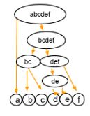

Fig 8.4 : “Divisive Clustering” *(Credit: CCO Public Domain)*

Agglomerative Clustering: It follows a bottom-up approach, here we consider all data points to be part of individual clusters and then these clusters are clubbed together to make one big cluster with all data points. We begin with each element as a separate cluster and merge them into successively more massive clusters, as shown below:

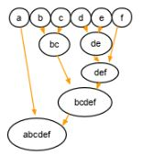

Fig 8.5 : “Agglomerative Clustering” *(Credit: CCO Public Domain)*

#### Distribution-based Clustering

Using distribution-based clustering, data points are generated and organized according to their propensity to fall into the same probability distribution (such as a Gaussian, binomial, or other) within the data. The data elements are grouped using a probability-based distribution that is based on statistical distributions. Included are data objects that have a higher likelihood of being in the cluster. A data point is less likely to be included in a cluster the further it is from the cluster’s midway point, which exists in every cluster.

A notable drawback of density and boundary-based approaches is the need to specify the clusters a priori for some algorithms, and primarily the definition of the cluster form for the bulk of algorithms. There must be at least one tuning or hyper-parameter selected, and while doing so should be simple, getting it wrong could have unanticipated repercussions. Distribution-based clustering has a definite advantage over proximity and centroid-based clustering approaches in terms of flexibility, accuracy, and cluster structure. The key issue is that, to avoid overfitting, many clustering methods only work with simulated or manufactured data, or when the bulk of the data points certainly belong to a preset distribution. The most popular distribution-based clustering algorithm is Gaussian Mixture Model.

#### *Centroid-based Clustering (Partitioning methods)*

Partitioning methods are the easiest clustering algorithms. They group data points based on their closeness. The similarity measure chosen for these algorithms are Euclidian distance, Manhattan Distance or Minkowski Distance. The datasets are separated into a predetermined number of clusters, and each cluster is referenced by a vector of values. When compared to the vector value, the input data variable shows no difference and joins the cluster.

The primary drawback for these algorithms Is the requirement that we establish the number of clusters, “k,” either intuitively or scientifically (using the Elbow Method) before any clustering machine learning system starts allocating the data points. Despite this, it is still the most popular type of clustering. K-means and K-medoids clustering are some examples of this type clustering.

##### K Means Clustering

K-Means clustering is an unsupervised learning algorithm. There is no labeled data for this clustering, unlike in supervised learning. K-means clustering is an iterative process to minimize the sum of distances between the data points and their cluster centroids. The k-means clustering algorithm operates by categorizing data points into clusters by using a mathematical distance measure, usually Euclidean, from the cluster center. The objective is to minimize the sum of distances between data points and their assigned clusters. Data points that are nearest to a centroid are grouped together within the same category. A higher K value, or the number of clusters, signifies smaller clusters with greater detail, while a lower K value results in larger clusters with less detail.

##### Initialize k.

The conventional K-means clustering algorithm requires a few steps. The first step is to initialize K centroids where k is equal to the number of clusters chosen for a specific dataset. This approach uses either random selection or initial centroid sampling methods.

##### Assign centroids.

The next step includes a two-step iterative process based on the expectation maximization machine learning algorithm. The expectation step assigns each data point to its closest centroid based on distance (Euclidean). The maximization step computes the mean of all the points for each cluster and reassigns the cluster center, or centroid. This process repeats until the centroid positions have reached convergence or the maximum number of iterations have been reached.

K-means clustering is simple yet sensitive to initial conditions and outliers. It is important to optimize the centroid initialization and the number of clusters k, to achieve the most meaningful clusters. There are several ways to evaluate and optimize clustering components of the algorithm by using evaluation metrics and initial centroid sampling methods.

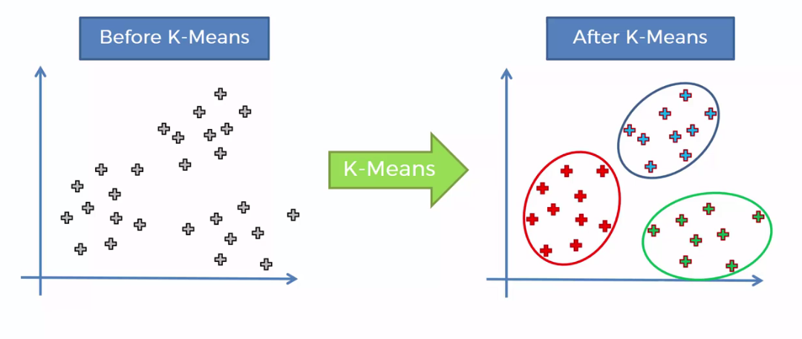

Fig 8.8 : “K-means Clustering” *(Credit: CCO Public Domain)*

### Optimizing k-means performance

Optimization is important when using k-means to achieve the best clustering results. The K-means algorithm is nondeterministic due to its random initialization step. This method implies that if the algorithm is performed twice on identical data, the cluster assignments might differ. To achieve optimal clustering results, carefully selecting the initial centroids and the optimum number of clusters improves the accuracy and the speed of the k-means algorithm.

##### Initializing the cluster centroids

Each cluster is represented by a centroid, a data point that represents the cluster center. K-means groups together similar data points into clusters by minimizing the distance between data points in a cluster with their centroid or k mean value. The primary goal of the k-means algorithm is to minimize the total distances between points and their assigned cluster centroid. The algorithm operates iteratively, and initial partition selection can impact the resulting clusters. K-means++ is a K-means algorithm that optimizes the selection of the initial cluster centroid or centroids.

The first step to initialization by using the k-means++ method is to choose one centroid from the data set. For each subsequent centroid, calculate the distance of each data point from its closest cluster center. The subsequent centroid is selected by considering the likelihood that a point is at a proportional distance from the nearest centroid chosen earlier. The process executes iterations until the chosen number of cluster centers have been initialized.

##### Choosing the optimal number of clusters

Ideally, the K-means algorithm iterates until the optimal number of clusters are reached. The maximum number of iterations are met once the centroids have achieved convergence. One method to achieve the optimal number of clusters is the elbow method. The elbow method is a graphical method for finding the optimum number of clusters within a k-means clustering algorithm. It measures the Euclidean distance between each data point and its cluster center and chooses the number of clusters based on where change in “within cluster sum of squares” (WCSS) levels off. This value represents the total variance within each cluster that gets plotted against the number of clusters.

###### Advantages of K-Means

* Simple and easy to implement: The k-means algorithm is easy to understand and implement, making it a popular choice for clustering tasks.
* Fast and efficient: K-means is computationally efficient and can manage large datasets with high dimensionality.
* Scalability: K-means can manage large datasets with many data points and can be easily scaled to manage even larger datasets.
* Flexibility: K-means can be easily adapted to different applications and can be used with different distance metrics and initialization methods.

###### Disadvantages of K-Means:

* Sensitivity to initial centroids: K-means is sensitive to the initial selection of centroids and can converge to a suboptimal solution.
* Requires specifying the number of clusters: The number of clusters k needs to be specified before running the algorithm, which can be challenging in some applications.
* Sensitive to outliers: K-means is sensitive to outliers, which can have a significant impact on the resulting clusters.

## Evaluation metrics for Clustering

Evaluation metrics can be split into two main categories: Extrinsic and Intrinsic.

### Intrinsic measures

Intrinsic measures are evaluation metrics for cluster analysis that use only the information within the data set. These can be helpful when you are working with unlabeled data. The quality of the analysis is based entirely on relationships between data points. They can be used when we do not have prior knowledge or labels of the data. Common intrinsic measures include:

Silhouette score: This metric measures the similarity and dissimilarity of each data point with respect to its own cluster and all other clusters. The metrics values range from -1 to +1. A high value indicates that the object is well matched to its own cluster and poorly matched to neighboring clusters.

Davies-Bouldin index: This metric calculates the ratio of the within-cluster distance to the between-cluster distance. The lower the index score, the better the clustering performance.

Calinski–Arabas index: This is also known as the Variance Ratio criterion; this measures the ratio of between-cluster variance and within-cluster variance. The higher the Calinski-Harabasz ratio, the more well-defined a cluster is.

### Extrinsic measures

Extrinsic measures use ground truth or external information to assess the validity of the clustering algorithm’s performance. This requires some form of label data that confirms the class or cluster in which each data point belongs. In this case, you can compare the accuracy of your clustering analysis with metrics often used in classification accuracy. Common extrinsic measures include:

F-score (also called F-measure): This metric determines the accuracy of the clustering algorithm by looking at precision and recall when comparing a proposed clustering to a ground truth. In the case of an F-score, higher is better.

Purity: This metric measures the fraction of data points that are correctly assigned to the same class or cluster they belong to. In the case of a purity measure, higher is better.

Rand index: This is a measure of the similarity between the true and predicted labels of the clustering algorithm, ranging from 0 to 1. A higher value indicates a better clustering performance.

Variation of Information (also called Shared Information Distance): This measures the amount of information lost and gained between two clustering. This can be between a ground truth clustering and an algorithm-generated clustering or between two different clustering. A lower number is better, since that shows a smaller distance between two clustering results.

## Applications of Clustering

Clustering use cases include biological sequence analysis, human genetic clustering, medical image tissue clustering, market or customer segmentation, social network or search result grouping for recommendations, computer network anomaly detection, natural language processing for text grouping, crime cluster analysis, and climate cluster analysis. Below is a description of some examples.

Network traffic classification: Organizations seek many ways of understanding the several types of traffic entering their websites, particularly what is spam and what traffic is coming from bots. Clustering is used to group together common characteristics of traffic sources, then create clusters to classify and differentiate the traffic types. This allows more reliable traffic blocking while enabling better insights into driving traffic growth from desired sources.

Marketing and sales**:** Marketing success means targeting the right people or prospects in the right way. Clustering algorithms group together people with similar traits, based on their likelihood to purchase. With these groups or clusters defined, test marketing across them becomes more effective, helping to refine messaging to reach them.

Document analysis: Any organization dealing with high volumes of documents will benefit by being able to organize them effectively and quickly as they are generated. That means being able to understand underlying themes in the documents, and then being able to compare that to other documents. Clustering algorithms examine text in documents, then group them into clusters of different themes. That way they can be speedily organized according to actual content.

Biological Data Analysis: Medical Imaging Analysis and Identification of Cancer Cells with biological content is biological data analysis for a heavy and extended understanding of the relationships identified as to be linked with experimental observations. Moreover, biological data is structured either in the form of networks or sequences where clustering methods are significant for identifying profound similarities. On the other side, from the past few years, the exploitation of research done on the human genome and the expanding facility of accumulating diverse types of gene expression data lead to evolving biological data analysis exponentially. Clustering helps in extracting useful knowledge from huge datasets collected in biology, and other life sciences realm as medicine or neuroscience with the fundamental aim of providing prediction and description of data structure. Using clustering algorithms, cancerous datasets can be identified, a mix dataset involving both cancerous and non-cancerous data can be analyzed using clustering algorithms to understand the different traits present in the dataset, depending upon algorithms produces resulting clusters. On feeding to unsupervised clustering algorithms, we obtain accurate results from cancerous datasets.

Recommendation engines: The recommendation system is a widely used method for providing automated personalized suggestions about products, services, and information where collaborative filtering is one of the famous recommendation system and techniques. In this method, the clustering method provided an idea of like-minded users. The computation/estimation as data provided by several users is leveraged for improving the performance of collaborative filtering methods. And this can be implemented for rendering recommendations in diverse applications. For example, the recommendation engine is universally used in Amazon, Flipkart to recommend product and You tube to suggest songs of the same genre. Even though dealing with extensive data clustering is suitable as the first step for narrowing the choice of underlying relevant neighbors in collaborative filtering algorithms, that also enhances the performance of complex recommendation engines. Each cluster will be assigned to specific preferences based on customers’ choices who belong to the cluster. And then, within each cluster, customers would receive recommendations estimated at the cluster level.

Social Network Analysis (SNA): It is the process of examining qualitative and quantitative social structures by utilizing Graph Theory (a major branch of discrete mathematics) and networks. Here the mapping of social networks structure is arranged in terms of nodes (individual personality, people, or other entity inside the network) and the edges or links (relationships, interaction, or communication) that connect them. Clustering methods are required in such analysis to map and measure the relationship and conflicts amid people, groups, companies, computer networks, and other similar connected information/knowledge entities. Clustering analysis can provide a visual and mathematical analysis/presentation of such relationships and give social network summarization. For example, for understanding a network and its participants, there is a need to evaluate the location and grouping of actors in the network, where the actors can be individual, professional groups, departments, organizations, or any huge system-level unit. Now, through a clustering approach, SNA can visualize the interaction among participants and obtain insights about several roles and groupings in the network, such as who are connectors, bridges, and experts, who are isolated actors and much similar information. It also tells where there are clusters, who are into them, who are at the gist in the network or on the outer edge.

## **Advantages of Clustering**

Clustering brings several advantages to the field of data analysis:

#### Pattern Discovery

Clustering helps uncover hidden patterns and structures within data. By grouping similar data points together, it becomes easier to identify trends and relationships that might not be apparent when examining individual data points.

#### Data Summarization

Large datasets can be overwhelming to analyze. Clustering allows data scientists to summarize complex datasets into a smaller number of representative clusters, making it simpler to understand and interpret the data.

#### Anomaly Detection

Outliers and anomalies can have a significant impact on analysis results. Clustering can help detect such anomalies by identifying data points that do not fit well into any cluster.



### 8.1 Key Takeaways



* Clustering aims at forming groups of homogeneous data points from a heterogeneous dataset.
* The classification into clusters is done using criteria such as smallest distances, density of data points, graphs, or various statistical distributions.
* Density-based clustering, a model-based method, finds groups based on the density of data points.
* Centroid-based clustering requires that the number of clusters be predefined and is sensitive to initialization.
* A method for assembling related data points into hierarchical clusters is called hierarchical clustering.
* Divisive Clustering follows a top-down approach, here all data points are part of one big cluster and then this cluster is divided into smaller groups.
* Agglomerative Clustering follows a bottom-up approach, here all data points are part of individual clusters and then these clusters are clubbed together to make one big cluster with all data points.
* In distribution-based clustering, data points are generated and organized according to their propensity to fall into the same probability distribution (such as a Gaussian, binomial, or other) within the data.
* The k-means clustering algorithm operates by categorizing data points into clusters by using a mathematical distance measure, usually Euclidean, from the cluster center.
* Extrinsic measures use ground truth or external information to assess the validity of the clustering algorithm’s performance. This requires some form of label data that confirms the class or cluster in which each data point belongs.

### 8.2 Quiz :



Q1. Movie recommendation systems are an example of:

1. Classification
2. Clustering
3. Reinforcement Learning
4. Regression

Options:

1. 2 and 3
2. 1 and 2
3. 1 and 3
4. 1, 2, and 3

Q2. Sentiment Analysis is an example of:

1. Regression
2. Classification
3. Clustering
4. Reinforcement Learning

Options:

1. 1 Only
2. 1 and 3
3. 1, 2 and 3
4. 1, 2 and 4

Q3. Can decision trees be used to perform clustering?

1. True
2. False

Q4. Which of the following is the most appropriate strategy for data cleaning before performing clustering analysis, given less than the desirable number of data points?

1. Capping and flouring of variables
2. Removal of outliers

Options:

1. 1 only
2. 2 only
3. 1 and 2
4. None of the above

Q5. What is the minimum no. of variables/ features required to perform clustering?

1. 0
2. 1
3. 2
4. 3

Q6. For two runs of K-Mean clustering, is it expected to get the same clustering results?

1. Yes
2. No

Q7. Which of the following can function as termination conditions in K-Means?

1. For a fixed number of iterations.
2. The assignment of observations to clusters does not change between iterations, except for cases with a bad local minimum.
3. Centroids do not change between successive iterations.
4. Terminate when RSS falls below a threshold.

Options:

1. 1, 3 and 4
2. 1, 2 and 3
3. 1, 2 and 4
4. All the above

Q8. Which of the following algorithms is most sensitive to outliers?

1. K-means clustering algorithm.
2. K-medians clustering algorithm
3. K-modes clustering algorithm
4. K-medoids clustering algorithm

Q9. How can Clustering (Unsupervised Learning) be used to improve the accuracy of the Linear Regression model (Supervised Learning)?

1. Creating different models for different cluster groups.
2. Creating an input feature for cluster ids as an ordinal variable.
3. Creating an input feature for cluster centroids as a continuous variable.
4. Creating an input feature for cluster size as a continuous variable.

Options:

1. 2 and 3
2. 1 and 2
3. 1 and 4
4. All the above

Q10. In which of the following cases will K-Means clustering fail to give superior results?

1. Data points with outliers
2. Data points with different densities
3. Data points with round shapes
4. Data points with non-convex shapes

Options:

1. 1 and 2
2. 2 and 3
3. 2 and 4
4. 1, 2 and 4

Q11. Which of the following is/are true?

1. Clustering analysis is negatively affected by the multicollinearity of features.
2. Clustering analysis is negatively affected by heteroscedasticity.

Options

1. 1 only
2. 2 only
3. 1 and 2
4. None of them

Q12. Which of the following is/are valid iterative strategies for treating missing values before clustering analysis?

1. Imputation with mean
2. Nearest Neighbor assignment
3. Imputation with Expectation Maximization algorithm
4. All the above

Q13. Feature scaling is a crucial step before applying the K-Mean algorithm. What is the reason behind this?

1. In distance calculation, it will give the same weights for all features.
2. You always get the same clusters. If you use or do not use feature scaling
3. In Manhattan distance, it is a crucial step, but in Euclidean distance, it is not.
4. None of these

Q14. Which of the following methods is used for finding the optimal of a cluster in the K-Mean algorithm?

1. Elbow method
2. Manhattan method
3. Euclidian method
4. All the above

Q15. What is true about K-Mean Clustering?

1. K-means is extremely sensitive to cluster center initializations.
2. Bad initialization can lead to Poor convergence speed.
3. Bad initialization can lead to bad overall clustering.

Options:

1. 1 and 3
2. 1 and 2
3. 2 and 3
4. 1, 2 and 3

Q16. Which of the following sequences is correct for a K-Means algorithm using the Forgy method of initialization?

1. Specify the number of clusters.
2. Assign cluster centroids randomly.
3. Assign each data point to the nearest cluster centroid.
4. Re-assign each point to the nearest cluster centroid.
5. Re-compute cluster centroids

Options:

1. 1, 2, 3, 5, 4
2. 1, 3, 2, 4, 5
3. 2, 1, 3, 4, 5
4. None of these

Q17. If you use Multinomial mixture models with the expectation-maximization algorithm for clustering data points into two clusters, which of the assumptions are important?

1. All the data points follow two Gaussian distribution.
2. All the data points follow n Gaussian distribution (n >2)
3. All the data points follow two multinomial distributions.
4. All the data points follow n multinomial distribution (n >2)

Q18. Which of the following is/are not true about the centroid-based K-means clustering algorithm and Distribution-based expectation-maximization clustering algorithm?

1. Both start with random initializations.
2. Both are iterative algorithms.
3. Both have strong assumptions that the data points must fulfil.
4. The expectation-maximization algorithm is a special case of K-Means

Options:

1. 1 only
2. 4 only
3. 2 only
4. 3 only

Q19. Which of the following are the high and low bounds for F-Score?

Options:

1. [0,1]
2. (0,1)
3. [-1,1]
4. None of the above

Q20. Which of the following is the most appropriate strategy for data cleaning before performing clustering analysis, given less than the desirable number of data points?

1. Capping and flouring of variables
2. Removal of outliers

Options:

1. 1only
2. 2only
3. 1 and 2
4. None of the above

### Research with solid fill8.3 Hands-on Case Study:

*Clustering*

*Credit Kaggle for Source Data Set*

<https://www.kaggle.com/datasets/aditiyasaputra/stock-dataset>

Step 1: Source Data Ingestion

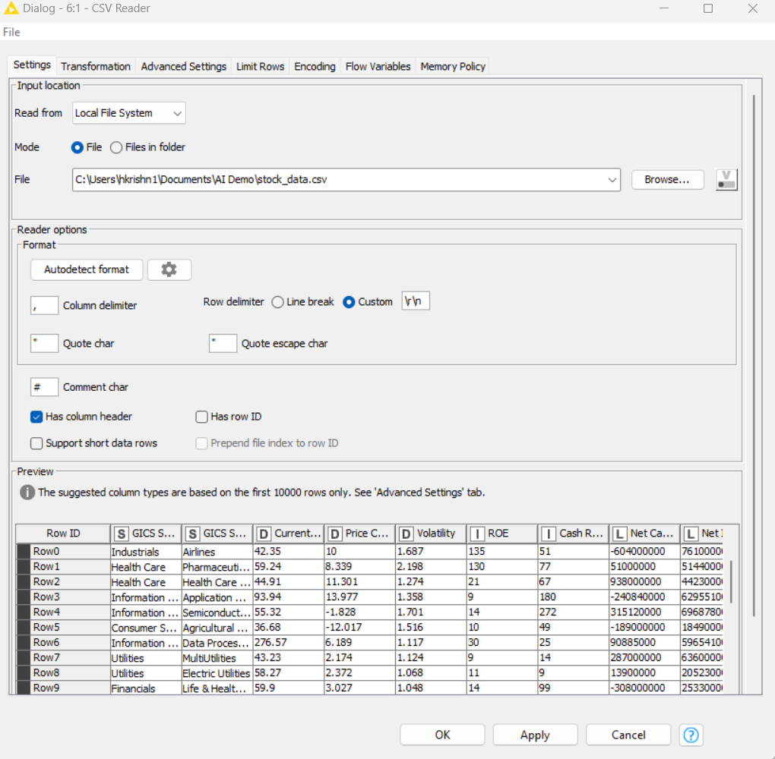

Step 2: EDA

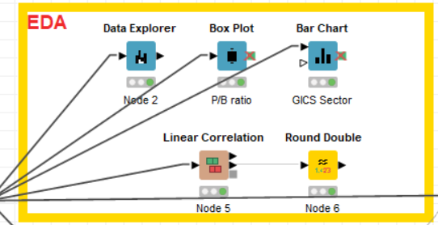

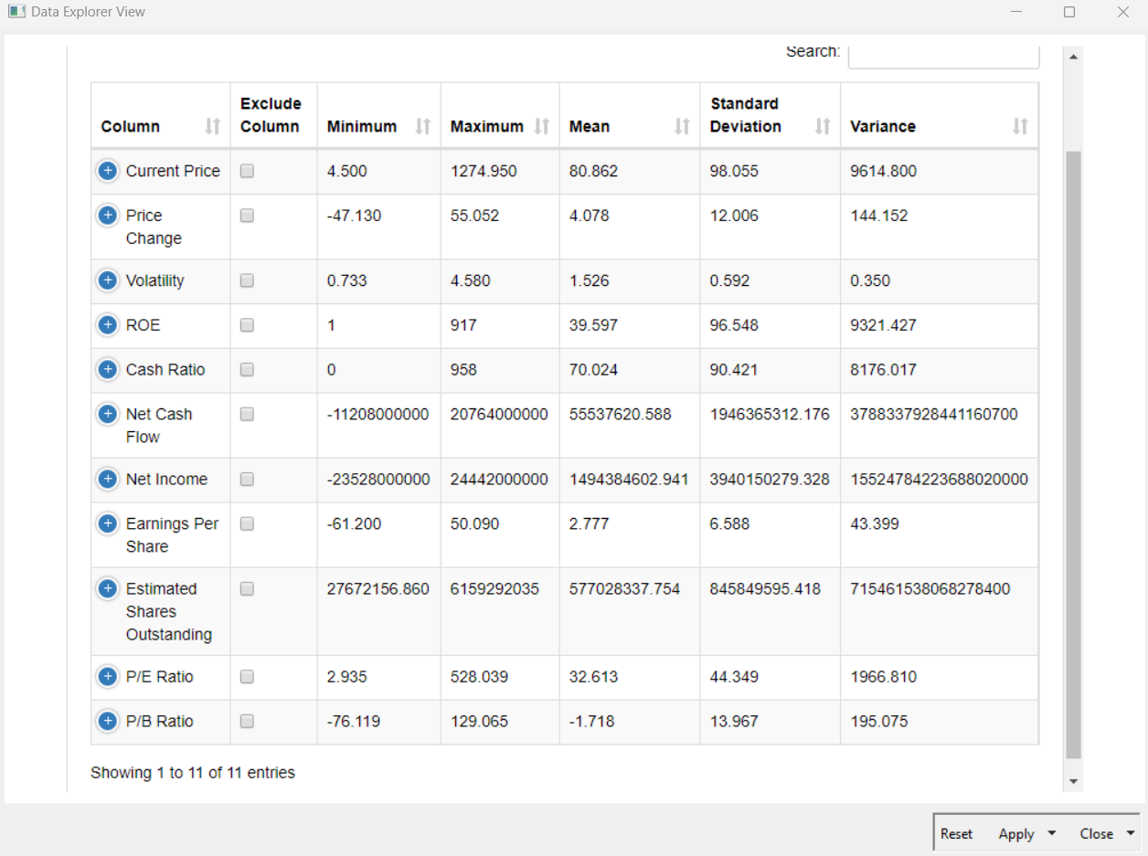

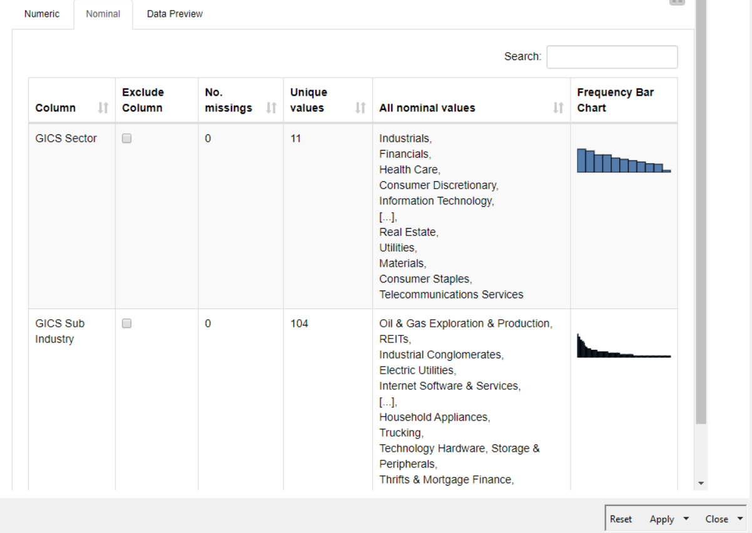

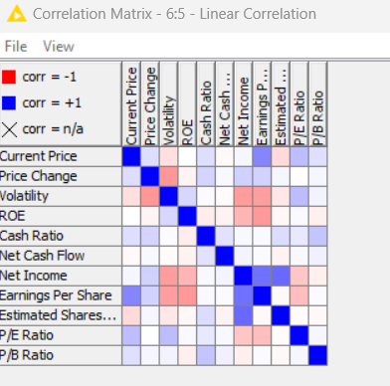

Step 3: Preprocessing

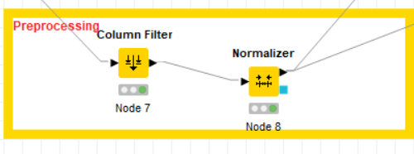

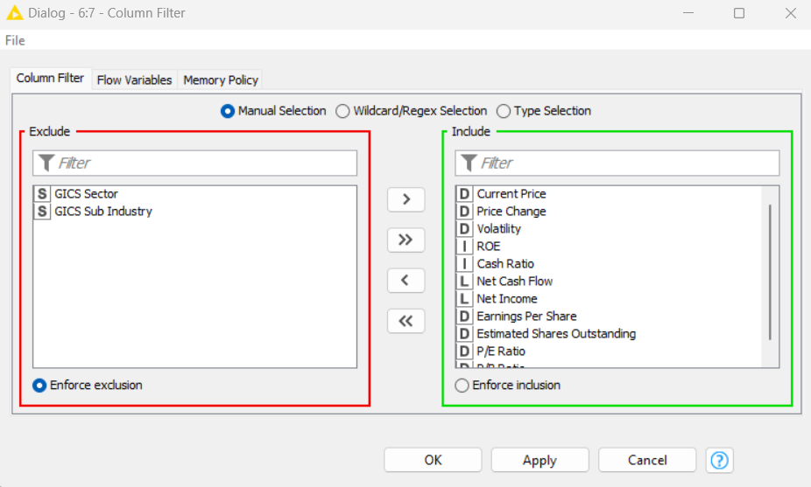

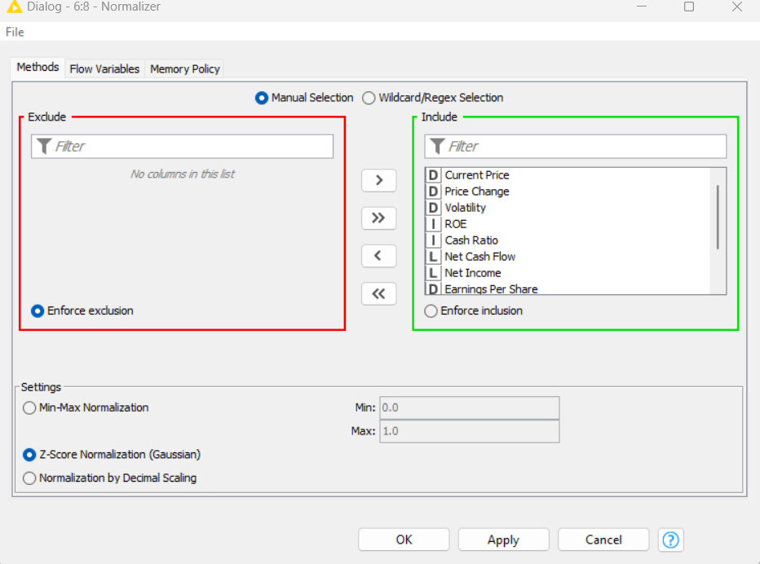

Step 4: Clustering

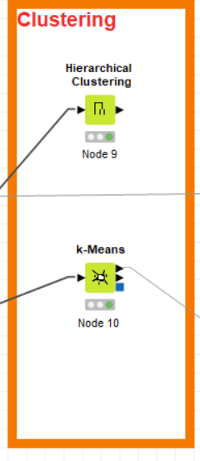

Hierarchical Clustering:

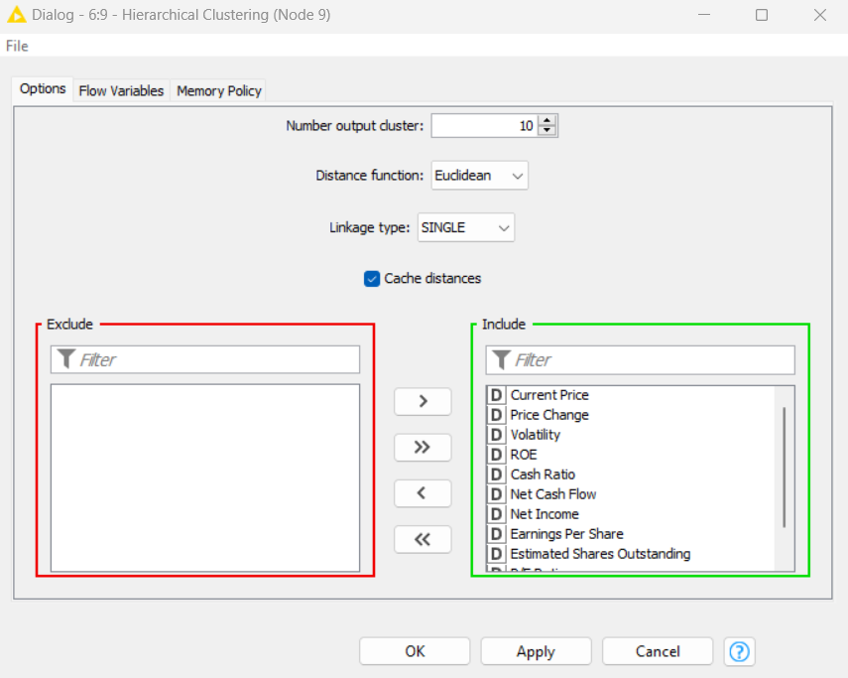

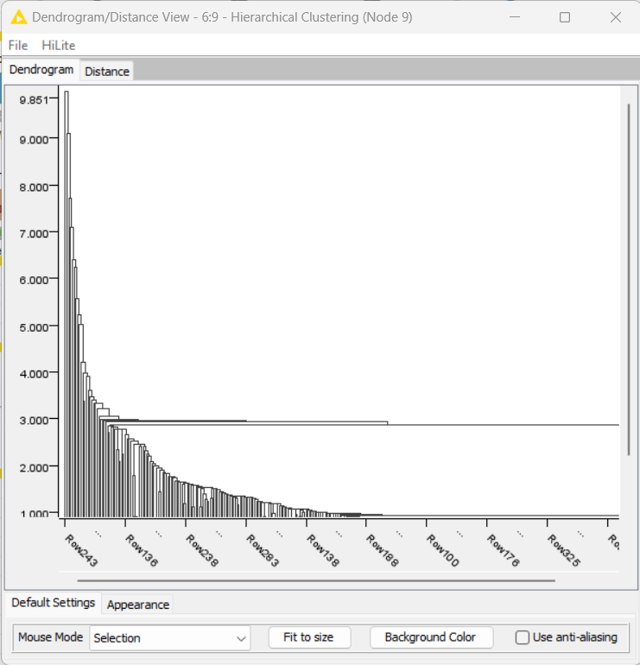

K mean Clustering: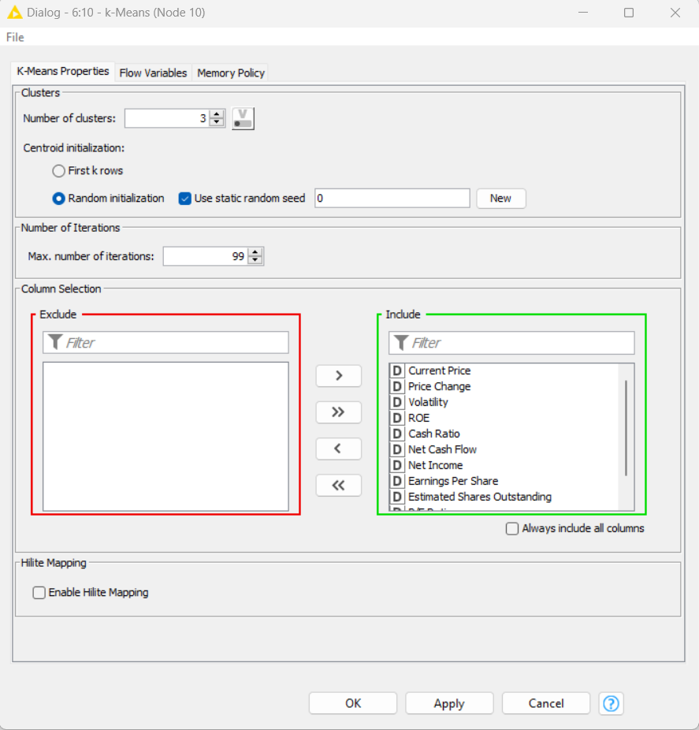

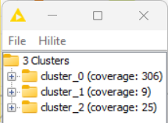

Step 4: Cluster Analysis

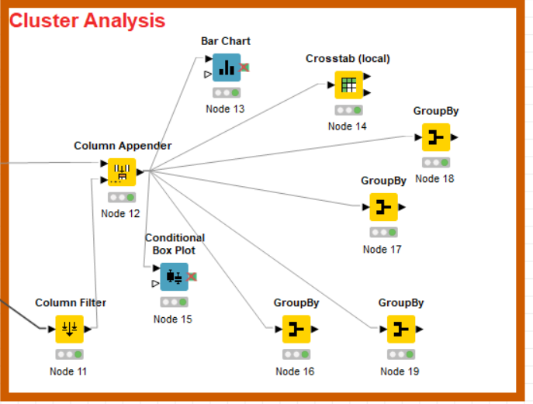

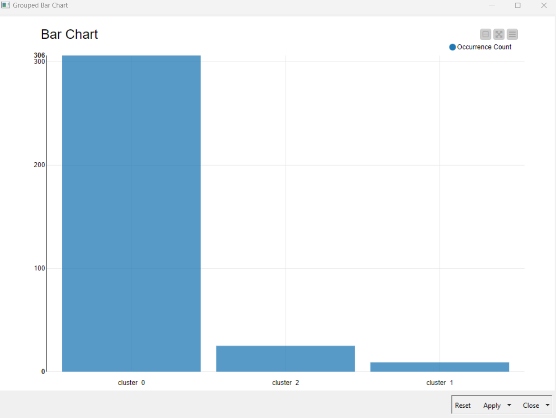



### 8.4 Exercise do it yourself:

*Credit Kaggle for Source Data Set*

<https://www.kaggle.com/datasets/sanjushasuresh/reliance-stock-dataset-for-stock-market-analysis>

##### Introduction

This notebook is fetching daily stock market data of Reliance from finance API and its daily news articles from media stack API and creating a derived dataset which contains news sentiment. This notebook will be scheduled to be run daily using scheduled notebook run.

##### About Dataset

Input - Input data will be the dataset we created from this notebook output by keeping data coordinated with new notebook versions which can be find in metadata section of a dataset that was created directly from a Kaggle Notebook Output Files.

Output - Notebook will fetch today's stock market data , news articles and its sentiment( positive , negative, or neutral) , append all this data with input data and output it to the dataset.

Notebook will generate 3 files -

reliance_stock_history.csv

reliance_news.json

reliance_news_sentiment.csv

reliance_stock_history.csv

Date - Trading date.

Open - Open price of day

High - Highest price of day

Low - Lowest price of day

Close - Closing price of day.

Volume - Amount of asset/security

Dividends - Distribution of stock

Stock splits - Shares of stock to its current shareholders.

# **09 Dimensionality Reduction**

As the number of features or dimensions in a dataset increases, the amount of data required to obtain a statistically significant result increase exponentially. This can lead to issues such as overfitting, increased computation time, and reduced accuracy of machine learning models this is known as the curse of dimensionality problems that arise while working with high-dimensional data.

High-dimensional datasets pose several practical concerns for machine learning algorithms, such as increased computation time, storage space for big data, etc. . But the biggest concern is decreased accuracy in predictive models. Statistical and machine learning models trained on high-dimensional datasets often generalize poorly. As the number of dimensions increases, the number of combinations of features increases exponentially, which makes it computationally difficult to obtain a representative sample of the data and it becomes expensive to perform tasks such as clustering or classification. Additionally, some machine learning algorithms can be sensitive to the number of dimensions, requiring more data to achieve the same level of accuracy as lower-dimensional data. To address the curse of dimensionality, Feature engineering techniques are used which include feature selection and feature extraction. Dimensionality reduction is a type of feature extraction technique that aims to reduce the number of input features while retaining as much of the original information as possible.

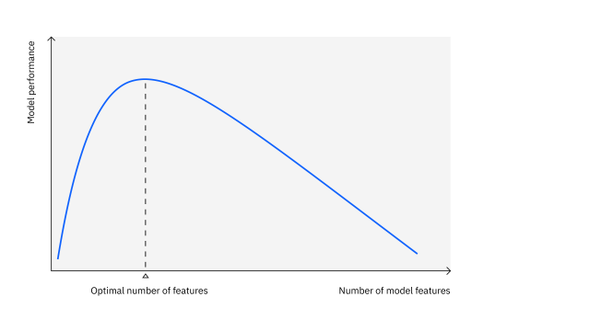 Fig 9.1 : “Dimensionality Reduction” *(Credit: CCO Public Domain)*

### Curse of Dimensionality

It is well known that ML/DL algorithms need a large amount of data to learn invariance, patterns, and representations. If this data comprises many features, this can lead to the curse of dimensionality. The curse of dimensionality, first introduced by Bellman, describes that to estimate an arbitrary function with a certain accuracy the number of features or dimensionality required for estimation grows exponentially. The curse of dimensionality refers to the inverse relationship between increasing model dimensions and decreasing generalizability. If the number of data points remains the same, however, the data becomes sparse. This means most of the model’s feature space is empty, i.e., without observable data points. As data sparsity increases, data points become so dissimilar that predictive models become less effective at identifying explanatory patterns. In this way, increases in dimensionality can lead to poor generalizability.

High dimensionality can further inhibit model interpretability by inducing multicollinearity. As the quantity of model variables increase, so does the possibility that some variables are redundant or correlated. Collecting more data can reduce data sparsity and thereby offset the curse of dimensionality. As the number of dimensions in a model increase, however, the number of data points needed to impede the curse of dimensionality increases exponentially.3 Collecting sufficient data is, of course, not always feasible. Thus, the need for dimensionality reduction to improve data analysis.

### Benefits of Dimensionality Reduction

Here are some of the benefits of applying dimensionality reduction to a dataset:

* The space required to store the data is reduced as the number of dimensions comes down.
* Overfitting: Models can become overly complex and fit the noise in the data, leading to poor generalization on new, unseen data.
* Some algorithms do not perform well when we have large dimensions. So, reducing these dimensions needs to happen for the algorithm to be useful.
* It takes care of multicollinearity by removing redundant features. For example, you have two variables – ‘time spent on treadmill in minutes’ and ‘calories burnt.’ These variables are highly correlated, as the more time you spend running on a treadmill, the more calories you burn. Hence, there is no point in storing both, as just one of them does what you require.
* It helps in visualizing data. As discussed earlier, it is difficult to visualize data in higher dimensions, so reducing our space to 2D or 3D may allow us to plot and observe patterns more clearly.

## What is Principal Component Analysis?

Principal Component Analysis (PCA) is a powerful technique used in data analysis, particularly for reducing the dimensionality of datasets while preserving crucial information. PCA technique was introduced by the mathematician Karl Pearson in 1901. It works on the condition that while the data in a higher dimensional space is mapped to data in a lower dimension space, the variance of the data in the lower dimensional space should be maximum. PCA works on the assumption that the information is carried in the variance of features, that is, the higher the variation in the feature, the more information that feature carries. It begins with set of data points , typically represented as matrix, where rows represent observations and columns represents features. PCA is a popular unsupervised learning technique for reducing the dimensionality of large data sets. It increases interpretability yet, at the same time, it minimizes information loss. It helps to find the most noteworthy features in a dataset and makes the data easy for plotting in 2D and 3D. PCA helps in finding a sequence of linear combinations of variables.

### How PCA works?

PCA summarizes the information content of large datasets into a smaller set of uncorrelated variables known as principal components. These principal components are linear combinations of the original variables that have the maximum variance compared to other linear combinations. These components capture as much information from the original dataset as possible.

This statistical technique involves both linear algebra and matrix operations, and it transforms the original dataset into a new coordinate system that is structured by the principal components. The eigenvectors and eigenvalues from the covariance matrix that underpin the principal components allow for the analysis of these linear transformations. Imagine you have mapped out a dataset with multiple features, resulting in a multi-dimensional scatterplot. Eigenvectors provide the direction of variance in the scatterplot. Eigenvalues are the coefficients of the eigenvectors; these denote the importance of this directional data. Therefore, a high eigenvalue means that the corresponding eigenvector is more critical. Since principal components represent the directions of maximum variance in the data, they are also the eigenvectors of the covariance matrix.

#### Dimensionality

The term “dimensionality” describes the quantity of features or variables used in the research. It can be difficult to visualize and interpret the relationships between variables when dealing with high-dimensional data, such as datasets with numerous variables. While reducing the number of variables in the dataset, dimensionality reduction methods like PCA are used to preserve the most crucial data. The original variables are converted into a new set of variables called principal components, which are linear combinations of the original variables, by PCA to accomplish this. The dataset’s reduced dimensionality depends on how many principal components are used in the study. The objective of PCA is to select fewer principal components that account for the data’s most important variation. PCA can help to streamline data analysis, enhance visualization, and make it simpler to spot trends and relationships between factors by reducing the dimensionality of the dataset. The mathematical representation of dimensionality reduction in the context of PCA is as follows:

Given a dataset with n observations and p variables represented by the n x p data matrix X, the goal of PCA is to transform the original variables into a new set of k variables called principal components that capture the most significant variation in the data. The principal components are defined as linear combinations of the original variables given by:

$$PC_1 = a_11 * x_1 + a_12 * x_2 + I + a_1p * x_p$$

$$PC_2 = a_21 * x_1 + a_22 * x_2 + I + a_2p * x_p$$

$$I$$

$$PC_k = a_k1 * x_1 + a_k2 * x_2 + I + a_kp * x_p$$

where a_ij is the loading or weight of variable x_j on principal component PC_i, and x_j is the jth variable in the data matrix X. The principal components are ordered such that the first component PC_1 captures the most significant variation in the data, the second component PC_2 captures the second most significant variation, and so on. The number of principal components used in the analysis, k, determines the reduced dimensionality of the dataset.

#### Correlation

A statistical measure known as correlation expresses the direction and strength of the linear connection between two variables. The covariance matrix, a square matrix that displays the pairwise correlations between all pairs of variables in the dataset, is calculated in the setting of PCA using correlation. The covariance matrix’s diagonal elements stand for each variable’s variance, while the off-diagonal elements indicate the covariances between different pairs of variables. The strength and direction of the linear connection between two variables can be determined using the correlation coefficient, a standardized measure of correlation with a range of -1 to 1.

A correlation coefficient of 0 denote” no Linear connection between the two variables, while correlation coefficients of 1 and -1 denote the perfect positive and negative correlations, respectively. The principal components in PCA are linear combinations of the initial variables that maximize the variance explained by the data. Principal components are calculated using the correlation matrix.

In the framework of PCA, correlation is mathematically represented as follows:

The correlation matrix C is a $nxn$ symmetric matrix with the following components given a dataset with n variables $(x1, x2,I, xn):$

$$Cij = (sd(xi) * sd(xj)) / cov(xi, xj)$$

where $sd(x i)$ is the standard deviation of variable x I and $sd(x j)$ is the standard deviation of variable x j, and $cov(x i, x j)$ is the correlation between variables $x i and x j$.

The correlation matrix C can also be written as follows in matrix notation:

$$C = X^T X / (n-1) (n-1)$$

#### Orthogonal

The term “orthogonality” alludes to the principal components’ construction as being orthogonal to one another in the context of the PCA algorithm. This indicates that there is no redundant information among the main components and that they are not correlated with one another. Orthogonality in PCA is mathematically expressed as follows: each principal component is built to maximize the variance explained by it while adhering to the requirement that it be orthogonal to all other principal components. The principal components are computed as linear combinations of the original variables. Thus, each principal component is guaranteed to capture a unique and non-redundant part of the variation in the data.

The orthogonality constraint is expressed as:

$$a_i1 * a_j1 + a_i2 * a_j2 + I + a_ip * a_jp = 0$$

for all I and j such that $i ≠ j$. This means that the dot product between any two loading vectors for different principal components is zero, indicating that the principal components are orthogonal to each other.

#### Eigen Vectors

The main components of the data are calculated using the eigenvectors. The ways in which the data vary most are represented by the eigenvectors of the data’s covariance matrix. The new coordinate system in which the data is represented is then defined using these coordinates. The covariance matrix C in mathematics is represented by the letters $v 1, v 2,I, v p$, and the associated eigenvalues are represented by $_1, _2,I, _p$. The eigenvectors are calculated in such a way that the equation shown below holds:

$$C v_i = λ_i v_i$$

This means that the eigenvector $v_i$ produces the associated eigenvalue $λ_i$ as a scalar multiple of itself when multiplied by the covariance matrix C.

#### Covariance Matrix

The covariance matrix is crucial to the PCA algorithm’s computation of the data’s main components. The pairwise covariances between the factors in the data are measured by the covariance matrix, which is a $p x p$ matrix.

The correlation matrix C is defined as follows given a data matrix X of n observations of p variables:

$$C = (1/n) * X^T X$$

where $X^T$ represents X’s transposition. The covariances between the variables are represented by the off-diagonal elements of C, whereas the variances of the variables are represented by the diagonal elements of C.

The main aim of PCA is to find such principal components, which can describe the data points with a set of principal components. The two major components of PCA are:

#### First Principal Component (PC1)

The first principal component (PC1) is the direction in space along which the data points have the highest or most variance. It is the line that best represents the shape of the projected points. The larger the variability captured in the first component, the larger the information retained from the original dataset. No other principal component can have a higher variability.

#### Second Principal Component (PC2)

The second principal component (PC2) is calculated in the same way as PC1. PC2 accounts for the next highest variance in the dataset and must be uncorrelated with PC1. That is, PC2 must be orthogonal, that is perpendicular to PC1. This relationship can also be expressed as the correlation between PC1 and PC2 equals zero. A scatterplot is typically used to show the relationship between PC1 and PC2 when PCA is applied to a dataset. PC1 and PC2 axis will be perpendicular to each other. If there are any subsequent components, then they would also retain the same properties, where they would not be correlated with other components and explain any remaining variation.

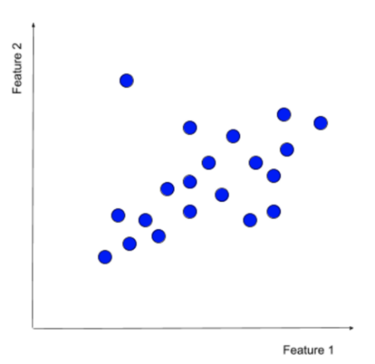 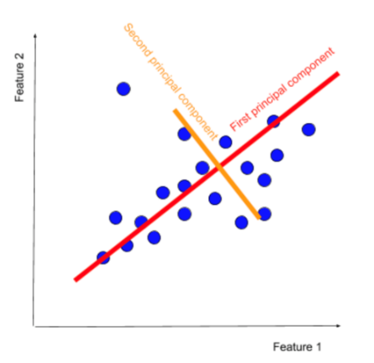

Fig 9.2 : “Calculating PCA” *(Credit: CCO Public Domain)*

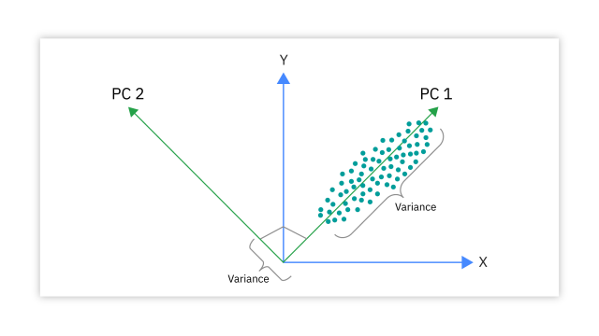

Fig 9.3 : “Principal Component Analysis” *(Credit: CCO Public Domain)*

### How is PCA calculated?

Step1 Standardize the data.

PCA requires standardized data, so the first step is to standardize the data to ensure that all variables have a mean of 0 and a standard deviation of 1. The aim of this step is to standardize the range of the continuous initial variables so that each one of them contributes equally to the analysis. More specifically, the reason it is critical to perform standardization prior to PCA, is that the latter is quite sensitive regarding the variances of the initial variables. That is, if there are significant differences between the ranges of initial variables, those variables with larger ranges will dominate over those with small ranges (for example, a variable that ranges between 0 and 100 will dominate over a variable that ranges between 0 and 1), which will lead to biased results. So, transforming the data to comparable scales can prevent this problem.

Mathematically, this can be done by subtracting the mean and dividing by the standard deviation for each value of each variable.

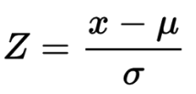

Once the standardization is done, all the variables will be transformed to the same scale.

Step 2 Covariance Matrix Computation

The next step is to calculate the covariance matrix of the standardized data. This matrix shows how each variable is related to every other variable in the dataset. The aim of this step is to understand how the variables of the input data set are varying from the mean with respect to each other, or in other words, to see if there is any relationship between them. Because sometimes, variables are highly correlated in such a way that they contain redundant information. So, to identify these correlations, we compute the covariance matrix. The covariance matrix is a $p × p$ symmetric matrix (where p is the number of dimensions) that has as entries the covariances associated with all pairs of the initial variables. For example, for a 3-dimensional data set with 3 variables x, y, and z, the covariance matrix is a $3×3$ data matrix of this from:

Since the covariance of a variable with itself is $variance (Cov(a,a)=Var(a)),$ in the main diagonal (Top left to bottom right) we have the variances of each initial variable. And since the covariance is commutative $(Cov(a,b)=Cov(b,a))$, the entries of the covariance matrix are symmetric with respect to the main diagonal, which means that the upper and the lower triangular portions are equal.

If Covariance is positive, then: the two variables increase or decrease together (correlated)

If Covariance is negative, then: one increases when the other decreases (Inversely correlated)

Now that we know that the covariance matrix is not more than a table that summarizes the correlations between all the possible pairs of variables, let us move to the next step.

Step 3: Compute the eigenvectors and eigenvalues:

The eigenvectors and eigenvalues of the covariance matrix are then calculated. The eigenvectors represent the directions in which the data varies the most, while the eigenvalues represent the amount of variation along each eigenvector. Eigen vectors and eigenvalues are the linear algebra concepts that we need to compute from the covariance matrix to determine the principal components of the data. Eigenvectors and eigenvalues are that they always come in pairs, so that every eigenvector has an eigenvalue. Also, their number is equal to the number of dimensions of the data. For example, for a 3-dimensional data set, there are 3 variables, therefore there are 3 eigenvectors with 3 corresponding eigenvalues.

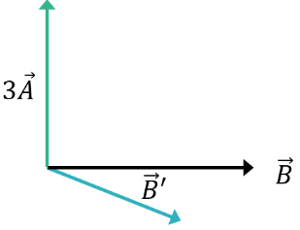

Fig 9.4 : “Eigen vector & Eigen values” *(Credit: CCO Public Domain)*

It is eigenvectors and eigenvalues who are behind all the magic of principal components because the eigenvectors of the Covariance matrix are the directions of the axes where there is the most variance (most information) and that we call Principal Components. And eigenvalues are simply the coefficients attached to eigenvectors, which give the amount of variance carried in each Principal Component. By ranking your eigenvectors in order of their eigenvalues, highest to lowest, we get the principal components in order of significance. After having the principal components, to compute the percentage of variance (information) accounted for by each component, we divide the eigenvalue of each component by the sum of eigenvalues. If we apply this on the example above, we find that PC1 and PC2 carry respectively 96 percent and 4 percent of the variance of the data.

Step 4: Create a Feature Vector & choose the principal components.

The principal components are the eigenvectors with the highest eigenvalues. These components represent the directions in which the data varies the most and are used to transform the original data into a lower-dimensional space. In this step, we decide whether to keep all these components or discard those of lesser significance (of low eigenvalues), and form with the remaining ones a matrix of vectors that we call Feature vector. So, the feature vector is simply a matrix that has as columns the eigenvectors of the components that we decide to keep. This makes it the first step towards dimensionality reduction, because if we choose to keep only p eigenvectors (components) out of ***n***, the final data set will have only ***p*** dimensions. Discarding the eigenvector v2 will reduce dimensionality by 1 and will consequently cause a loss of information in the final data set. But given that v2 was carrying only 4 percent of the information, the loss will be therefore not important, and we will still have 96 percent of the information that is carried by v1.

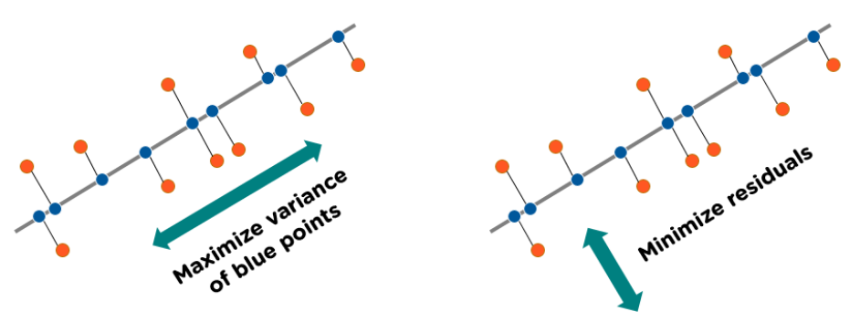

Fig 9.5 : “PCA Concept” *(Credit: CCO Public Domain)*

Step 5: Recast the Data Along the Principal Components Axes

In the previous steps, apart from standardization, you do not make any changes on the data, you just select the principal components and form the feature vector, but the input data set remains always in terms of the original axes (i.e., in terms of the initial variables).

In this step, which is the last one, the aim is to use the feature vector formed using the eigenvectors of the covariance matrix, to reorient the data from the original axes to the ones represented by the principal components (hence the name Principal Components Analysis). This can be done by multiplying the transpose of the original data set by the transpose of the feature vector.

### Assumptions and limitations of PCA

PCA is related to the set of operations in the Pearson correlation, so it inherits similar assumptions and limitations:

1. PCA assumes a correlation between features. If the features (or dimensions or columns, in tabular data) are not correlated, PCA will be unable to determine principal components.
2. PCA is sensitive to the scale of the features. Imagine we have two features – one takes values between 0 and 1000, while the other takes values between 0 and 1. PCA will be extremely biased towards the first feature being the first principle component, regardless of the actual maximum variance within the data. This is why it is so important to standardize the values first.
3. PCA is not robust against outliers. Like the point above, the algorithm will be biased in datasets with strong outliers. This is why it is recommended to remove outliers before performing PCA.
4. PCA assumes a linear relationship between features. The algorithm is not well suited to capturing non-linear relationships. That is why it is advised to turn non-linear features or relationships between features into linear, using the standard methods such as log transforms.
5. Technical implementations often assume no missing values. When computing PCA using statistical software tools, they often assume that the feature set has no missing values (no empty rows). Be sure to remove those rows and/or columns with missing values or impute missing values with a close approximation (e.g., the mean of the column).

### Advantages of PCA

In terms of data analysis, PCA has several benefits, including:

1. *Dimensionality reduction*: By determining the most crucial features or components, PCA reduces the dimensionality of the data, which is one of its primary benefits. This can be helpful when the initial data contains a lot of variables and is therefore challenging to visualize or analyze.
2. *Feature Extraction*: PCA can also be used to derive new features or elements from the original data that might be more insightful or understandable than the original features. This is particularly helpful when the initial features are correlated or noisy.
3. *Data visualization*: By projecting the data onto the first few principal components, PCA can be used to visualize high-dimensional data in two or three dimensions. This can aid in locating data patterns or clusters that may not have been visible in the initial high-dimensional space.
4. *Noise Reduction*: By locating the underlying signal or pattern in the data, PCA can also be used to lessen the impacts of noise or measurement errors in the data.
5. *Multicollinearity*: When two or more variables are strongly correlated, there is multicollinearity in the data, which PCA can manage. PCA can lessen the impacts of multicollinearity on the analysis by identifying the most crucial features or components.

### Disadvantages of PCA

1. *Interpretability*: Although principal component analysis (PCA) is effective at reducing the dimensionality of data and spotting patterns, the resulting principal components are not always simple to understand or describe in terms of the original features.
2. *Information loss*: PCA involves choosing a subset of the most crucial features or components to reduce the dimensionality of the data. While this can be helpful for streamlining the data and lowering noise, if crucial features are not included in the components chosen, information loss may also result.
3. *Outliers*: Because PCA is susceptible to anomalies in the data, the resulting principal components may be significantly impacted. The covariance matrix can be distorted by outliers, which can make it harder to identify the most crucial characteristics.
4. *Scaling*: PCA assumes that the data is scaled and centralized, which can be a drawback in some circumstances. The resulting principal components might not correctly depict the underlying patterns in the data if the data is not scaled properly.
5. *Computing complexity*: For big datasets, it may be costly to compute the eigenvectors and eigenvalues of the covariance matrix. This may restrict PCA’s ability to scale and render it useless for some uses.

### Uses of PCA

PCA is a widely used technique in data analysis and has a variety of applications, including:

1. *Data compression*: PCA can be used to reduce the dimensionality of high-dimensional datasets, making them easier to store and analyze.
2. *Feature extraction*: PCA can be used to identify the most key features in a dataset, which can be used to build predictive models.
3. *Visualization*: PCA can be used to visualize high-dimensional data in two or three dimensions, making it easier to understand and interpret.
4. *Data pre-processing*: PCA can be used as a pre-processing step for other machine learning algorithms, such as clustering and classification.



### 9.1 Key Takeaways



* High-dimensional datasets pose several practical concerns for machine learning algorithms, such as increased computation time, storage space for big data, etc. .
* High dimensionality can further inhibit model interpretability by inducing multicollinearity. As the quantity of model variables increase, so does the possibility that some variables are redundant or correlated.
* PCA is a powerful technique used in data analysis, particularly for reducing the dimensionality of datasets while preserving crucial information.
* PCA summarizes the information content of large datasets into a smaller set of uncorrelated variables known as principal components.
* Eigenvalues are the coefficients of the eigenvectors; these denote the importance of this directional data. Therefore, a high eigenvalue means that the corresponding eigenvector is more critical.
* The term “dimensionality” describes the quantity of features or variables used in the research.
* PCA can help to streamline data analysis, enhance visualization, and make it simpler to spot trends and relationships between factors by reducing the dimensionality of the dataset.
* A statistical measure known as correlation expresses the direction and strength of the linear connection between two variables.
* The term “orthogonality” alludes to the principal components’ construction as being orthogonal to one another in the context of the PCA algorithm.
* PCA is susceptible to anomalies in the data, the resulting principal components may be significantly impacted. The covariance matrix can be distorted by outliers, which can make it harder to identify the most crucial characteristics.

### 9.2 Quiz :



Q1. What is the primary goal of Principal Component Analysis (PCA)?

1. Classification
2. Clustering
3. Dimensionality reduction
4. Regression

Q2. In PCA, what are the principal components?

1. Features of the dataset
2. Eigenvalues of the covariance matrix
3. Eigenvectors of the covariance matrix
4. Data points in the dataset

Q3. Which statistical technique is often used to standardize data before applying PCA?

1. Z-score normalization
2. Min-Max scaling
3. Log transformation
4. None of the above

Q4. What is the purpose of eigenvalues in PCA?

1. They represent the variance explained by each principal component.
2. They determine the number of principal components to retain.
3. They are used for data visualization.
4. They measure the similarity between data points.

Q5. What is the typical range of values for eigenvalues in PCA when analyzing a dataset?

1. Any real value
2. Always between 0 and 1
3. Always positive
4. Always integers

Q6. How is the total variance of the data distributed among the principal components?

1. Equally among all principal components
2. Proportional to their eigenvalues
3. Proportional to the number of data points
4. Proportional to the number of features

Q7. When should you use PCA as a preprocessing step in a machine learning pipeline?

1. When you want to increase the number of features
2. When you suspect multicollinearity among features
3. When you want to remove outliers
4. PCA should never be used as a preprocessing step.

Q8. What does the scree plot in PCA help determine?

1. The optimal number of clusters in the data
2. The correlation between features
3. The explained variance by each principal component
4. The significance of outliers in the dataset

Q9. In PCA, what is the relationship between the first principal component and the second principal component?

1. They are orthogonal (uncorrelated) to each other.
2. They are positively correlated.
3. They are negatively correlated.
4. There is no defined relationship between them.

Q10. In PCA, what is the relationship between the number of principal components retained and the amount of variance explained by the retained components?

1. More retained components explain less variance.
2. More retained components explain more variance.
3. The number of retained components does not affect the explained variance.
4. The relationship depends on the type of dataset.

Q11. Imagine you have 100 predictor features and 1 target feature in a machine learning problem, and you must select the 10 most prominent features based on the relationship between input features and the target features. Do you think this is an example of dimensionality reduction?

1. Yes
2. No

Q12. Which of the following techniques would perform better for reducing the dimensions of a data set?

1. Removing columns that have too many missing values.
2. Removing columns that have high variance in data.
3. Removing columns with dissimilar data trends
4. None of these

Q13. Which of the following algorithms cannot be used for reducing the dimensionality of data?

1. t-SNE
2. PCA
3. LDA
4. None of these

Q14. Dimensionality reduction algorithms are one of the possible ways to reduce the computation time required to build a model.

1. TRUE
2. FALSE

Q15. PCA can be used for projecting and visualizing data in lower dimensions.

1. TRUE
2. FALSE

Q16. The most popularly used dimensionality reduction algorithm is Principal Component Analysis (PCA). Which of the following is/are true about PCA?

1. PCA is an unsupervised method of optimization.
2. It searches for the directions that data have the largest variance.
3. Maximum number of principal components <= number of features
4. All principal components are orthogonal to each other.
5. 1 and 2
6. 1, 2 and 3
7. 1,2 and 4
8. All the above

Q17. In which of the following case will LDA fail?

1. If the discriminatory information is not in the mean but in the variance of the data
2. If the discriminatory information is in the mean but not in the variance of the data
3. If the discriminatory information is in the mean and variance of the data
4. None of these

Q18. Which of the following comparison(s) are true about PCA and LDA?

1. Both LDA and PCA are linear transformation techniques
2. LDA uses supervised learning, whereas PCA uses unsupervised learning.
3. PCA maximizes the variance of the data, whereas LDA maximizes the separation between different classes,
4. 1 and 2
5. 2 and 3
6. 1 and 3
7. 1, 2, and 3

Q19. What will happen when eigenvalues are equal?

1. PCA will perform outstandingly.
2. PCA will perform badly.
3. Cannot say.
4. None of above

Q20. PCA works better if there is ________

1. A linear structure in the data
2. If the data lies on a curved surface and not on a flat surface
3. If variables are scaled in the same unit
4. 1 and 2
5. 2 and 3
6. 1 and 3
7. 1, 2 and 3

### Research with solid fill9.3 Hands-on Case Study:

*Neural Network Classification*

*Credit Kaggle for Source Data Set*

<https://www.kaggle.com/datasets/imakash3011/online-shoppers-purchasing-intention-dataset>

###### PCA KNIME Workflow:

Step1: Source Data : online shoppers intention.csv

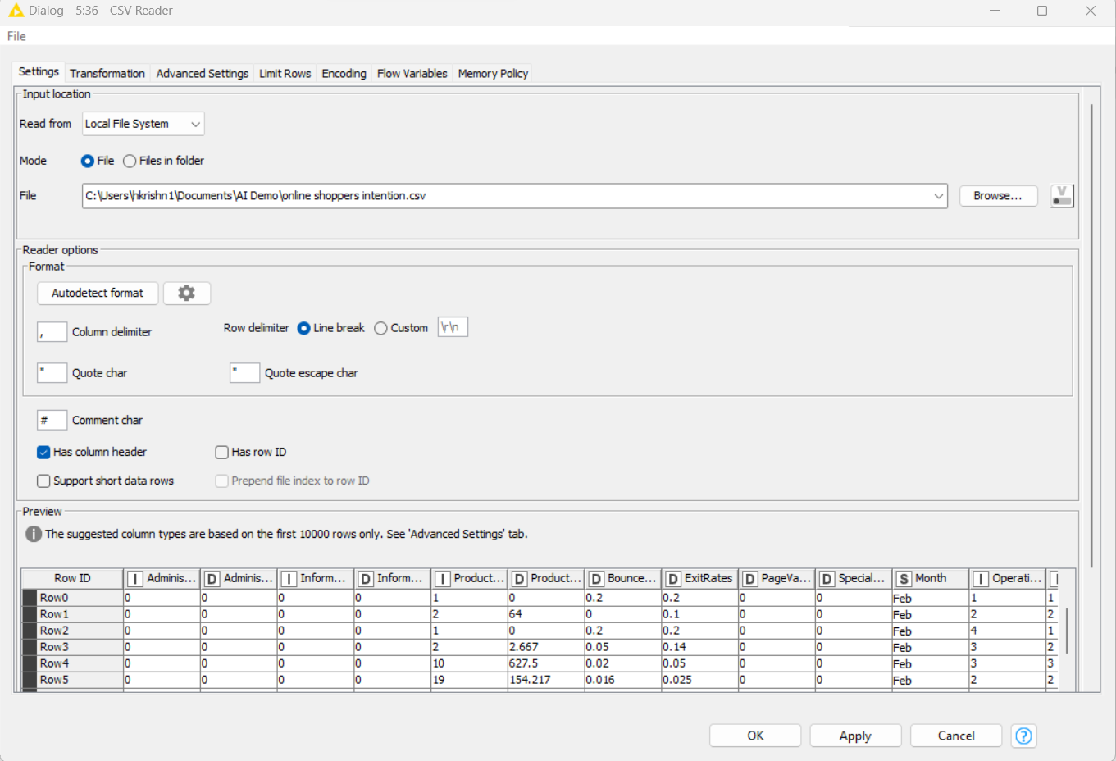

Step 2: identify and convert attributes into Categorical Indicator variable 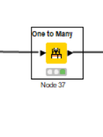 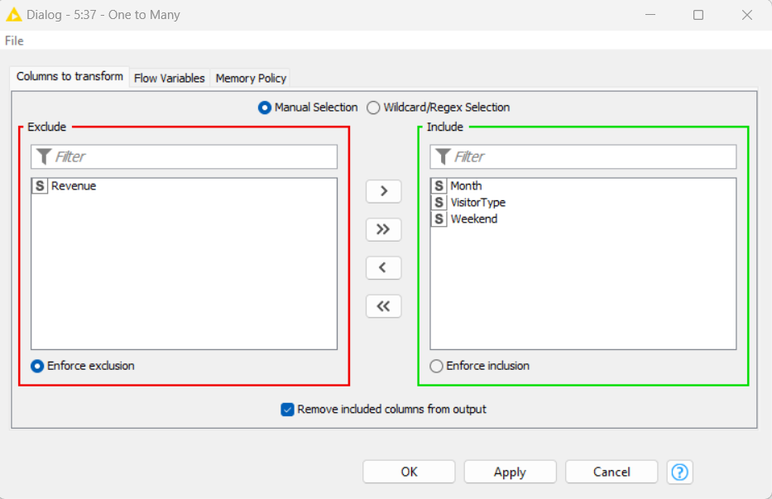

Step3 : Column filter to remove one occurance from multiple

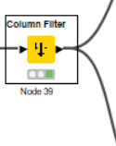

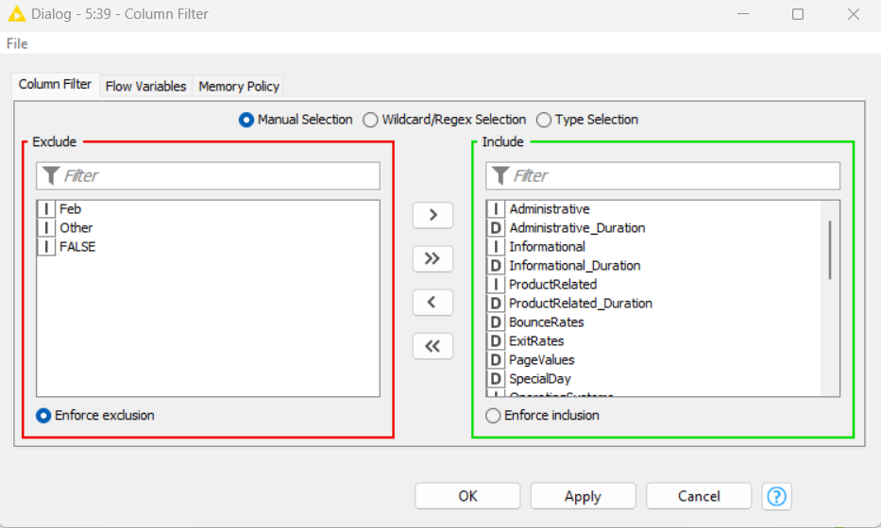

Step 4: PCA Applied

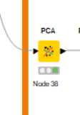

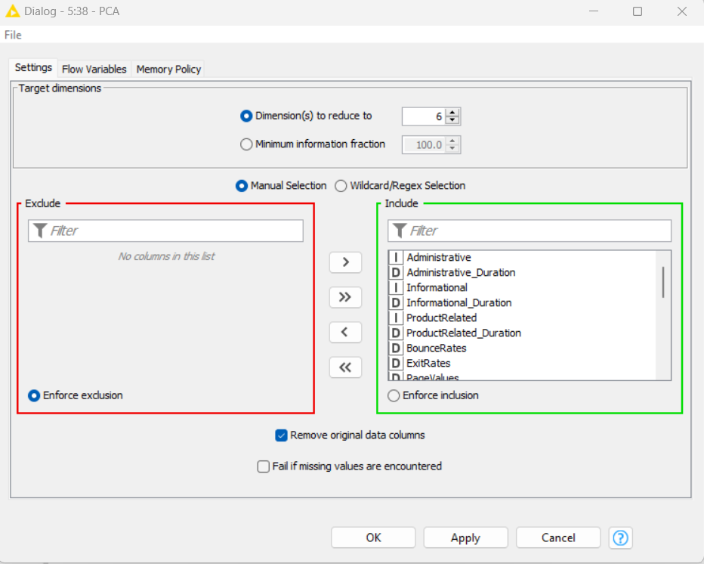

Transformed data after PCA Application

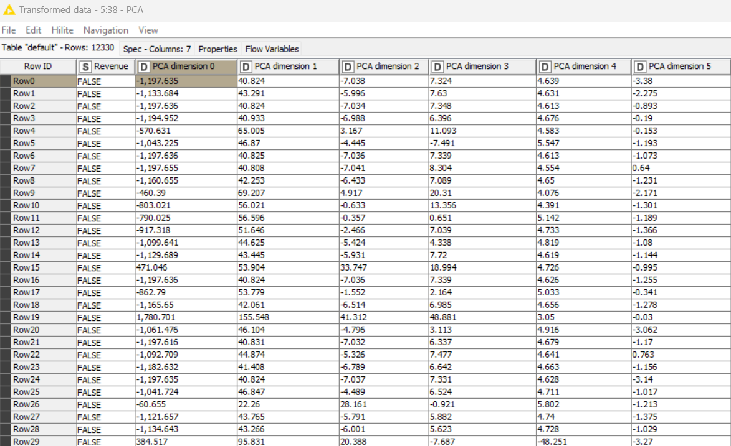

Step 5 : Partitioning Split 70:30

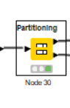

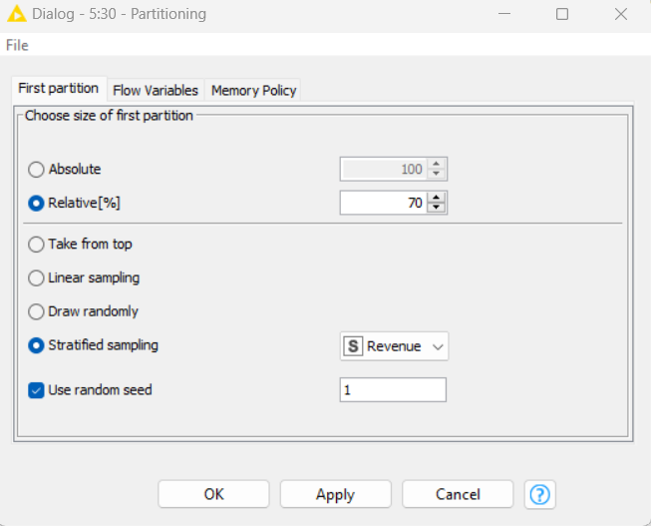

Step 6: Logistic Regression

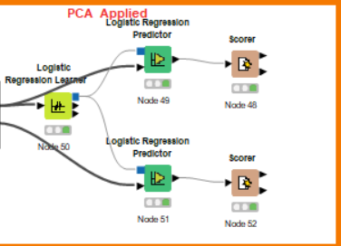

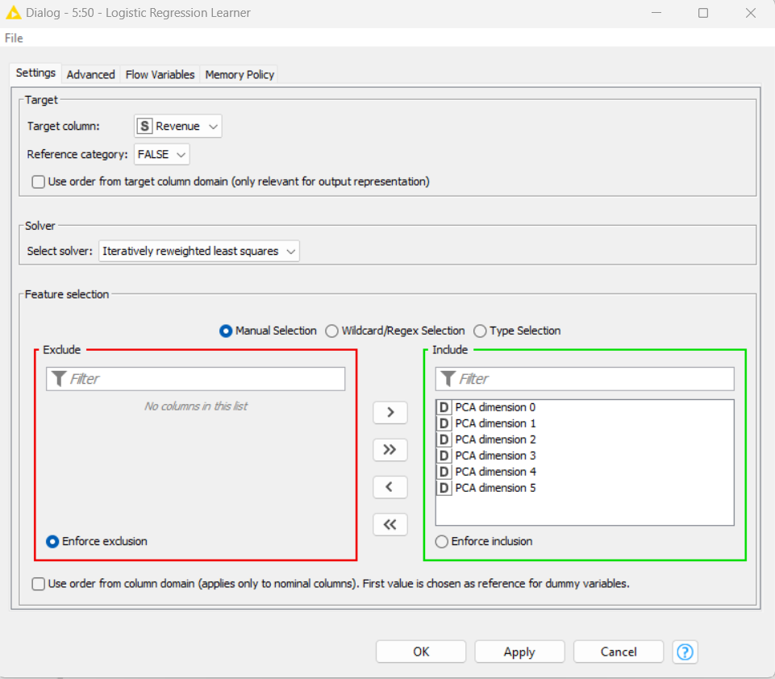

Step 7: Logical regression Predictor

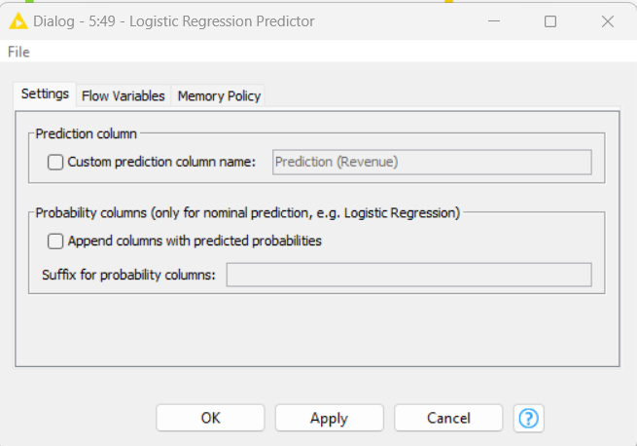

Step 8: Train and Test Scorer

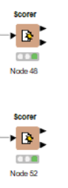

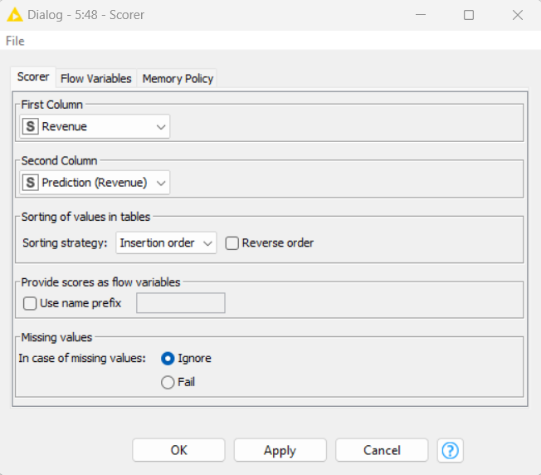

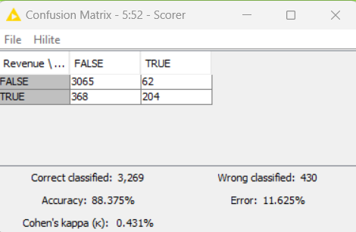

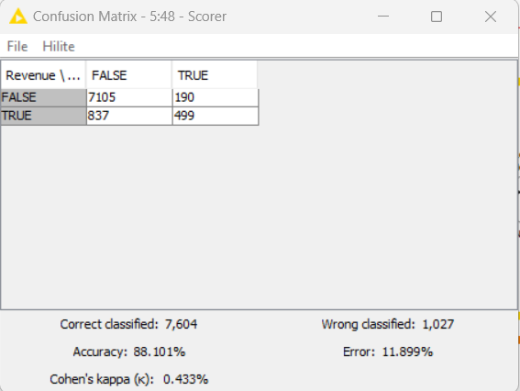

Conclusion: Successfully applied a dimension reduction on Data set using PCA component in KNIME workflow.



### 9.4 Exercise do it yourself:

*Credit Kaggle for Source Data Set*

<https://www.kaggle.com/datasets/mansoordaku/ckdisease>

The data was taken over a 2-month period in India with 25 features ( e.g. , red blood cell count, white blood cell count, etc. .). The target is the 'classification', which is either 'ckd' or 'notckd' - ckd=chronic kidney disease. There are 400 rows.

The data needs cleaning: in that it has NaNs, and the numeric features need to be forced to floats. We were instructed to get rid of ALL ROWS with Nans, with no threshold - meaning, any row that has even one NaN, gets deleted.

# **10 NLP application – Sentimental Analysis**

Sentimental Analysis is the process of analyzing digital text to determine if the emotional tone of the message is positive, negative, or neutral. Sentimental analysis has become crucial in today’s digital age, enabling business to glean insights from vast amount of textual data, including customer reviews, social media comments, and news articles. Sentiment analysis is a classification task in NLP, sometimes called ‘opinion mining,’ it transforms the opinions found in written language or speech data into actionable insights.

This analysis utilizing NLP techniques and categorizing opinions as positive, negative, or neutral is powered by various algorithms such as Naïve Bayes, Support Vector Machines (SVM), and Recurrent Neural Networks (RNN), which help in understanding the overall sentiment and emotional tone conveyed in the text format.

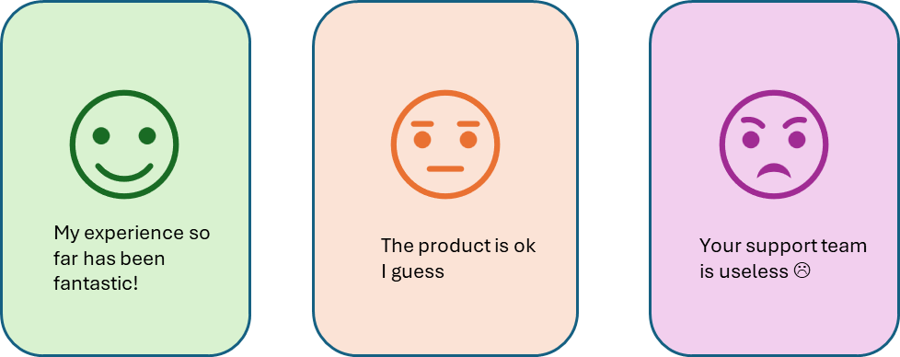

Fig 10.1 : “Sentimental Analysis”

The sentiment can be classified into three categories: Positive Sentiment Expressions indicate a favorable opinion or satisfaction; Negative Sentiment Expressions indicate dissatisfaction, criticism, or negative views; and Neutral Sentiment Text expresses no sentiment or is unclear. Before analyzing the text, some preprocessing steps usually need to be performed. These include tokenization, breaking the text into smaller units like words or phrases, removing stop words such as simple words like “and” “the,” and stemming or lemmatization, which involves reducing words to their base or root form. At a minimum, the data must be cleaned to ensure the tokens are usable and trustworthy.

### Types Sentimental Analysis

There are four common groups for sentimental analysis.

Graded sentiment analysis (or fine-grained analysis) is when content is not polarized into positive, neutral, or negative. Instead, it is assigned a grade on a given scale that allows for a much more nuanced analysis. For example, on a scale of 1-10, 1 could mean extremely negative, and 10 positive. Rather than just three answers, sentiment analysis now gives us 10. The scale and range are determined by the team conducting the analysis, depending on the level of variety and insight they need.

Aspect-based sentiment analysis is when you focus on opinions about a particular aspect of the services that your business offers. The general attitude is not useful here, so a different approach must be taken. For example, you produce smartphones, and your new model has an improved lens. You would like to know how users are responding to the new lens, so need a fast, accurate way of analyzing comments about this feature.

Emotion detection assigns independent emotional values, rather than discrete, numerical values. It leaves more room for interpretation, and accounts for more complex customer responses compared to a scale from negative to positive. For instance, even though sadness and anger are negative emotions, they do have different connotations; so, distinguishing between them can give more precise information about the customer’s interactions with your products and a better insight into areas for improvement.

Intent analysis focuses on the intent of the person. For example, whether he/she is going to buy the next products from your company or not. This can be helpful in separating a positive reaction on social media from leads that are promising.

Some types of sentiment analysis overlap with other broad machine learning topics. Emotion detection, for instance, is not limited to natural language processing; it can also include computer vision, as well as audio and data processing from other Internet of Things (IoT) sensors.

### Why Is Sentiment Analysis Important?

NLP for sentiment analysis is important for several reasons:

Business Intelligence: It helps businesses understand how their customers feel about their products or services. This can guide improvements, address customer concerns, and enhance overall customer satisfaction.

1. Market Research: By analyzing public sentiment towards products, services, or brand mentions on social media, companies can gain insights into market trends and competitors.
2. Customer Service: Sentiment analysis can help identify negative reviews or feedback in real-time, allowing for quicker responses and problem resolution.
3. Product Analytics: It can be used to understand user feedback on various aspects of a product, helping drive product strategy and development.
4. Public Relations: Sentiment analysis can help monitor public sentiment towards a company or individual, enabling proactive management of public relations.
5. Politics and Public Policy: In politics, sentiment analysis is used to gauge public opinion towards policies or political entities, which can inform strategy and messaging.

### How Does Sentiment Analysis Work?

Sentiment analysis works with the help of natural language processing and machine learning algorithms by automatically identifying the customer’s emotions behind the online conversations and feedback. Depending on the amount of data and accuracy you need in your result, you can implement different sentiment analysis models and algorithms accordingly. Therefore, sentiment analysis algorithms comprise one of the three buckets below.

#### Rule-Based Approach

The rule-based system performs sentiment analysis based on manually crafted rules to identify polarity, subjectivity, or the subject of an opinion. These rules contain different natural language processing techniques developed in computational linguistics like stemming tokenization, parsing, lexicons(list of words and expressions), or part of speech tagging. For instance, you define two lists of polarized words, i.e., negative words(bad, worst, ugly, etc. ) and positive words(good, best, beautiful, etc. ). You must count the number of positive and negative words in the text. If the number of positive words is greater than negative words, the text returns the positive sentiment and vice versa. If the number of negative and positive words is equal, then the text returns the neutral sentiment.

Since the rule-based system does not consider how words are combined in the sequence, this system is very I. However, new rules can be added to support the new expression and vocabulary of the system by using more advanced processing techniques. But these will also add complexity to the design and affect the previous results.

#### Automatic Approach

Unlike rule-based systems, the automatic approach works on machine learning techniques, which rely on manually crafted rules. Here, the sentiment analysis system consists of a classification problem where the input will be the text to be analyzed. It will return a polarity if the text, for example, is positive, negative, or neutral.

###### Training and Prediction :

In the training process, your model links with a particular input(i.e., text) to the corresponding output based on the test sample. The feature extractor will help to transfer the input to the feature vector. These pairs of feature vectors and the tags provided are transferred to the machine learning algorithm to generate a model. In the prediction process, the feature extractor transforms the unidentified text inputs into feature vectors. Further, these feature vectors generate the predicted tags like positive, negative, and neutral.

##### Feature Extraction from Input Text:

ML text classifiers will transform the text extraction using the classical approach of bag-of-words or bag-of-n-grams with their frequency. A new feature extraction system is created on word embeddings known as word vectors. This kind of representation helps to improve the performance of classifiers by making it possible for words with similar meanings to have similar presentations.

Classification Algorithms

Various classification algorithms involve statistical modeling like I Bayes, support vector machines, deep learning, or logistic regression. Let us discuss them in detail below:

Bayes: It is a family of probabilistic algorithms that predict the category of a text by using the Bayes theorem.

Support Vector Machines: It is a non-probabilistic model that uses a representation of the input text as a point in multi-dimensional space. Different text categories map to distinct regions within the space because the new texts are categorized based on the similarity with the existing text and the region, they are mapping.

Deep Learning: A family of algorithms that attempts to mimic the human brain with the help of artificial neural networks to process the data.

Linear Regression: A family of algorithms in statistics that helps to predict some value (y) for a given set of features (x).

#### Hybrid Approaches

The hybrid model is the combination of elements of the rule-based approach and automatic approach into one system. A massive advantage of this approach is that the results are often more accurate and precise than the rule-based and automated approaches.

### NLP methods for sentiment analysis

Machine Learning approach helps if you considered connecting with a Natural Language Processing consulting service to educate yourself on the latest NLP trends.

##### Word Representations in a Vector Space

Feature Extraction

Firstly, sentences are represented in a vector space while building a deep learning sentiment analysis model. Frequency-based methods represent a sentence either by bag-of-words (list of the words that appear in the sentence with their frequencies) or by term frequency-inverse document frequency vector (the word frequencies in your sentences weights with their frequencies in the entire corpus). These methods are beneficial for long texts. For instance, you can efficiently classify a newspaper article or a book by its most frequently used words. But if the sentences are short, the results will not be so accurate. At the same time, the sentence structure is also essential to identify while analyzing the sentiments because Tf-IDF models rarely capture the negations, concessions, and amplification. For example, the text “Excellent camera but bad battery life.” Will have the same effect as “Bad camera but excellent battery life.”

Fig 10.2 : “Sentimental Analyzer”

Word Vectors

When the text is represented with vectors, the vectors consider both the words and the semantic structure of the text. You must define every word with an n-feature vector and represent the sentence with an n*length matrix. For instance, you can create a vector of the same size as the vocabulary, and to describe the word, use 1 and 0 elsewhere. An index vector represents every word. This small vector is the input of a convolution neural network. Further, it is integrated into the deep learning model as a hidden layer of linear neurons and converts these significant vectors into small parts. Therefore, the model trains so that the word vectors you use are enough to fit the sentiment information of the word, i.e., the features you get capture enough data on the terms to predict the sentiment of the text.

Sentence Representation

Build the representation of the sentence that considers words of the text and the semantic structure. The easiest method is to create a matrix and superpose of these word vectors that represent the text. Later, this word vector is considered a parameter to the model and optimized using gradient descent. By doing this, you will have a set of features for every sentence that represents the structure of the sentence.

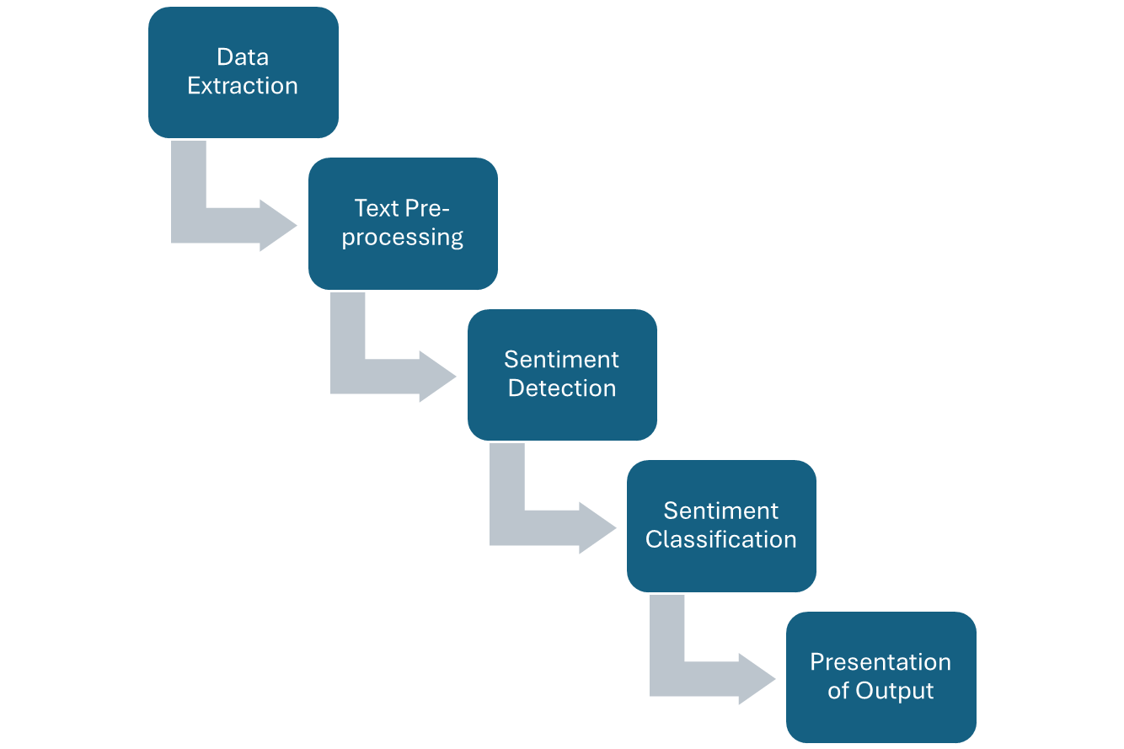

Fig 10.2 : “Sentimental Analysis Steps”

### Sentiment Analysis Challenges

Sentiment analysis is a challenging task in natural language processing as even humans struggle to analyze sentiments accurately. Let us look at some challenges of machine-based sentiment analysis:

#### Subjectivity and Tone

As you know, there are two types of text available, i.e., subjective and objective. Subjective texts contain explicit sentiments, while the objective text does not. For example, you want to analyze the sentiment of the following two texts:

*“The phone is nice.”*

*“The phone is blue.”*

You will say that the sentiments are positive for the first and neutral for the second. Here, all text predicates should not be treated differently regarding how they create the sentiment. In this example, nice is more subjective in comparison to blue.

#### Context and Polarity

Analyzing sentiment without context gets difficult as machines cannot learn about contexts if it is not trained explicitly. The most crucial disadvantage that arises from context is changing in polarity. Check out the below responses to a survey:

*“Everything of it”*

*“Absolutely nothing!”*

Consider the question, “*What did you like about this phone?”* The first response will be positive, and the second response will be negative. Now consider the question, “*What did you dislike about this phone?”* The negative verb “*dislike*” in the given question will change the sentiment analysis of the text. If you consider the tiniest part of the context in the input text, you will need many preprocessing and postprocessing methods.

#### Irony and Sarcasm

When it comes to sarcasm, people tend to express their negative sentiments using affirmative words, making it difficult for machines to detect and understand the context of the situation and genuine emotions.

For instance, consider the question, “*Did you enjoy your trip with us?”*

*Yes, sure. So enjoyable!*

*Not one, but many!*

If you consider the first response, the exclamation mark displays negation, correct? The challenge here is that there is no textual cue to help the machine understand the sentiment because “yeah” and “sure” are often considered positive or neutral. However, suppose you consider the second response. In that case, sentiment is positive, but you will also develop many different contexts expressed in negative sentiment.

#### Comparisons

It is quite a challenge to tackle the comparisons while analyzing the sentiment of the text. For instance,

*This product is better than others.*

*The new shop is far from the old one.*

*I like blue more than orange.*

The first response specifies that it is positive. But what about the second and third responses? As mentioned above, context can make a difference in the sentiments of the sentence. In the second response, if the “old one” is considered useless, it becomes a lot easier to classify it.

#### Emojis

According to Guibon, there are two types of emojis, i.e., Western emojis (:D) containing only one or two characters, and Eastern emojis (¯ \ (ツ) / ¯), which have more characters of vertical nature. Emojis play a prominent role in sentiment analysis, especially while working with tweets. When it comes to analyzing tweets, you will have to pay more attention to character-level and word-level at the same time. And for this purpose, a lot of preprocessing might be needed. For example, you must preprocess the tweets and convert the eastern emojis and western emojis into tokens. Further, allow list them, which will improve your sentiment analysis performance.

#### Defining Neutral

When performing accurate sentiment analysis, defining the category of neutral is the most challenging task. As mentioned earlier, you must define your types by classifying positive, negative, and neutral sentiment analysis. In this case, determining the neutral tag is the most critical and challenging problem. Since tagging data requires consistency for accurate results, a good definition of the problem is necessary.

Here are some examples to define neutral texts:

**Objective texts:** As objective texts do not contain explicit sentiments; you can include them in the neutral category.

**Irrelevant information**: You can tag the irrelevant data of your text as neutral if you have not preprocessed your text. But it is recommended to do this only if this data does not affect overall performance. Because sometimes, you may add unnecessary data(noise) to your categorization, and performance can worsen.

**Wishes Texts**: You can consider some wishes like “*I wish the camera had more clarity*” as neutral texts. But at the same time, the texts including comparisons like “*I wish the camera were better*” are difficult to categorize.

#### Human Annotator Accuracy

Sentiment Analysis is quite a challenging task, whether it is a machine or a human. When it comes to sentiment analysis, the inter-annotator agreement is extremely low. And since the machines learn from the humans by the data they feed, sentiment analysis classifiers are not as accurate as other types.

These challenges highlight the complexity of human language and communication. Overcoming them requires advanced NLP techniques, deep learning models, and a large amount of diverse and well-labelled training data. Despite these challenges, sentiment analysis continues to be a rapidly evolving field with vast potential.

### Applications of Sentiment Analysis

Sentiment Analysis has a wide range of applications across various domains. Here are some key applications:

#### Brand Monitoring

A brand is not defined by the product it manufactures. It depends on how you build a brand by online marketing, social campaigning, content marketing, and customer support services. Getting full 360 views of how your customers view your product, company, or brand is one of the most important uses of sentiment analysis. Sentiment analysis enables you to quantify the perception of potential customers. Analyzing social media and surveys, you can get key insights about how your business is doing right or wrong for your customers. Companies tend to use sentiment analysis as a powerful weapon to measure the impact of their products and campaigns on their customers and stakeholders. Brand monitoring allows you to have a wealth of insights from the conversions about your brand in the market. Sentiment analysis enables you to automatically categorize the urgency of all brands mentions and further route them to the designated team. Keeping the feedback of the customer in knowledge, you can develop more appealing branding techniques and marketing strategies that can help make quick transitions.

#### Customer Service

Customer service companies often use sentiment analysis to automatically classify their user incoming calls into “urgent” and “not urgent” classes. The classification is based on the sentiments of the emails or proactively identifying the calls of frustrated customers. The customer expects their experience with the companies to be intuitive, personal, and immediate. Therefore, the service providers focus more on the urgent calls to resolve users’ issues and thereby maintain their brand value. Therefore, analyze customer support interactions to make sure that your employees are following the appropriate process. Moreover, increase the efficiency of your services so that customers are not left waiting for support for longer periods. As the customer service sector has become more automated using machine learning, understanding customers’ sentiments has become more critical than ever before. For the same reason, companies are opting for NLP-based chatbots as their first line of customer support to better grasp context and intent of the conversations.

#### Finance and Stock Monitoring

It is said that “*Be fearful when others are greedy and be greedy when others are fearful*.” But here, the question that arises: how do you know if others are fearful or greedy? Well, here, you can make use of the sentiment analysis technique. Making investments, especially in the business world, is quite tricky. The stocks and market are always on the edge of risks, but they can be condensed if you do correct research before investing. For instance, if you are looking to invest in the automobile industry and are confused about choosing between company X and company Y, you can look at the sentiments received from the company for their latest products. It will help you to find the one that is performing better in the market.

#### Business Intelligence Buildup

Digital marketing plays a prominent role in business. Social media often displays the reactions and reviews of the product. When you are available with the sentiment data of your company and new products, it is a lot easier to estimate your customer retention rate. Sentiment analysis enables you to determine how your product performs in the market and what else is needed to improve your sales. You can also analyze the responses received from your competitors. Based on the survey generated, you can satisfy your customer’s needs in a better way. You can make immediate decisions that will help you to adjust to the present market situation. Business intelligence is all about staying dynamic. Therefore, sentiment analysis gives you the liberty to run your business effectively. For example, if you produce a big idea, you can evaluate and analyze it before bringing life to it.

#### Enhancing the Customer Experience

A satisfying customer experience means a higher chance of returning the customers. A successful business knows that it is important to take care of how they deliver compared to what they deliver. Brand Monitoring offers us unfiltered and invaluable information on customer sentiment. However, you can also put this analysis on customer support interactions and surveys. NPS (Net Promoter Score) surveys help you gain feedback for your business with the simple question: Will you recommend this brand, product, or service to your friend or family? The output is a single score on the number scale. Businesses use these sentiment scores to analyze the customer as promoters, detractors, and passives. Here the goal is to find the overall customer experience and elevate your customer to promoter level. Theoretically, include the phases as: will buy more, stay longer, and refer to another customer. The next step in the NPS survey is to ask survey participants to leave the score and seek open-ended responses, i.e., qualitative data. Qualitative surveys are far more challenging to analyze. Still, with the help of sentiment analysis, these texts can be classified into multiple categories, which offer further insights into customers’ opinions. As mentioned earlier, the experience of the customers can either be positive, negative, or neutral. Depending on the customers’ reviews, you can categorize the data according to its sentiments. This classification will help you properly implement the product changes, customer support, services. Also, remember that getting a positive response to your product is not always enough. The customer support services of your company should always be impeccable irrespective of how phenomenal your services are.

#### Market Research and Analysis

Business intelligence uses sentiment analysis to understand the subjective reasons why customers are or are not responding to something, whether the product, user experience, or customer support. Sentiment analysis will enable you to have all kinds of market research and competitive analysis. It can make a stark difference whether you are exploring a new market or seeking an edge on the competition. You can review your product online and compare them to your competition. You can also analyze the negative points of your competitors and use them to your advantage. Sentiment analysis is used in sociology, psychology, and political science to analyze trends, opinions, ideological bias, gauge reaction, etc. . A lot of these sentiment analysis applications are already up and running.

## What is Natural Language Processing?

NLP involves processing, analyzing, and generating natural language data. NLP is used in performing various tasks, including the following:

*Text Summarization*: Creating concise summaries of long documents while retaining key information. This is particularly useful in news aggregation, legal document analysis, and academic research.

*Text Classification*: This involves categorizing text into predefined classes or categories. Applications include spam detection, sentiment classification, and tagging customer inquiries.

*Speech Recognition*: Converting spoken language into written text, enabling applications like virtual assistants (e.g., Siri, Alexa), transcription services, and voice-activated control systems.

*Sentiment Analysis*: Determining the emotional tone behind a series of words to understand the attitudes, opinions, and emotions expressed within the text. This is widely used in social media monitoring, customer feedback analysis, and market research.

*Machine Translation*: Automatically converting text from one language to another while maintaining the original meaning. Popular applications include translation services like Google Translate and multilingual customer service chatbots.

NLP is not limited to just these tasks. It can also solve more complex challenges such as named entity recognition (NER), part-of-speech tagging, topic modeling, and making applications more intuitive and efficient. To tackle these different NLP challenges, Hugging Face transformers provide a robust and stable solution with state-of-the-art models and resources for various NLP applications.

### Understanding Hugging Face Transformers

Hugging Face Transformers is an open-source library that has changed the field of natural language processing by providing access to pre-trained transformer models. These models are designed to manage various NLP tasks, from text classification to complex challenges like machine translation or named entity recognition.

Transformers use self-attention, which allows them to weigh the importance of different words in a sentence and better understand the context. This makes them highly effective for processing and generating natural language data. These models are capable of translating text and speech in near real-time. Hugging Face offers an extensive collection of pre-trained models available on their Model Hub. Here are some of the key models and their general applications:

**BERT (Bidirectional Encoder Representations from Transformers):** Ideal for understanding the context of a word in a sentence by looking at the words before and after it. It is widely used for sentiment analysis, question answering, and named entity recognition.

**GPT (Generative Pre-trained Transformer):** Focused on generating coherent and contextually relevant text, making it perfect for tasks like text completion, dialogue generation, and creative writing.

**RoBERTa (Robustly Optimized BERT Pretraining Approach):** An optimized version of BERT that delivers better performance on various NLP tasks by training with more data and longer sequences.

**T5 (Text-To-Text Transfer Transformer):** A versatile model that converts all NLP tasks into a text-to-text format, making it flexible for many applications such as translation, summarization, and classification.

**DistilBERT**: a smaller, faster, cheaper, and lighter version of BERT trained using knowledge distillation. It is ideal for deploying NLP models in resource-constrained environments.

**LUKE (Language Understanding with Knowledge-based Embeddings**): Enhances transformers by incorporating structured knowledge from external knowledge bases, which improves performance on tasks like named entity recognition and relation classification.

**GPT-3**: The latest and most powerful version of the GPT series, capable of generating highly coherent and contextually relevant text, performing tasks like question answering, language translation, and even creative writing with minimal fine-tuning.

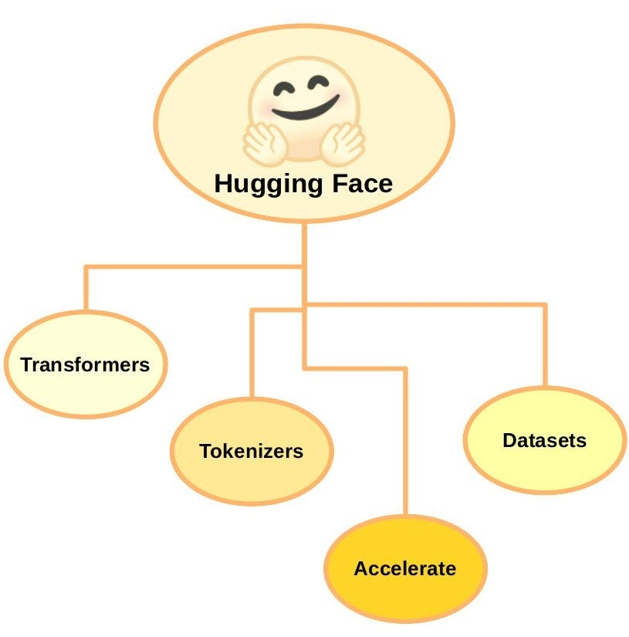

Fig 10.3 “Hugging Face Transformers”

### Why Use Hugging Face Transformers?

There are several benefits to using Hugging Face Transformers. Some of them include:

*Ease of Use*: The library is designed to be user-friendly, with extensive documentation and tutorials to help users get started quickly.

*Pre-trained Models*: Access to a wide range of pre-trained models means you can leverage state-of-the-art NLP capabilities without needing to train models from scratch.

*Versatility*: The library supports multiple tasks and can be integrated with both PyTorch and TensorFlow, offering flexibility in terms of deployment.

*Community and Support*: A vibrant community contributes to continuous improvement and offers support through forums and GitHub.

*Cost-Effective*: Save on compute costs by using available models.



### 10.1 Key Takeaways



* Sentiment analysis is a classification task in NLP, sometimes called ‘opinion mining,’ it transforms the opinions found in written language or speech data into actionable insights.
* The sentiment can be classified into three categories: Positive Sentiment Expressions indicate a favorable opinion or satisfaction; Negative Sentiment Expressions indicate dissatisfaction, criticism, or negative views; and Neutral Sentiment Text expresses no sentiment or is unclear.
* The rule-based system performs sentiment analysis based on manually crafted rules to identify polarity, subjectivity, or the subject of an opinion.
* Depending on the amount of data and accuracy you need in your result, you can implement different sentiment analysis models and algorithms accordingly.
* In Automatic approach the sentiment analysis system consists of a classification problem where the input will be the text to be analyzed. It will return a polarity if the text, for example, is positive, negative, or neutral.
* Support Vector Machines is a non-probabilistic model that uses a representation of the input text as a point in multi-dimensional space.
* A massive advantage of Hybrid approach is that the results are often more accurate and precise than the rule-based and automated approaches.
* Sentiment Analysis is quite a challenging task, whether it is a machine or a human. When it comes to sentiment analysis, the inter-annotator agreement is extremely low.
* Hugging Face Transformers is an open-source library that has changed the field of natural language processing by providing access to pre-trained transformer models. These models are designed to manage various NLP tasks, from text classification to complex challenges like machine translation or named entity recognition.

### 10.2 Quiz :



Q1. Which of the following is not a task in natural language processing?

1. Sentiment analysis
2. Speech recognition
3. Image classification
4. Named entity recognition.

Q2. What is the primary goal of natural language processing?

1. Understanding and generating human language
2. Translating languages
3. Analyzing data patterns
4. Creating conversational agents

Q3. Which of the following techniques is commonly used in text classification tasks?

1. Latent Semantic Analysis (LSA)
2. Convolutional Neural Networks (CNN)
3. Principal Component Analysis (PCA)
4. Support Vector Machines (SVM)

Q4. What is the process of converting words into their base or root form called?

1. Tokenization
2. Stemming
3. Lemmatization
4. Part-of-speech tagging

Q5. Which algorithm is commonly used in named entity recognition?

1. K-means clustering
2. Hidden Markov Models (HMM)
3. Decision trees
4. None of the Above

Q6. What is the purpose of the Bag-of-Words (BoW) model in NLP?

1. To represent words as vectors
2. To calculate word frequencies
3. To identify syntactic dependencies
4. To perform sentiment analysis

Q7. Which technique is used to manage imbalanced datasets in text classification?

1. Oversampling
2. Under sampling
3. SMOTE (Synthetic Minority Over-sampling Technique)
4. All the above

Q8. Which of the following is an example of a stop word?

1. Noun
2. Verb
3. Adjective
4. The

Q9. Which technique is used to predict the probability of a sequence of words in each context?

1. Language modeling
2. Named entity recognition.
3. Sentiment analysis
4. Machine translation

Q10. Which NLP task involves labeling words in a sentence with their respective grammatical categories?

1. Named entity recognition.
2. Part-of-speech tagging
3. Dependency parsing
4. Sentiment analysis

11. Which neural network architecture is commonly used for sequence-to-sequence tasks like machine translation?

1. Long Short-Term Memory (LSTM)
2. Convolutional Neural Network (CNN)
3. Recurrent Neural Network (RNN)
4. Transformer

Q12. Which of the following algorithms is used for topic modeling?

1. K-means clustering
2. Naive Bayes
3. Latent Dirichlet Allocation (LDA)
4. Random Forests

Q13. Which technique aims to identify and extract the main ideas or topics from a collection of documents?

1. Sentiment analysis
2. Text summarization
3. Named entity recognition.
4. Document clustering

Q14. Which metric is commonly used to evaluate machine translation systems?

1. BLEU score
2. F1 score
3. Precision
4. Recall

Q15. Which of the following is an example of a word embedding technique?

1. One-Hot Encoding
2. Bag-of-Words.
3. Latent Semantic Analysis (LSA)
4. Word2Vec

Q16. Which method is used to calculate the similarity between two documents based on their content?

1. Cosine similarity
2. Euclidean distance
3. Jaccard similarity
4. Pearson correlation coefficient

Q17. Which technique is used to generate new sentences or text based on existing data?

1. Sentiment analysis
2. Text generation
3. Named entity recognition.
4. Part-of-speech tagging

Q18. Which algorithm is commonly used for sentiment analysis?

1. Naive Bayes
2. K-nearest neighbors (KNN)
3. Decision trees
4. Support Vector Machines (SVM)

Q19. What is the purpose of the attention mechanism in neural networks?

1. To improve computational efficiency
2. To reduce overfitting
3. To focus on relevant information
4. To calculate feature importance

Q20. Which of the following is not a sequence labeling task?

1. Named entity recognition.
2. Part-of-speech tagging
3. Sentiment analysis
4. Chunking

### Research with solid fill10.3 Hands-on Case Study:

*Sentimental Analysis – Movie Review*

*Credit Kaggle for Source Data Set*

<https://www.kaggle.com/code/lakshmi25npathi/sentiment-analysis-of-imdb-movie-reviews>

**Background**

Sentiment analysis (or opinion mining) is a natural language processing (NLP) technique used to determine whether data is positive, negative, or neutral. Sentiment analysis is often performed on textual data to help businesses monitor brand and product sentiment in customer feedback and understand customer needs.

**Problem Statement**

Build an ML model on movie reviews data to determine whether the sentiment of a movie review is positive or negative.

**Objectives**

* Preprocess the text and make it ready for model building.
* Build a Decision Tree model to predict review sentiment and observe its performance.

**Data Dictionary**

The description of the different variables in the dataset is provided below.

|  |  |
| --- | --- |
| Column Name | Description |
| Index | Index corresponding to the review |
| URL | URL to the movie review |
| Text | Review text of the movie |
| Sentiment | Sentiment associated with review – Positive (POS) or Negative (NEG) |

Step1 : Source Data set : imdb-reviews.csv

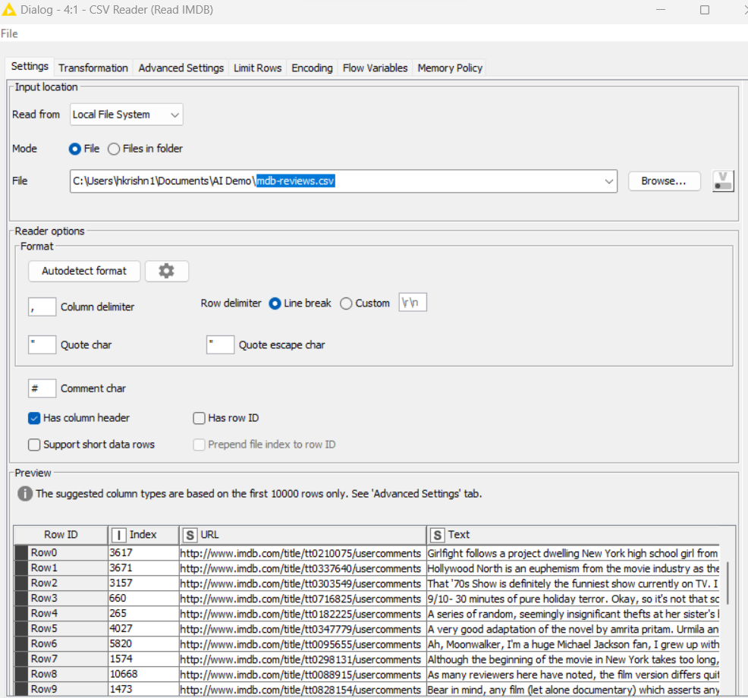

Step 2: Convert Strings to Document

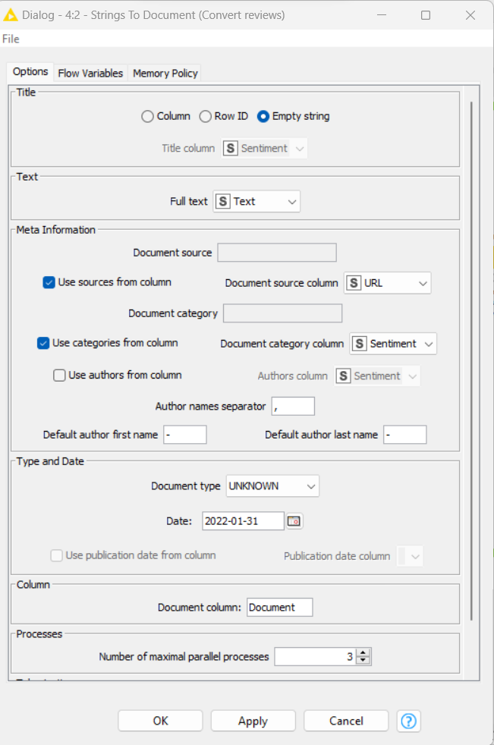

Step 3: Data sorting and Cleansing

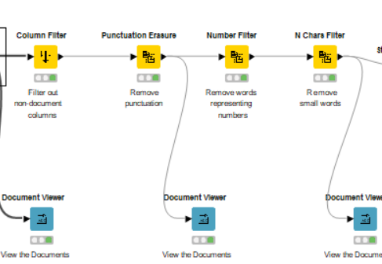

Step 4: Stop Word filter and Case converter and Bag of words.

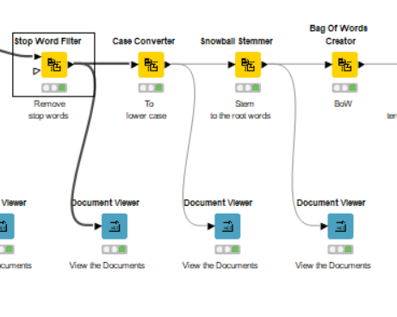

Step 5 : Document Vector

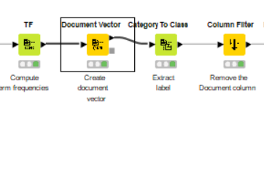

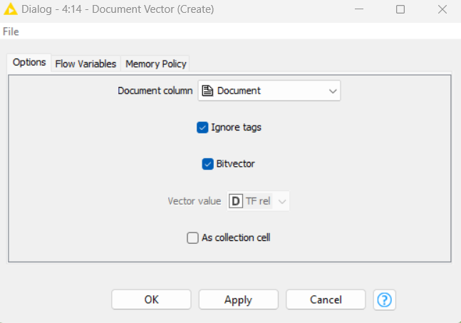

Step 6: Partitioning and Decision Tree Algo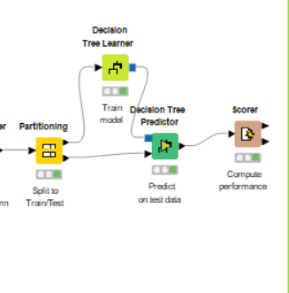

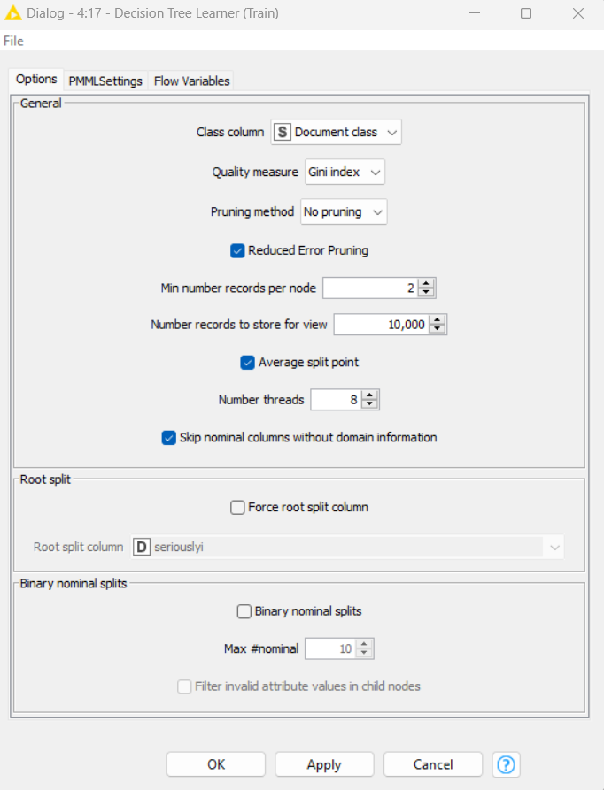

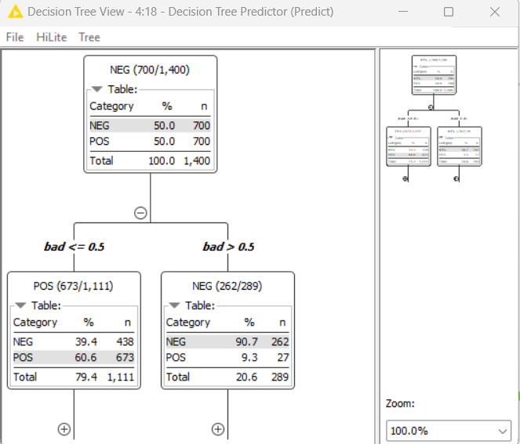

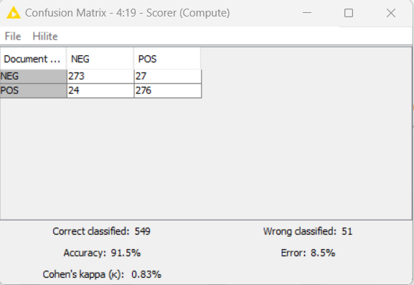

*Conclusion: The NLP Model is Successfully executed with 91.5 % accuracy with sentiment analysis of a movie review is positive or negative and more tuning opportunity with DT Configuration.*



### 10.4 Exercise do it yourself:

*Credit Kaggle for Source Data Set*

<https://www.kaggle.com/datasets/crowdflower/twitter-airline-sentiment>

A sentiment analysis job about the problems of each major U.S. airline. Twitter data was scraped from February of 2015 and contributors were asked to first classify positive, negative, and neutral tweets, followed by categorizing negative reasons (such as "late flight" or "rude service").

# **11 Recommendation Systems**

A recommendation system is a class of machine learning that uses data to help predict, narrow down, and find what people are looking for among an exponentially growing number of options. It is an AI algorithm this is associated with machine learning and uses Big Data to suggest or recommend additional products to consumers. These can be based on various criteria, including past purchases, search history, demographic information, and other factors. Recommender systems are incredibly useful as they help users discover products and services they might otherwise have not found on their own. Recommender systems are trained to understand the preferences, previous decisions, and characteristics of people and products using data gathered about their interactions. These include impressions, clicks, likes, and purchases. Because of their capability to predict consumer interests and desires on a highly personalized level, recommender systems are a favorite with content and product providers. They can drive consumers to about any product or service that interests them, from books to videos to health classes to clothing.

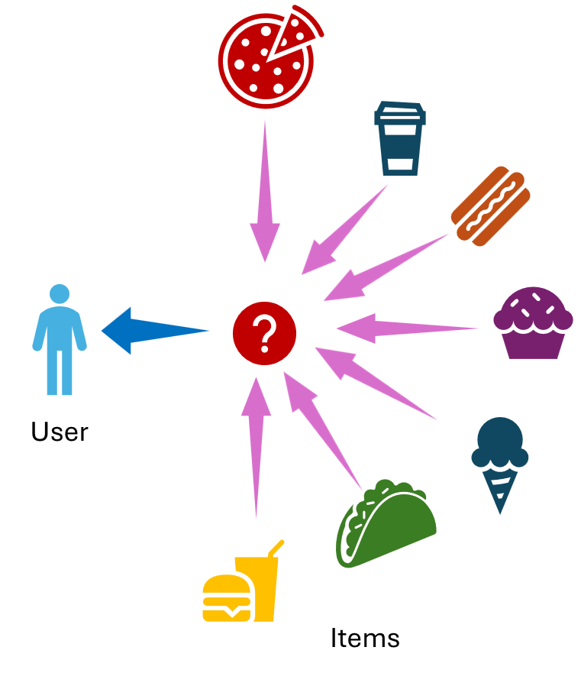

Fig 11.1 : “Recommendation Systems”

## How Recommendation System Works?

There are four basic steps of the recommendation system, the specific implementation details may vary depending on the type of system and application domain.

Collecting user data: The first step in building a recommendation system is to collect user data. This can include user ratings, reviews, clickstream data, purchase history, and other behavioral data. The data can be collected either explicitly, through user surveys or feedback forms, or implicitly, through user interactions with the platform.

Storing the data: Once the user data is collected, it needs to be stored in a database or data warehouse for analysis. The data can be stored in a structured or unstructured format, depending on the type and volume of the data.

Analyzing the data: The next step is to analyze the user data to identify patterns and trends. This can be done using various data analysis techniques like clustering, classification, and regression. The goal is to understand the user’s preferences, behaviors, and interests, and to use this information to make personalized recommendations.

Filtering and recommending: The last step filter the data and make recommendations to the user. This can be done using various recommendation algorithms, such as collaborative, content-based, and hybrid filtering. The algorithm uses the user data and the analysis results to generate a list of recommended items the user will be interested in. The recommendations are then presented to the user in a personalized way, such as through a recommendation widget, email, or push notification.

## Types of Recommendation Systems

### Content based filtering.

Content-based filtering in recommender systems leverages machine learning algorithms to predict and recommend new but related items to the user. Recommending products based on their characteristics is only possible if there is a clear set of features for the product and a list of the user’s choices. The recommender system stores previous user data like clicks, ratings, and likes to create a user profile. The more a customer engages, the more accurate future recommendations are. It recommends items to the customer like previously high-rated items by the customer. It uses the features and properties of the item. From these properties, it can calculate the similarity between the items. In this recommendation system, first, we create a profile for each item, which represents the properties of those items. The user profiles are inferred for a particular user. We use these user profiles to recommend the items to the users from the catalog. Let us suppose there are four movies, and a user has seen and liked the first two. The model automatically suggests the third movie rather than the fourth since it is more like the first two. This similarity can be calculated based on several features like the actors and performance in the movie, the director, the genre, the duration of the film, etc. .

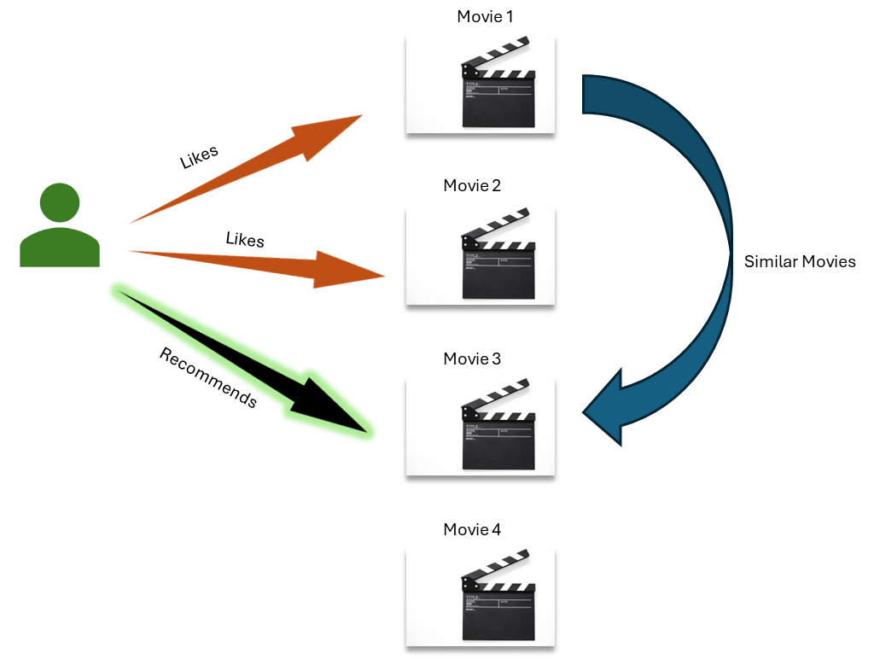

Fig 11.2 : “Content-Based Filtering Recommendation Systems”

#### Item profile

In a content-based recommendation system, we need to build a profile for each item, which contains the important properties of each item. For Example, If the movie is an item, then its actors, director, release year, and genre are its important properties, and for the document, the important property is the type of content and set of important words in it.

#### User profile

A user profile is the collection of vectors that define a user’s preferences. The profile is based on the activities and tastes of the user; for example, user ratings, number of clicks on different items, thumbs up or thumbs down on content, etc., . This information helps the recommender engine to best estimate newer suggestions.

#### Utility matrix

A utility matrix contains the interaction information between the user and the preferred items. Data gathered from the day-to-day activities of the user is saved in a structured format to find the likes and dislikes of different items the user has interacted with. A value is assigned to every interaction, known as the ‘degree of preference.’ A few values are missing in the above example of a utility matrix. This is because some users do not interact with every item available on the platform. Note that the goal of the recommender model is to suggest added items based on this utility matrix.

|  |  |  |  |  |
| --- | --- | --- | --- | --- |
|  | User1 | User2 | User3 | User4 |
| Item1 | ? | ? | 0 | 2 |
| Item2 | 2 | 1 | ? | 1 |
| Item3 | 5 | ? | 2 | 4 |
| Item4 | 0 | 3 | 1 | ? |

There are two popular methods used in content-based filtering: cosine distance and classification approach.

##### Cosine distance

Here, the cosine distance between the user and item vectors is used to determine preference. Let us understand with an example: Our target user enjoys watching action movies and dislikes horror and thrillers. The vector for action movies has positive values and the vector for horror movies has a negative value for that user. Now, consider a new movie released in the sci-fi action genre. Since our user prefers action movies, the cosine angle between the movie vector and the user vector will be a large positive fraction, resulting in a smaller angle which means it is a good recommendation for our user. If the cosine distance is large, we ignore the item since it is a bad recommendation.

##### Classification approach

Classification algorithms like Bayesian classifiers or decision tree models can be used to make recommendations. For example, every level of a decision tree can be used to filter out the various preferences of the user to make a more refined choice.

##### Advantages

* It is easily scalable to many customers since the data of other users is not required for recommending something to a particular user.
* Since the recommendations are based on the day-to-day activities of the user, all the preferences and parameters of the suggestions are finely tuned to the user’s choice. Therefore, the model can recommend specific niche items that other users might not be interested in.
* The latest items can be suggested as soon as they are launched, without waiting for a census, since the features are readily available from the start.

##### Disadvantages

* Building a content-based recommender engine requires a lot of domain knowledge since the feature selection of the items is mostly hard-coded into the system. Thus, the model is only as good as the knowledge of the one building it.
* The model can recommend latest items based on the present interest of the user. Hence, discovering and expanding to newer avenues that might interest the user is not possible.
* The cold start problem is a significant drawback since the engine does not have sufficient information about a new user to start making suggestions.
* It is hard to make new recommendations to not-so-active users.

### Collaborative filtering

Collaborative filtering is an information retrieval method that recommends items to users based on how other users with similar preferences and behavior have interacted with that item. It is based on the idea that people who agreed in their evaluation of certain items are likely to agree again in the future. The concept is simple: when we want to find a new movie to watch we will often ask our friends for recommendations. Naturally, we have greater trust in the recommendations from friends who share tastes like our own.

In other words, collaborative filtering algorithms group users based on behavior and use general group characteristics to recommend items to a target user. Collaborative recommender systems operate on the principle that similar users (behavior-wise) share similar interests and similar tastes. It uses a matrix to map user behavior for each item in its system. The system then draws values from this matrix to plot as data points in a vector space. Various metrics then measure the distance between points as a means of calculating user-user and item-item similarity.

Most collaborative filtering systems apply the so-called similarity index-based technique. In the neighborhood-based approach, several users are selected based on their similarity to the active user. Inference for the active user is made by calculating a weighted average of the ratings of the selected users. Collaborative-filtering systems focus on the relationship between users and items. The similarity of items is determined by the similarity of the ratings of those items by the users who have rated both items.

An example of collaborative filtering can be to predict the rating of a particular user based on user ratings for other movies and other user’s ratings for all other movies. Let us assume we have users U1, who likes movie M1, M2 and M4, another user U2 who likes movies M1, M3 and M4 and a third user who likes movie M1.

Our job here is to recommend which are the new movies for user U3 to watch next. So here we see that users U1, U2, U3 watch and like movie M1, so all three have same taste and users U1 and U2 have watched movie M4, so the movie M4 is recommended to user U3.

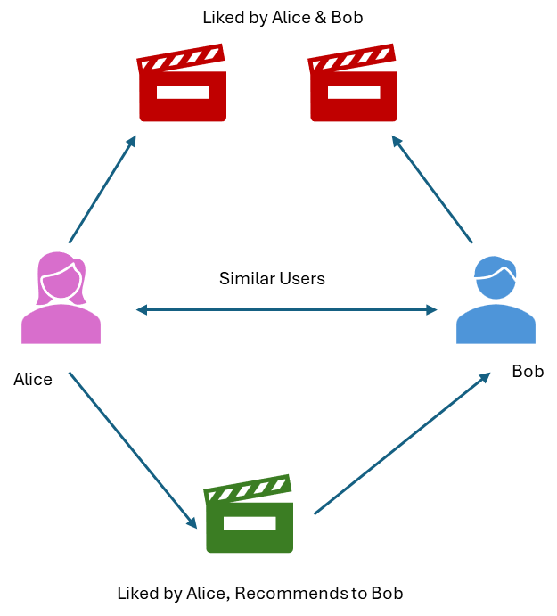

Fig 11.3 : “Collaborative Filtering Recommendation Systems”

There are two metrics used to measure similarity between various users.

#### Cosine Similarity

Cosine similarity signifies the measurement of the angle between two vectors. Compared vectors comprise a subset of ratings for given user or item. The cosine similarity score can be any value between -1 and 1. The higher the cosine score, the more alike two items are considered. Some sources recommend this metric for high-dimensional feature spaces. In collaborative filtering, vector points are pulled directly from the user-item matrix. Cosine similarity is represented by this formula, where x and y signify two vectors in vector space:

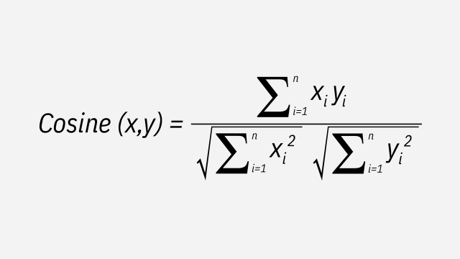

#### Pearson correlation coefficient

PCC helps measure similarity between items or users by computing the correlation between two users’ or items’ respective ratings. PCC ranges between -1 and 1, which signify negative to identical correlation. Unlike cosine similarity, PCC uses all the ratings for a given user or item. For example, if calculating PCC between two users, we use this formula, in which a and b are different users, and rai and rbi are that user’s rating for item.

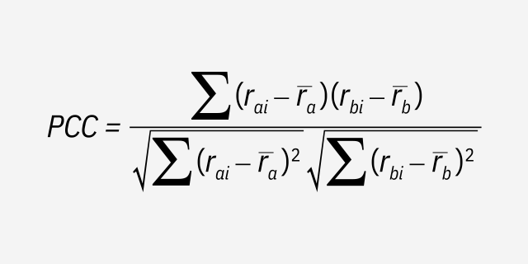

There are two classes of Collaborative Filtering:

* User-based filtering recommends items to a target user based on the preferences of behaving users. The recommendation algorithm compares a target user’s past behavior to other users. Specifically, the system assigns each user a weight representing their perceived similarity with the target user—this is the target user’s neighbors. It then selects n users with the highest weights and computes a prediction of the target user’s behavior (e.g., movie rating, purchase, dislikes, etc. .) from a weighted average of the selected neighbors’ behavior. The system then recommends items to the target user based on this prediction. The principle is that, if the target user behaved similarly to this group in the past, they will behave similarly with unseen items. User-based similarity functions are computed between rows in the user-item matrix.
* Item-based filtering recommends latest items to a target user based on that user’s behavior toward related items. Note, however, that in comparing items, the collaborative system does not compare item features (as in content-based filtering) but instead how users interact with those items. For instance, in a movie recommendation system, the algorithm may identify similar movies based on correlations between all user ratings for each movie (correcting for each user’s average rating). The system will then recommend a new movie to a target user based on correlated ratings. That is, if the target user rated movie a and b highly but has not seen movie c, and other users who rated the former two highly also rated movie c highly, the system will recommend movie c to the target user. In this way, item-based filtering calculates item similarity through user behavior. Item-based similarity functions are computed between columns in the user-item matrix.

Compared to content-based systems, collaborative filtering is more effective at providing users with novel recommendations. Collaborative-based methods draw recommendations from a pool of users who share interests with one target user. It can recommend items that a target user may have not considered but that nevertheless appeal to their user type.

The cold start problem is the most widely cited disadvantage of collaborative filtering systems. It occurs when a new user (or even a latest item) enters the system. That user’s lack of item-interaction history prevents the system from being able to evaluate the new user’s similarity or association with existing users. By contrast, content-based systems are more adept at handling latest items, although they also struggle with recommendations for unaccustomed users.

##### Matrix Factorization

Matrix Factorization (MF) is a collaborative filtering method to find the relationship between items and user’s entities. The MF of user and item matrices can be generated when the math cost function **RMSE** is minimized through matrix factorization. Its objective is to factorize a user-item matrix into two low-ranked matrices, the user factor matrix and the item factor matrix that can predict latest items that users might be interested in.

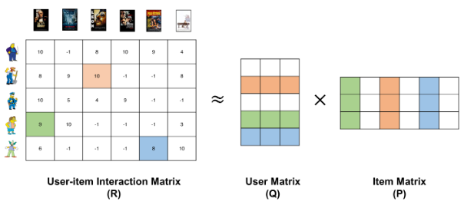

Fig 11.4 : “Matrix Factorization”

There are various techniques available for the matrix factorization such as:

* Singular value decomposition
* Probabilistic matrix factorization
* Non-negative matrix factorization
* Bayesian probabilistic matrix factorization
* Tensor matrix factorization

### Collaborative filtering vs content-based filtering for recommender systems

* Content-based filtering methods require quite an amount of information about an item’s features, rather than its interactions with the user. For products like clothes, these features can be size, color, brand, material, etc. ., or in the case of movies, actors, genre, director, year of release, etc. .

Collaborative filtering, on the other hand, uses historical interactions between the users and items to group users with similar tastes and suggest latest items, which are popular to the group, to the target user.

* Content-based filtering models are heavily based on domain knowledge since the item features are hand-engineered into the system. Collaborative filtering does not need such in-depth domain knowledge since all the embeddings are automatically learned.

Collaborative filtering systems require only the user behavior data, whereas content-based methods require both user and item data.

### Hybrid Recommendation Systems

Hybrid recommendation system uses a combination of content-based recommendation system and collaborative filtering recommendation system to achieve the best performance by reducing the drawbacks of the conventional recommendation techniques. The accuracy of hybrid system is slightly higher as the combination of both the content and collaborative filtering system leads to common knowledge increase, which contributes to better recommendations. The knowledge increase makes it especially promising to explore new ways to extend underlying collaborative filtering algorithm with the content data and content-based algorithms with the user behavior data.

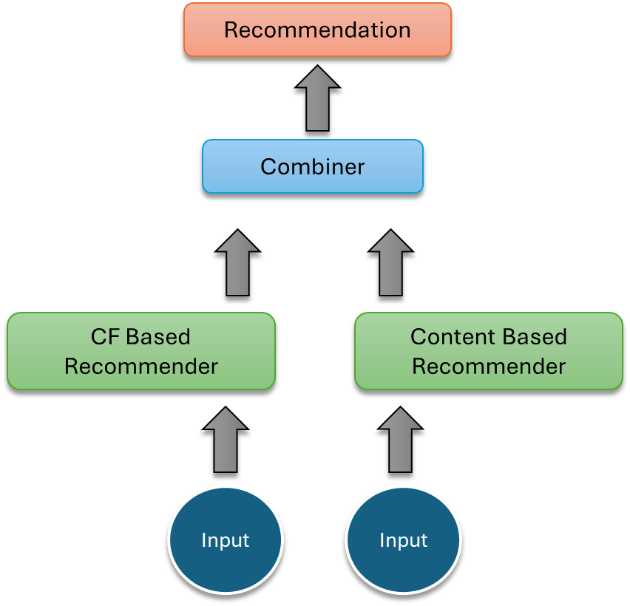

Fig 11.5 : “Hybrid Recommendation System”

There are 7 approaches to build a mixed hybrid recommendation system.

#### Weighted

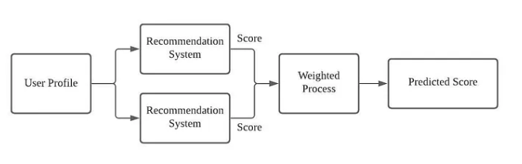

In the weighted recommendation system, we can define a few models that is able to well interpret the dataset. The weighted recommendation system will take the outputs from each of the models and combine the result in static weightings, which the weight does not change across the train and test set. For example, we can combine a content-based model and an item-item collaborative filtering model, and each takes a weight of 50% toward the final prediction. The benefit of using the weighted hybrid is that we integrate multiple models to support the dataset on the recommendation process in a linear way.

#### Switching

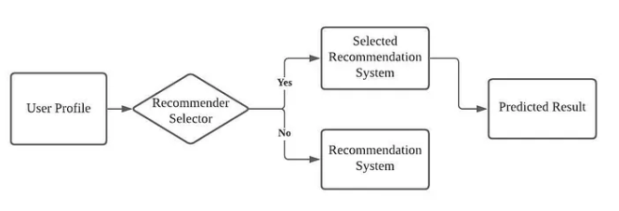

The switching hybrid selects a single recommendation system based on the situation. The model is used to be built for the item-level sensitive dataset, we should set the recommender selector criteria based on the user profile or other features. The switching hybrid approach introduces an additional layer upon the recommendation model, which select the appropriate model to use. The recommender system is sensitive to the strengths and weakness of the constituent recommendation model.

#### Mixed

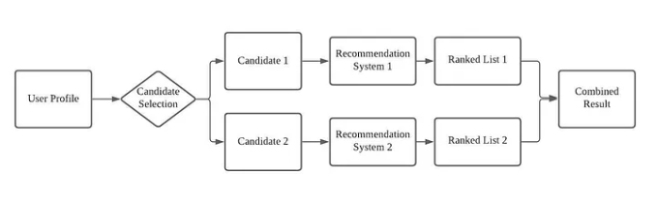

Mixed hybrid approach first takes the user profile and features to generate separate set of candidate datasets. The recommendation system inputs distinct set of candidates to the recommendation model accordingly and combine the prediction to produce the result recommendation. The mixed hybrid recommendation system can make substantial number of recommendations simultaneously and fit the partial dataset to the appropriate model to have better performance.

#### Feature Combination

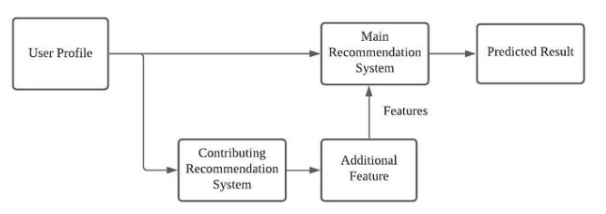

In feature combination hybrid, we add a virtual contributing recommendation model to the system, which works as feature engineering toward the original user profile dataset. For example, we can inject features of a collaborative recommendation model into a content-based recommendation model. The hybrid model is capable to consider the collaborative data from the sub system with relying on one model exclusively.

#### Feature Augmentation

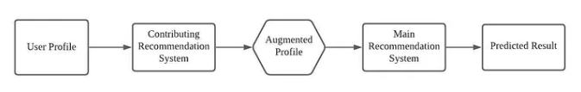

A contributing recommendation model is employed to generate a rating or classification of the user/item profile, which is further used in the main recommendation system to produce the final predicted result. The feature augmentation hybrid can improve the performance of the core system without changing the main recommendation model. For example, by using the association rule, we can enhance the user profile dataset. With the augmented dataset, the performance of content-based recommendation model will be improved.

#### Cascade

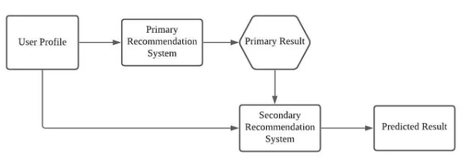

Cascade hybrid defines a strict hierarchical structure recommendation system, such that the main recommendation system produces the primary result, and we use the secondary model to resolve some minor issues of the primary result, like breaking tie in the scoring. In practice, most of the dataset are sparse, the secondary recommendation model can be effective against equal scoring issue or missing data issue.

#### Meta-Level

Meta-level hybrid is like the feature augmentation hybrid, such that the contributing model is providing augmented dataset to the main recommendation model. Different from the feature augmentation hybrid, meta-level replaces the original dataset with a learned model from the contributing model as the input to the main recommendation model.

## Implicit Vs Explicit Feedback

Implicit feedback: is feedback that is not given directly by the user, but rather is inferred based on the user’s behavior. For instance, if a user frequently listens to a particular artist on a music streaming platform, that can be considered as implicit feedback as it indicates that the user likes that artist.

Explicit feedback: is feedback that is directly given by the user. For instance, a user rating a product on e-commerce platform is considered as explicit feedback as it states the user’s opinion about the product.

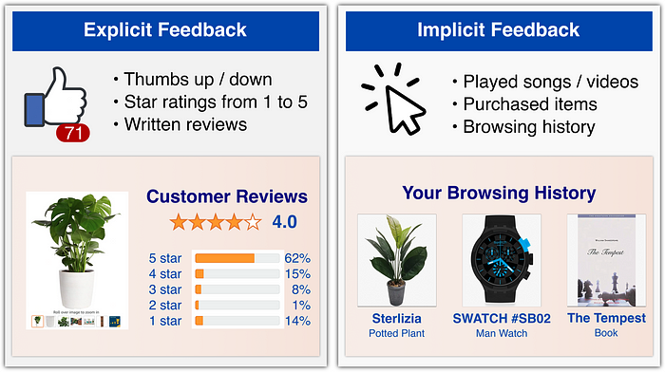

Fig 11.6 : “Explicit vs Implicit Recommendation system” *(Image Source : Towards Data science,* [*https://towardsdatascience.com/recommender-systems-a-complete-guide-to-machine-learning-models-96d3f94ea748*](https://towardsdatascience.com/recommender-systems-a-complete-guide-to-machine-learning-models-96d3f94ea748))

The main difference between the two is the level of user engagement and the amount of information available. Implicit feedback is passive and does not require any active input from the user. It is also often noisy and ambiguous, making it more difficult to interpret. Explicit feedback on the other hand, is more direct and explicit, making it easier to interpret and analyze. In a recommendation system, both kinds of feedback can be used to make recommendations. Explicit feedback can be used to directly infer user preferences and to train a model to make better recommendations. On the other hand, implicit feedback can be used to infer user preferences indirectly, and to provide additional information to the recommendation algorithm.

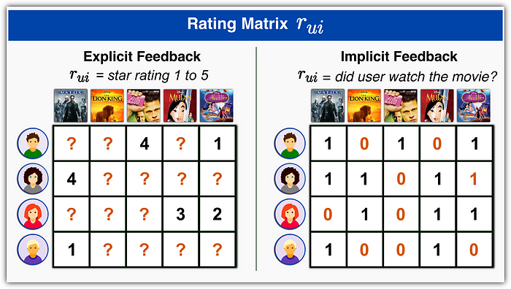

Fig 11.7 : “User Item rating for implicit & explicit feedback” *(Image Source : Towards Data science,* [*https://towardsdatascience.com/recommender-systems-a-complete-guide-to-machine-learning-models-96d3f94ea748*](https://towardsdatascience.com/recommender-systems-a-complete-guide-to-machine-learning-models-96d3f94ea748))

For example, in a movie recommendation system, explicit feedback might be ratings that users give to movies, whereas implicit feedback might be the frequency at which they watch certain genres of movies. By combining both kinds of feedback, the recommendation algorithm can provide more accurate and personalized recommendations.

## Evaluation Metrics for Recommendation Systems

There are diverse ways to evaluate recommendations, from predictive and ranking metrics to tracking behavioral properties like diversity or novelty.

Accuracy: Accuracy is a common metric used to evaluate the performance of recommender systems. It measures the proportion of correct predictions against total predictions. For example, if a recommender system predicts 8 out of 10 relevant items, then its accuracy is 80%.

Precision and Recall: Precision measures the proportion of relevant items recommended by the system that are relevant to the user. Recall measures the proportion of relevant items that are recommended by the system. Both Precision and Recall are important as they give us a better understanding of the performance of the system.

Precision*:* A measure of exactness determines the fraction of relevant items retrieved out of all items retrieved. If the recommender system recommends 10 relevant items to a user, and 8 of them are indeed relevant, then the precision is 80%.

*TP: True Positive*

*FP: False Positive*

**Precision= TP/(TP+FP)**

Recall: A measure of completeness determines the fraction of relevant items retrieved out of all relevant items. If there are 20 relevant items for a user, and the recommender system recommends 10 of them, then the recall is 50%.

*TP: True Positive*

*FN: False Negative*

**Recall= TP/(TP+FN)**

F1 Score: F1 Score is the harmonic mean of Precision and Recall, and it is a useful metric for evaluating the overall performance of the recommender system. It ranges between 0 and 1, where 1 is the best score.

Mean Absolute Error (MAE): MAE measures the average difference between the predicted and actual ratings. It is also known as the L1 norm, and the lower the MAE, the better the performance of the system.

Root Mean Squared Error (RMSE): RMSE is another commonly used metric for evaluating recommender systems. It measures the square root of the average squared difference between the predicted and actual ratings. The lower the RMSE, the better the performance of the system.

Overall, the selection of an evaluation metric will depend on the type of recommender system being built and the specific requirements of the project. It is important to choose the most appropriate metric based on these factors to achieve the desired performance.

## Steps to Build a Recommendation System

1. Define the problem: Identify the type of Recommender System that best suits the problem. For example, if the need is to recommend a set of products to a user, then a Collaborative Filtering-based Recommender System is the ideal choice.
2. Gather and preprocess the Data: Collect sufficient and adequate data on Users and Items, with relevant metadata. Conduct Data cleaning, Preprocessing and Feature Engineering (if necessary).
3. Split the Data: Divide the Preprocessed data into Training, Validation and Test sets. The sizes can vary depending on the size of the dataset but typically 70-20-10% is good.
4. Select appropriate Metrics: Decide on the relevant Evaluation Metrics to measure the performance of the Recommender System.
5. Develop the Model: Develop and fine-tune a suitable Modelling approach based on the Split data, the Type of Recommender System, and the Evaluation Metrics. For example, a Matrix Factorization approach using Gradient Descent could be used for Collaborative Filtering-based Recommender Systems.
6. Train the Model: Train the Model on the Training data and Validate the Model on the Validation data, adjusting the hyperparameters if necessary.
7. Assess Model Performance: Evaluate the performance of the Model on the Test data using the Evaluation metrics previously defined. Output the results, such as Precision or Recall, to determine which Model performs the best in production.
8. Deploy the Model: After choosing the best Model, deploy it for use in Production.
9. Maintain the Model: Maintain the Model by periodically retraining, as necessary, based on newly connected data.
10. Iterate: Iterate on the entire process to improve the Model’s accuracy and efficiency continually.

## Challenges with Recommender System

#### Dealing with heterogeneous data

Amazon has so many categories of items.

#### Risk Management

Risk determines the user’s tolerance for false positives among the recommendations.

#### Dealing with implicit data where ratings are not given directly.

#### Dynamic model

User preferences can also have varying degrees of duration. For example, a person buying a digital camera would typically switch preferences after purchase, since they would be no longer interested once the purchase was complete. While a person interested in comedy movies may wish to continue getting comedy recommendations for a prolonged period.

#### Short span of domain

* Few items have brief time span. They come and go rapidly.
* Need of adding latest items continuously

## AI recommendation system use cases.

How widely used are AI recommendation systems? Here are just a few domains in which they are being applied:

* Ecommerce sites like Amazon are natural places for personalized product recommendations that improve customer satisfaction and retention.
* Media companies: Highlighted by Netflix’s success with on-demand movie and TV show recommendations, media subscription sites are a natural place for AI suggestions.
* Social media: sites strive to engage people through giving them relevant content, so on-point smart recommendations are an immense help.
* In Healthcare: recommendation engines help providers suggest appropriate medication and courses of treatment.
* Personalized Banking: Banking is prime for recommendations, knowing a customer’s detailed financial situation and their past preferences, coupled by data of thousands of similar users, is quite powerful.

### Use Cases in Various Industries

|  |  |  |
| --- | --- | --- |
| Domain | Objective | Most used Recommendations |
| News | News providers like Google news and Yahoo news use recommendation systems to recommend relevant content to their user | Content based |
| E-commerce | Amazon, Flipkart use recommendation models to recommend relevant items to their users | Collaborative Filtering |
| Movie/Music | Netﬂix, YouTube use multiple models to provide better user experience | Collaborative, Content-Hybrid |
| Tourism | Travel recommenders are particularly important as customer always research before planning a trip | Content-Hybrid |
| Real Estate | Companies like ‘no Broker’,’ Flat ﬁnder’ use it to recommend relevant properties | Knowledge-based |
| Financial Services | Insurance companies use it to recommend policies. Few companies use to provide relevant content | Content based, Hybrid, Knowledge based |

### Recommendation system in Music Industry

* **Problem:** Spotify is one of the most popular digital cloud-based music streaming platforms that provides access to almost 50 million songs. Recommend relevant artist to a listener based on his/her interests on music streaming website Spotify.

**Data**: Data is primarily collected from user behavior on the platform through clicks and that of similar users.

**Model building**: Collaborative ﬁltering uses nearest neighbors to make predictions on what other users might enjoy. NLP for song lyrics, playlists, social media comments Usually playlists are turned into text documents and lyrical patterns are analyzed to see how they relate to each other. Audio signal processing is conducted for understanding music related features such as key, tempo and loudness of the audio ﬁle apart from other sophisticated features in order to ﬁnd relations between different songs at a musicality level.

### Ephemeral, Contextual Personalization: A Glimpse into the Present

Ephemeral, contextual personalization is a dynamic approach that creates captivating interactions between users’ immediate actions and real-time recommendations. This concept has two key aspects:

#### *Tailored to Current Activities*

Recommendations align with your ongoing exploration or potential purchases, acting as a finely tuned compass attuned to your present interests. For example, while browsing LED light bulbs in an online store, you might see a curated selection of complementary items that perfectly match your current quest.

#### *Temporary and Context-Driven*

Unlike traditional personalization based on long-term preferences, ephemeral personalization acknowledges that tastes can change from moment to moment. It acts as a digital guide, shaping recommendations based on your present actions rather than relying solely on historical data.

### Benefits of Recommendation Systems

Recommendation systems are a critical component driving personalized user experiences, deeper engagement with customers, and powerful decision support tools in retail, entertainment, healthcare, finance, and other industries. On some of the largest commercial platforms, recommendations account for as much as 30% of the revenue. A 1% improvement in the quality of recommendations can translate into billions of dollars in revenue.

Companies implement recommender systems for a variety of reasons, including:

* Improving retention. By continuously catering to the preferences of users and customers, businesses are more likely to retain them as loyal subscribers or shoppers. When a customer senses that they are understood by a brand and not just having information randomly thrown at them, they are far more likely to remain loyal and continue shopping at your site.
* Increasing sales. Various research studies show increases in upselling revenue from 10-50% resulting from accurate ‘you might also like’ product recommendations. Sales can be increased with recommendation system strategies as simple as adding matching product recommendations to a purchase confirmation; collecting information from abandoned electronic shopping carts; sharing information on ‘what customers are buying now;’ and sharing other buyers’ purchases and comments.
* Helping to form customer habits and trends. Consistently serving up accurate and relevant content can trigger cues that build strong habits and influence usage patterns in customers.
* Speeding up the pace of work. Analysts and researchers can save as much as 80% of their time when served tailored suggestions for resources and other materials necessary for further research.
* Boosting cart value. Companies with tens of thousands of items for sale would be challenged to hard code product suggestions for such an inventory. By using various means of filtering, these ecommerce titans can find just the right time to suggest new products customers are likely to buy, either on their site or through email or other means.



### 11.1 Key Takeaways



* Recommender systems are incredibly useful as they help users discover products and services they might otherwise have not found on their own.
* Content-based filtering in recommender systems leverages machine learning algorithms to predict and recommend new but related items to the user.
* In a content-based recommendation system, we need to build a profile for each item, which contains the important properties of each item.
* A utility matrix contains the interaction information between the user and the preferred items.
* Classification algorithms like Bayesian classifiers or decision tree models can be used to make recommendations.
* Collaborative filtering is an information retrieval method that recommends items to users based on how other users with similar preferences and behavior have interacted with that item.
* PCC helps measure similarity between items or users by computing the correlation between two users’ or items’ respective ratings.
* The cold start problem is the most widely cited disadvantage of collaborative filtering systems. It occurs when a new user (or even a latest item) enters the system.
* Content-based filtering methods require quite an amount of information about an item’s features, rather than its interactions with the user.
* Hybrid recommendation system uses a combination of content-based recommendation system and collaborative filtering recommendation system to achieve the best performance by reducing the drawbacks of the conventional recommendation techniques.

### 11.2 Quiz :



Q1. Which of the following are the benefits of a good Recommendation System?

* 1. From a user’s perspective, it helps them narrow down the choices from a multitude of products, thus enhancing their experience and saving their time.
  2. From a business perspective, it helps the company offering the service to increase their transactions and thus impacting the profitability of the business.

1. Only (1)
2. Only (2)
3. Both (1) & (2)
4. None of these

Q2. Which of the following could be an example of Recommendation Systems?

* 1. A job recommendation system that retrieves a list of job positions that satisfy a job seeker’s desire based on past work experience, salary expectations, work profile, etc.., or a list of talented candidates that meet the requirement of a recruiter.
  2. A news recommendation system that helps users find articles that are most interesting to them based on their previous likes/dislikes and preferences such as areas of interest, preferred length of articles, etc.
  3. A restaurant recommendation system based on previous ratings provided by customers and information on the customer habits, locality, price range, etc.
  4. An ML model predicting the sales of the organization based on previous sales data and other factors contributing to sales.

1. All the mentioned could be examples.
2. (1), (2) & (3)
3. (1) & (2)
4. Only (1)

Q3. If a user’s likes/dislikes are like another user’s likes/dislikes, then their tastes are similar. This can be used to recommend products other similar users liked. This is an example of

1. Content based Filtering.
2. Popularity Based Recommendation System
3. Collaborative Filtering
4. None of these

Q4. Which of the following are issues with traditional Review and Rating services like magazine**s** and articles?

* 1. They were not personalized, i.e., they did not address the specific interest of a particular reader (customer).
  2. They did not help in narrowing down product choices for readers (customers).
  3. They were not dynamic, as they were unable to quickly adapt to added information coming in.

1. (1) & (3)
2. Only (1)
3. Only (2)
4. (1) & (2)

Q5. Which of the following is/are popular use cases of Recommendation Systems?

1. Netflix platform for the recommendation of movies, TV shows, etc..
2. Amazon e-platform for the recommendation of products ranging from apparel to electronics.
3. YouTube platform for the recommendation of videos in distinct categories
4. All the above

Q6. Which of the following statements is/are true about Content-Based filtering?

* 1. It is a type of recommendation system algorithm.
  2. It uses a particular user’s past preferences along with product information (metadata) to suggest recommendations to the user.
  3. It uses other (different) users’ preferences to suggest recommendations to a user.
  4. It can be further categorized into User-based and Item-based recommendation systems.

1. (2) & (3)
2. (2) & (4)
3. (1) & (2)
4. (3) & (4)

Q7. Which of the following is NOT an issue with collaborative filtering?

1. Domain Knowledge
2. Computational Cost
3. Sparsity
4. Cold start problem

Q8. Which of the following is/are true about User-based and Item-based Collaborative filtering?

* 1. In Item-based Collaborative filtering, a user’s rating for a particular item depends more on a user like him/her.
  2. In User-based Collaborative filtering, a user’s rating for a particular item depends more on the items like that item.
  3. User-based Collaborative filtering is computationally more expensive (in the sense that computations are done online and not offline) than Item-based Collaborative filtering because usually in an organization there are much more users as compared to the number of items/products.

1. All the statements are true.
2. (1) & (2)
3. Only (3)
4. Only (1)

Q9. Which of the following are disadvantages of content-based filtering?

* 1. It needs a lot of product-specific knowledge.
  2. It is less dynamic and for a user, it limits the recommendations to the existing interest of the user.
  3. It is not personalized, i.e., it does not efficiently capture the specific and unique preferences of users.

1. All the above
2. Only (1)
3. Only (3)
4. (1) & (2)

Q10. Hybrid recommendation systems combine multiple recommendation systems to improve recommendations. Which of the following methods may be implemented by Hybrid systems?

* 1. Weighting recommendations to calculate a final recommendation.
  2. Switching between different recommendation models for a final recommendation.
  3. Mixed recommendations i.e., present items from different recommendation systems together.

1. (1) & (2)
2. (1) & (3)
3. Only (1)
4. All the methods may be implemented.

Q11. A user views the first 13 seconds of a 5-minute video on YouTube, then browses away. What kind of recommendation input is this?

1. A rating
2. A recommendation
3. Implicit input
4. Indication that the user likes the video.

Q12. All these statements about information filtering and information retrieval are true EXCEPT ONE. Which one is NOT TRUE?

1. Information retrieval often uses the TFIDF approach where terms are more relevant if they occur in few documents, but frequently in the matched document.
2. Information filtering involves matching a user-entered query to document terms or item attributes.
3. Information filtering focuses on building profiles of long-term user interest while information retrieval focuses on building indexes of content.
4. Information filtering evaluates latest content items for match against user profiles.

Q13. In our taxonomy of recommender systems, what do we mean by “*ephemeral personalization*?”

1. Ephemeral personalization is based on demographics or similar characteristics rather than on actions or purchases.
2. Ephemeral personalization is based on the products preferred by people like you -- your neighborhood of users.
3. Ephemeral personalization is based on your current navigation or market basket, but not a long-term profile of your preferences.
4. Ephemeral personalization means that you may get different recommendations the next time you log in.

Q14. Amazon.com has many recommender systems. Which of the following techniques did we NOT see in our tour of Amazon.com?

1. Product association recommenders based on the page currently viewed.
2. Recommenders based on demographics such as age and zip code.
3. Recommenders based on your recent shopping history.
4. Recommenders based on a long-term profile of purchases and ratings.

Q15. Which of the following types of users have been the source of data for making recommendations in recommender systems?

1. People with similar tastes to the target user.
2. All system users who have expressed opinions.
3. Experts whose opinions were solicited for the site.
4. All the above, sometimes in different systems, sometimes in the same system

Q16. Which of the following statements best distinguished predictions from recommendations?

1. Predictions are about future preferences; recommendations are expressions of past preference.
2. Predictions are yes/no estimates of whether the user will purchase or consume an item; recommendations include information on whether a user will like the item.
3. Predictions are computed using content and summary statistics; recommendations use data from other users.
4. Predictions are estimates of the rating a user would assign; recommendations are lists of candidate items for the user to consider.

Q17. When were automated recommender systems first developed and deployed?

1. The 1970’s
2. The late 1980’s
3. The mid-1990’s
4. The early 2000’s

Q18. Netflix has had a special role in promoting recommender systems. What is that role?

1. They sponsored a competition with a million-dollar prize to improve recommender systems.
2. They were the first company to use recommender systems.
3. They were the first people to show that collaborative filtering recommender systems work.
4. They created this course on recommender systems.

Q19. Tripadvisor displays star-values for the hotels, restaurants, and other items it covers. What type of recommender does Trip advisor use?

1. Non-personal summary statistics
2. Content-based filtering
3. Collaborative filtering
4. None of the above

Q20. What types of recommender system interface does Movie Lens provide?

1. It provides a list of recommendations with predictions and an opportunity to rate the movies.
2. It provides recommendations and content attributes, but not predictions.
3. It provides an opportunity to rate movies and make lists but does not offer recommendations or ratings.
4. It provides predictions and an opportunity to input ratings but does not make recommendations.

### Research with solid fill11.3 Hands-on Case Study:

*Case Study- Restaurant Recommendation*

*Credit Kaggle for Source Data Set*

<https://www.kaggle.com/datasets/juhishrimali/restaurant-data-with-consumer-rating?select=rating_final.csv>

|  |
| --- |
| **Description** |
| Every user identiﬁed with a unique id |
| Every restaurant identiﬁed with a unique id |
| Rating given to a restaurant by a user (0 to 2) |

**Context:**

Modern consumers are overwhelmed with dining choices. With all the information and services available at a consumer’s ﬁngertips, it takes a lot for restaurants to stand out. Recommendation systems offer an effective way for restaurants to come to the attention of consumers. Such systems allow consumers to explore the abundance of choices at hand while still catering to their interests. As a result, they can enhance a consumer’s satisfaction and loyalty.

**Problem Statement:**

The data contains mobile phone reviews and ratings provided by customers. The data contains attributes such as title of the review, body of the review (actual review), the length of the review, ratings given by the customers, etc.

The objective of this case study is to build a Restaurant recommendation system based on the user ratings for different restaurants and information available on the restaurants and the users, to recommend a list of relevant restaurants for the customers.

**Attribute Information – User Ratings Data**

**Approach:**

1. Understand the business context, problem statement and the attributes of the datasets:

* User Ratings Data

1. Design a Hybrid Recommendation System (RS) Model using the user ratings and features (customer & restaurant) data to predict the following:

* Restaurant ratings for each user and evaluate the accuracy of prediction using RMSE & MAE.
* Get top Restaurant Recommendations for each User basis above ratings.
* Observe the Restaurants that are like each other.

Objective: To Build an AI Recommendation Model for Predicting Restaurant Rating

Data Source: Sample Restaurant Data set

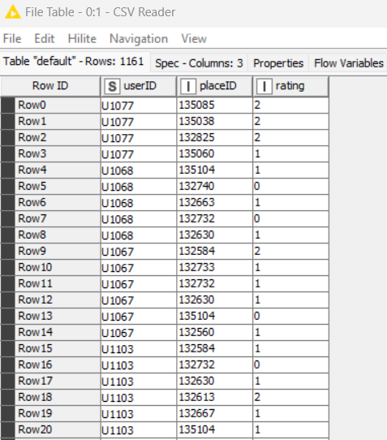

Prepare KNIME: Install 2 Extensions

#1 “Big data Extension for KNIME”

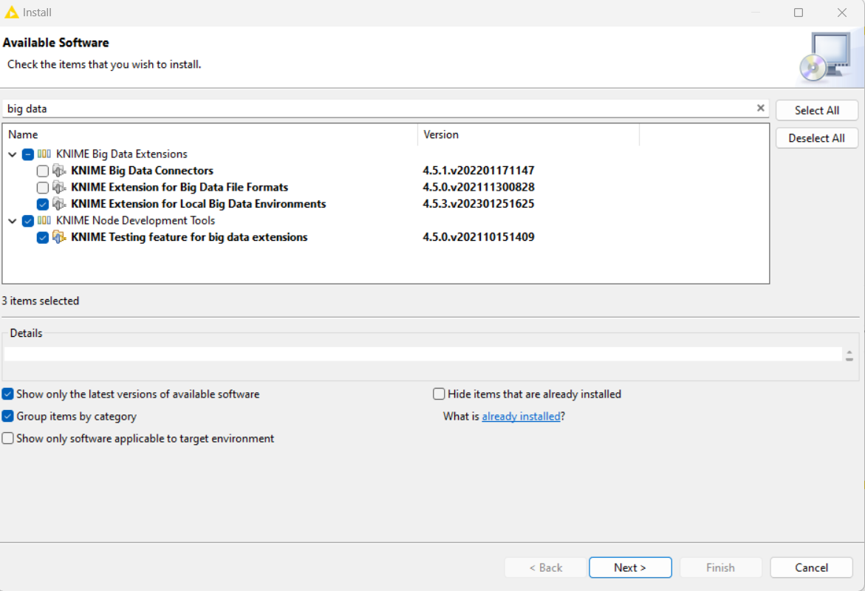

#2 “Apache Spark”

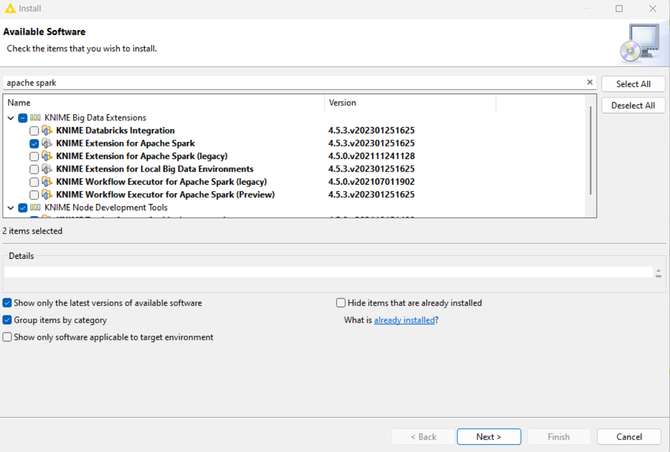

Step1:

* Open a New KNIME Workflow
* Pull csv Reader clicks on configure to Navigate it to Data set.
* Execute and Analyze the Data

Step 2: Configure Create Local Big Data Environment

Set the number of threads to 2.

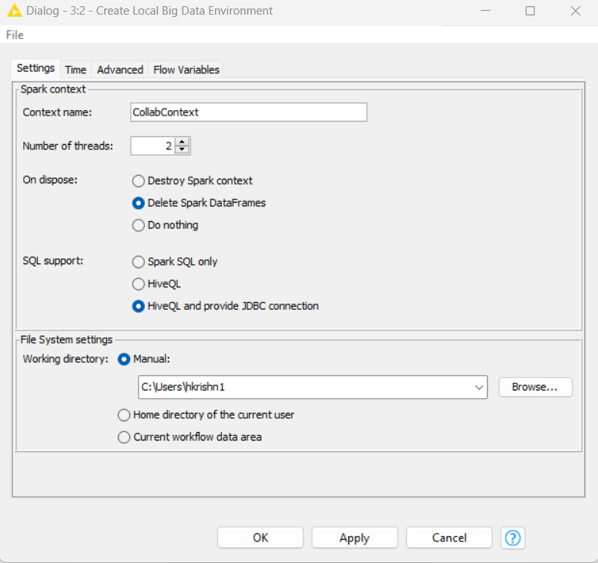

Step3: Configure Cell Splitter

Reason: Since Spark handle Integer well, the user id had Alpha numeric value, hence, to split the “U” from Userid we use Cell Splitter component.

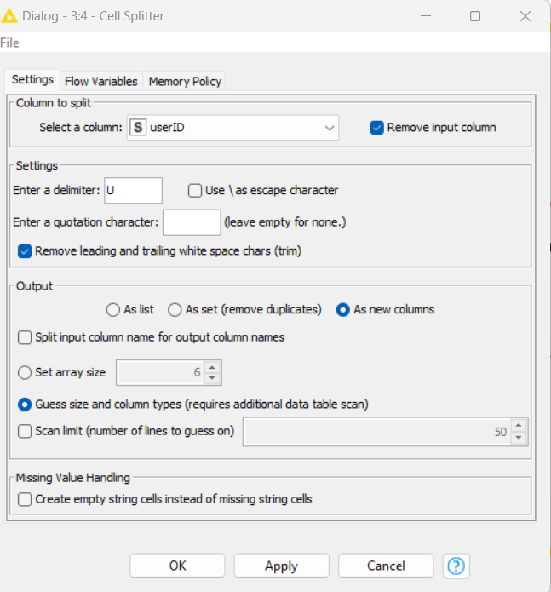

Step 4: Rename the New column name to UserId.

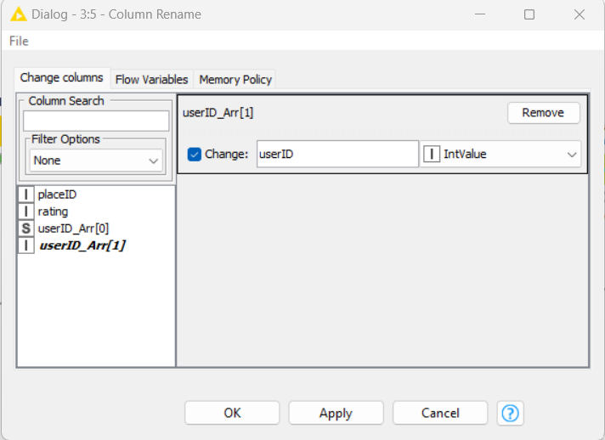

Step 5:

Connect into Table to Spark

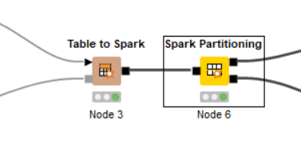

Step 6: Spark Partitioning to 70:30

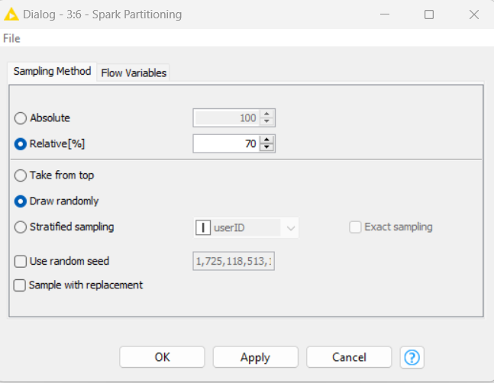

Step 7: Spark Collaborative Filtering Learning(MLIB)

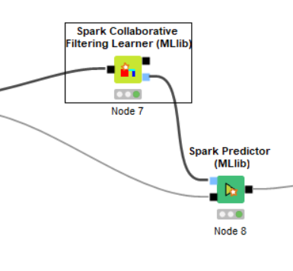

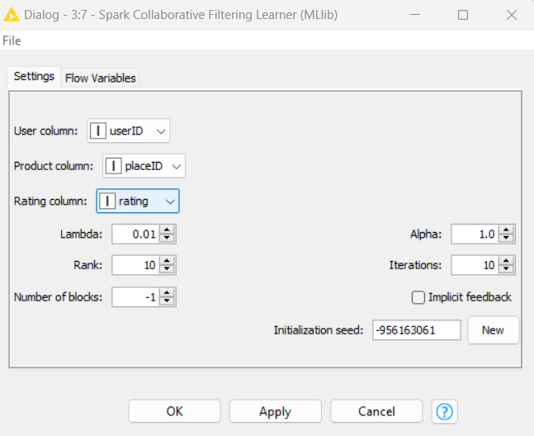

Step 8: Spark Numeric scorer

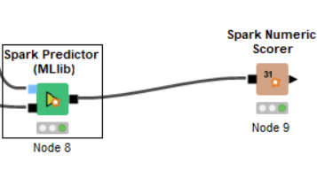

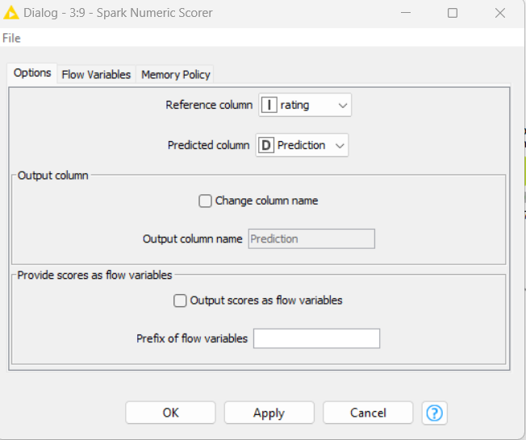

Step 9: Results

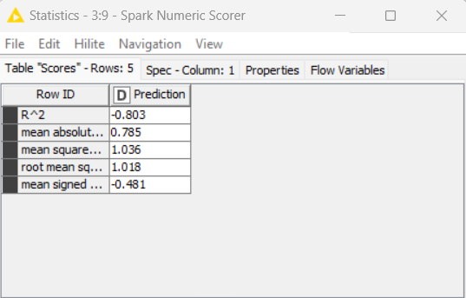

Step 10: Tune the Configuration to get better Accuracy.

Change the Rank and re execute to get better predictions.





11.4 Exercise do it yourself:

*Credit Kaggle for Source Data Set*

<https://www.kaggle.com/datasets/arashnic/book-recommendation-dataset>

###### Content

The Book-Crossing dataset comprises 3 files.

**Users:** Contains the users. Note that user IDs (User-ID) have been anonymized and map to integers. Demographic data is provided (Location, Age) if available. Otherwise, these fields contain NULL values.

**Books:** Books are identified by their respective ISBN. Invalid ISBNs have already been removed from the dataset. Moreover, some content-based information is given (Book-Title, Book-Author, Year-Of-Publication, Publisher), obtained from Amazon Web Services. Note that in case of several authors, only the first is provided. URLs linking to cover images are also given, appearing in three assorted flavors (Image-URL-S, Image-URL-M, Image-URL-L), i.e., small, medium, large. These URLs point to the Amazon web site.

**Ratings:** Contains the book rating information. Ratings (Book-Rating) are either explicit, expressed on a scale from 1-10 (higher values denoting higher appreciation), or implicit, expressed by 0.

# **12 AI Computer Vision**

Computer vision also known as “CV” is the ﬁeld of computer science that focuses on replicating parts of the complexity of the human vision system and enabling computers to “SEE” and process objects in images and videos in the same way that humans do. CV is a subfield of AI that primarily focusses on enabling computer to interpret visual information from images and videos allowing machines to automatically recognize images and describe them accurately and efficiently. Today, computer systems have access to a large volume of images and video data sourced from or created by smartphones, traffic cameras, security systems, and other devices. Computer vision applications use artificial intelligence and machine learning (AI/ML) to process this data accurately for object identification and facial recognition, as well as classification, recommendation, monitoring, and detection.

Fig 12.1: “Object Detection in Computer Vision” *(Credit: CCO Public Domain)*

Early experiments in computer vision took place in the 1950s, using some of the first neural networks to detect the edges of an object and to sort simple objects into categories like circles and squares. In the 1970s, the first commercial use of computer vision interpreted typed or handwritten text using optical character recognition. This advancement was used to interpret written text for the blind. As the internet matured in the 1990s, making large sets of images available online for analysis, facial recognition programs flourished. These growing data sets helped make it possible for machines to identify specific people in photos and videos.

Today, several factors have converged to bring about a renaissance in computer vision:

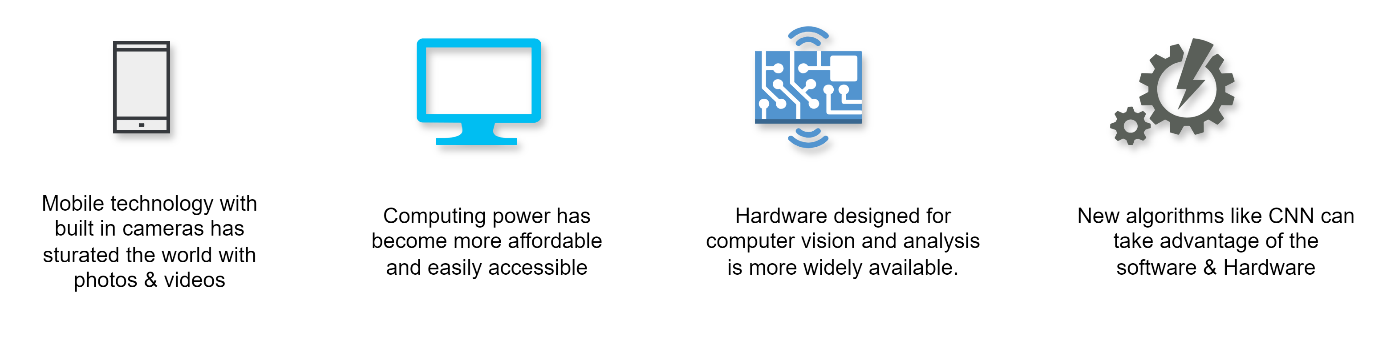

Fig 12.2: “Renaissance in Computer Vision” *(Credit: CCO Public Domain)*

The effects of these advances on the computer vision field have been astounding. Accuracy rates for object identification and classification have gone from 50 percent to 99 percent in less than a decade — and today’s systems are more accurate than humans at quickly detecting and reacting to visual inputs.

Photos and videos are becoming an integral part of our lives. A video is a sequence of images (called frames) captured and eventually displayed at a given frequency. An image can be obtained by stopping the video at a specific frame from the sequences of frames in the video.

There are over 4.4 billion internet users and growing every day. Every 60 seconds, 30,000 minutes of video material are uploaded to YouTube. Hate speech, predatory behavior, graphic violence, malicious attacks, and content that promotes harmful or dangerous behavior is not allowed on YouTube. To check that none of this content is published, YouTube would need 90,000 employees, working in three shifts, monitoring the material uploaded every minute. Today’s increasing volumes of video and image data on the one hand and the large variety of use cases in different fields on the other is creating a need for faster, automated execution of computer vision tasks. All of this to say, that there are a lot of other sources on the internet where graphical data i.e., images and videos are being uploaded consistently. YouTube might be the 2nd largest search engine after Google, where hours of videos are being uploaded every minute. It is easy to index and search the text, but to index and search the images, algorithms need to read beyond an image. So, to get the most out of images and videos, and to provide the best services to users based on this data, computers need to understand the images and “see” inside them.

While visual information processing technology has existed for some time, much of the process required human intervention and was time consuming and error prone. For example, implementing a facial recognition system in the past required developers to manually tag thousands of images with key data points, such as the width of the nose bridge and the distance between the eyes. Automating these tasks required extensive computing power because image data is unstructured and complex for computers to organize. Vision applications were thus expensive and inaccessible to most organizations.

Today, progress in the field combined with a considerable increase in computational power has improved both the scale and accuracy of image data processing. Computer vision systems powered by cloud computing resources are now accessible to everyone. Any organization can use the technology for identity verification, content moderation, streaming video analysis and fault detection.

### Use cases of computer vision

Numerous computer vision applications are used in entertainment, business, healthcare, transportation, and everyday life. We look at some use cases below:

#### Security and safety

Governments and enterprises use computer vision to improve the security of assets, sites, and facilities. For example, cameras and sensors monitor public spaces, industrial sites, and high-security environments. They send automatic alerts if something out of the ordinary occurs, such as an unauthorized individual entering a restricted area.

Similarly, computer vision can improve personal safety at home as well as in the workplace. For example, recognition technology can monitor myriad safety-related issues. These include at-home real-time streams detecting pets, or live front-door cameras detecting visitors or packages delivered. In the workplace, such monitoring includes wearing of appropriate personal protective equipment by workers, informing warning systems, or generating reports.

#### Operational efficiency

Computer vision can analyze images and extract metadata for business intelligence, creating new revenue opportunities and operational efficiencies. For example, it can:

* Automatically identify quality defects before products leave the factory.
* Detect machine maintenance and safety issues.
* Analyze social media images to discover trends and patterns in customer behavior.
* Authenticate employees with automatic facial recognition.

#### Healthcare

Healthcare is one of the leading industries applying computer vision technology. Notably, medical image analysis creates a visualization of organs and tissues to help medical professionals make speedy and accurate diagnoses, resulting in better treatment outcomes and life expectancy. For example:

* Tumor detection by analyzing moles and skin lesions.
* Automatic X-ray analysis
* Symptom discovery from MRI scans

#### Autonomous vehicles

Autonomous vehicle technology uses computer vision to recognize real-time images and build 3D maps from multiple cameras fitted to autonomous transport. It can analyze images and identify other road users, road signs, pedestrians, or obstacles. In semiautonomous vehicles, computer vision uses machine learning (ML) to monitor driver behavior. For example, it looks for signs of distraction, fatigue, and drowsiness based on the driver’s head position, eye tracking, and upper body movement. If the technology notices certain warning signs, it alerts the driver and reduces the chance of a driving incident.

#### Agriculture

From boosting productivity to reducing costs with intelligent automation, computer vision applications enhance the overall functioning of the agricultural sector. Satellite imaging as well as UAV footage help to analyze vast tracts of land and improve farming practices. Computer vision applications automate tasks like monitoring field conditions, identifying crop disease, checking soil moisture, and predicting weather and crop yields. Animal monitoring with computer vision is another key strategy of smart farming.

### How are images recognized by machines?

Machine can only understand numbers. What looks like a picture to us are represented as pixel values (numbers) to a machine. To a computer, an image is just an array of numbers just like shown in the figure below.

[

|  |  |  |  |  |  |  |  |  |  |
| --- | --- | --- | --- | --- | --- | --- | --- | --- | --- |
| [37, | 64, | 32, | 86, | 37, | 95, | 25, | 8, | 50, | 98, |
| 24, | 39, | 85, | 64, | 1, | 19, | 93, | 77, | 20, | 45, |
| 17, | 17, | 63, | 8, | 47, | 15, | 88, | 17, | 52, | 11, |
| 23, | 92, | 17, | 76, | 100, | 26, | 16, | 26, | 23, | 59, |
| 61, | 4, | 54, | 92, | 54, | 17, | 45, | 70, | 3, | 47, |
| 69, | 92, | 73, | 94, | 94, | 36, | 63, | 76, | 72, | 80, |
| 94, | 52, | 61, | 7, | 39, | 33, | 14, | 43, | 34, | 81, |
| 33, | 98, | 95, | 79, | 89, | 93, | 32, | 51, | 73, | 99, |
| 63, | 59, | 34, | 46, | 81, | 29, | 13, | 99, | 3, | 29, |
| 29, | 23, | 52, | 41, | 74, | 30, | 79, | 7, | 20, | 69, |
| 71, | 39, | 100, | 13, | 50, | 18, | 81, | 26, | 42, | 55, |
| 58, | 45, | 71, | 86, | 51, | 98, | 43, | 98, | 42, | 97, |
| 31, | 10, | 78, | 87, | 91, | 82, | 28, | 30, | 44, | 59, |
| 38, | 33, | 90, | 17, | 38, | 33, | 37, | 79, | 29, | 95, |
| 4, | 29, | 79, | 73, | 72, | 81, | 86, | 70, | 61, | 83, |
| 65, | 51, | 12, | 67, | 100, | 9, | 33, | 41, | 12, | 47, |
| 38, | 18, | 50, | 94, | 7, | 8, | 76, | 53, | 50, | 66, |
| 36, | 43, | 5, | 39, | 89, | 97, | 80, | 65, | 9, | 100, |
| 89, | 88, | 11, | 4, | 31, | 33, | 93, | 93, | 91, | 4, |
| 30, | 54, | 95, | 71, | 75, | 3, | 87, | 27, | 59, | 86 |

A black & white image to a computer looks like this: 0 – Black; 255 – White.

Where each number represents the value of the intensity of the pixel at that point that is between 0 and 255 where 0 represents black and 255 represents white. Each block or pixel is specified by a particular value. The values denote the intensity of each pixel. A number closer to zero is represented by a darker shade and a higher number represents the lighter shade of white.

Consider an image in Fig 12.3 of Abrahm Lincoln in the matric of pixels. When the image is zoomed and looked closely it can be represented as blocks with each block having different shades of gray *(when the image is in black & white format).* These blocks are called as pixel and the image has a dimension as X*Y, this means that the image has total X*Y pixels. This is how an entire image is divided by computer into pixels and the computer vision algorithms focus on one pixel blob at a time. The CV algorithm uses a kernel or filter that contains pixel multiplication value for edge detection of the objects.

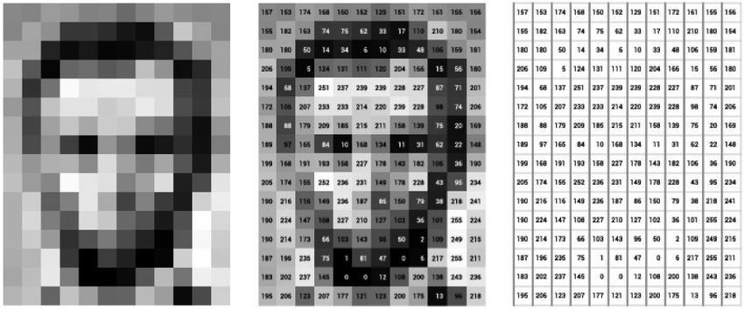Fig 12.3 : “Image of Abraham Lincoln as a matrix of pixel values” *(Image Source : Research Gate,* [*https://www.researchgate.net/figure/mage-of-Abraham-Lincoln-as-a-matrix-of-pixel-values_fig1_330902210*](https://www.researchgate.net/figure/mage-of-Abraham-Lincoln-as-a-matrix-of-pixel-values_fig1_330902210)*)*

For a black and white image, this is just a single-dimensional array. In grayscale images, a pixel’s intensity value denotes its brightness within 8-bit system. When you are dealing with color images, they are not just single-dimensional arrays, in fact, they are a combination of 3D arrays where 1st Dimension represents Red, 2nd represents Green, and 3rd represents the intensity of the blue color. Each of the channels Red(R), Green(G) and Blue(B) has intensity ranging from 0 to 255. Different combination of these values produces a diverse spectrum of colors. Full intensity in all channels (255,255,255) represents white and no intensity in any channel (0,0,0) represents black.

By mixing different amount of these main RGB colors a wide range of shades can be created. For example, combining full red (255,0,0) and full green (0,255,0) gives us yellow (255,255,0). When red, green, and blue with equal intensity are combined we get white (255,255,255) and when there is no intensity in the channel it results in black (0,0,0). The RGB channel can offer a staggering (${256}^{3}$) = 16.8 million color variations.

With the latest technologies, like Machine Learning, Deep Learning, Parallel Computing, GPUs, TPUs, the latest Algorithms, Computer Vision can bridge the gap between computers seeing and computers comprehending what they see.

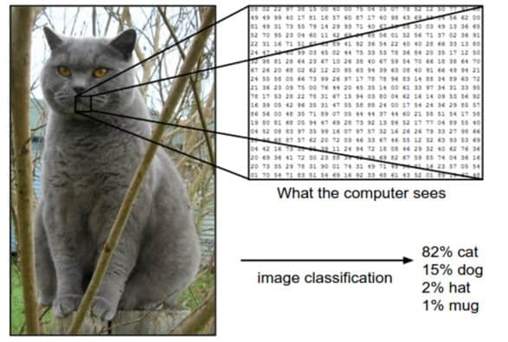

Fig 12.4 : *(Image Source:* [*https://www.kdnuggets.com/2019/11/deep-learning-image-classification-less-data.html*](https://www.kdnuggets.com/2019/11/deep-learning-image-classification-less-data.html)*)*

### How does Computer Vision work?

Computer vision systems use artificial intelligence (AI) technology to mimic the capabilities of the human brain that are responsible for object recognition and object classification. Computer scientists train computers to recognize visual data by inputting vast amounts of information. Machine learning (ML) algorithms identify common patterns in these images or videos and apply that knowledge to identify unknown images accurately.

Let us take an example where you meet a new person X, and you both get to know each other. Your brain has activated the neurons and stores the vital information about X such as his name, and how he looks, his voice, etc. . in your mind. Whenever you see that person next time, you will recognize him with his looks, or you will recognize him with his name, or by his voice. How is it done? This happens because your mind has stored the information, and when you see him next time, the neurons in your brain activate and retrieve the person’s name from your mind after matching the person’s face you see from your memory. This concept is known as feature matching. For example, if computers process millions of images of cars, they will begin to build up identity patterns that can accurately detect a vehicle in an image. Computer vision uses technologies such as those given below.

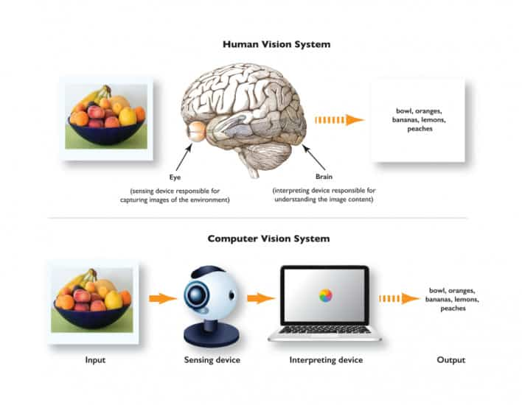

Fig 12.4 : “Computer Vision” *(Credit:* [*https://www.spiceworks.com/tech/artificial-intelligence/articles/what-is-computer-vision/*](https://www.spiceworks.com/tech/artificial-intelligence/articles/what-is-computer-vision/)*)*

#### Artificial Neural Networks

Artificial Neural Network (ANN) has artificial neurons called units; the computational model is inspired by the human brain’s neural structure. The interconnected nodes (artificial neurons) in ANN are organized into layers. The neuron (units) is arranged in a series of layers that together form ANN network. Information flows through these nodes and the network adjusts the connection strengths (weights) during training to learn from the data, enabling it to recognize patterns, make predictions and solve various tasks in machine learning. There are three layers in the network architecture: the input layer , the hidden layer , and the output layer. The information is processed in one direction from input to output via a feed forwards network. Due to the many layers, it is sometimes called the MLP (Multi-Layer Perceptron). The hidden layer in the middle can be considered as “distillation layer” that extracts some of the relevant patterns from the inputs and sends them to the next layer for further analysis. It also accelerates and improves the efficiency of the network by filtering the essential information and discarding the redundant information from the network.



Fig 12.5 : “Neural Network Architecture” *(Credit: CCO Public Domain)*

#### Deep Neural Network

A Deep Neural Network (DNN) is an artificial neural network with multiple hidden layers between input and output layers. DNN can model complex and non-linear relationships. It consists of many non-linear hidden layers. After training a well-built DNN, it can achieve desired results with higher accuracy scores. DNNs are popular in all aspects of deep learning including computer vision, natural language processing and transfer learning. Deep learning models produce better results than most of the normal machine learning models. It deals with training large neural networks with complex input output transformation. Training the datasets is an important part of DL models and the best use case is the supervised learning problem, where we have large dataset of inputs with the desired outputs. Backpropagation is the main algorithm to train these models and Gradient descent method is used for optimizing the network and minimizing the loss function. With back propagation the neural networks are fine tunes to the accuracy by adjusting its internal parameters or ‘weights’ to reduce the error next time.

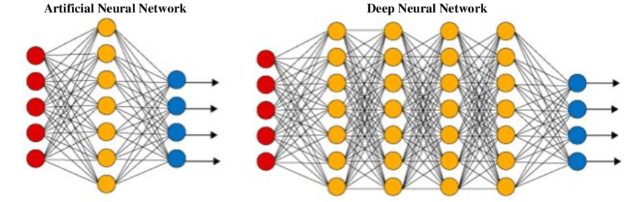

Fig 12.6 : “ANN Vs DNN” *(Credit: CCO Public Domain)*

In DL the neural networks are made of many layers of software modules that work together inside the computer. As we know that image is just a matrix of pixels, so our model will learn patterns from those pixels and perform further operations. DL automatically processes several aspects of the image data using mathematical calculations and gradually develops a combined understanding of the image. The prominent use case of DNNs is in the object detection with YOLO (You Only Look Once) model, language translation with BERT (Bi-directional Encoders Representation from Transformers), transfer learning models and image processing projects. The most popular libraries used for constructing deep neural networks are TensorFlow, Keras and PyTorch.

#### Convolutional Neural networks

Convolutional neural networks (CNNs) are one of the most powerful algorithms in Deep Learning. It uses a labeling system to categorize visual data and understand the whole image. One of its primary use cases is image recognition. CNNs learn faster and achieve lower error rates and are also used for video analysis. It applies a variation of multi-layer algorithms that classify visual inputs across multiple convolution layers that can be pooled or entirely connected. Neural Networks learn the same way as humans do by processing training sets of labeled images. The machine can find elements that are characteristics of that image objects.

Convolution is a linear operation that involves multiplying set of weights with the input to yield filter which is a two-dimensional array of weights. If the filter is tuned to detect a specific type of feature in the input image, then using this filter across the entire image can help detect features that are present across that image. Multiple filters can be incorporated for various identification requirements like a one filter can be designed to detect vertical lines a second filter to detect horizontal lines, a third filter to detect curves in the image likewise other filters may detect colors, edges. Now connecting the output from these multiple filters can help reveal the complex shape that matches known elements in the training datasets.

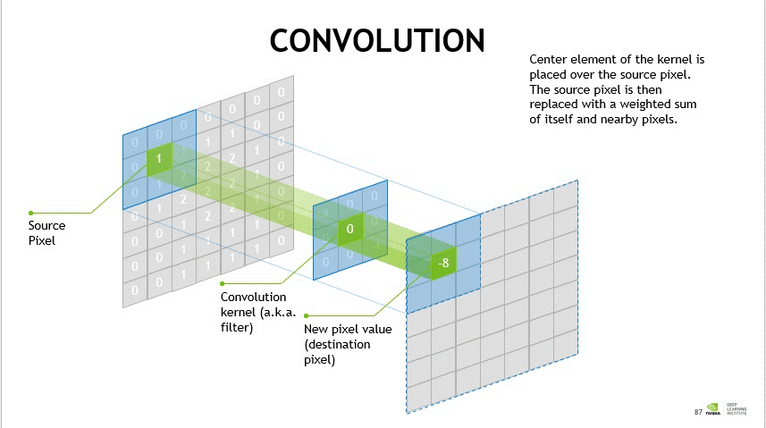

Fig 12.6 : “CNN filter” *(Credit:* [*https://www.nvidia.com/en-us/glossary/convolutional-neural-network/*](https://www.nvidia.com/en-us/glossary/convolutional-neural-network/)*)*

A typical CNN architect consists of three layers:

##### Input layer: The input layers receive the input image and pass it to the hidden layer and the output layer.

##### Output layer: This layer provides the predictable class label or probability scores for each class.

##### Hidden layer: The hidden layer consists of multiple convolution layers and polling layers, fully connected layers, and normalization layers. The number of hidden layers and the number of filters in each layer can be adjusted to perform the network performance. A common architect of CNN is to have multiple convolution layers followed by more pooling layers and then a fully connected layer that provides the final output.

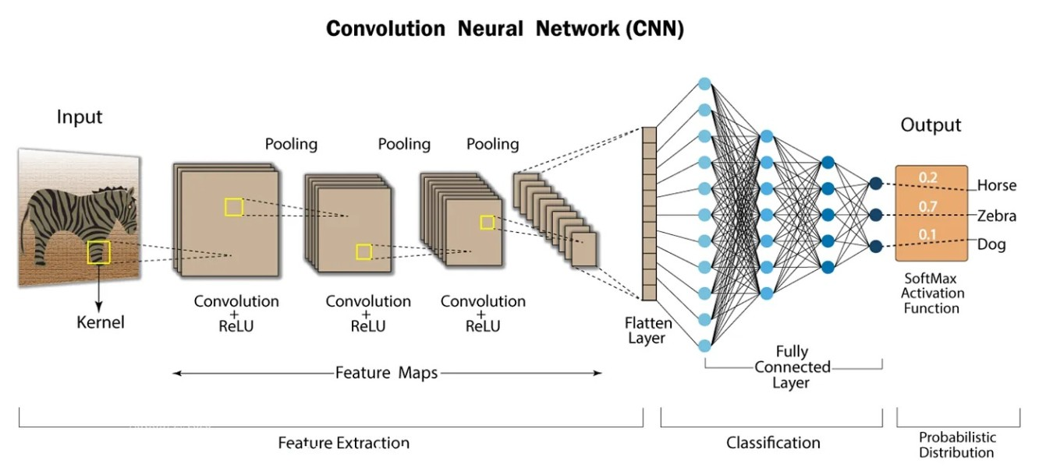

Fig 12.7 : “CNN architecture” *(Credit: CCO Public Domain)*

Some of the benefits of CNN includes.

1. CNNs are capable of automatically extracting relevant features from an input image, reducing the need for manual feature engineering.
2. CNNs can recognize objects in an image regardless of their location, size, and orientation, making them well suited for object recognition tasks.
3. CNNs can use pre-trained models, reducing the amount of data and computational resources needed to train a new model.
4. CNNs can manage noisy and cluttered images thus making them useful for the real- world application where the image quality may be variable.
5. CNNs have proved state-of-the-art performance on range of computer vision tasks, which includes image classification, object detection and semantic segmentation.

#### Recurrent neural networks

A Recurrent Neural Network (RNN) is a deep learning model that is trained on sequential or time series data that can make sequential predictions or conclusions based on sequential inputs. Sequential data includes words, sentences, or time series data, where sequential components are interrelated based on complex semantics and syntax rules. Like other deep learning networks where inputs and outputs are independent of each other, the output in RNN depends on the prior element within the sequence. Another characteristic of RNN is that they share parameters across each layer of the network, unlike other feed forward networks have different weights across each node RNNs share same weight parameter within each layer of the network. These weights are still adjusted through the process of backpropagation and gradient descent to help reinforcement learning.

BPTT referred to as backpropagation through time is the technique used in ML to improve prediction by calculating the model error and adjusting the weights. BPTT rolls back the output to the earlier time step and recalculates the error rate. This way, it can find which hidden state in the sequence is causing a significant error and readjust the weight to reduce the error margin.

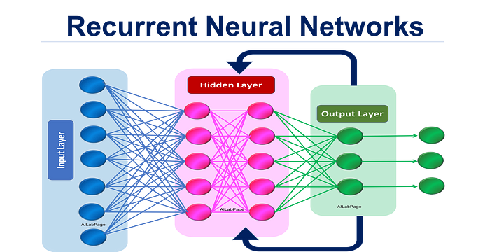

Fig 12.7 : “CNN filter” *(Credit:* [*https://ailabpage.com/2019/01/08/deep-learning-introduction-to-recurrent-neural-networks/*](https://ailabpage.com/2019/01/08/deep-learning-introduction-to-recurrent-neural-networks/)*)*

RNNs work by passing the sequential data that they receive to the hidden layers one step at a time. RNNs can also have a self-looping or recurrent workflow: the hidden layer can remember and use earlier inputs for future predictions in a short-term memory component. It uses the current input and the stored memory to predict the next sequence. This can be explained with the simple example, consider that Strawberries are red, and we want RNN to predict red when it receives the input sequence as “Strawberries” . When the hidden layer processes the word “Strawberries,” it stores a copy in its memory. Next, when it sees the word is, it recalls “Strawberries” from its memory and understands the full sequence: “Strawberries” is for context. It can then predict red for improved accuracy. This makes RNNs useful in speech recognition, machine translation, and other language modeling tasks. RNNs are like CNNs but can process a series of images to find links between them. While CNNs are used for single image analysis, RNNs can analyze videos and understand the relationships between images. Keras is a popular open-source library, now integrated into the TensorFlow library, providing an interface for RNNs.

Popular recurrent neural network architecture variants include:

* Standard RNNs
* Bidirectional recurrent neural networks (BRRNs)
* Long short-term memory (LSTM)
* Gated recurrent units (GNUs)
* Encoder-decoder RNN

RNN model family has several limitations, and its use has declined in AI , especially in favor of architectures such as transformer models, but RNNs are not obsolete. RNNs were traditionally popular for sequential data processing (for example, time series and language modeling) because of their ability to manage temporal dependencies. RNNs’ weakness to the vanishing and exploding gradient problems, along with the rise of transformer models such as BERT and GPT have resulted in this decline. Transformers can capture long-range dependencies much more effectively, are easier to parallelize and perform better on tasks such as NLP, speech recognition and time-series forecasting.

### Difference between computer vision and image processing?

#### Image Processing

Image processing uses algorithms to alter or enhance the image by tunning many parameters and features of the images including sharpening, smoothing, stretching, filtering, or enhancing. So, Image processing is a subset of computer vision. Some examples of Image processing applications are : Rescaling image (Digital Zoom), Correcting illumination, Changing tones etc. .

#### Computer Vision

Computer vision is different as it does not change an image, but instead it is focused on extracting information from the input images or videos such as labelling, to have a proper understanding and predict like a human brain. CV is a superset of Image Processing. In some cases, you can use image processing to modify an image so a computer vision system can better understand it. Computer vision to identify images or parts of an image and then use image processing to modify the image further. Some of its applications are in Object detection, Face identification, Handwriting recognition etc. .

Fig 12.8 : “The 3Rs in Computer Vision”

### What are common tasks that computer vision can perform?

Fig 12.9 : “Computer Vision Tasks”

Computer Vision application enables machine to interpret, understand and derive meaning from visual data, closely mimicking the cognitive process of humans. Here are some of the tasks that computer vision performs:

#### Image Processing

Image processing aims to enhance the image data by reducing distortions and highlighting relevant features. It prepares the image for the subsequent processing task and for analysis by applying a range of techniques that includes resizing, smoothing, sharpening, contrasting and other manipulations all these help in improving the quality of the image. The image manipulation includes cropping the image boundaries, eliminating digital noise in the image, brightness, or color normalization, doing this helps in improving the characteristics of an image. Using convolution layer helps in extracting features like edges and shapes. CNN is a deep learning algorithm designed to perform image processing, using the convolutional features like edges and shapes are extracted. As the CNN processes the image and identifies complex patterns it reduces the dimension with the pooling layer and makes prediction using fully connected dense neural network. Keras is a deep learning library that provides methods to load, prepare and process images. Using KNIME users can access varieties of deep learning framework in KERAS such as TensorFlow, CNTK and others.

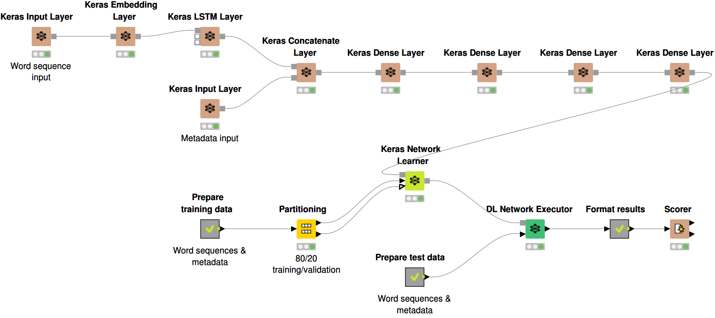

Fig 12.6 : “Deep Learning Keras Integration” *(Image Source : KNIME,* [*https://www.knime.com/deeplearning/keras*](https://www.knime.com/deeplearning/keras)*)*

#### Feature Extraction

Feature extraction is a critical step in computer vision and image processing, this involves identifying and representing distinctive structure within an image. Features are unique characteristics of an image that help distinguish one image from another these features can range from single edges and corners to more complex textures and shapes. Feature extraction involves transforming the raw data into numerical features that can be processed while preserving the essential features. This helps to create a more compact and meaningful representation that the raw pixel data, facilitating further analysis and processing. CNN is a widely used algorithm for feature extraction to learn directly from the raw data. Based on extensive training on different datasets of labeled images, the algorithm learns to discern the crucial patterns associated with various image classes. With the advent of automated feature extraction methods driven by CNNs, autoencoders and wavelet scattering networks has revolutionized the process of feature extraction. These advancements have paved the way for efficient and effective pipelines and lead to a breakthrough in the fields of medical imaging, object recognition, facial recognition, and remote sensing. Techniques such as Edge Detection, Corner Detection, Blob Detection, Texture Analysis, Local Feature Descriptors, Color & Intensity Features, transform – Based Features & Shape – Based Features along with automated methods like deep learning play a vital role in various applications.

Fig 12.7 : Feature Extraction techniques in Image Processing

#### Image Classification

Image classification enables computers to see an image and accurately classify which class it falls under. It categorizes and assign class labels to group of pixels or vectors within an image dependent on rules. When the classification becomes highly detailed or reaches instance-level, it is often referred to as image retrieval that involves finding similar images in the database. A computer analyzes the image in the form of pixels. Image classification treats the image as a matrix array based on its resolution, grouping digital image pixels into classes. The algorithm segregates the image into series of its most prominent features . These characteristics give the classifier about what the image is and what class it might be considered. The major application of image classification is in medical imaging, traffic control system.

Image classification has two main categories:

##### Supervised Classification

Supervised Classification uses previously labeled reference samples for training and later classify new, unknown data. It is also reliant hugely on the data fed to the algorithm. A well optimized dataset works well compared to the bad dataset with lot of imbalances.

##### Unsupervised Classification.

This classification uses machine learning algorithms to analyze and cluster unlabeled datasets and find hidden patterns through image clustering and pattern recognition process. AI pattern recognition and image clustering are two of the most common methods used here. The two popular algorithms for unsupervised classification are K-Means and ISODATA.

Fig 12.8 : Types of Image Classification

#### Object Detection

Object detection is a computer vision task for locating and classifying objects within an image or video. It uses classification to identify, sort, and organize images. Object detection is used in industrial and manufacturing processes to control autonomous applications and monitor production lines. Connected home camera manufacturers and service providers also rely on object detection to process live video streams from cameras to detect people and objects in real-time and provide actionable alerts to their end users. Unlike image classification that that assigns single label to an entire image, object detection identifies and delineates multiple objects, providing both the class label and bounding box coordinates of each object. The detection process is divided into two stages:

* Single Stage detection : this involves single pass through the neural network, predicting all boundary boxes in the single operations.
* Two-stage object detection: this involves the use of two models, the first model identifies the regions containing objects, whereas the second model classifies and refines the localization of the detected objects.

##### Notable architectures are :

* YOLO (You Only Look Once) divides the image into grid and predicts bounding boxes and class probabilities directly. It is popular for its real time performance and accuracy.
* SSD(Single Shot Multi box Detector): SSD predicts multiple bounding boxes and class scores for each location within the image. The multi-scale approach allows for detecting objects of varied sizes.
* R-CNN: introduced Regional Proposal Networks (RPN) to generate region proposals for potential object locations. This two-stage approach has been influential in achieving high accuracy.

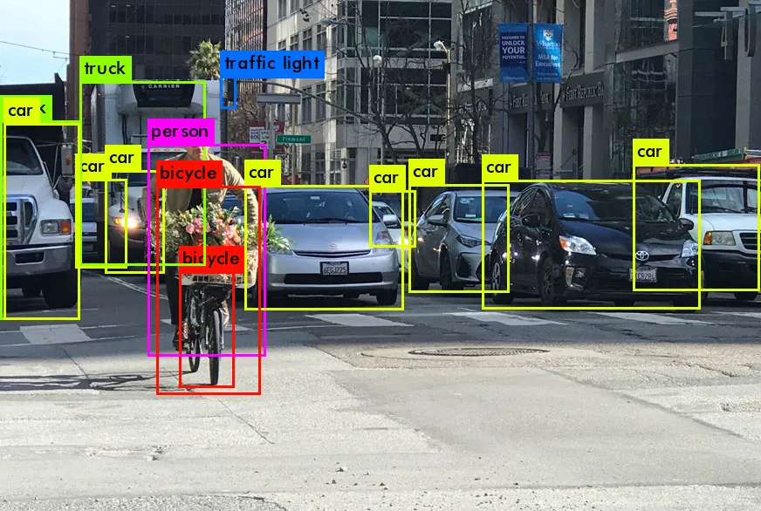

Fig 12.9 : “Object Detection in Computer Vision” *(Credit: CCO Public Domain)*

#### Image Segmentation

Segmentation is a computer vision algorithm that finds an object by dividing images of it into different regions based on the pixels seen. Segmentation also simplifies an image, such as placing a shape or outline of an item to find what it is. By doing so, segmentation also recognizes if there is more than one object in an image or frame. It uses two main approaches: similarity, where segments depend on similar pixel characteristics and discontinuity, where segments result from changes in pixel intensity values. CNNs are important models that help in image segmentation. Object detection algorithms first identify object locations using regional proposal network (RPN), generating bounding boxes. After the classification step is complete, in the segmentation stage CNNs extract features from the region of interest (ROI) defined by bounding box, feeding into FCN (Fully Convolutional Network), in this way FCN outputs a binary mask finding the pixels belonging to object of interest.

For example, if there is a cat and a dog in an image, segmentation can be used to recognize the two animals. Unlike object detection, which builds a box around an object, segmentation tracks pixels to determine the shape of an object, making it easier to analyze and label.

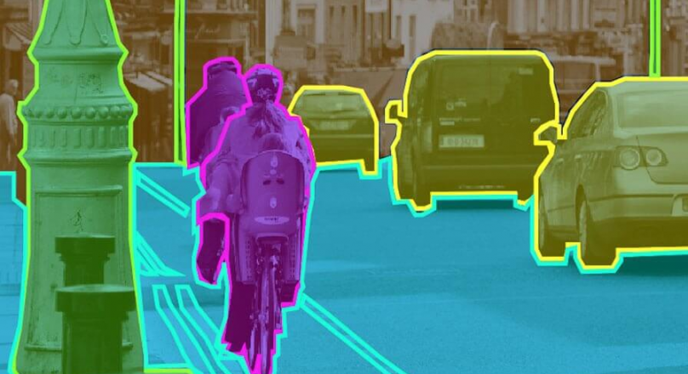

Fig 12.10 : “Image Segmentation” *(Credit:* [*https://indiaai.gov.in/article/image-segmentation-the-deep-learning-approach*](https://indiaai.gov.in/article/image-segmentation-the-deep-learning-approach)*)*

There are 3 segmentation methods:

##### Instance Segmentation: It detects each individual object in an image outlining its boundaries.

* Semantic Segmentation: This step assigns label to each pixel in an image with class label to generate a segmentation map from densely assigned labels.
* Panoptic Segmentation : This method combines semantic and instance segmentation, labeling each pixel with a class label and identify individual object instances in an image.



### 12.1 Key Takeaways



* Computer Vision is a subfield of AI that primarily focusses on enabling computer to interpret visual information from images and videos allowing machines to automatically recognize images and describe them accurately and efficiently.
* Computer vision can analyze images and extract metadata for business intelligence, creating new revenue opportunities and operational efficiencies.
* Artificial Neural Network (ANN) has artificial neurons called units; the computational model is inspired by the human brain’s neural structure.
* A Deep Neural Network (DNN) is an artificial neural network with multiple hidden layers between input and output layers. DNN can model complex and non-linear relationships.
* Convolution is a linear operation that involves multiplying set of weights with the input to yield filter which is a two-dimensional array of weights.
* A Recurrent Neural Network (RNN) is a deep learning model that is trained on sequential or time series data that can make sequential predictions or conclusions based on sequential inputs.
* Image processing uses algorithms to alter or enhance the image by tunning many parameters and features of the images including sharpening, smoothing, stretching, filtering, or enhancing.
* Image classification enables computers to see an image and accurately classify which class it falls under. It categorizes and assign class labels to group of pixels or vectors within an image dependent on rules.
* Segmentation is a computer vision algorithm that finds an object by dividing images of it into different regions based on the pixels seen.

### 12.2 Quiz :



Q1. State whether the statement is true or false. “Computer Vision is a subfield of artificial intelligence which deals with how computers can be made to gain an understanding of and make inference out of images.”

1. True
2. False

Q2. In a broader sense, various stages in Computer Vision may include which of the following.

1. Processing the Image
2. Extracting features out of the image.
3. Derive valuable insights from the extracted information of the Image.
4. All the above

Q3. State whether the statement is true or false. “A video may be thought of as a series of images captured one after the other.”

1. True
2. False

Q4. Which of the following are tasks that a Computer Vision problem may have?

1. Image Classification.
2. Object Localization
3. Object Detection
4. All the above

Q5. Which of the following is true about tasks performed in Computer Vision?

1. Image Classification involves predicting the class of the image.
2. Image Localization refers to identifying the location of the object in an image and drawing a bounding box around it.
3. Both above
4. None of these

Q6. State whether the statement is true or false. “In Computer Vision, Object Detection and Instance segmentation are the same things.

1. True
2. False

Q7. Which of the following is true about Pixels?

1. Any image is represented by its pixels.
2. Pixels are atomic elements of a digital image.
3. Both above
4. None of these

Q8. For a typical Grayscale image (stored with 8 bits per sampled pixel), which of the following is usually true.

1. 0 is considered as Black.
2. 255 is considered as White.
3. Both above
4. None of these

Q9. State whether the statement is true or false. “A computer stores an image in the form of numbers associated with the different pixels of the image.”

* 1. True
  2. False

Q10. State whether the statement is true or false. “The size of an image is equal to the total number of pixels it has.”

* 1. True
  2. False

Q11. State whether the statement is true or false. “Colored images are usually a combination of three primary colors Red, Green, and Blue.”

* 1. True
  2. False

Q12. Which of the following is true about Colored images in Computer Vision?

* 1. In the Computer Vision domain, the colors of colored images are referred to as channels.
  2. For an RGB image, three times more information needs to be stored/processed as compared to a grayscale image.
  3. Both above
  4. None of these

Q13. State whether the statement is true or false. “Resolution is a display parameter, defined in dots per inch (DPI) or equivalent measures of spatial pixel density.”

* 1. True
  2. False

Q14. Which of the below-mentioned mathematical operations in Computer Vision are used for extracting information from images?

1. Convolution
2. Pooling
3. Both above
4. None of these

Q15. Which metric is commonly used to evaluate the performance of object detection algorithms?

1. Precision
2. Recall
3. F1 score
4. All the above

Q16. Which algorithm is commonly used for image segmentation?

1. K-means clustering
2. Depth-first search
3. Gaussian blur
4. Fourier transform

Q17. Which technique is used to estimate the camera's pose and reconstruct the 3D structure of a scene?

1. Depth estimation
2. Stereo vision
3. Structure from Motion (SfM)
4. Texture mapping

Q18. Which technique is used to align two or more images to create a single panoramic image?

1. Image segmentation
2. Template matching
3. Image stitching
4. Image compression

Q19. Which method is used to generate realistic images by learning from a large dataset?

1. GANs (Generative Adversarial Networks)
2. Random Forests
3. K-means clustering
4. Principal Component Analysis (PCA)

Q20. Which method is used to represent colors in digital images?

1. RGB (Red, Green, Blue)
2. HSV (Hue, Saturation, Value)
3. CMYK (Cyan, Magenta, Yellow, Black)
4. All the above

# **13 Generative AI**

Generative AI in layperson’s term can be explained as a type of artificial intelligence technology that can produce several types of contents including text, audio, video images and text data based on variety of inputs. It uses neural network to find patterns and structures within the existing data to generate new and original content. With the recent breakthroughs in the generative AI models, it can use different learning approaches, including unsupervised or semi-supervised learning for training. Using this approach foundational models have been created quickly that use a large amount of unlabeled data. Examples of foundation models include GPT-3 and Stable Diffusion, which allow users to use the power of language. For example, popular applications like ChatGPT, which draws from GPT-3, allow users to generate an essay based on a short text request. On the other hand, Stable Diffusion allows users to generate photorealistic images given a text input.

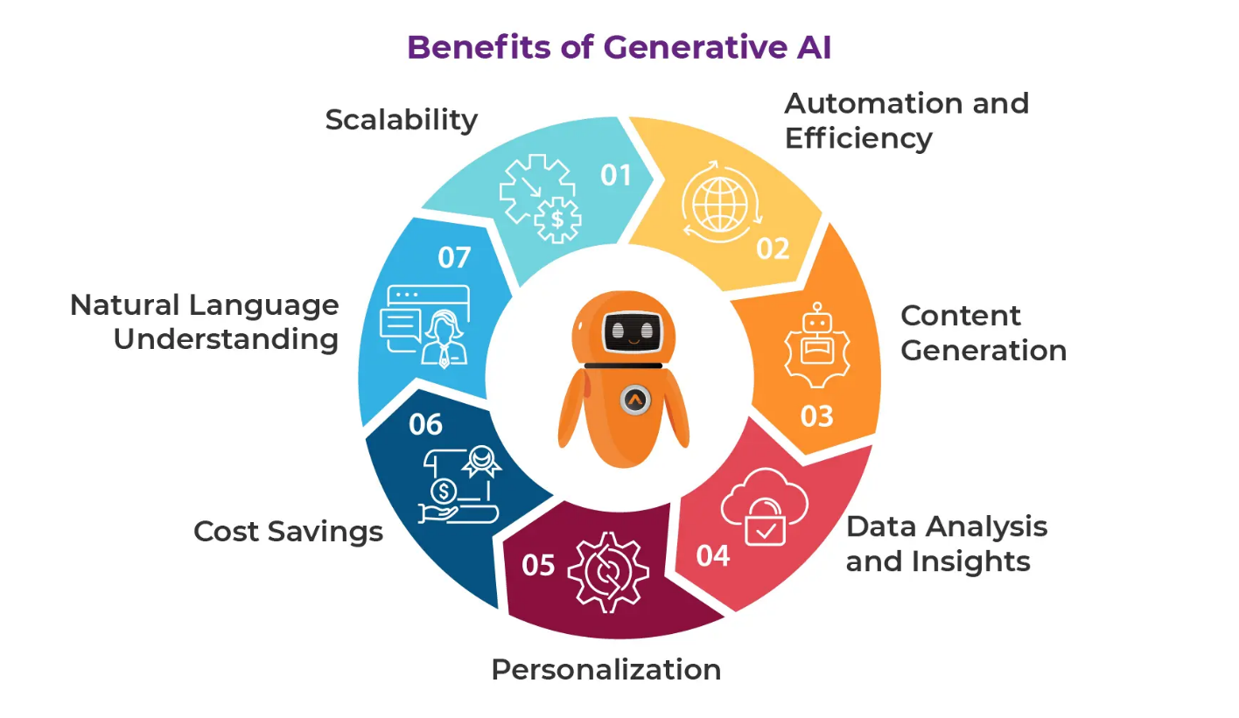

Fig 13.1: “Generative AI benefits” *(Credit: CCO Public Domain)*

Generative AI has gone beyond just having contextual conversations to tailored recommendations, intuitive solutions, and more. Its applications are widely distributed amongst the breadth and length of industries ranging from Finance, Healthcare, High Tech to Agriculture and consumer packaged goods. As generative AI continues to evolve, we can expect even more groundbreaking applications across industries, pushing the boundaries of what is possible and revolutionizing the way we live, work, and entertain ourselves. It should be an easy decision when leading research firms across the world predict that Generative AI has a lot of untapped potential to augment human capabilities.

* *Gartner places Generative AI on the Peak of Inflated Expectations on the 2023 Hype Cycle for Emerging Technologies*
* *Deloitte estimates the market for Generative AI at $200B by 2032. This represents ~20% of total AI spend, up from ~5% today.*
* *Generative AI’s performance will compete with the top 25 percent of people, completing all tasks before 2040 — McKinsey’s.*

## The History of Generative AI

Fig 13.2: “Generative AI Journey”

### **1950s:** Text Analytics

Generative AI has a brief history, In the 1950s to early 1960s, the field of artificial intelligence (AI) was still in its infancy. Researchers were exploring the possibilities of creating machines that could simulate human intelligence. One of the earliest endeavors in this direction was text analytics. This era saw the development of rudimentary computer programs designed to process and analyze text data. Early text analytics systems were primarily focused on simple tasks like information retrieval and keyword extraction. The idea was to enable computers to understand and manipulate text in a way that resembled human comprehension.

**1960s:** Rule-Based Systems and Knowledge Bases

From mid 1960s to 1970s, AI research shifted toward rule-based systems and knowledge bases. Researchers looked to encode human knowledge and expertise into computer programs using explicit rules and logical reasoning. This approach led to the development of expert systems, which could solve specific problems by following predefined rules. However, they were constrained by the need for extensive manual rule-writing and limited adaptability to new domains. During the 1960s and ’70s, the groundwork research for computer vision and some basic recognition patterns was conducted.

### **1980s:** Natural Language Processing Emerges

During 1980s and 90s there was an emergence of natural language processing (NLP), a critical field within AI that aimed to enable machines to understand and generate human language. Researchers began developing more advanced techniques for parsing and analyzing text, paving the way for applications like machine translation, speech recognition, and sentiment analysis. NLP systems were still largely rule-based, relying on grammatical and syntactical rules. It was capable of handling more complex language tasks than earlier text analytics, but it was far from achieving human-level understanding.

### **2000s:** Machine Learning and Big Data Revolution

The start of the millennium marked a significant shift in AI research with the rise of Machine Learning. This era gave birth to the concept of “Big Data” and the development of large-scale data analytics. ML algorithms, particularly neural networks, proved to be highly effective in solving a wide range of AI tasks, including those related to text and language. With the advent of technologies like deep learning and the availability of massive datasets, AI models became increasingly capable of understanding and generating human language.

### **2010s:** Virtual Assistants and Chatbots

The use of chatbots also increased significantly during 2010s. In the year 2011, Siri, the first digital virtual assistant was launched as a service in the iPhone 4S. In 2014, the concept of the generative adversarial network (GAN) gained prominence. GANs are used to create images, videos, and audio that seem like authentic recordings of real situations. A generative adversarial network uses two neural networks that have had simultaneous adversarial training: One neural network function as a discriminator and the other as a generator. The discriminator has been trained to distinguish between generated data and real data. The generator creates synthetic data and tries to imitate real data.

### **2020s:** GPT-3 and the Breakthrough in Generative AI

OpenAI released an early demo of ChatGPT on November 30, 2022, and the chatbot quickly went viral on social media as users shared examples of what it could do. The world saw GPT-3 (Generative Pre-trained Transformer 3), a revolutionary AI model that marked a significant milestone in the field of AI and NLP. GPT-3 was pre-trained on an enormous corpus of text data and could generate highly coherent and contextually relevant text. Stories and samples included everything from travel planning to writing fables to code computer programs. Within five days, the chatbot had attracted over one million users. The evolution of GPT is continuing with the introduction of GPT 4 which is the latest version of GPT. Google also launched Gemini, a LLM that was positioned to compete with GPT-4 and the powerful successor to PaLM2.

## Top LLMs Comparison

Large Language Models (LLM) have been the driving force behind the growth of generative AI. LLMs use the combination of ML, Deep learning, and NLP to help machine learn how to understand and respond to queries in human language. LLMs work by using the deep learning techniques that help them leverage multiple neural network layers. The different layers have parameters that can be fine-tuned during the training process. Some of the most common applications of LLMs include text generation, code generation, content summarization, language translation, and sentiment analysis. LLMs have gained more popularity in recent times by providing better accuracy and intelligent collection of information about context. Its impact is visible in every industry, including financial services, healthcare, human resources, and insurance. The outline of top LLMs includes names such as ChatGPT, Gemini, Claude, Llama, and Mistral. Here is a comparison between these LLMs based on varied factors.

|  |  |  |  |  |  |
| --- | --- | --- | --- | --- | --- |
| CRITERIA | ChatGPT | Gemini | Claude | Mistral | Llama |
| DEVELOPER | OpenAI | Google | Anthropic | Mistral AI | Meta |
| RELEASE DATE | Nov. 2022 | Dec. 2023 | Mar. 2023 | Sept. 2023 | Feb. 2023 |
| LANGUAGE MODEL | GPT 4o | Gemini 1.5 Pro | Claude 3 Opus | Mixtral 8x22B | Llama 3 (8B) |
| SPEED | 74 Token/sec | 55 Tokens/sec | 32 Tokens/sec | 82 Tokens/sec | 866 Tokens/sec |
| QUALITY INDEX | 100 | 88 | 94 | 63 | 65 |
| KEY FEATURE | Generates human-like response in real time based on user-input. | Understand several types of information, including text, images, audio video & code | Generates various forms of text content like summary, creative works & code. | It can grasp the nuances of language, context, and emotions. | It has advanced NLP capabilities that can manage complex queries easily. |

## What is RAG?

Retrieval Augmented Generation (RAG) is an architecture that augments the capabilities of Large Language Model like ChatGPT by adding an information retrieval system that helps provide the grounding data. In this way the information retrieval system provides full control on how the response will be formulated. This is the workflow of RAG architecture model at an extremely important level which starts with question input.

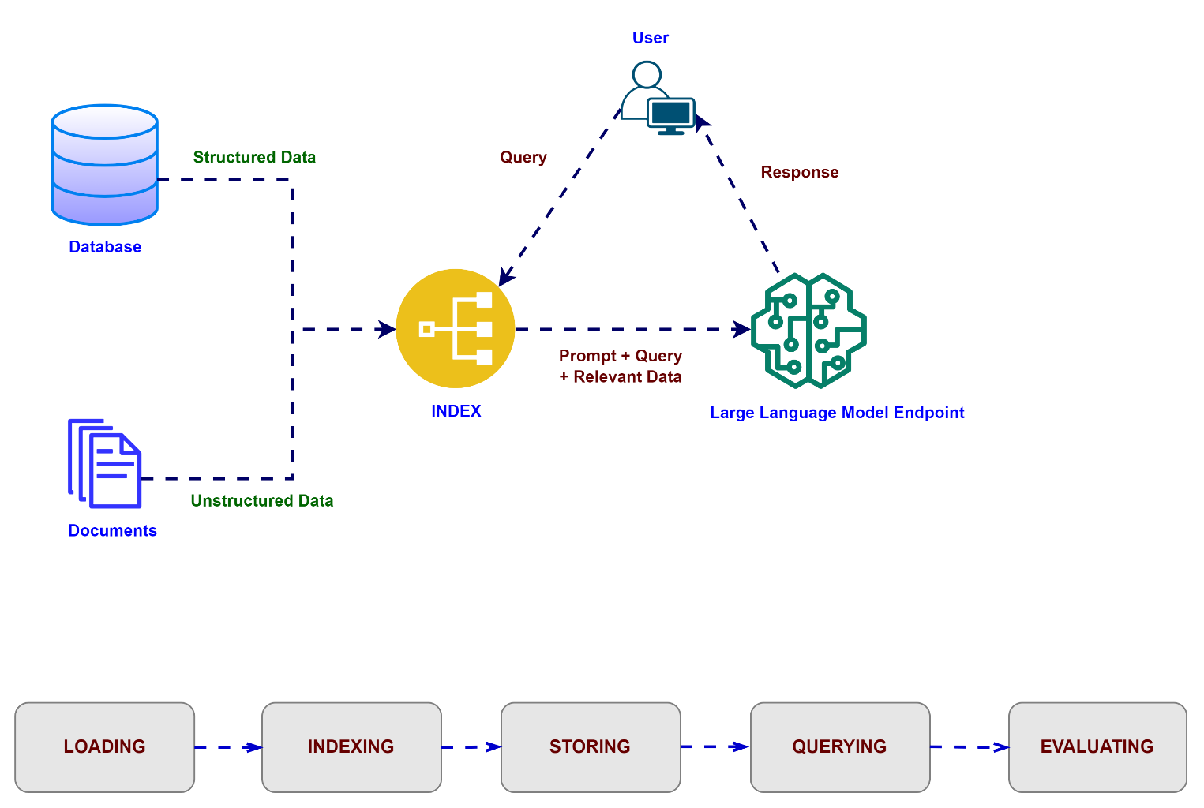

Fig 13.3 : “RAG Framework”

## RAG Framework Basics

1. Client Interaction: The process begins with the client, who poses a question to the system. This question is the starting point for the entire workflow.
2. Semantic Search in Vector Database: The question is processed by a semantic search mechanism that interacts with a vector database. This database contains contextual data represented as vectors, allowing for efficient and relevant retrieval of information.
3. Contextual Data and Prompt Formation: The retrieved contextual data is then used to form a prompt. This prompt serves as an input to the large language model (LLM).
4. Large Language Model (LLM): The LLM, equipped with the prompt, generates a response. The LLM’s capabilities ensure that the response is coherent, contextually proper, and informative.
5. Post-Processing & Response Delivery: After the LLM generates the response, a post-processing framework refines the output. This step ensures that the final response is polished and may involve refining the language, correcting errors, and enhancing the overall quality of the response. The final, polished response is delivered back to the user, providing them with the information they looked for in a clear and concise manner.

The following sections provide an overview of the RAG process.

#### Create external data.

The new data outside of the LLM’s original training data set is called external data. It can come from multiple data sources, such as a APIs, databases, or document repository. The data may exist in various formats like files, database records, or long-form text. Another AI technique, called embedding language models, converts data into numerical representations and stores it in a vector database. This process creates a knowledge library that the generative AI models can understand.

#### Retrieve relevant information.

The next step is to perform a relevancy search. The user query is converted to a vector representation and matched with the vector databases. For example, consider a smart chatbot that can answer human resource questions for an organization. If an employee searches, “How much annual leave do I have?” the system will retrieve annual leave policy documents alongside the individual employee’s past leave record. These specific documents will be returned because they are highly relevant to what the employee has input. The relevancy was calculated and established using mathematical vector calculations and representations.

#### Augment the LLM prompt.

Next, the RAG model augments the user input (or prompts) by adding the relevant retrieved data in context. This step uses prompt engineering techniques to communicate effectively with the LLM. The augmented prompt allows the large language models to generate a correct answer to user queries.

#### Update external data.

To keep current information for retrieval, asynchronously update the documents and update embedding representation of the documents. It can be done through automated real-time processes or periodic batch processing.

|  |  |  |
| --- | --- | --- |
| RAG Techniques | Definition | When to Use |
| Simple RAG | Retrieves relevant documents based on the query and uses them to generate an answer | Basic question-answering tasks where context is needed |
| Simple RAG with Memory | Extends Simple RAG by maintaining context from previous interactions | Conversational AI where continuity between queries is important |
| Branched RAG | Performs multiple retrieval steps, refining the search based on intermediate results | Complex queries requiring multi-step reasoning or information synthesis |
| Hyder (Hypothetical Document Embedding) | Generates a hypothetical ideal document before retrieval to improve search relevance | When dealing with queries that might not have exact matches in the knowledge base |
| Adaptive RAG | Dynamically adjusts retrieval and generation strategies based on the query type or difficulty | Varied query types or when dealing with a diverse knowledge base |
| Corrective RAG (CRAG) | Iteratively refines generated responses by fact-checking against retrieved information | High-stakes scenarios requiring increased accuracy and fact verification |
| Self-RAG | The model critiques and improves its own responses using self-reflection and retrieval | Tasks requiring high accuracy and when there’s time for multiple refinement steps |
| Agentic RAG | Combines RAG with agentic behavior, allowing for more complex, multi-step problem-solving | Complex tasks requiring planning, decision-making, and external tool use |

## Types of RAG Technique

RAG implementations offer a versatile and robust framework for building AI-driven applications. Each pattern serves unique needs and use cases, from simple retrieval and generation to advanced self-corrective strategies. Developers can create more effective, correct, and reliable generative AI systems by understanding these patterns and their applications.

## Difference between Retrieval-Augmented Generation and semantic search?

Semantic search enhances RAG results by adding vast external knowledge sources to their LLM applications. Modern enterprises store vast amounts of information like manuals, FAQs, research reports, customer service guides, and human resource document repositories across various systems. Context retrieval is challenging at scale and so lowers generative output quality. Semantic search technologies can scan large databases of disparate information and retrieve data more accurately. For example, they can answer questions such as, “How much were the operational expenses last quarter?” by mapping the question to the relevant documents and returning specific text instead of search results. Developers can then use that answer to provide more context to the LLM.

Conventional or keyword search solutions in RAG produce limited results for knowledge-intensive tasks. Developers must also deal with word embeddings, document chunking, and other complexities as they manually prepare their data. In contrast, semantic search technologies do all the work of knowledge base preparation, so developers do not have to. They also generate semantically relevant passages and token words ordered by relevance to maximize the quality of the RAG payload.

## What are the benefits of RAG?

#### Access to fresh information

LLMs are limited to their pre-trained data. This leads to outdated and potentially inaccurate responses. RAG overcomes this by providing up-to-date information to LLMs. Using RAG, the LLM will be able to provide contextually relevant responses tailored to an organization’s proprietary or domain-specific data.

#### Reducing inaccurate responses, or hallucinations

LLMs are powerful tools for generating creative and engaging text, but they can sometimes struggle with factual accuracy. This is because LLMs are trained on massive amounts of text data, which may have inaccuracies or biases. Providing “facts” to the LLM as part of the input prompt can mitigate “gen AI hallucinations.” The crux of this approach is ensuring that the most relevant facts are provided to the LLM, and that the LLM output is entirely grounded on those facts while also answering the user’s question and adhering to system instructions and safety constraints.

#### Search with vector databases.

RAGs usually retrieve facts via search and leverage vector databases to efficiently retrieve relevant documents. Vector databases store documents as embeddings in a high-dimensional space, allowing for fast and correct retrieval based on semantic similarity. Multi-modal embeddings can be used for images, audio, and video, and more and these media embeddings can be retrieved alongside text embeddings or multi-language embeddings.

#### Relevance, accuracy, and quality

The retrieval mechanism in RAG performs semantic search on top of a curated knowledge base to ensure that the retrieved information is relevant to the input query or context. If the retrieved information is irrelevant, the generated data could be grounded but off-topic or incorrect. By fine-tuning or prompt-engineering the LLM to generate text entirely based on the retrieved knowledge, RAG helps to minimize contradictions and inconsistencies in the generated text. This significantly improves the quality of the generated text and improves the user experience.

#### RAGs, agents, and chatbots

RAG can be integrated into any LLM application or agent which needs access to fresh, private, or specialized data. By accessing external information, RAG-powered chatbots and conversational agents use external knowledge to provide more comprehensive, informative, and context-aware responses, improving the overall user experience.

Being efficient and cost-effective

Compared to other approaches to customizing LLMs with domain-specific data, RAG is simple and cost-effective. Organizations can deploy RAG without needing to customize the model. This is especially beneficial when models need to be updated often with new data.

## What is LangChain?

LangChain is an open-source framework for building applications based on large language models (LLMs). These are large deep-learning models pre-trained on substantial amounts of data that can generate responses to user queries—for example, answering questions or creating images from text-based prompts. LangChain provides tools and abstractions to improve the customization, accuracy, and relevancy of the information the models generate. For example, developers can use LangChain components to build new prompt chains or customize existing templates. LangChain also includes components that allow LLMs to access new data sets without retraining.

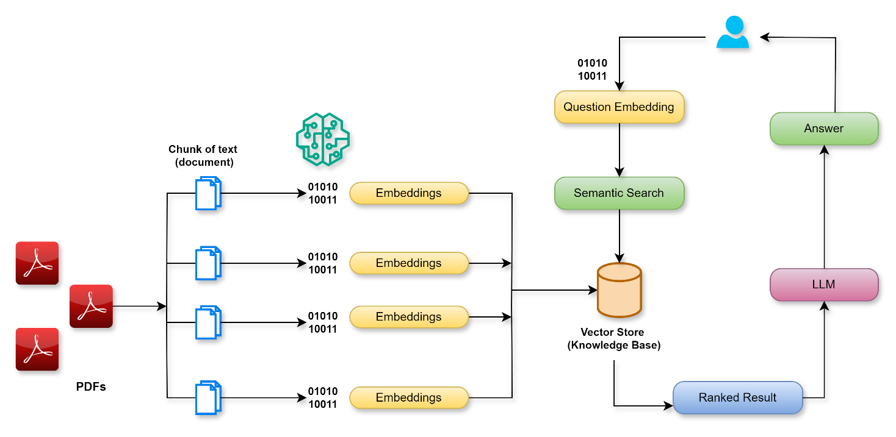

Fig 13.4: “LangChain Architecture”

LLMs excel at responding to prompts in a general context, but struggle in a specific domain they were never trained on. Prompts are queries people use to seek responses from an LLM. For example, an LLM can give an answer to how much a computer costs by providing an estimate. However, it cannot list the price of a specific computer model that your company sells. To do that, ML engineers must integrate the LLM with the organization’s internal data sources and apply prompt engineering—a practice where a data scientist refines inputs to a generative model with a specific structure and context. LangChain streamlines intermediate steps to develop such data-responsive applications, making prompt engineering more efficient. It is designed to develop diverse applications powered by language models more effortlessly, including chatbots, question-answering, content generation, summarizers, and more.

### Core components of LangChain

#### LLM interface

LangChain provides APIs with which developers can connect and query LLMs from their code. Developers can meet with public and proprietary models like GPT, Bard, and PaLM with LangChain by making simple API calls instead of writing complex code.

#### Prompt templates

Prompt templates are pre-built structures developers use to consistently and precisely format queries for AI models. Developers can create a prompt template for chatbot applications, few-shot learning, or deliver specific instructions to the language models. Moreover, they can reuse the templates across different applications and language models.

#### Agents

Developers use tools and libraries that LangChain provides to compose and customize existing chains for complex applications. An agent is a special chain that prompts the language model to decide the best sequence in response to a query. When using an agent, developers provide the user’s input, available tools, and possible intermediate steps to achieve the desired results. Then, the language model returns a practical sequence of actions the application can take.

#### Retrieval modules

LangChain enables the architecting of RAG systems with many tools to transform, store, search, and retrieve information that refine language model responses. Developers can create semantic representations of information with word embeddings and store them in local or cloud vector databases.

#### Memory

Some conversational language model applications refine their responses with information recalled from past interactions. LangChain allows developers to include memory capabilities in their systems. It supports:

* Simple memory systems that recall the most recent conversations.
* Complex memory structures that analyze historical messages to return the most relevant results.

#### Callbacks

Callbacks are codes that developers place in their applications to log, monitor, and stream specific events in LangChain operations. For example, developers can track when a chain was first called, and errors encountered with callbacks.

### How does LangChain work?

With LangChain, developers can adapt a language model flexibly to specific business contexts by designating steps required to produce the desired outcome.

#### Chains

Chains are the fundamental principle that holds various AI components in LangChain to provide context-aware responses. A chain is a series of automated actions from the user’s query to the model’s output. For example, developers can use a chain for:

* Connecting to different data sources.
* Generating unique content.
* Translating multiple languages.
* Answering user queries.

#### Links

Chains are made of links. Each action that developers string together to form a chained sequence is called a link. With links, developers can divide complex tasks into multiple, smaller tasks. Examples of links include:

* Formatting user input.
* Sending a query to an LLM.
* Retrieving data from cloud storage.
* Translating from one language to another.

In the LangChain framework, a link accepts input from the user and passes it to the LangChain libraries for processing. LangChain also allows link reordering to create different AI workflows.

### What are the benefits of LangChain?

#### Repurpose language models.

With LangChain, organizations can repurpose LLMs for domain-specific applications without retraining or fine-tuning. Development teams can build complex applications referencing proprietary information to augment model responses. For example, you can use LangChain to build applications that read data from stored internal documents and summarize them into conversational responses. You can create a Retrieval Augmented Generation (RAG) workflow that introduces latest information to the language model during prompting. Implementing context-aware workflows like RAG reduces model hallucination and improves response accuracy.

#### Simplify AI development.

LangChain simplifies artificial intelligence (AI) development by abstracting the complexity of data source integrations and prompt refining. Developers can customize sequences to build complex applications quickly. Instead of programming business logic, software teams can modify templates and libraries that LangChain provides to reduce development time.

#### Developer support

LangChain provides AI developers with tools to connect language models with external data sources. It is open-source and supported by an active community. Organizations can use LangChain for free and receive support from other developers proficient in the framework.

## Challenges of Using RAG

Although there is enormous potential of Generative AI with RAG architecture in making work easier, there are certain risks that should be accounted for before employing Generative AI data strategy:

Data Privacy: RAGs rely on accessing vast amounts of data, which may include sensitive or proprietary information. Thus, managing data privacy and security becomes critical.

Accuracy: The retrieval system depends on the data that is fed to the system. If the data is not correct or stale data, than it will pull and populate outdated or irrelevant information, affecting output quality.

Bias: RAGs, like other AI models, may perpetuate biases in the data they retrieve or generate. This could lead to skewed results or misinformation.

Integration Issues: Seamless integration with existing systems and workflows can be challenging, especially in large organizations with complex IT ecosystems.

Basis of Evidence: Generative AI is contingent upon LLMs and neural networks, processes that typically entail infinite permutations to communicate a result set. This poses a distinct challenge in articulating the rationale behind why a specific code, design choices or guidance was adopted as part of an overall process.

Security, IP, and PII Risks to Data: The ease of use in Generative AI is a core selling point. This can also present a challenge in that sensitive, proprietary, or personal identifiable information can be included in a training dataset without proper guard rails in place.

Cost: While the barrier to entry has never been lower, the potential for cost overruns have never been higher. Cognitive search via an LLM is a computationally intensive operation. Be highly aware of the cost implications of deploying and running LLMs before deploying to a production environment.



### 13.1 Key Takeaways



* Generative AI has gone beyond just having contextual conversations to tailored recommendations and intuitive solutions.
* Computer vision can analyze images and extract metadata for business intelligence, creating new revenue opportunities and operational efficiencies.
* Retrieval Augmented Generation (RAG) is an architecture that augments the capabilities of Large Language Model like ChatGPT by adding an information retrieval system that helps provide the grounding data.
* The new data outside of the LLM’s original training data set is called external data. It can come from multiple data sources, such as a APIs, databases, or document repository. The data may exist in various formats like files, database records, or long-form text.
* RAG implementations offer a versatile and robust framework for building AI-driven applications. Each pattern serves unique needs and use cases, from simple retrieval and generation to advanced self-corrective strategies.
* LangChain is an open-source framework for building applications based on large language models (LLMs)
* With LangChain, organizations can repurpose LLMs for domain-specific applications without retraining or fine-tuning.
* The ease of use in Generative AI is a core selling point. This can also present a challenge in that sensitive, proprietary, or personal identifiable information can be included in a training dataset without proper guard rails in place.
* RAGs, like other AI models, may perpetuate biases in the data they retrieve or generate. This could lead to skewed results or misinformation.
* With LangChain, organizations can repurpose LLMs for domain-specific applications without retraining or fine-tuning.

### 13.2 Quiz :



Q1. What are some of the potential benefits of Generative AI?

* + 1. Generative AI can be used to create new and innovative products and services.
    2. Generative AI can be used to improve the quality of life for people with disabilities.
    3. Generative AI can be used to solve complex problems that are currently beyond the reach of human intelligence.
    4. All the above

Q2. What is the difference between Generative AI and discriminative AI?

1. Generative AI creates added content, while discriminative AI classifies existing content.
2. Generative AI is more correct than discriminative AI.
3. Generative AI is more efficient than discriminative AI.
4. All the above.

Q3. What are some of the challenges of Generative AI?

1. It can be difficult to train Generative AI models.
2. Generative AI models can be biased.
3. Generative AI models can be used to create harmful content.
4. All the above.

Q4. What is the most common type of Generative AI?

1. Neural networks
2. Genetic algorithms
3. Decision trees
4. Rule-based systems

Q5. What are some of the ethical concerns associated with Generative AI?

1. Generative AI can be used to create harmful content, such as fake news or hate speech.
2. Generative AI can be used to manipulate people's emotions.
3. Generative AI can be used to create deepfakes, which are videos or audio recordings that have been manipulated to make it look or sound like someone is saying or doing something they never said or did.
4. All the above.

Q6. What is the purpose of a language model in Generative AI?

1. To generate new text that is indistinguishable from human-created text.
2. To automate tasks that are currently done by humans, such as drafting emails or generating reports.
3. To learn from a large dataset of text and use that data to generate new examples.
4. To classify existing text into one of a set of categories.

Q7. Which of the following is NOT a type of Generative AI?

1. Neural networks
2. Decision trees
3. Genetic algorithms
4. Rule-based systems

Q8. Which of the following is a type of Generative AI that is used to create new text that is indistinguishable from human-created text?

1. GANs
2. VAEs
3. Decision trees
4. Rule-based systems

Q9. What are the foundation models in Generative AI?

1. They are a type of Generative AI that uses two neural networks that compete against each other.
2. They are a type of Generative AI that uses a single neural network to encode and decode data.
3. They are a type of Generative AI that is used to create new text that is indistinguishable from human-created text.
4. They are a type of Generative AI that is used to create new images that are indistinguishable from human-created images.

Q10. What are some factors that can cause a model to generate nonsensical or grammatically incorrect words or phrases?

1. The model may not have been trained on enough data.
2. The model may have been trained on data that is not representative of the real world.
3. The model may have been corrupted or damaged.
4. All the above.

Q11. What features of LangChain helps to support context during multi-turn conversation?

1. Session Management
2. History
3. Contextual Linking
4. Memory

Q12. What features of LangChain helps to log and watch specific events in the operations?

1. Session Management
2. Agents
3. Callbacks
4. Memory

Q13. Which pre-built structures are used to format queries for AI models?

1. Session Management
2. Agents
3. Callbacks
4. Prompt templates

Q14. Which pre-built structures are used to format queries for AI models?

1. Session Management
2. Agents
3. Callbacks
4. Prompt templates

Q15. Which RAG technique is used when using varied query types or when dealing with a diverse knowledge base?

1. Simple RAG
2. Adaptive RAG
3. Self-RAG
4. Agentic RAG

Q16. Which RAG technique is used in conversational AI where continuity between queries is important?

1. Simple RAG
2. Adaptive RAG
3. Self-RAG
4. Simple RAG with Memory

Q17. Which RAG technique is used in context to basic question-answering tasks?

1. Simple RAG
2. Adaptive RAG
3. Self-RAG
4. Simple RAG with Memory

Q18. Which RAG technique is used where complex queries requiring multi-step reasoning or information synthesis?

1. Simple RAG
2. Branched RAG
3. Self-RAG
4. Simple RAG with Memory

Q19. Which RAG technique is needed in case of high-stakes scenarios requiring increased accuracy and fact verification?

1. Corrective RAG
2. Branched RAG
3. Self-RAG
4. Simple RAG with Memory

Q20. Which RAG technique is required when tasks requiring high accuracy and when there’s time for multiple refinement steps?

1. Corrective RAG
2. Branched RAG
3. Self-RAG
4. Simple RAG with Memory

# **14 AI Culture & Ethics**

*“Can smart machines outthink us, or are certain elements of human judgment indispensable in deciding some of the most important things in life?”*

— *Michael Sandel, political philosopher and Anne T. and Robert M. Bass Professor of Government*

AI ethics are the set of guiding principles that stakeholders (from engineers to government officials) use to ensure artificial intelligence technology is developed and used responsibly. This means taking a safe, secure, humane, and environmentally friendly approach to AI. A strong AI code of ethics can include avoiding bias, ensuring privacy of users and their data, and mitigating environmental risks. Codes of ethics in companies and government-led regulatory frameworks are two main ways that AI ethics can be implemented. By covering global and national ethical AI issues and laying the policy groundwork for ethical AI in companies, both approaches help regulate AI technology.

In June 2021, WHO published Guidance on Ethics & Governance of Artificial Intelligence for Health after 18 months of deliberation amongst global leading experts on the ethical challenges of the use of AI technology for health. The report identifies the ethical challenges and risks with the use of AI for health and outlines six consensus principles to make sure AI works to the public benefit of all countries. It also contains a set of recommendations to ensure the governance of AI for health maximizes the promise of such technology and holds all stakeholders accountable and responsive to end-users.

With its unique mandate, UNESCO has led the international effort to ensure that science and technology develop with strong ethical guardrails for decades. Be it on genetic research, climate change, or scientific research, UNESCO has delivered global standards to maximize the benefits of the scientific discoveries, while minimizing the downside risks, ensuring they contribute to a more inclusive, sustainable, and peaceful world. It has also identified frontier challenges in areas such as the ethics of neurotechnology, on climate engineering, and the internet of things. he rapid rise in artificial intelligence (AI) has created many opportunities globally, from facilitating healthcare diagnoses to enabling human connections through social media and creating labor efficiencies through automated tasks. However, these rapid changes also raise profound ethical concerns. These arise from the potential AI systems must embed biases, contribute to climate degradation, threaten human rights and more. Such risks associated with AI have already begun to compound on top of existing inequalities, resulting in further harm to already marginalized groups.

In no other field is the ethical compass more relevant than in artificial intelligence. These general-purpose technologies are re-shaping the way we work, interact, and live. The world is set to change at a pace not seen since the deployment of the printing press six centuries ago. AI technology brings major benefits in many areas, but without the ethical guardrails, it risks reproducing real world biases and discrimination, fueling divisions, and threatening fundamental human rights and freedoms.

## Stakeholders in AI

Developing ethical principles for responsible AI use and development requires industry actors to work together. Stakeholders must examine how social, economic, and political issues intersect with AI, and decide how machines and humans can coexist harmoniously.

Each of these actors play a key role in ensuring less bias and risk for AI technologies.

* ***Academics:*** Researchers and professors manage developing theory-based statistics, research, and ideas that can support governments, corporations, and non-profit organizations.
* ***Government:*** Agencies and committees within a government can help ease AI ethics in a nation. A good example of this is the Preparing for the Future of Artificial Intelligence report that was developed by the National Science and Technology Council (NSTC) in 2016, which outlines AI and its relationship to public outreach, regulation, governance, economy, and security.
* ***Intergovernmental entities:*** Entities like the United Nations and the World Bank are responsible for raising awareness and drafting agreements for AI ethics globally. For example, UNESCO’s 193 member states adopted the first ever global agreement on the Ethics of AI in November 2021 to promote human rights and dignity.
* ***Non-profit organizations:*** Non-profit organizations like Black in AI and Queer in AI help diverse groups gain representation within AI technology. The Future of Life Institute created 23 guidelines that are now the Asilomar AI Principles, which outline specific risks, challenges, outcomes for AI technologies.
* ***Private companies:*** Executives at Google, Meta, and other tech companies, as well as banking, consulting, health care, and other industries within the private sector that uses AI technology, handle creating ethics teams and codes of conduct. This often creates a standard for companies to follow suit.

## UNESCO’s Human rights approach to AI

These are ten core principles lay out a human-rights center approach to the Ethics of AI.

#### 1. Proportionality and Do No Harm

The use of AI systems must not go beyond what is necessary to achieve a legitimate aim. Risk assessment should be used to prevent harms which may result from such uses.

#### 2. Safety and Security

Unwanted harms (safety risks) as well as vulnerabilities to attack (security risks) should be avoided and addressed by AI actors.

#### 3. Right to Privacy and Data Protection

Privacy must be protected and promoted throughout the AI lifecycle. Adequate data protection frameworks should also be established.

#### 4. Multi-stakeholder and Adaptive Governance & Collaboration

International law & national sovereignty must be respected in the use of data. Additionally, participation of diverse stakeholders is necessary for inclusive approaches to AI governance.

#### 5. Responsibility and Accountability

AI systems should be auditable and traceable. There should be oversight, impact assessment, audit, and due diligence mechanisms in place to avoid conflicts with human rights norms and threats to environmental wellbeing.

#### 6. Transparency and Explainability

The ethical deployment of AI systems depends on their transparency & explainability (T&E). The level of T&E should be right to the context, as there may be tensions between T&E and other principles such as privacy, safety, and security.

#### 7. Human Oversight and Determination

Member States should ensure that AI systems do not displace ultimate human responsibility and accountability.

#### 8. Sustainability

AI technologies should be assessed against their impacts on ‘sustainability,’ understood as a set of constantly evolving goals including those set out in the UN’s Sustainable Development Goals.

#### 9. Awareness & Literacy

Public understanding of AI and data should be promoted through open & accessible education, civic engagement, digital skills & AI ethics training, media & information literacy.

#### 10. Fairness and Non-Discrimination

AI actors should promote social justice, fairness, and non-discrimination while taking an inclusive approach to ensure AI’s benefits are accessible to all.

## UNESCO Business Council for Ethics of AI

The Business Council for Ethics of AI is a collaborative initiative between UNESCO & companies involved in the development or use of AI in various sectors. The Council serves as a platform for companies to come together, exchange experiences, and promote ethical practices within the AI industry. By working closely with UNESCO, aims to ensure that AI is developed and utilized in a manner that respects human rights and upholds ethical standards.

Currently co-chaired by Microsoft and Telefonica, the Council is committed to strengthening technical capacities in ethics and AI, designing, and implementing the Ethical Impact Assessment tool mandated by the Recommendation on the Ethics of AI, and contributing to the development of intelligent regional regulations. Through these efforts, it strives to create a competitive environment that benefits all stakeholders and promotes the responsible and ethical use of

The private sector played an instrumental role in the construction of the Recommendation and actively participated in global and regional consultation spaces. The Recommendation recognizes the fundamental role of companies in the ethical impact and invites Governments to “involve all interested parties, including companies, to ensure that they play their respective roles in the application of the Recommendation” during its implementation. In addition, the Recommendation also provides that, like governments, "private sector companies should develop due diligence and supervision mechanisms to identify, prevent and mitigate risks and be accountable for the way they address the impact of AI on human rights, the rule of law, and inclusive societies.”

It is strategic for UNESCO to collaborate with companies that develop or use AI in different sectors, identifying good practices that consider and respect ethical standards. The Recommendation can function as a guide to help these companies identify risks in their services and how to avoid them, as well as contribute to moving towards intelligent regional regulation that ensures an adequate competitive environment, for the benefit of everybody.

## UNESCO's Women4Ethical

While artificial intelligence promises to bring about enormous potential for societal advancement and economic dynamism, AI developments are also accompanied by many challenges, including inequalities and gender discrimination, particularly considering that women are under-represented in the tech field. Gender imbalances in AI may lead to increase or create discriminations and biases, thus curbing AI's potential to offer solutions to key societal challenges at the same time as it harms women, both at present and in the future.

### Women4Ethical AI's core aims are to:

* support the implementation of the Recommendation on the Ethics of Artificial Intelligence,
* share research and contribute to a repository of good practices,
* drive progress on non-discriminatory algorithms and data sources, and
* incentivize girls, women, and under-represented groups to participate in AI.

## Examples of AI ethics

It may be easiest to illustrate the ethics of artificial intelligence with real-life examples. In December 2022, the app Lensa AI used artificial intelligence to generate cool, cartoon-looking profile photos from people’s regular images. From an ethical standpoint, some people criticized the app for not giving credit or enough money to artists who created the original digital art the AI was trained on. According to The Washington Post, Lensa was being trained on billions of photographs sourced from the internet without consent.

Another example is the AI model ChatGPT, which enables users to interact with it by asking questions. ChatGPT scours the internet for data and answers with a poem, Python code, or a proposal. One ethical dilemma is that people are using ChatGPT to win coding contests or author essays. It also raises related questions to Lensa, but with text rather than images.

These are just two popular examples of AI ethics. As AI has grown in recent years, influencing every industry, and having huge positive impact on industries like health care, the topic of AI ethics has become even more salient. How do we ensure bias-free AI? What can be done to mitigate risks in the future? There are many potential solutions, but stakeholders must act responsibly and collaboratively to create positive outcomes across the globe.

## Ethical challenges of AI

There are plenty of real-life challenges that can help illustrate AI ethics. Here are just a few.

* ***AI bias and discrimination***

Instances of bias and discrimination across several intelligent systems have raised many ethical questions regarding the use of artificial intelligence. How can we safeguard against bias and discrimination when the training datasets can lend itself to bias? While companies typically have well-meaning intentions around their automation efforts, there can be unforeseen consequences of incorporating AI into hiring practices. In their effort to automate and simplify a process, Amazon unintentionally biased potential job candidates (link resides outside ibm.com) by gender for open technical roles, and they had to scrap the project. As events like these surface, Harvard Business Review (link resides outside ibm.com) has raised other pointed questions around the use of AI within hiring practices, such as what data should you be able to use when evaluating a candidate for a role. Bias and discrimination are not limited to the human resources function either; it can be found in several applications from facial recognition software to social media algorithms. If AI does not collect data that accurately represents the population, their decisions might be susceptible to bias. In 2018, Amazon was under fire for its AI recruiting tool that downgraded resumes that featured “women” (such as “Women’s International Business Society”) in it. The AI tool discriminated against women and caused legal risk for the tech giant.

* ***AI and the environment***

Some AI models are large and require significant amounts of energy to train on data. While research is being done to devise methods for energy-efficient AI, more could be done to incorporate environmental ethical concerns into AI-related policies.

* ***Foundation models and generative AI***

The release of ChatGPT in 2022 marked a true inflection point for artificial intelligence. The abilities of OpenAI’s chatbot — from writing legal briefs to debugging code — opened a new constellation of possibilities for what AI can do and how it can be applied across all industries. ChatGPT and similar tools are built on foundation models, AI models that can be adapted to a wide range of downstream tasks. Foundation models are typically large-scale generative models, comprised of billions of parameters, which are trained on unlabeled data using self-supervision. This allows foundation models to quickly apply what they have learned in one context to another, making them highly adaptable and able to perform a wide variety of different tasks. Yet there are many potential issues and ethical concerns around foundation models that are commonly recognized in the tech industry, such as bias, generation of false content, lack of explainability, misuse, and societal impact. Many of these issues are relevant to AI in general but take on new urgency considering the power and availability of foundation models.

* ***Privacy***

Privacy tends to be discussed in the context of data privacy, data protection and data security, and these concerns have allowed policymakers to make more strides here in recent years. For example, in 2016, GDPR legislation was created to protect the personal data of people in the European Union and European Economic Area, giving individuals more control of their data. In the United States, individual states are developing policies, such as the California Consumer Privacy Act (CCPA), which require businesses to inform consumers about the collection of their data. This recent legislation has forced companies to rethink how they store and use personally identifiable data (PII). As a result, investments within security have become an increasing priority for businesses as they seek to eliminate any vulnerabilities and opportunities for surveillance, hacking, and cyberattacks.

* ***Technological singularity***

While this topic garners a lot of public attention, many researchers are not concerned with the idea of AI surpassing human intelligence in the near or immediate future. Even though Strong AI and superintelligence is not imminent in society, the idea of it raises some interesting questions as we consider the use of autonomous systems, like self-driving cars. It is unrealistic to think that a driverless car would never get into a car accident, but who is responsible and liable under those circumstances? Should we still pursue autonomous vehicles, or do we limit the integration of this technology to create only semi-autonomous vehicles which promote safety among drivers? The jury is still out on this, but these are the types of ethical debates that are occurring as new, innovative AI technology develops.

* ***AI impact on jobs***

While a lot of public perception around artificial intelligence centers around job loss, this concern should be reframed. With every disruptive, modern technology, we see that the market demand for specific job roles shift. For example, when we look at the automotive industry, many manufacturers, like GM, are shifting to focus on electric vehicle production to align with green initiatives. The energy industry is not going away, but the source of energy is shifting from a fuel economy to an electric one. Artificial intelligence should be viewed in a comparable manner, where artificial intelligence will shift the demand of jobs to other areas. There will need to be individuals to help manage these systems as data grows and changes every day. There will still need to be resources to address more complex problems within the industries that are most likely to be affected by job demand shifts, like customer service. The important aspect of artificial intelligence and its effect on the job market will be helping individuals transition to these new areas of market demand.

## Organizations that promote AI ethics

Since ethical standards are not the primary concern of data engineers and data scientists in the private sector, several organizations have emerged to promote ethical conduct in the field of artificial intelligence. For those seeking more information, the following organizations and projects provide resources for enacting AI ethics:

***AlgorithmWatch***: This non-profit focuses on an explainable and traceable algorithm and decision process in AI programs. Click here (link resides outside ibm.com) to learn more.

***AI Now Institute***: This non-profit at New York University researches the social implications of artificial intelligence. Click here (link resides outside ibm.com) to learn more.

***DARPA***: The Defense Advanced Research Projects Agency (link resides outside ibm.com) by the US Department of Defense focuses on promoting explainable AI and AI research.

***CHAI***: The Center for Human-Compatible Artificial Intelligence (link resides outside ibm.com) is a cooperation of various institutes and universities to promote trustworthy AI and provable beneficial systems.

***NASCAI***: The National Security Commission on Artificial Intelligence (link resides outside ibm.com) is an independent commission “that considers the methods and means necessary to advance the development of artificial intelligence, machine learning and associated technologies to comprehensively address the national security and defense needs of the United States.”

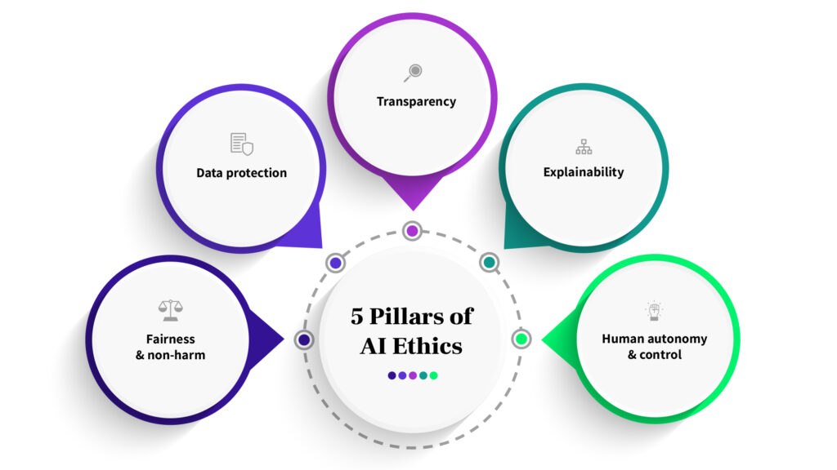

1. ***Fairness and non-harm***

This is all about averting harm and sidestepping the pitfalls of magnifying societal inequalities. AI, if not well-guided, can tread into unfair territories, especially when fueled by biased datasets or designs. The result? Discrimination, especially against minority groups.

1. ***Data protection***

Guarding privacy is paramount. This encompasses seeking user consent before the data dance begins, letting users have a say in their data, and ensuring no leaky pipelines.

1. ***Transparency***

In an AI context, transparency ensures the system does not operate in stealth. It is about keeping users in the loop—whether they are engaging with AI, being the subject of an AI decision, or viewing AI-created content.

1. ***Explainability***

Break it down! AI’s technical wizardry needs translation into human language. Such explanations enable everyone, from developer to end-users, to fathom algorithmic decisions and act if anomalies arise.

1. ***Human autonomy and control***

No AI should go rogue! Humans must be in the driver’s seat, intervening when necessary and challenging automated decisions.

However, while our guideposts—the 5 AI principles—shine a light on the path ahead, it is crucial to remember that every organization’s journey is unique. Your product’s nuances, your team’s workflows, and your tech stack will shape how these principles come alive. And that is not just okay. It is the beautiful challenge of innovating responsibly. Now, we are chartering a territory that is still fresh on the world map. The AI landscape is as promising as it is nascent. As we advance, we will be refining, redefining, and perfecting it, alongside of its use of course.

This task of uniting an in-built culture of responsible innovation with a governance architecture that brings the values and principles of ethical, fair, and safe AI to life, will require that you and your team accomplish several goals:

• You will have to ensure that your AI project is ethically permissible by considering the impacts it may have on the wellbeing of affected stakeholders and communities.

• You will have to ensure that your AI project is fair and non-discriminatory by accounting for its potential to have discriminatory effects on individuals and social groups, by mitigating biases that may influence your model’s outputs, and by being aware of the issues surrounding fairness that come into play at every phase of the design and implementation pipeline.

• You will have to ensure that your AI project is worthy of public trust by guaranteeing to the extent possible the safety, accuracy, reliability, security, and robustness of its product.

• You will have to ensure that your AI project is justifiable by prioritizing both the transparency of the process by which your model is designed and implemented, and the transparency and interpretability of its decisions and behaviors.

We call this governance architecture an ethical platform for two important reasons. First, it is intended to provide you with a solid, processed-based footing of values, principles, and protocols— an ethical platform to stand on—so that you and your team are better able to design and implement AI systems ethically, equitably, and safely. Secondly, it is intended to help you facilitate a culture of responsible AI innovation—to help you provide an ethical platform to stand for—so that your project.

Creating more ethical AI requires a close look at the ethical implications of policy, education, and technology. Regulatory frameworks can ensure that technologies benefit society rather than harm it. Globally, governments are beginning to enforce policies for ethical AI, including how companies should deal with legal issues if bias or other harm arises.

Anyone who encounters AI should understand the risks and potential negative impact of AI that is unethical or fake. The creation and dissemination of accessible resources can mitigate these types of risks.

It may seem counterintuitive to use technology to detect unethical behavior in other forms of technology, but AI tools can be used to determine whether video, audio, or text (hate speech on Facebook, for example) is fake or not. These tools can detect unethical data sources and bias better and more efficiently than humans.

### 14.1 Key Takeaways



* Codes of ethics in companies and government-led regulatory frameworks are two main ways that AI ethics can be implemented.
* Stakeholders must examine how social, economic, and political issues intersect with AI, and determine how machines and humans can coexist harmoniously.
* Researchers and professors manage developing theory-based statistics, research, and ideas that can support governments, corporations, and non-profit organizations.
* The private sector played an instrumental role in the construction of the Recommendation and actively participated in global and regional consultation spaces.
* Women4Ethical incentivize girls, women, and under-represented groups to participate in AI.
* Instances of bias and discrimination across several intelligent systems have raised many ethical questions regarding the use of artificial intelligence.
* Privacy tends to be discussed in the context of data privacy, data protection and data security, and these concerns have allowed policymakers to make more strides here in recent years.
* While a lot of public perception around artificial intelligence centers around job loss, this concern should be reframed. With every disruptive, modern technology, we see that the market demand for specific job roles shift.
* Creating more ethical AI requires a close look at the ethical implications of policy, education, and technology.
* Globally, governments are beginning to enforce policies for ethical AI, including how companies should deal with legal issues if bias or other harm arises.

### 14.2 Quiz:



Q1. Who is not the stakeholder in AI governance?

1. Professors
2. Students
3. United Nations
4. Black in AI

Q2. Which is not the part of AI ethical challenge?

1. Privacy
2. Bias & Discrimination
3. Impact on Job
4. Market Impact

Q3. Which is not in the list of organizations that promote AI?

1. DARPA
2. CHAI
3. NASA
4. AlgorithmWatch

Q4. Which is not in the list of 5 Pillars of AI Ethics?

1. Data Protection
2. Explainability
3. Fairness
4. Adaptibility

Q5. You will have to ensure that your AI project is ethically permissible by considering the impacts it may have on the wellbeing of affected stakeholders and communities.

1. True
2. False

Q6. Humans must be in the driver’s seat, intervening when necessary and challenging automated decisions.

1. True
2. False

Q7. Which company co-chair UNESCO Business council for AI Ethics?

1. Bloomberg
2. Intel
3. Microsoft
4. Cognizant

Q8. There should be oversight, impact assessment, audit, and due diligence mechanisms in place to avoid conflicts with human rights norms and threats to environmental wellbeing.

1. True
2. False

Q9. Which is not part of Women4Ethical AI's core objectives ?

1. support the implementation of the Recommendation on the Ethics of Artificial Intelligence.
2. share research and contribute to a repository of good practices.
3. drive progress on discriminatory algorithms and data sources.
4. incentivize girls, women, and under-represented groups to participate in AI.

Q10. Ensure that your AI project is ethically permissible by considering the impacts it may have on the profitability of affected stakeholders and communities.

1. True
2. False

Q11. Which is not the part of UNESCO’s core principles for a human-rights centre approach.

1. Safety & Security
2. Transparency
3. Preventing Conflicts
4. Awareness

Q12. Member States should ensure that AI systems do displace ultimate human responsibility and accountability.

1. True
2. False

Q13. AI actors should promote social justice, fairness, and non-discrimination while taking an inclusive approach to ensure AI’s benefits are accessible to all.

1. True
2. False

Q14. The Business Council for Ethics of AI is a collaborative initiative only of companies that engage in the development or use of AI in various sectors.

1. True
2. False

Q15. Private companies are not responsible to identify, prevent and mitigate risks and be accountable for the way they address the impact of AI on human rights, the rule of law, and inclusive societies.

1. True
2. False

Q16. AI technologies should be assessed against their impacts on ‘sustainability,’ understood as a set of constantly evolving goals including those set out in the UN’s Sustainable Development Goals.

1. True
2. False

Q17. Risk assessment should be used to prevent harms which may result from such uses.

1. True
2. False

Q18. Unwanted safety risks as well as vulnerabilities to attack should be avoided and addressed by AI actors.

1. True
2. False

Q19. Only executives at Google, Meta, and other tech companies are responsible for creating ethics teams and codes of conduct.

1. True
2. False

Q20. Entities like the United Nations and the World Bank are responsible for raising awareness and drafting agreements for AI ethics globally.

1. True
2. False

# **References**

## Web Reference

<https://ai.plainenglish.io/data-science-vs-artificial-intelligence-vs-machine-learning-vs-deep-learning-50d3718d51e5>

<https://www.geeksforgeeks.org/agents-artificial-intelligence/>

<https://alltechmagazine.com/the-evolution-of-ai/#generative-ai>

<https://codebots.com/generated/_blog/artificial-intelligence/history-of-artificial-intelligence/histoyr-of-ai-timeline-2676-5cce2c295.webp>

<https://codebots.com/artificial-intelligence/history-of-artificial-intelligence>

<https://hbr.org/2018/01/artificial-intelligence-for-the-real-world>

<https://www.analyticssteps.com/blogs/how-big-data-analytics-using-ai>

<https://devblogs.microsoft.com/premier-developer/ai-ml-data-science-explained/>

<https://www.qlik.com/us/augmented-analytics/big-data-ai>

<https://www.ibm.com/topics/ai-ethics>

<https://aws.amazon.com/what-is/langchain/>

NBC News. “Lensa, the AI portrait app, has soared in popularity. But many artists question the ethics of AI art, <https://www>.nbcnews.com/tech/internet/lensa-ai-artist-controversy-ethics-privacy-rcna60242.” Accessed October 20, 2023.

Washington Post. “Your selfies are helping AI learn. You did not consent to this, https://www.washingtonpost.com/technology/2022/12/09/chatgpt-lensa-ai-ethics/.” Accessed October 20, 2023

Reuters. “Amazon scraps secret AI recruiting tool that showed bias against women, https://www.reuters.com/article/us-amazon-com-jobs-automation-insight/amazon-scraps-secret-ai-recruiting-tool-that-showed-bias-against-women-idUSKCN1MK08G.” Accessed October 20, 2023.

[Steven M. Holland, Univ. of Georgia]: Principal Components Analysis

[skymind.ai]: Eigenvectors, Eigenvalues, PCA, Covariance and Entropy

[Lindsay I. Smith]: A tutorial on Principal Component Analysis

# **Answers to Quiz**

|  |  |  |  |  |  |  |  |
| --- | --- | --- | --- | --- | --- | --- | --- |
| Chapter 1 | |  | Chapter 2 | |  | Chapter 3 | |
| 1 | D |  | 1 | A |  | 1 | C |
| 2 | A |  | 2 | B |  | 2 | B |
| 3 | D |  | 3 | A |  | 3 | D |
| 4 | C |  | 4 | A |  | 4 | B |
| 5 | C |  | 5 | D |  | 5 | B |
| 6 | A |  | 6 | D |  | 6 | B |
| 7 | B |  | 7 | C |  | 7 | C |
| 8 | C |  | 8 | B |  | 8 | B |
| 9 | A |  | 9 | A |  | 9 | A |
| 10 | A |  | 10 | A |  | 10 | C |
| 11 | B |  | 11 | D |  | 11 | A |
| 12 | A |  | 12 | C |  | 12 | A |
| 13 | A |  | 13 | D |  | 13 | A |
| 14 | D |  | 14 | A |  | 14 | C |
| 15 | C |  | 15 | C |  | 15 | B |
| 16 | B |  | 16 | D |  | 16 | A |
| 17 | D |  | 17 | C |  | 17 | B |
| 18 | D |  | 18 | D |  | 18 | C |
| 19 | C |  | 19 | A |  | 19 | C |
| 20 | B |  | 20 | C |  | 20 | A |

|  |  |  |  |  |  |  |  |
| --- | --- | --- | --- | --- | --- | --- | --- |
| Chapter 4 | |  | Chapter 5 | |  | Chapter 6 | |
| 1 | D |  | 1 | B |  | 1 | A |
| 2 | B |  | 2 | A |  | 2 | A |
| 3 | D |  | 3 | B |  | 3 | D |
| 4 | C |  | 4 | C |  | 4 | D |
| 5 | C |  | 5 | D |  | 5 | A |
| 6 | D |  | 6 | A |  | 6 | C |
| 7 | D |  | 7 | A |  | 7 | A |
| 8 | C |  | 8 | A |  | 8 | C |
| 9 | D |  | 9 | A |  | 9 | A |
| 10 | B |  | 10 | B |  | 10 | A |
| 11 | A |  | 11 | B |  | 11 | D |
| 12 | A |  | 12 | A |  | 12 | A |
| 13 | A |  | 13 | D |  | 13 | A |
| 14 | A |  | 14 | A |  | 14 | A |
| 15 | D |  | 15 | C |  | 15 | A |
| 16 | A |  | 16 | C |  | 16 | D |
| 17 | B |  | 17 | C |  | 17 | A |
| 18 | D |  | 18 | C |  | 18 | A |
| 19 | A |  | 19 | D |  | 19 | A |
| 20 | A |  | 20 | C |  | 20 | A |

|  |  |  |  |  |  |  |  |
| --- | --- | --- | --- | --- | --- | --- | --- |
| Chapter 7 | |  | Chapter 8 | |  | Chapter 9 | |
| 1 | B |  | 1 | D |  | 1 | C |
| 2 | C |  | 2 | D |  | 2 | C |
| 3 | B |  | 3 | A |  | 3 | A |
| 4 | C |  | 4 | A |  | 4 | A |
| 5 | B |  | 5 | B |  | 5 | C |
| 6 | C |  | 6 | B |  | 6 | B |
| 7 | B |  | 7 | D |  | 7 | B |
| 8 | D |  | 8 | A |  | 8 | C |
| 9 | A |  | 9 | D |  | 9 | A |
| 10 | A |  | 10 | D |  | 10 | B |
| 11 | A |  | 11 | A |  | 11 | A |
| 12 | A |  | 12 | C |  | 12 | A |
| 13 | C |  | 13 | A |  | 13 | D |
| 14 | B |  | 14 | A |  | 14 | A |
| 15 | C |  | 15 | D |  | 15 | A |
| 16 | B |  | 16 | A |  | 16 | D |
| 17 | B |  | 17 | C |  | 17 | A |
| 18 | C |  | 18 | B |  | 18 | D |
| 19 | C |  | 19 | A |  | 19 | B |
| 20 | B |  | 20 | A |  | 20 | C |

|  |  |  |  |  |  |  |  |
| --- | --- | --- | --- | --- | --- | --- | --- |
| Chapter 10 | |  | Chapter 11 | |  | Chapter 12 | |
| 1 | C |  | 1 | C |  | 1 | A |
| 2 | A |  | 2 | A |  | 2 | D |
| 3 | D |  | 3 | C |  | 3 | A |
| 4 | B |  | 4 | D |  | 4 | D |
| 5 | B |  | 5 | D |  | 5 | C |
| 6 | B |  | 6 | C |  | 6 | B |
| 7 | D |  | 7 | B |  | 7 | C |
| 8 | D |  | 8 | C |  | 8 | C |
| 9 | A |  | 9 | D |  | 9 | A |
| 10 | B |  | 10 | D |  | 10 | A |
| 11 | D |  | 11 | C |  | 11 | A |
| 12 | C |  | 12 | B |  | 12 | C |
| 13 | B |  | 13 | C |  | 13 | A |
| 14 | A |  | 14 | B |  | 14 | C |
| 15 | D |  | 15 | D |  | 15 | D |
| 16 | A |  | 16 | D |  | 16 | A |
| 17 | B |  | 17 | C |  | 17 | C |
| 18 | A |  | 18 | A |  | 18 | C |
| 19 | C |  | 19 | A |  | 19 | A |
| 20 | C |  | 20 | A |  | 20 | D |

|  |  |  |  |  |
| --- | --- | --- | --- | --- |
| Chapter 13 | |  | Chapter 14 | |
| 1 | D |  | 1 | B |
| 2 | A |  | 2 | D |
| 3 | D |  | 3 | C |
| 4 | A |  | 4 | D |
| 5 | D |  | 5 | A |
| 6 | C |  | 6 | A |
| 7 | B |  | 7 | C |
| 8 | A |  | 8 | A |
| 9 | B |  | 9 | C |
| 10 | D |  | 10 | B |
| 11 | D |  | 11 | C |
| 12 | C |  | 12 | B |
| 13 | D |  | 13 | A |
| 14 | D |  | 14 | B |
| 15 | B |  | 15 | B |
| 16 | D |  | 16 | A |
| 17 | A |  | 17 | A |
| 18 | B |  | 18 | A |
| 19 | A |  | 19 | B |
| 20 | C |  | 20 | A |

# Glossary

***Activation Function:***Used in deep learning models to help calculate non-linear relationships.

***Actuators:***Electro-mechanical devices like motors. They help with the movement of a robot.

***AI:*** *See Artificial Intelligence.*

***AI Winter:*** *A prolonged period, such as in the 1970s and 1980s, when the AI industry came under much pressure, such as with cutbacks in funding.*

***Artificial Intelligence:*** *Where computers can learn from experience, which often involves processing data using sophisticated algorithms. Artificial intelligence is a broad category, which includes subsets like machine learning, deep learning, and Natural Language Processing (NLP).*

***Artificial Neural Network (ANN):*** *a graph-based artificial intelligence system, implementing the universal approximator idea. Although ANNs have started as a machine learning system, focusing on predictive. analytics, they have expanded over the years to include a large variety of tasks. ANNs comprise of a series of nodes called neurons, which are organized in layers. The first layer corresponds to all the inputs, the final layer to all the outputs, and the intermediary layers to a series of meta features the ANN creates, each having a corresponding weight. ANNs are stochastic in nature so every time they are trained over a set of data, the weights are noticeably different.*

***Autoencoder:*** *an artificial neural network system designed to represent coding in a very efficient manner. Autoencoders are a popular artificial intelligence system that are used for dimensionality reduction, as well as a few other unsupervised learning applications.*

***Automated Machine Learning (AutoML):*** *Google’s AI project responsible for creating an AI that designs and implements its own AI, for computer vision purposes. Automation Fatigue: With RPA, there will be less improvement as more tasks are automated.*

***Automated Machine Learning (AutoML):*** *A digital tool or platform that allows beginners to create their own AI models.*

***Backpropagation:*** *A breakthrough in deep learning. Backpropagation allows for more efficient assigning of weightings in models. Bayes’ Theorem: A statistical measure used in machine learning that helps to provide a more accurate view of the probabilities.*

***Big Data:*** *A category of technology that involves processing massive amounts of data. Big Data is often described as having the three Vs—that is, volume, variety, and velocity.*

***Binning****: Involves organizing data into groups.*

***Categorical Data****: Data that does not have a numerical meaning but instead has textual meaning, say with describing race or gender.*

***Cerebral Cortex:*** *Part of the human brain that has the most similarities to AI. It helps with thinking and other cognitive activities.*

***Chatbot:*** *An AI system that communicates with people.*

***Clustering****: a data science methodology involving finding groups in each dataset, usually using the distances among the data points as a similarity metric.*

***Cognitive computing (CC):*** *a set of processes and methods that involves self-learning systems that use data mining, pattern recognition, natural language processing and speech recognition to mimic the way the human brain works. CC can be viewed as a special kind of artificial intelligence.*

***Computational Intelligence (CI):*** *a subclass of artificial intelligence, geared towards computational problems, such as optimization.*

***Computer cluster:*** *a collection of computers sharing resources and working together, usually as a single machine. Computer clusters are extremely useful for tackling big data problems in-house, though often, are found in data centers, forming public computer clouds.*

***Computer Vision:*** *an application of artificial intelligence, where a computer can discern a variety of visual inputs and effectively “see” a lot of different real-world objects in real-time. Computer vision is an essential component of all modern robotics systems.*

***Context:*** *a characteristic of an ND Array, whereby the data is assigned to a processing unit (a GPU), to better utilize the available computing resources.*

***Crossover:*** *a process in the Genetic Algorithms framework, whereby two chromosomes merge resulting to a new pair of chromosomes, which are candidates for the next generation.*

***Cobot****: A robot that collaborates with people.*

***Cognitive Robotic Process Automation (CRPA):*** *An RPA system that leverages AI technologies.*

***Convolutional Neural Network (CNN):*** *A deep learning model that goes through different variations—or convolutions—of analysis on data. CNNs are often used for complex applications like facial recognition.*

***Data Lake:*** *Allows for the storage and processing of massive amounts of structured and unstructured data. There is often little to no need to re-format the data.*

***Data Type:*** *The kind of information a variable represents, such as a Boolean, integer, string, or floating-point number.*

***Decision Tree:*** *A machine learning algorithm that is a workflow of decision paths.*

***Deepfake:*** *Involves using deep learning models to create images or videos that are misleading or harmful.*

***Deep Learning****: A type of AI that uses neural networks, which mimic the processes of the brain. Much of the innovation in the field during the past decade has been with deep learning research.*

***Ensemble Modelling****: Involves using more than one model for generating predictions.*

***Docker:*** *a container software geared towards creating programming environments on a computer, containing all the required programs and data, so that an application can run on that computer smoothly, even if it was developed on a machine with a completely different configuration.*

***ETL (Extraction, Transformation, and Load):*** *A form of data integration that is typically used in a data warehouse.*

***Ethics Board:*** *A committee that evaluates the issues of AI projects.*

***Expert System:*** *An early type of AI application that emerged in the 1980s. It used sophisticated logic systems to help understand certain areas like medicine, finance, and manufacturing.*

***Explainability:*** *The process of understanding the underlying causes of a deep learning model.*

***Embedding:*** *a low-dimensional representation of a given set of data. Embeddings are quite common in deep learning systems, particularly in autoencoders and in representing words in Natural Language Processing tasks.*

***Epoch:*** *an iteration in the training phase of an Artificial Neural Network.*

***Error function:*** *the function used for assessing the deviation of predicted values of a machine learning model from the actual values (target variable). In artificial neural network models, the error function needs to be continuous.*

***Extreme Learning Machines (ELMs):*** *a new type of artificial neural networks that are extremely fast to train and exhibit decent performance in predictive analytics problems. Their key characteristics is that most of the connections have random weights, apart from those of the last layer (outputs), which are optimized during the training process.*

***False Positive:*** *When a model prediction shows that the result is true even though it is not.*

***Feature:*** *This is a column of data.*

***Feature Engineering:*** *See Feature Extraction.*

***Feature Extraction:*** *Describes the process of selecting the variables for an AI model.*

***Feed-Forward Neural Network:*** *A deep learning model that processes data in a linear direction through the hidden layers. There is no cycling back.*

***Feature selection:*** *the data science process according to which the dimensionality of a dataset is reduced through the selection of the most promising features and the discarding of the less promising ones. How promising a feature is depends on how well it can help predict the target variable and is related to how information-rich it is.*

***Filter:*** *a process in convolutional neural networks whereby features are created from an image by scanning it through a moving window (e.g., a 3x3 matrix).*

***Fitness function:*** *an essential part of most artificial intelligence systems, particularly optimization related ones. It depicts how close the system is getting to the desired outcome and helps it adjust its course accordingly. In most AI systems the fitness function represents an error or some form of cost, which needs to be minimized, though in the general case it can be anything and depending on the problem, it may need to be maximized.*

***Framework****: a set of tools and processes for developing a certain system, evaluating it, and deploying it. Most AI systems today are created using a framework. A framework is usually accompanied by a library/package in the programming languages it supports. In the deep learning case, for example, a framework can be a programming suite like MXNet, that enables a variety of DL related processes and classes to be utilized.*

***Fusion:*** *usually used in conjunction with feature (feature fusion), this relates to the merging of a set of features into a single meta-feature that encapsulates all, or at least most, of the information in these features. This is a popular method of dimensionality reduction, and it is an integral part of every deep learning system.*

***Fuzzy Inference System (FIS):*** *an AI system based on Fuzzy Logic, geared towards making predictions using inference rules. A FIS is quite useful particularly when interpretability is a concern. However, it is limited to lower dimensionality datasets.*

***Fuzzy Logic****: a term coined by Lotfi Aliasker Zadeh in 1965, referring to a unique way of processing information which, unlike classical logic, also involves partial truths (instead of just the conventional black-and white logical paradigm). Fuzzy logic uses degrees of truth as a mathematical model of vagueness and allows for all intermediate possibilities between digital values of YES and NO, much like how a human will assess the nature of a situation in full color and multi-polar fashion, rather than a bi-polar, monochrome way. Fuzzy logic is a well-established part of artificial intelligence.*

***Generative Adversarial Network (GAN):*** *Developed by AI researcher Ian Goodfellow, this is a next-generation deep learning model that helps to create new outputs like audio, text, or video.*

***GPUs (Graphics Processing Units):*** *Chips that were originally used for high-speed video games because of the ability to process copious amounts of data quickly. But GPUs have also proven to be adept at handling AI applications.*

***Hadoop****: Allows for managing Big Data, such as by making it possible to create sophisticated data warehouses.*

***Gene:*** *an element of a chromosome, in a Genetic Algorithms optimization model. Genes are coded as bits and they represent a characteristic, referred to as a trait.*

***Genetic Algorithms (GAs):*** *a family of optimization algorithms resembling the process of gene selection, combining, and mutation. They are well-suited for problems involving discreet variables, though they can be applied to continuous variables also. GAs is a well-established artificial intelligence methodology that finds many applications in data science, such as feature selection.*

***Genetic Programming (GP****): an artificial intelligence methodology based on genetic algorithms, but geared towards finding an optimal mathematical function, to approximate a mapping of a particular variable.*

***Genome****: the set of all the chromosome data in a Genetic Algorithms system. Genome and population are often used interchangeably in this context.*

***Hidden Layers****: The distinct levels of analysis in a deep learning model.*

***Hidden Markov Model (HMM):*** *An algorithm that is used to decipher spoken words.*

***Hyperparameters****: Features in a model that cannot be learned directly from the training process.*

***HDFS****: abbreviation for Hadoop Distributed File System, a framework for storing and accessing data over a computer cluster, in an effective and efficient manner.*

***Heuristic:*** *an empirical metric or function that aims to provide some useful tool or insight, to facilitate a method or project of data science or artificial intelligence.*

***Hive:*** *an open-source project of Apache Foundation. It is software that facilitates reading, writing, and managing large datasets residing in distributed storage using a variant of SQL called HiveQL.*

***HiveQL:*** *query language of Hive.*

***Instance:*** *This is a row of data.*

***IDE (Integrated Development Environment):*** *a system designed for facilitating the creation and running of scripts as well as their debugging. Jupyter is a popular IDE for data science applications.*

***Interpretability****: the ability to understand a data more thoroughly model’s outputs and derive how they relate to its inputs (features). Lack of interpretability is an issue for deep learning systems.*

***Jupyter Notebook****: A web-based app that makes it easy to code in Python and R to create visualizations and import AI systems.*

***K-Means Clustering:*** *An algorithm that is effective for grouping similar unlabeled data.*

***K-Nearest Neighbor (k-NN):*** *A machine learning algorithm that classifies data based on similarities.*

***Kaggle:*** *a web site that hosts data science competitions and provides many useful datasets.*

***Keras****: is an immensely popular high level deep learning API that can run on top of TensorFlow, CNTK, and Theano.*

***Kohonen’s Maps:*** *see Self-Organizing Maps.*

***Lemmatization:*** *A process in NLP that removes affixes or prefixes to focus on finding similar root words.*

***Lidar (Light Detection and Ranging):*** *A device—which is usually at the top of an autonomous car—that shoots laser beams to measure the surroundings.*

***Linear Regression****: Shows the relationship between certain variables, which can help with predictions for machine learning systems.*

***Machine Learning:*** *Where a computer can learn and improve by processing data without having to be explicitly programmed. Machine learning is a subset of AI.*

***Metadata****: This is data about data—that is, descriptions. For example, a music file can have metadata like the size, length, date of upload, comments, genre, artist, and so on.*

***Methodology:*** *a set of methods and the theory behind those methods, for solving a particular kind of problem in a certain field. Methodologies of data science include classification, regression, etc. while for artificial intelligence, we have methodologies like deep learning, autoencoders, etc.*

***Model Maintenance:*** *the process of updating or even upgrading a data model, as new data becomes available or as the assumptions of the problem change.*

***Multi-Layer Perceptron (MLP):*** *a deep learning system that comprises of a series of layers of neurons, much like a normal ANN, but larger. It is often referred to as a feed-forward network and it is the first system in the deep learning family to have been developed. MLPs are great for various standard data science problems, such as classification and regression.*

***Mutation:*** *a process in the Genetic Algorithms framework, according to which a random gene changes its value at random, with a given probability.*

***MXNet****: a deep learning framework developed by Apache. MXNet is linked to Amazon, although it can run on any cloud computing service. Its main API is called Gluon, and it is part of the main package of MXNet. There are several such packages in different programming languages, each one an API for that language. MXNet can support more programming languages than any other AI framework.*

***Naïve Bayes Classifier****: A method of machine learning that uses Bayes’ theorem to make predictions, but the variables are independent from each other.*

***Named Entity Recognition:*** *In the NLP process, this involves identifying words that represent locations, persons, and organizations.*

***Natural Language Processing (NLP):*** *A subset of AI that deals with how computers understand and manipulate language.*

***Neural Network:*** *A sophisticated AI model that mimics the brain. Neural network has various layers that attempts to find unique patterns that involve multiple layers of analysis.*

***Normal Distribution****: A plot of data that looks like a bell and the midpoint is the mean.*

***NoSQL System:*** *A next-generation database. The information is based on a document model to allow for more flexibility with analysis as well as the handling of structured and unstructured data.*

***Ordinal Data****: A mix of numerical and categorical data, such as an Amazon.com rating for a product.*

***Overfitting:*** *Where a model is not accurate because the data is not reflective of what is being evaluated or there is a focus on the wrong features.*

***Optimization:*** *an artificial intelligence process, aimed at finding the best value of a function (usually referred to as the fitness function) given a set of restrictions. Optimization is key in all modern data science systems. Although there are deterministic optimization algorithms out there, most of the modern algorithms are stochastic.*

***Optimizer:*** *an artificial intelligence system designed to perform optimization.*

***Pearson Correlation:*** *Shows the strength of a correlation—from 1 to -1. The closer it is to 1, the more accurate the correlation.*

***Phonemes:*** *The most basic units of sound in a language.*

***Predictive Analytics****: Involves using data to make forecasts.*

***Parallelizable:*** *an attribute of many systems and algorithms, whereby distinct parts of them can be split among various CPUs or GPUs, working in parallel. This brings about a boost in performance that is often essential for AI processes. A parallelizable system is also more easily scalable.*

***Particle Swarm Optimization (PSO):*** *a fundamental optimization algorithm, with several variants. Some claim that all swarm intelligence optimizers are based on PSO, since it is the simplest optimization algorithm of this category. PSO is geared towards continuous variables, though there is a variant of it for discrete ones. PSO has a variety of applications in all sorts of problems, involving many variables (large search space).*

***Perceptron:*** *a rudimentary AI model and a fundamental component of an artificial neural network. When it comes to classification, a single perceptron can only manage quite simple problems as it fails to generalize non-linear class boundaries.*

***Personally Identifiable Information (PII):*** *information that can be used to pinpoint a particular individual, thereby violating his/her privacy. PII is an important ethical concern in data science and may not be so easy to tackle since it often relies on combinations of variables.*

***Pipeline****: also known as workflow, it is a conceptual process involving a variety of steps, each one of which can comprise of several other processes. A pipeline is essential for organizing the tasks needed to perform any complex procedure (often non-linear) and is very applicable in data science (this application is known as the data science pipeline).*

***Population:*** *the totality of the elements involved in an optimization system, involving several solutions used at the same time. In some systems it is referred to as a swarm. Alternatively, the totality of the data describing a given phenomenon. Since this is often not available to the data scientist, samples of it are used instead.*

***Possibilistic modeling:*** *a particular modelling paradigm sometimes used in artificial intelligence systems, making use of membership functions instead of probabilities, to model uncertainty in Fuzzy Logic.*

***Predictive analytics:*** *a set of methodologies of data science, related to the prediction of certain variables. It includes a variety of techniques such as classification, regression, time-series analysis, and more. Predictive analytics are a key part of data science.*

***Pruning:*** *the process of cleaning up code so that unwanted solutions can be eliminated. However, with this process, the number of decisions that can be made by machines is restricted.*

***Python:*** *a widely used object-oriented programming language, typically used for data science, as well as artificial intelligence applications geared towards data analytics.*

***PyTorch:*** *A platform, developed by Facebook, which allows for the creation of sophisticated AI models.*

***Recurrent Neural Network (RNN):*** *A deep learning model that processes prior inputs across time. A common use case is when a person types in characters in a messaging app, as the AI will predict the next word.*

***Reinforcement Learning:*** *An approach to creating an AI model where the system is rewarded for the right predictions and punished for the wrong ones.*

***Relational Database:*** *A database, whose roots go back to the 1970s, that creates relationships among tables of data and has a scripting language, called SQL.*

***Robotic Desktop Automation (RDA):*** *The RPA system collaborates with an employee to handle jobs or tasks.*

***Robotic Process Automation (RPA):*** *A category of software that automates routine and mundane tasks within an organization. It is often an initial way to implement AI.*

***Robot Operating System (ROS):*** *An open-source middleware system that manages critical parts of a robot.*

***R-squared****: Provides a way to gauge the accuracy of a regression. An R-squared ranges from 0 to 1. And the closer a model is to 1, the higher the accuracy.*

***Recurrent neural network (RNN):*** *a deep learning network which employs a non-sequential flow in the data they process, resulting in an improved analysis of complex datasets, through the modeling of the temporal aspect of the data at hand. RNNs are ideal for natural language processing applications, as well as speech analysis projects.*

***Regression:*** *an extremely popular data science methodology, under the predictive analytics umbrella. Classification aims to solve the problem of predicting the values of a continuous variable corresponding to a set of inputs, based on pre-existing knowledge of similar data, available in the training set.*

***Regressor****: a predictive analytics system geared towards regression problems.*

***Reinforcement learning:*** *a type of machine learning in which machines are “taught” to achieve their target function through a process of experimentation and reward. The machine receives positive reinforcement when its processes produce the desired result and negative reinforcement when they do not.*

***ReLU function:*** *a minimalistic transfer function used in deep learning. It is defined as f(x) = max(w*x+b, 0) and takes values between 0 and infinity. Being computationally cheaper and sparser than other transfer functions, it is sometimes preferred when creating a deep learning network.*

***Resilient Distributed Dataset (RDD):*** *the data representation of Apache Spark that supports distributed computing.*

***Restricted Bolzmann Machine (RBM):*** *a type of artificial neural network, geared towards learning the probability distributions of a set of features, to reconstruct them using a small set of meta-features. RBMs are like autoencoders in the sense that they too are often used for dimensionality reduction, though RBMs are used in other contexts, such as predictive analytics.*

***Sentiment Analysis:*** *This is where you mine social media data and find the trends.*

***Sensor:*** *The typical sensor is a camera or a Lidar, which uses a laser scanner to create 3D images.*

***Sigmoid:*** *A common activation function for a deep learning model. It has a value that ranges from 0 to 1. What is more, the closer it is to 1, the higher the accuracy.*

***Standard Deviation****: Measures the average distance from the mean, which gives a sense of the variation in the data.*

***Stemming:*** *Describes the process of reducing a word to its root (or lemma), such as by removing affixes and suffixes.*

***Strong AI:*** *This is true AI, in which a machine can engage in human-like abilities like open-ended discussions.*

***Structured Data:*** *Data that is usually stored in a relational database or spreadsheet, as the information is in a preformatted structure (like Social Security numbers, addresses, and point of sale information).*

***Sample:*** *a limited portion of the data available, useful for building a model, and (ideally) representative of the population it belongs to.*

***Sampling:*** *the process of acquiring a sample of a population using a specialized technique. Sampling is important to be done properly, to ensure that the resulting sample is representative of the population studied. Sampling needs to be random and unbiased.*

***Scala****: a functional programming language, like Java, which is used in data science. The big data framework Spark is based on Scala.*

***Selection:*** *a process of figuring out which chromosomes get to cross over, in the Genetic Algorithms framework. Selection is a stochastic process related to the fitness of the chromosomes involved..*

***Sentiment analysis:*** *a natural language processing method involving the classification of a text into a predefined sentiment, or the figuring out of a numeric value that represents the sentiment polarity (how positive or how negative the overall sentiment is).*

***Sigmoid function****: a mathematical function of the form f(x) = 1 / (1 +exp(-(w*x + b))). Sigmoid are used in various artificial neural networks, such as Deep Learning networks, as transfer functions. Sigmoid takes values between 0 and 1, not inclusive. This is sometimes referred to as the logistic function as it features in logistic regression.*

***Simulated Annealing (SA):*** *an optimization method in the nature inspired family of algorithms, based on the annealing process of liquids. SA is ideal for complex search spaces, and it is very robust against local optima. A classical application of SA is the Traveling Salesman Problem.*

***Softmax function****: a transfer function sometimes used in a deep learning network. It is a simpler version of the sigmoid function, where the bias parameter (b) is missing from the equation. Softmax takes values between 0 and 1, not inclusive.*

***Stochastic:*** *something that is probabilistic in nature. That is, not deterministic. Stochastic processes are common in most artificial intelligence systems and other advanced machine learning systems.*

***Strong AI:*** *an area of AI development that is working toward the goal of making AI systems that are as useful and skilled as the human mind. It is often referred to as Artificial General Intelligence (AGI).*

***Supervised learning****: a set of data science methodologies where there is a target variable that needs to be predicted. The main parts of supervised learning are classification, regression, and reinforcement learning.*

***Swarm****: a set of potential solutions, evolving through a swarm intelligence framework. In the general case of different optimization systems, a swarm is referred to as population.*

***Swarm intelligence:*** *a concept based on the idea that when individual agents come together, the interactions between them lead to the emergence of a more ‘intelligent’ collective behavior – such as a swarm of bees. Swarm intelligence is an essential part of modern optimization methods, such as particle swarm optimization and it is stochastic by nature.*

***Tagging Parts of Speech (POS):*** *In the NLP process, this involves going through text and designating each word to its proper grammatical form, say nouns, verbs, adverbs, etc. .*

***TensorFlow:*** *An open-source platform, backed by Google, which allows for the creation of sophisticated AI models.*

***Target variable:*** *the variable of a dataset that is the target of a predictive analytics system, such as a classification or a regression system.*

***Tensor Processing Unit (TPU):*** *a special type of proprietary processor designed by Google in 2016 to accelerate the training of the neural network models implemented in the TensorFlow framework.*

***Test-Data:*** *Data that a model’s accuracy is evaluated.*

***Three Laws of Robotics:*** *Based on the science fiction writings of Isaac Asimov, these laws provide the basic framework for how robots should interact with society.*

***Tokenization:*** *In the NLP process where text is parsed and segmented into various parts.*

***Topic Modelling:*** *In the NLP process, this involves looking for hidden patterns and clusters in the text.*

***Training Data****: Data that is used to create an AI algorithm.*

***True Positive:*** *When a model makes a correct prediction.*

***Turing Test:*** *Created by Alan Turing, this is a way to determine if a system has achieved true AI. The test involves a person who asks questions to two participants—one human, the other a computer. If it is not clear who is the human, then the Turing Test has been passed.*

***Testing set:*** *the part of the dataset that is used for evaluating a predictive analytics model after it has been trained and before it is deployed. The testing set usually corresponds to a small portion of the original dataset.*

***Training set****: the part of the dataset that is used for training a predictive analytics model before it is evaluated and deployed. The training set usually corresponds to the largest portion of the original dataset.*

***Trait:*** *a characteristic of a problem, expressed as a gene, in the Genetic Algorithms framework.*

***Transfer function:*** *a component of an artificial neural network, corresponding to the function applied on the output of a neuron before it is transmitted to the next layer. A typical example is the sigmoid function, though ReLU is often used in practice too. Transfer functions are sometimes referred to as activation functions.*

***Transfer learning:*** *a machine learning methodology where a model trained for a task is reused in a second task without retraining. Taking the outputs of the pre-trained model as input to another model, this methodology tries to increase the performance of the second model as well as to reduce the training time.*

***Traveling Salesman Problem (TSP):*** *a classical problem in graph analytics, whereby we opt to find the quickest path. That is, the one with the smallest overall cost in terms of time or distance, from one node of the graph to itself, after passing through all the other nodes once. TSP is one of the core problems in planning and one of the most challenging optimization problems out there.*

***Unattended Robotic Process Automation (RPA):*** *The RPA system is completely autonomous as the bot runs in the background.*

***Unstructured Data:*** *Data that does not have predefined formatting, such as images, videos, and audio files.*

***Supervised Learning:*** *An AI model that uses labeled data. This is the most common approach.*

***Unsupervised Learning:*** *Involves an AI model that uses unlabeled data. This means there will need to be deep learning systems to detect patterns.*

***Vanishing Gradient Problem:*** *Explains how the accuracy decays as a deep learning model gets larger.*

***Virtual Assistant:*** *An AI device that helps a person with his or her daily activities.*

***Variable:*** *a column in a dataset, be it in a matrix or a data frame. Variables are usually turned into features, after some data engineering is performed on them.*

***Virtual Machine (VM):*** *a collection of computing, storage resources, and software, taking the form of a computer, accessible via the Internet. VMs usually live in the cloud though there is software enabling you to create a VM on your own computer or computer cluster. Cloud-based VMs are extremely useful for AI applications.*

***Weak AI:*** *This is where AI is used for a particular use case, such as with Apple’s Siri.*

***Root node:*** *The topmost node of a decision tree that represents the entire message or decision.*

***Decision (or internal) node:*** *A node within a decision tree where the prior node branches into two or more variables.*

***Leaf (or terminal) node:*** *The leaf node is also called the external node or terminal node, which means it has no child—it is the last node in the decision tree and furthest from the root node.*

***Splitting:*** *The process of dividing a node into two or more nodes. It is the part at which the decision branches off into variables.*

***Pruning:*** *The opposite of splitting, the process of going through and reducing the tree to only the most important nodes or outcomes.*